# Instructions on how to use Parish Scheduler

In order to use Scheduler, you will need to use an e-mail address to register and logon.

1. Log in to ‘www.oloa.info’ – you can access it from both your computer and your mobile. You will be presented with the login screen below:

Use your email and default password *Password100*. You can change it as soon as you log in.

Password100

1. After successfully logging in, you will see the greeting screen with a menu at the top of the screen:
2. Click on *User*.

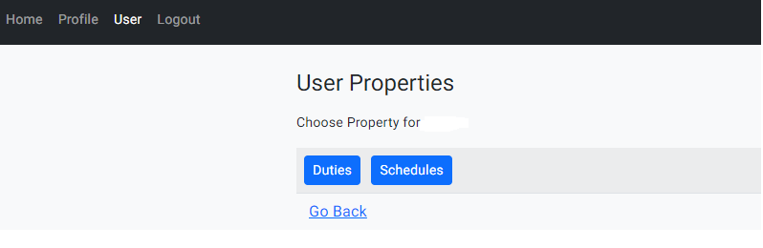

1. Click on *Duties*. This will allow you to see what ‘duties’ you are assigned to (E.g. Reader).

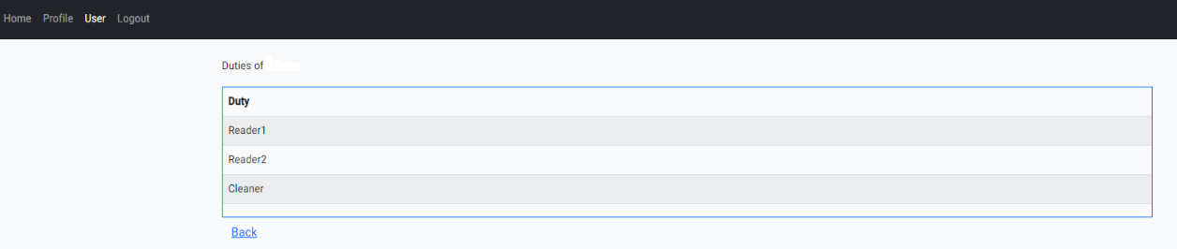

Click *Back* to go back to the main screen.

1. 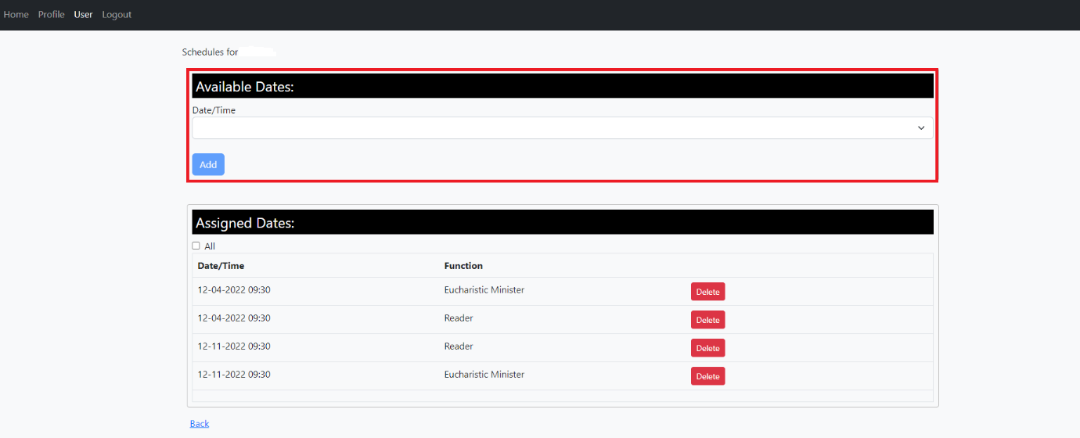Click on *Schedules*. Under *Available Dates* you will see the dates that are available to be assigned to you or another team member/volunteer.

Under *Your Currently Assigned Dates* you will see all the dates assigned to you by the parish administrator.

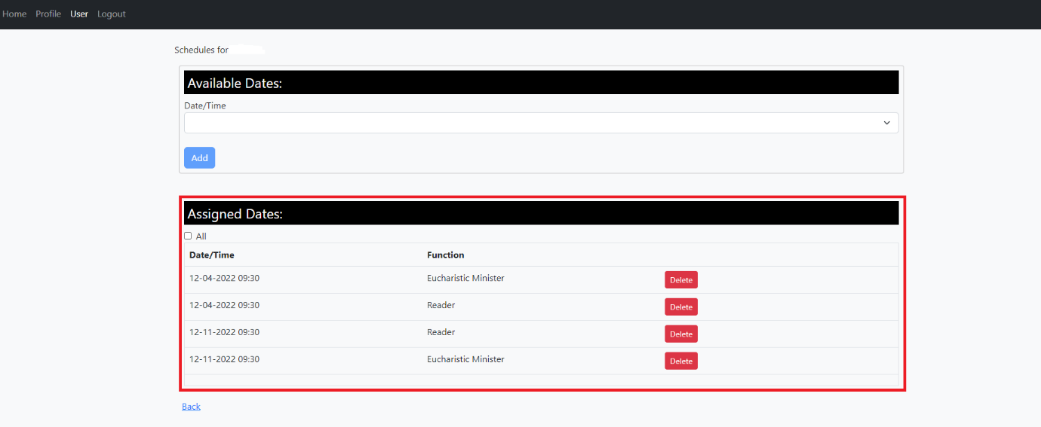(Note: you may be assigned more than 1 function).

If you cannot make the date assigned to you, you will need to click *delete* to remove it from the list of currently assigned dates, so the parish administrator and your team members may be notified, and you can be replaced. Conversely, you may want to check periodically if dates become available under the *Available Dates* section. These dates may have been removed from your team member’s assigned dates and so need to be filled.

The checkbox *All* underneath *Assigned Dates* willallow you to see either all assigned dates including past dates (if checked) or just the latest dates (if left blank).

1. Click on *Profile*.

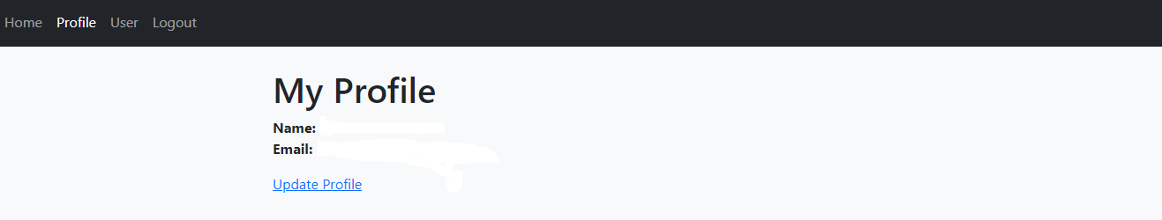

Click *Update Profile* and you will be able to change any of your details (e.g., e-mail, password).

