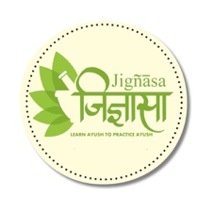



**Asavarishta Kalpam**

by

**Vaidya Bhupathy Sri. Krishna rao**

Published on

**1929**

This is a book detailing variety of Asavas, Arishtas and santhana kriyas. Written in Tamil, the author hand picked and compiled Arishtasava formulations from the classics of Ayurveda viz Bhaishaja Rathnavali, Gadanigraha and Charaka Samhitha. A great work by the Author

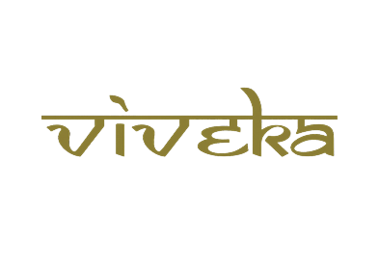

***A tribute to***

***Padmashri Krishnakumar ji***





**Amarakosam**

by

**Kaikulankara Rama Varier**

Published on

**1925**

The Ancient Sanskrit Thesaurus with Balabodhini Bhasha commentary in malayalam is a rare work



***A tribute to***

***Padmashri Krishnakumar ji***





**Aswathi Sastram**

by

**Sri. Sabapathi Mudaliyar**

Published on

**1935**

A rare book on Aswa sasthram( Ayurveda Veterinary Science on Horses) Ayurveda details medical science on Elephants and Horses- precisely known as Mrigayurveda



***A tribute to***

***Padmashri Krishnakumar ji***





**Bala Chikitasa**

by

**Godhavarman Tirumulpad**

Published on

**1923**

The book narrates about Peadiatric ailments and simple herbal remedies



***A tribute to***

***Padmashri Krishnakumar ji***





**Kaviraja Sekaram**

by

**Vaidya Bhupathy S.Krishnarao**

Published on

**1954**

The book has 3 volumes and details about Ayurveda medicine formulations and applications. The author compiled various yogas from a number of Ayurveda classics including Ashtanga Hrudayam to publish the compendium



***A tribute to***

***Padmashri Krishnakumar ji***





**Moovar**

by

**Narayana Iyengar**

Published on

**1925**

The book is a compilation of the author who wrote the content as a weekly article in a health magazine then published. Its a rare book about Bruhath thrayees and about many unknown facts about our great Acharyas, their work and period with historical evidence. He also describes about 7 important Acharyas and mentions about 27 siddhars. A great work



***A tribute to***

***Padmashri Krishnakumar ji***





**Pathinen Siddharkal Nadi Sasthiram**

by

**Kalathur Kandasamy Mudaliyar**

Published on

**1925**

The book contains Tamil poems and paragraphs detailing all about Nadi Pareeksha and prognosis of different acute health conditions and also about omens



***A tribute to***

***Padmashri Krishnakumar ji***





**Paribashai Vilakkam**

by

**K. Srinivasarao**

Published on

**1959**

The book is a compendium of different raw drugs classified and grouped in duo, three, four and upto ten by their properties and Therapeutic actions. A great work by the author



***A tribute to***

***Padmashri Krishnakumar ji***





**Nigandu Ratnakaram**

by

**Vaidya Bhupathy S.Krishnarao**

Published on

**1925**

The book is a dictionary of herbal drugs. A compendium of synonyms of each herbal drug.



***A tribute to***

***Padmashri Krishnakumar ji***





**Sadharana Bhasmas**

by

**Dr. P. S. Ramanathan**

Published on

**1950**

A hand written note by the author on different varieties of Bhasma preparations and their Therapeutic indications. He has also mentioned a number of drugs and their properties. This note was written before 1950 using Sanskrit, Malayalam and Tamil



***A tribute to***

***Padmashri Krishnakumar ji***





**Sahasra Siddha Yogam**

by

**Vaidya Bhupathy S.Krishnarao**

Published on

**1930**

The book has 2 volumes. The Author details different formulations of Kasayam, Curnam and others for every single ailments. A very useful book for medical practioners



***A tribute to***

***Padmashri Krishnakumar ji***





**Sudhikramalankaram**

by

**Ayurveda Visarada K.Srinivasarao**

Published on

**1959**

The book narrates purification of raw drugs before subjecting them to formulations



***A tribute to***

***Padmashri Krishnakumar ji***





**Tridosha Lok**

by

**Viswanath Dwiwedi**

Published on

**1965**

The book details about three doshas ( Vata, Pitta and Kapha ), their normal and abnormal status



***A tribute to***

***Padmashri Krishnakumar ji***





**Visa Chikitsa Pravesika**

by

**Keralavarma Cheriyamaman Thamburan**

Published on

**1925**

The book details toxic effects of different types of insects, animals and snakes. The author explains management protocol for every toxic bites



***A tribute to***

***Padmashri Krishnakumar ji***





**Yoga Rathnakaram**

by

**V. B. Nataraja Sastrigal**

Published on

**1925**

The book details elaborately about diseases starting from Jwara and variety of medications and formularies in a unique way



***A tribute to***

***Padmashri Krishnakumar ji***





**Pathanchala yoga suthram**

by

**Kadalangudi Natesa Sastri**

Published on

**1927**

The book details Yoga Darsanam and outlines Nyayam, Sankhyam, Vaiseshikam and Meemamsa. A unique work on Pathanjala yoga sutra in Sanskrit verses and Tamil narrative



***A tribute to***

***Padmashri Krishnakumar ji***