**Amarakosam**

by

**Kaikulankara Rama Varier**

Published on

**1925**

The Ancient Sanskrit Thesaurus with Balabodhini Bhasha commentary in malayalam is a rare work

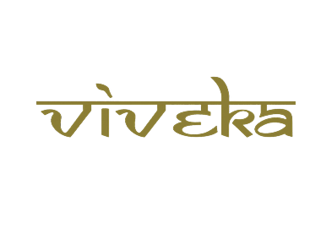

***A tribute to***

***Padmashri Krishnakumar ji***