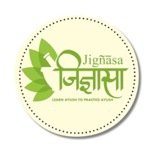



**Aswathi Sastram**

by

**Sri. Sabapathi Mudaliyar**

Published on

**1935**

A rare book on Aswa sasthram( Ayurveda Veterinary Science on Horses) Ayurveda details medical science on Elephants and Horses- precisely known as Mrigayurveda



***A tribute to***

***Padmashri Krishnakumar ji***