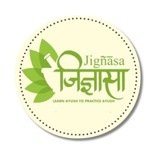



**Bala Chikitasa**

by

**Godhavarman Tirumulpad**

Published on

**1923**

The book narrates about Peadiatric ailments and simple herbal remedies

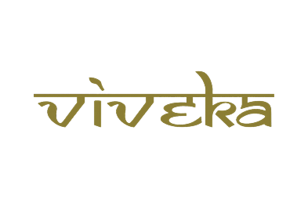

***A tribute to***

***Padmashri Krishnakumar ji***