**Kaviraja Sekaram**

by

**Vaidya Bhupathy S.Krishnarao**

Published on

**1954**

The book has 3 volumes and details about Ayurveda medicine formulations and applications. The author compiled various yogas from a number of Ayurveda classics including Ashtanga Hrudayam to publish the compendium

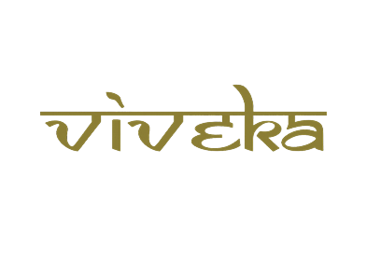

***A tribute to***

***Padmashri Krishnakumar ji***