**Moovar**

by

**Narayana Iyengar**

Published on

**1925**

The book is a compilation of the author who wrote the content as a weekly article in a health magazine then published. Its a rare book about Bruhath thrayees and about many unknown facts about our great Acharyas, their work and period with historical evidence. He also describes about 7 important Acharyas and mentions about 27 siddhars. A great work

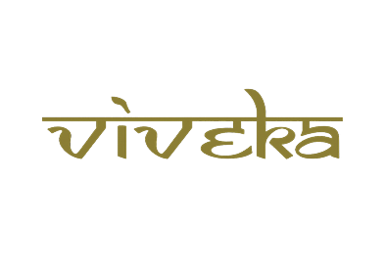

***A tribute to***

***Padmashri Krishnakumar ji***