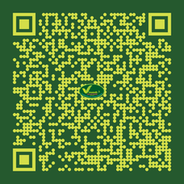

**Paribashai Vilakkam**

by

**K. Srinivasarao**

Published on

**1959**

The book is a compendium of different raw drugs classified and grouped in duo, three, four and upto ten by their properties and Therapeutic actions. A great work by the author

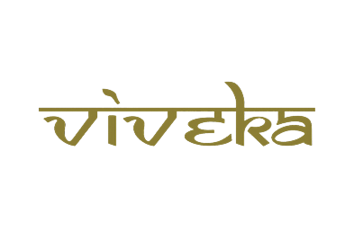

***A tribute to***

***Padmashri Krishnakumar ji***