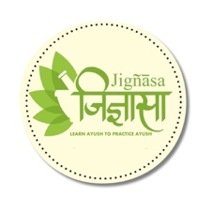



**Nigandu Ratnakaram**

by

**Vaidya Bhupathy S.Krishnarao**

Published on

**1925**

The book is a dictionary of herbal drugs. A compendium of synonyms of each herbal drug.

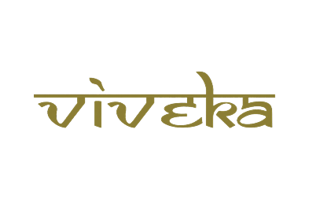

***A tribute to***

***Padmashri Krishnakumar ji***