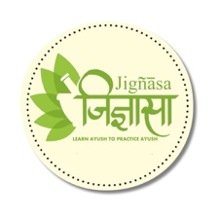



**Sadharana Bhasmas**

by

**Dr. P. S. Ramanathan**

Published on

**1950**

A hand written note by the author on different varieties of Bhasma preparations and their Therapeutic indications. He has also mentioned a number of drugs and their properties. This note was written before 1950 using Sanskrit, Malayalam and Tamil

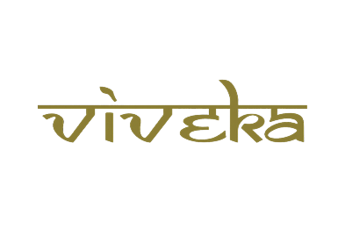

***A tribute to***

***Padmashri Krishnakumar ji***