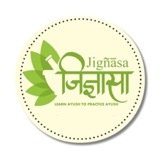



**Sahasra Siddha Yogam**

by

**Vaidya Bhupathy S.Krishnarao**

Published on

**1930**

The book has 2 volumes. The Author details different formulations of Kasayam, Curnam and others for every single ailments. A very useful book for medical practioners

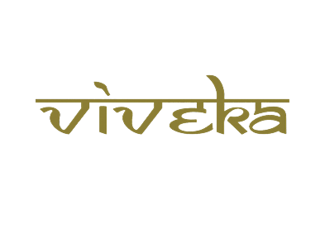

***A tribute to***

***Padmashri Krishnakumar ji***