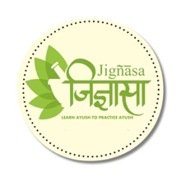



**Sudhikramalankaram**

by

**Ayurveda Visarada K.Srinivasarao**

Published on

**1959**

The book narrates purification of raw drugs before subjecting them to formulations

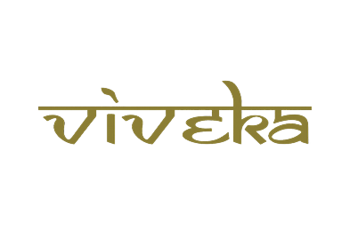

***A tribute to***

***Padmashri Krishnakumar ji***