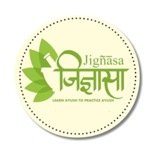



**Pathanchala yoga suthram**

by

**Kadalangudi Natesa Sastri**

Published on

**1927**

The book details Yoga Darsanam and outlines Nyayam, Sankhyam, Vaiseshikam and Meemamsa. A unique work on Pathanjala yoga sutra in Sanskrit verses and Tamil narrative

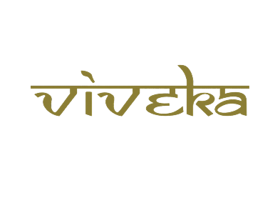

***A tribute to***

***Padmashri Krishnakumar ji***