{{qrcode}}

**{{title}}**

by

**{{author}}**

Published on

**{{year}}**

{{description}}

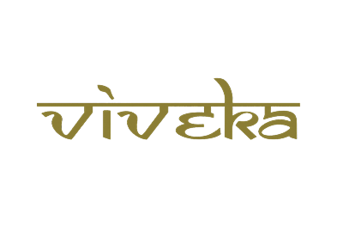

***A tribute to***

***Padmashri Krishnakumar ji***