{{qrcode}}

**{{tamilname}}**

**{{botanicalname}}**

**{{familyname}}**

{{description}}

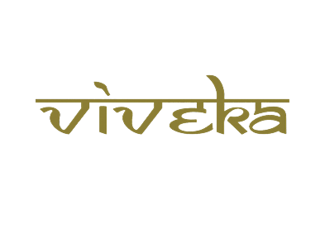

***A tribute to***

***Padmashri Krishnakumar ji***