American International University-Bangladesh (AIUB)
Introduction to Database

Final term Lab Tasks-01
DDL-DML-Constraints
- a) Create the following DEPARTMENT table according to given data type and constraint.

Column Name | Data Type | Constraint
DEPT_ID | number(3) | primary key
DEPT_NAME | varchar2(6) | only CSE, EEE, BBA, ENG, ACH allowed
BUDGET | number(6) | default value 0

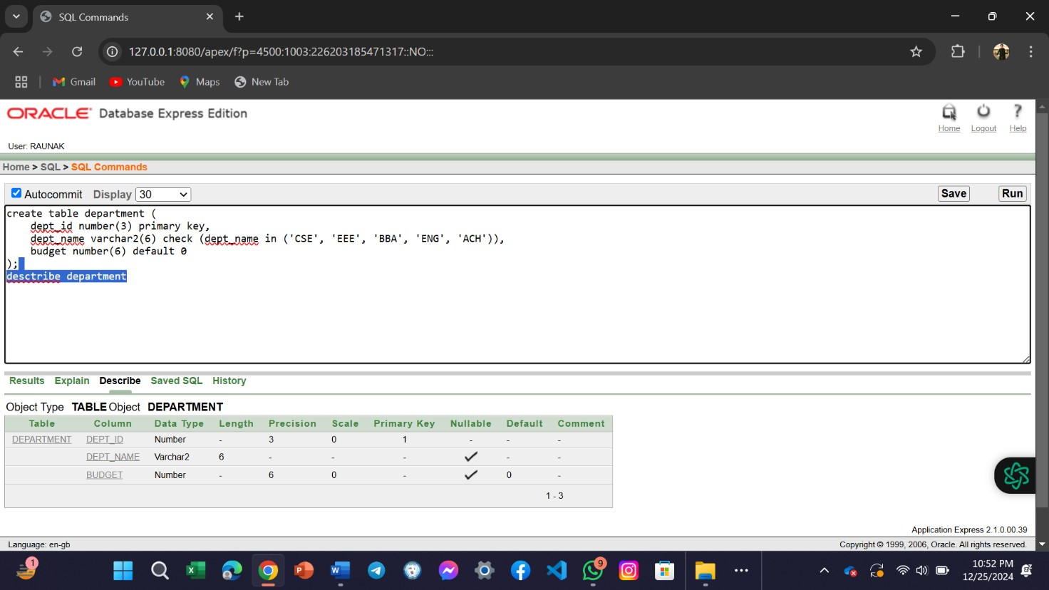

b)Insert the values as per the following information-

DEPT_ID | DEPT_NAME | BUDGET
1 | CSE | 800000
2 | EEE | 750000
3 | BBA | 600000
4 | ENG | 500000
5 | ACH | -
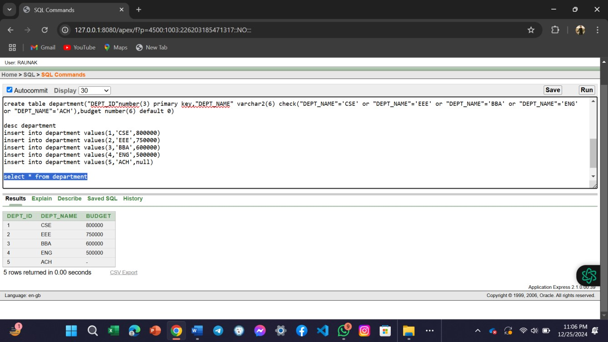 c)Delete all the inserted rows using DDL operation.
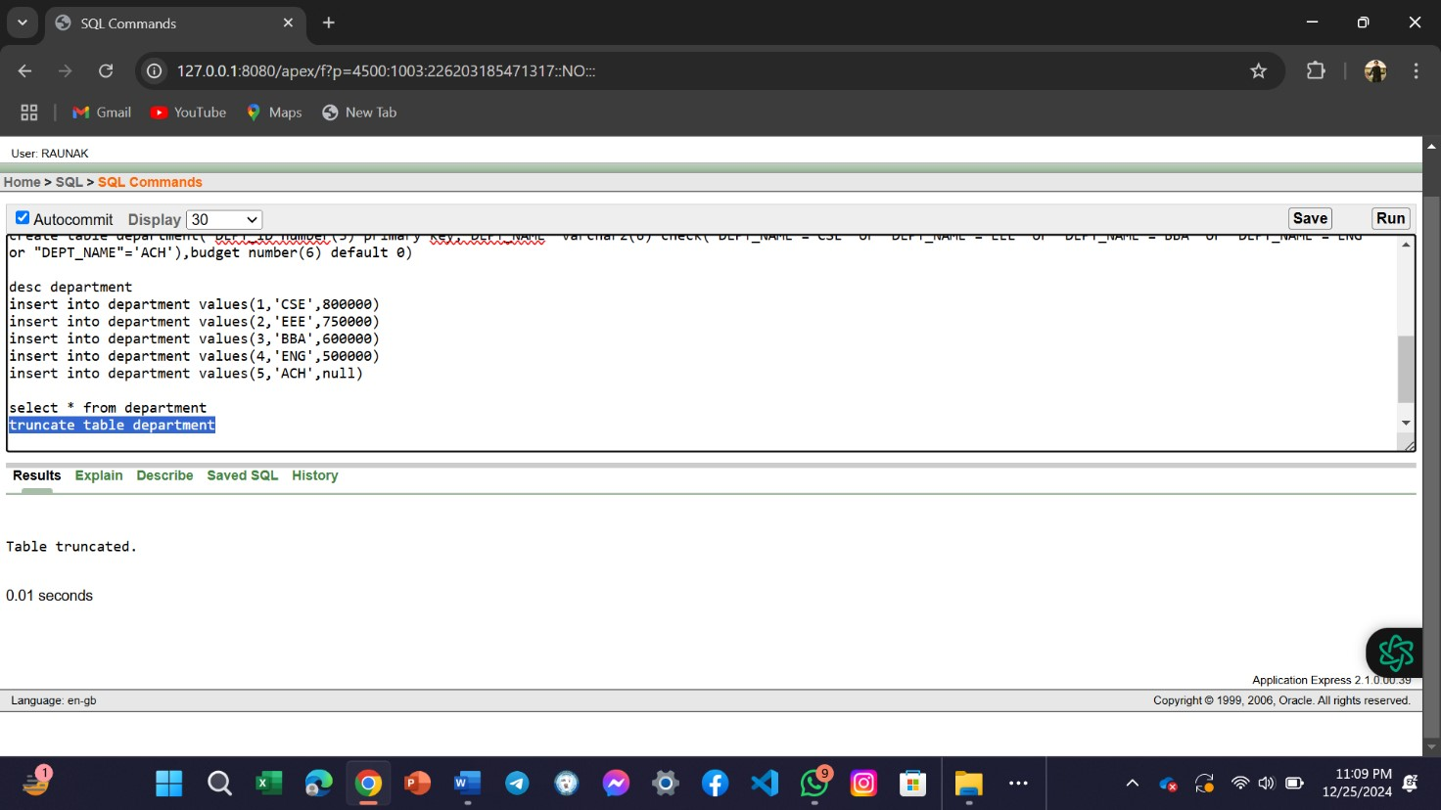

- a) Create the following COURSE table according to given data type and constraint.

Column Name | Data Type | Constraint
CRS_ID | number(4) | primary key
CRS_NAME | varchar2(20) | not null
DEPT_ID | number(3) | foreign key taking reference from DEPARTMENT table

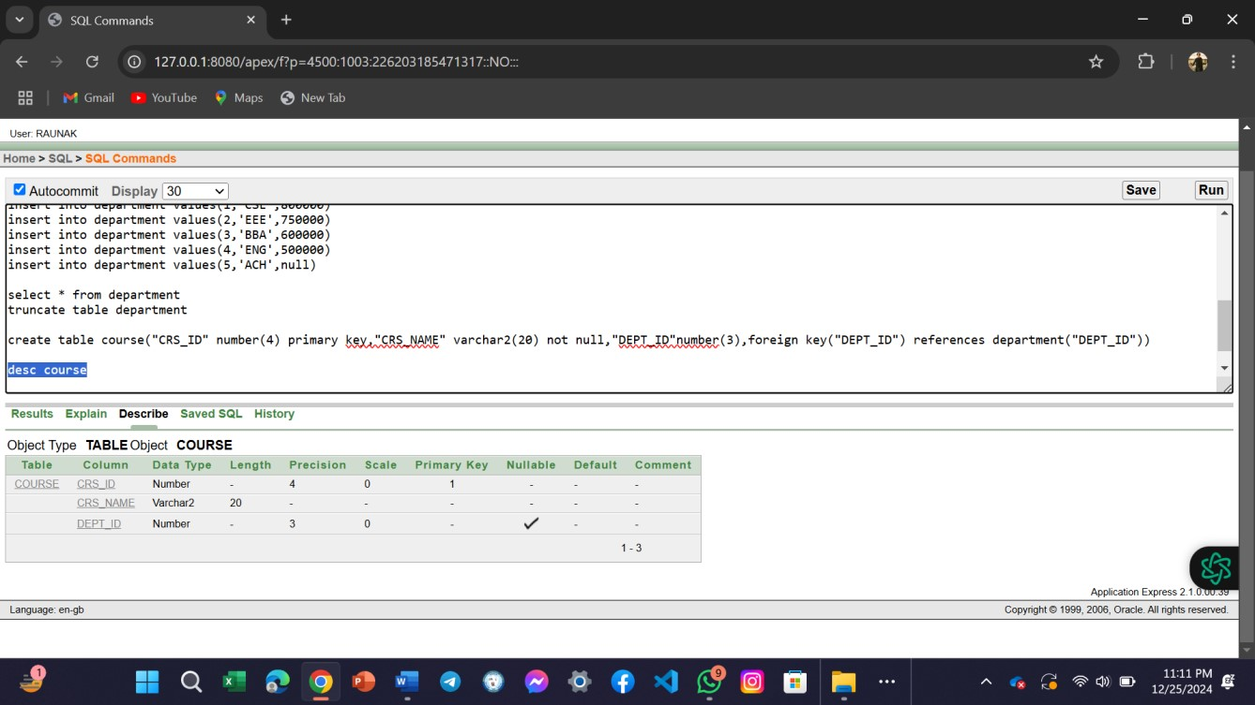

b)Insert the values as per the following information-

CRS_ID | CRS_NAME | DEPT_ID
1113 | DATABASE | 1
1133 | MATH3 | 1
1142 | ENGLISH2 | 4
1153 | DEVICE | 2
1154 | DEVICE_LAB | 2
1185 | BUSINESS_LAW | 3
1193 | PHOTOGRAPHY | 5

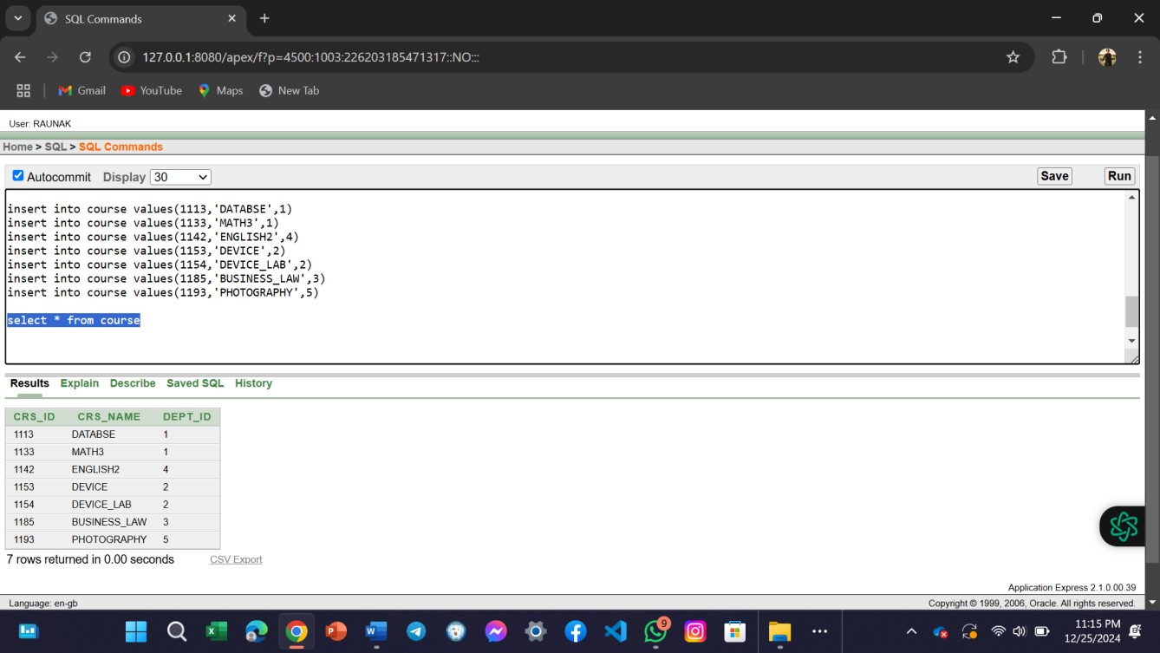
c)Delete all the inserted rows using DML operation.

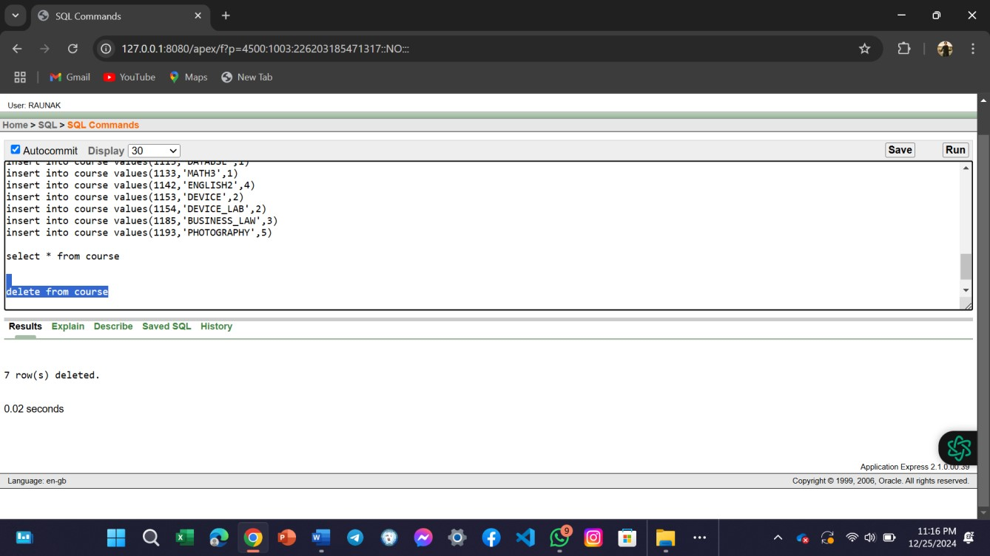
- a) Create the following STUDENT table below according to given data types.

Column name | Data type
S_ID | number
S_NAME | varchar2(20)
GENDER | varchar2(6)
PHONE | number
ADDRESS | varchar2(50)
EMAIL | varchar2(30)
CREDIT_COMPLETED | number(3)
COURSE_COMPLETED | number(2)
CGPA | number
DEPT_ID | number(3)

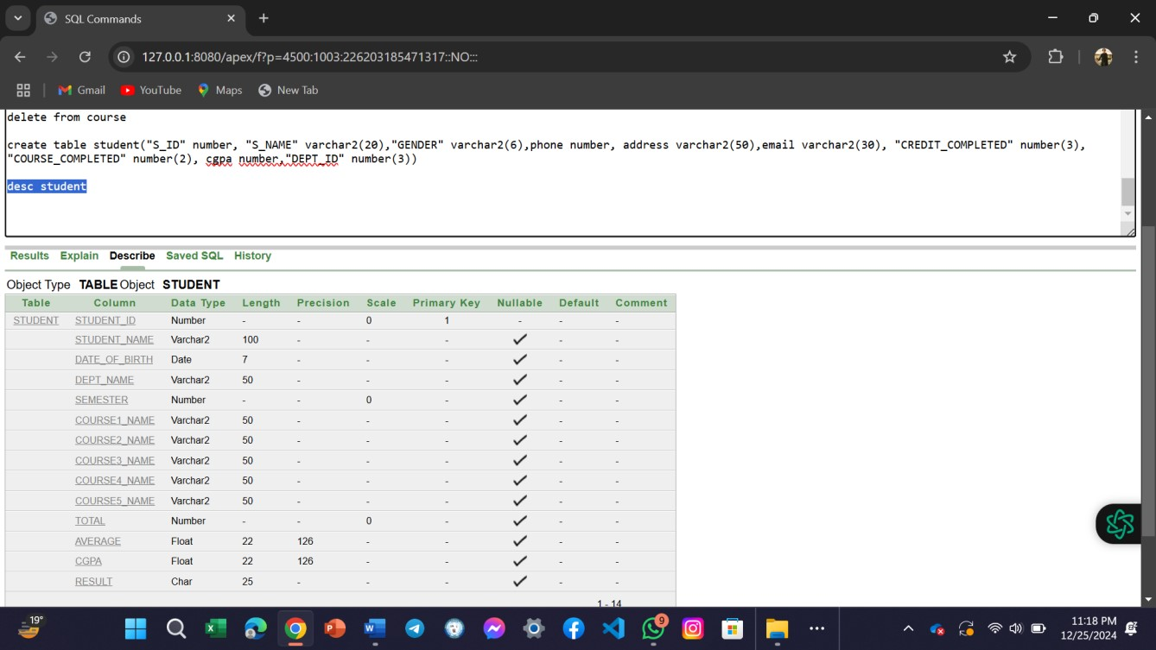 b) Set S_ID as primary key of the table.

  - Set constraint not null on the column S_NAME.
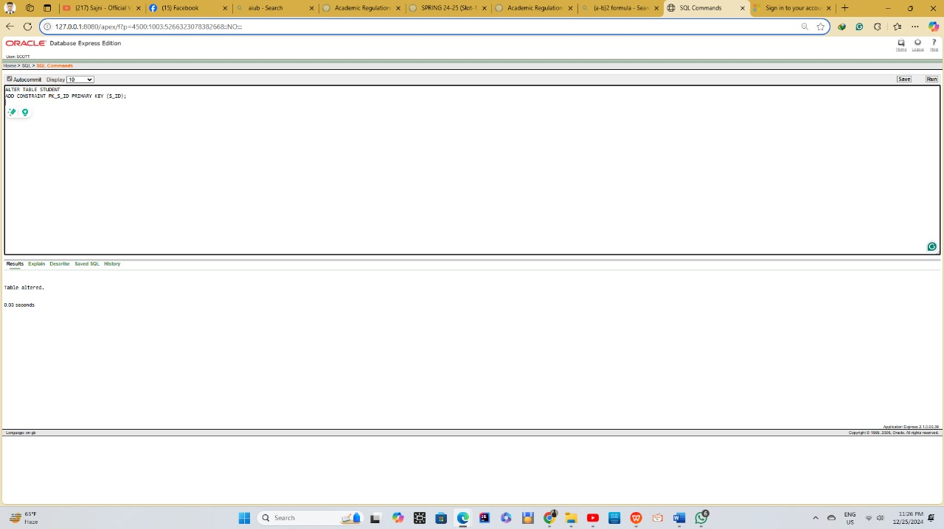

  - Add a constraint to GENDER so that it only allows the value ‘M’ and ‘F’.
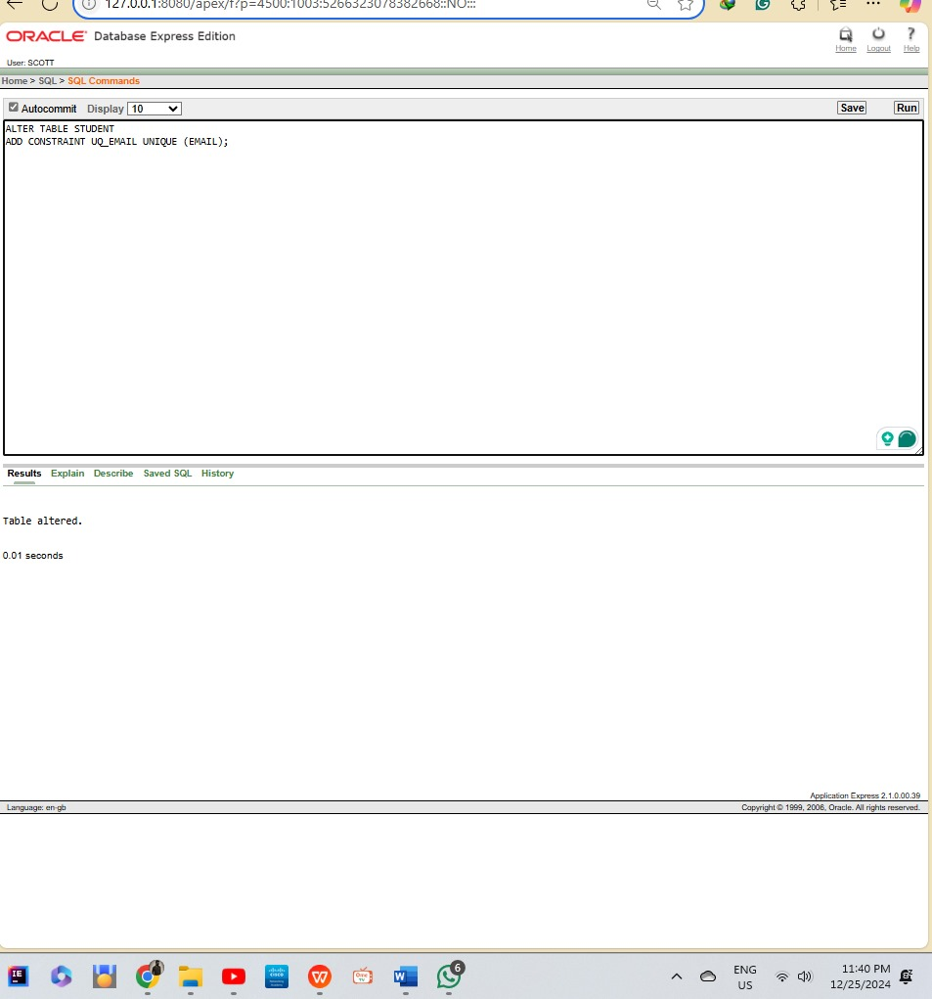

  - Modify the datatypes of PHONE and CGPA as number(11) and number(3,2) respectively.

  - Add a constraint on the columns named CGPA, CREDIT_COMPLETED and COURSE_COMPLETED so that their default value will be 0.
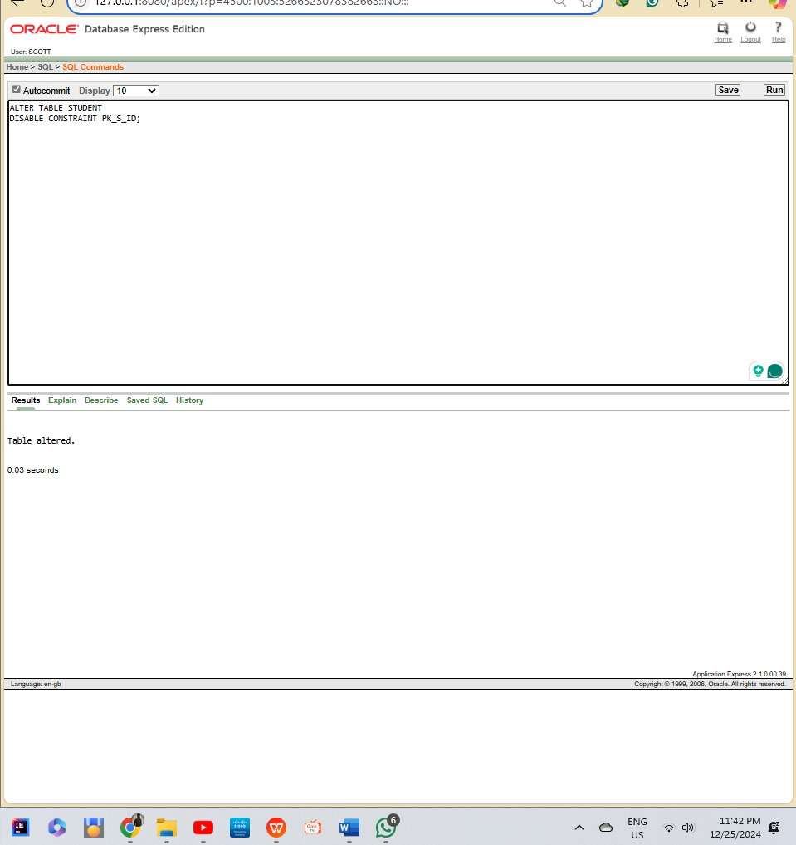
  - Make EMAIL unique.

  - Make DEPT_ID as foreign key taking reference from DEPARTMENT table.

  - Disable the constraint of S_ID.
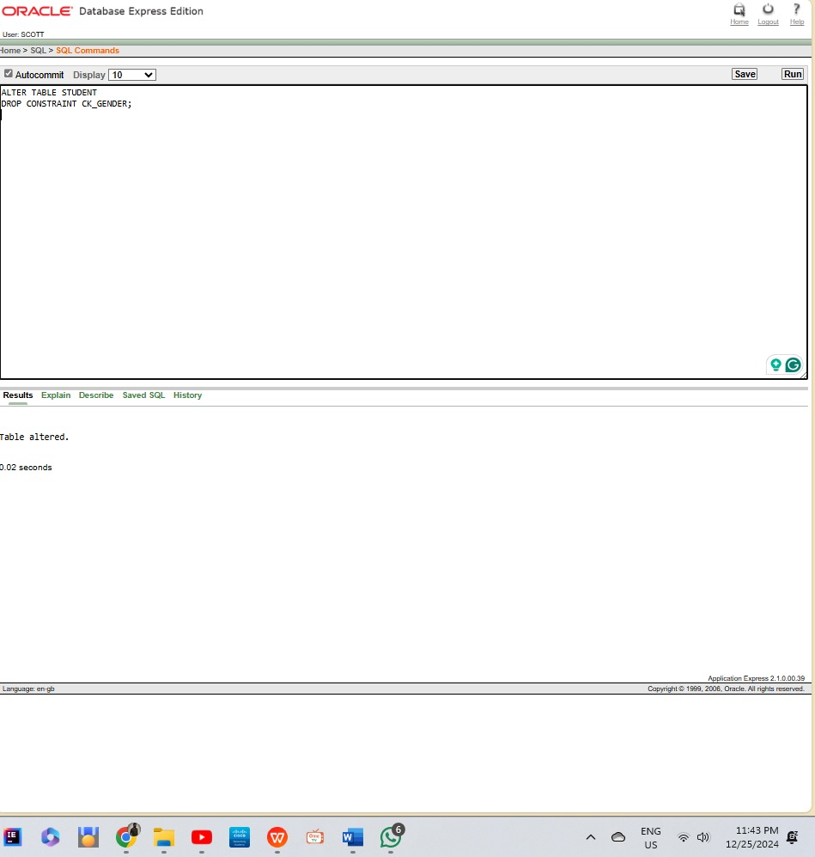

  - Drop the constraint from GENDER.

  - Enable the constraint of S_ID..
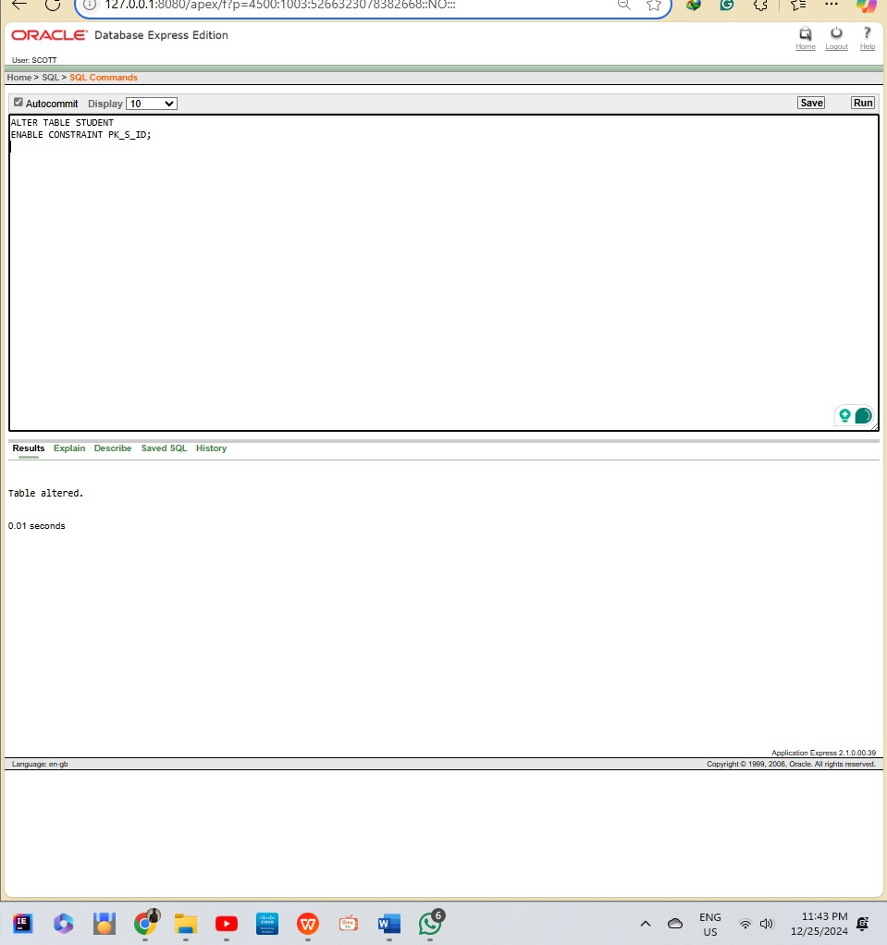

- Drop all the existing tables used for this lab task.
