American International University-Bangladesh (AIUB)
Introduction to Database
Final term Lab Tasks-02
Subqueries
A subquery is a SELECT statement that is embedded in a clause of another SELECT statement. You can build powerful statements out of simple ones by using subqueries. They can be very useful when you need to select rows from a table with a condition that depends on the data in the table itself.
You can place the subquery in a number of SQL clauses:
- WHERE clause
- HAVING clause
- FROM clause
Guidelines for Using Subqueries
- A subquery must be enclosed in parentheses.
- A subquery must appear on the right side of the comparison operator.
- Subqueries cannot contain an ORDER BY clause. You can have only one ORDER BY clause for a SELECT statement, and if specified it must be the last clause in the main SELECT statement.
- Two classes of comparison operators are used in subqueries: single-row operators and multiple-row operators.
Errors with Subqueries
One common error with subqueries is more than one row returned for a single-row subquery. To correct this error, change the = operator to IN.
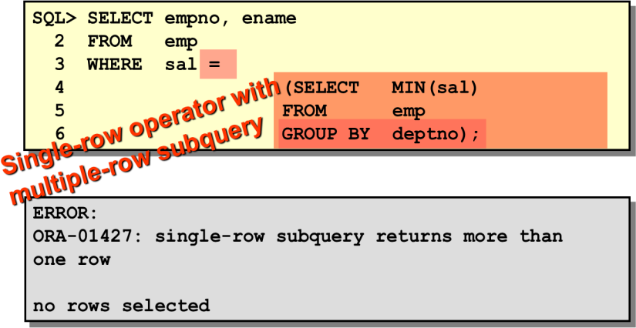

Exercise
- Display all the employees who are earning more than all the managers.
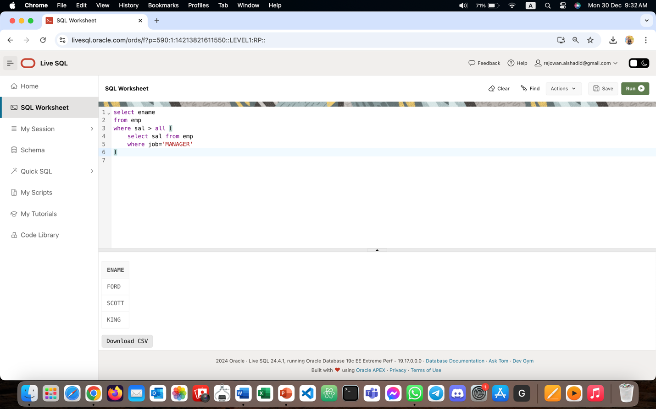
- Display all the employees who are earning more than any of the managers.
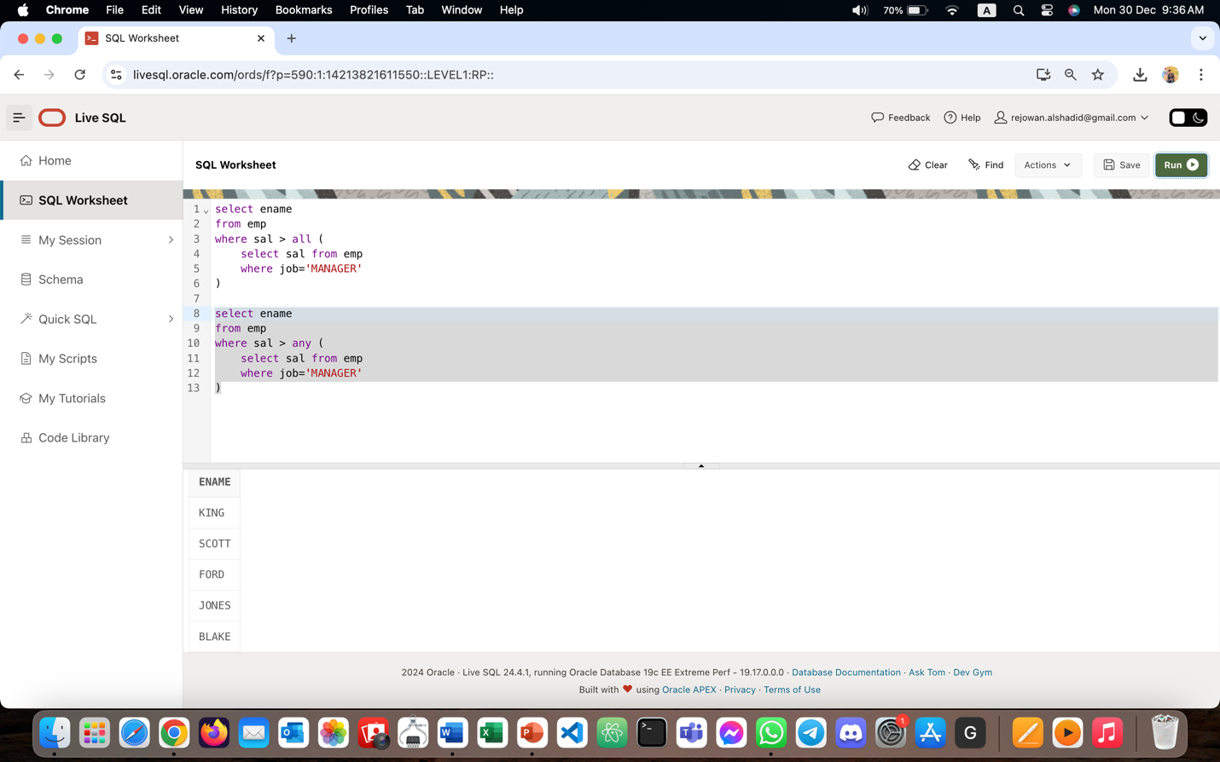
- Select employee number, job & salaries of all the Analysts who are earning more than any of the managers.
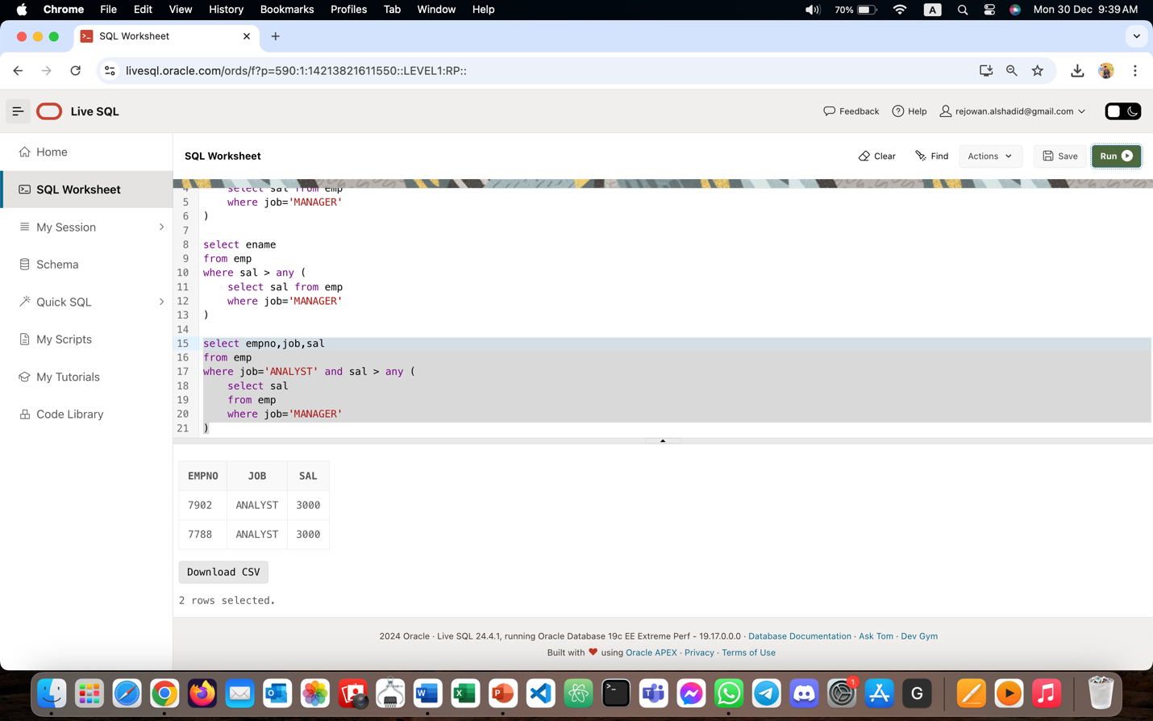
- Select all the employees who work in DALLAS.
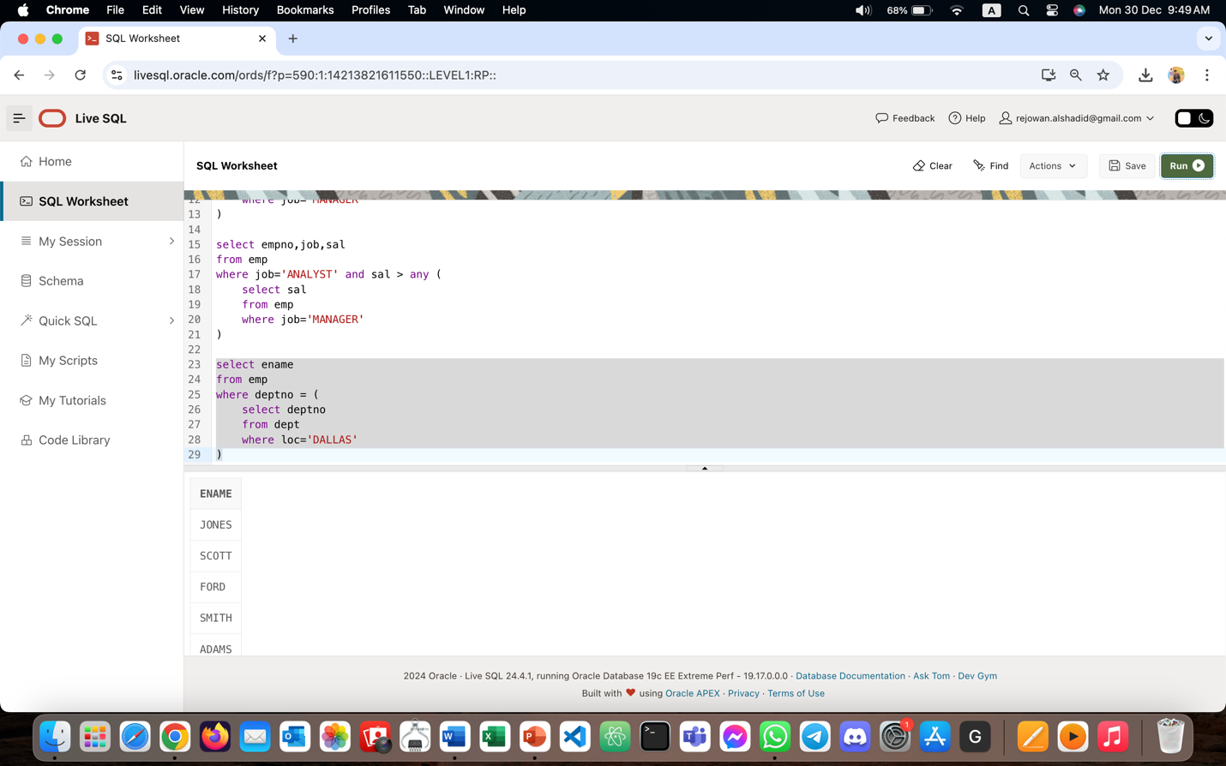
- Select department name & location of all the employees working for CLARK.
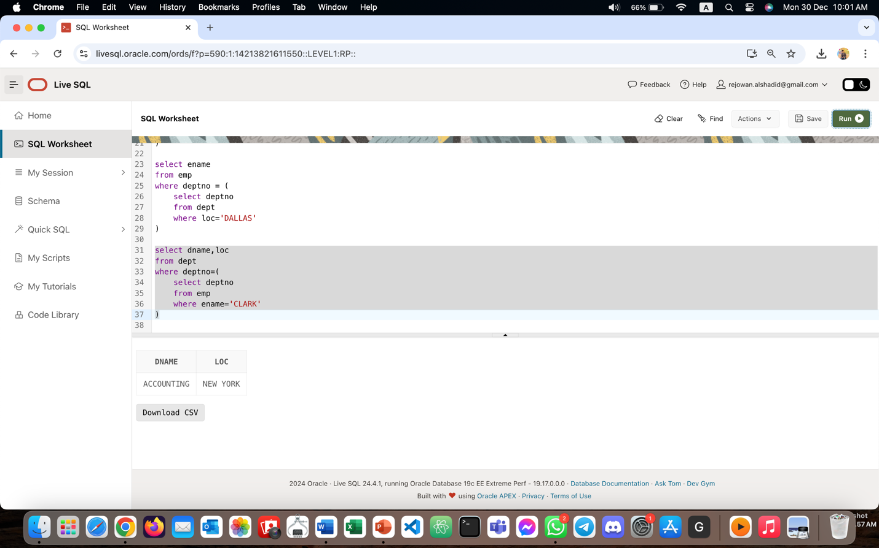
- Select all the departmental information for all the managers
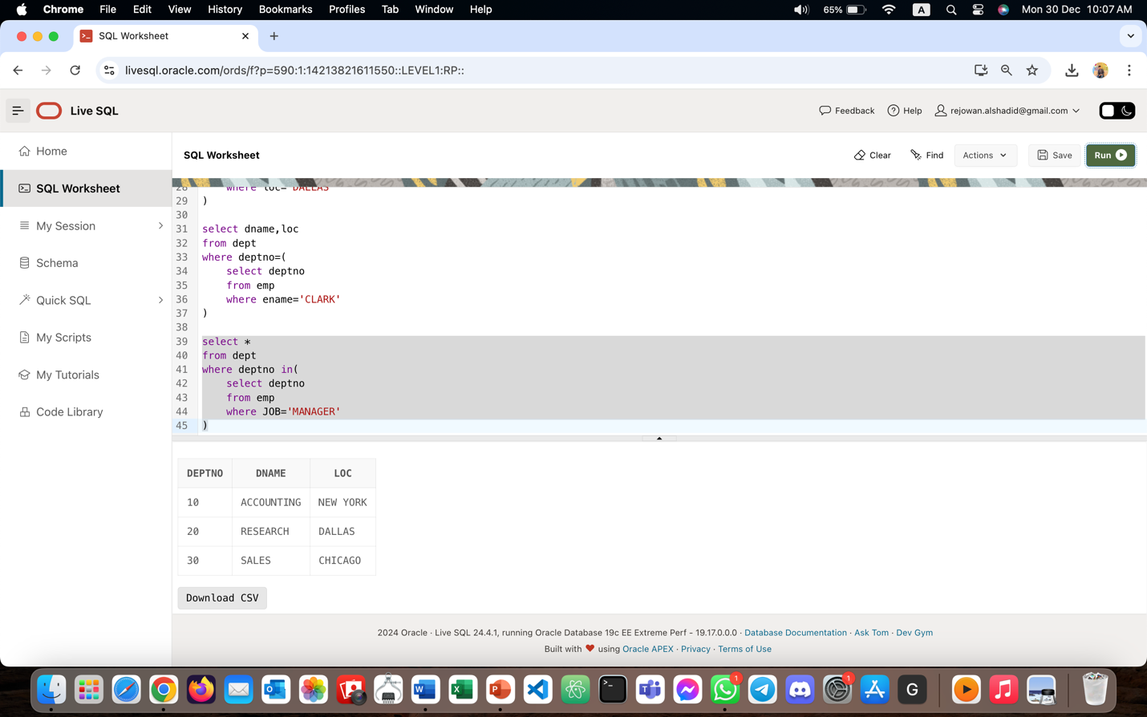

- Display the first maximum salary.
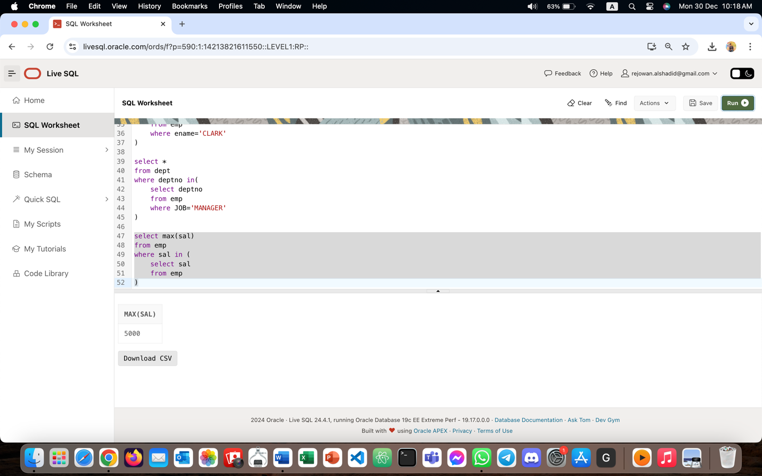
- Display the second maximum salary.
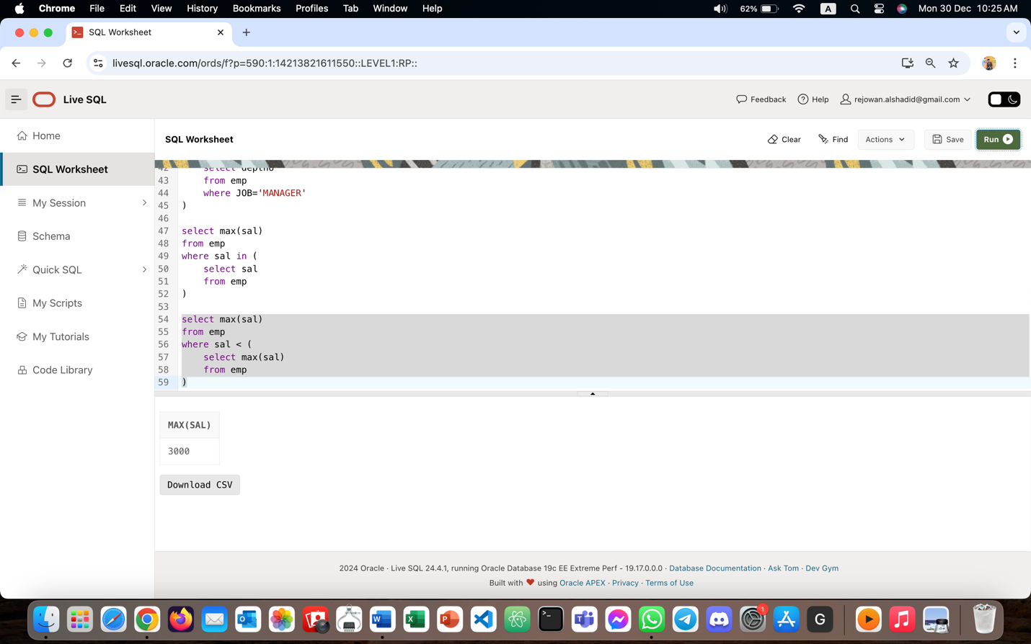

- Display the third maximum salary.
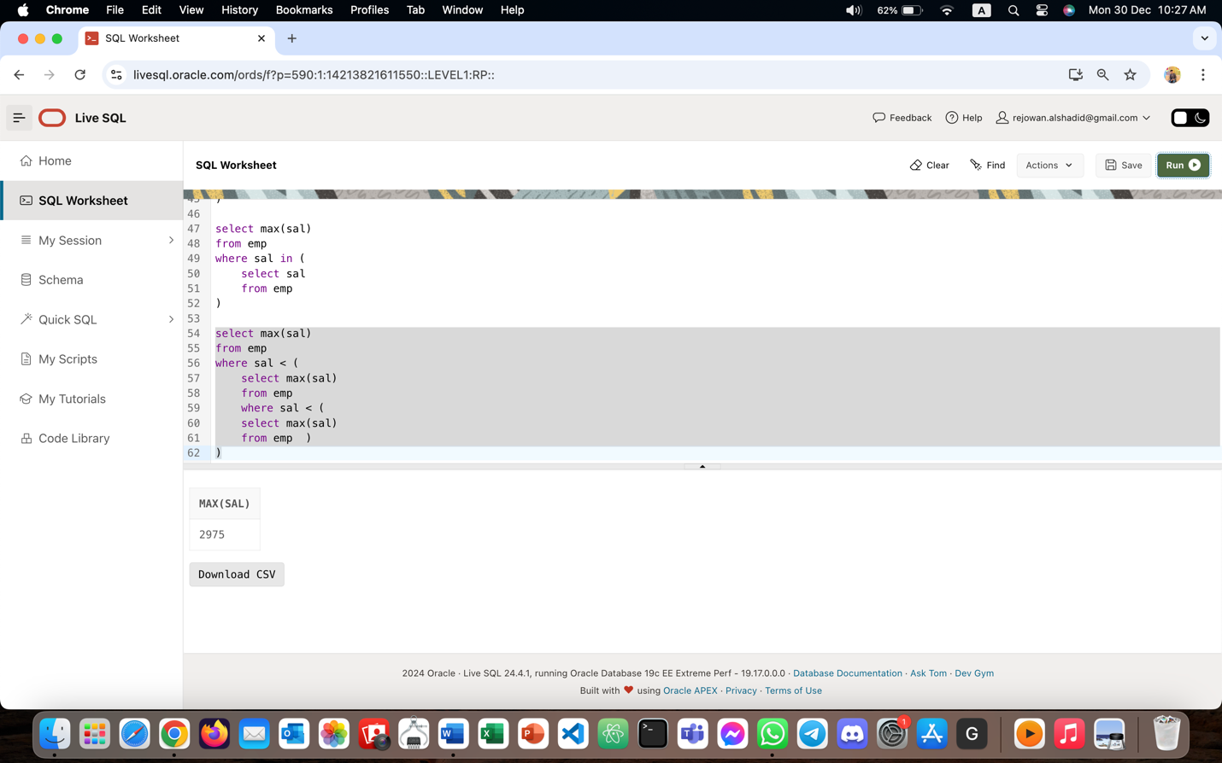
- Display all the managers & clerks who work in Accounts and Marketing departments.
SELECT ename, job, deptno
FROM emp
WHERE job IN ('MANAGER', 'CLERK')
AND deptno IN (
SELECT deptno
FROM dept
WHERE dname IN ('Accounts', 'Marketing')
);
- Display all the salesmen who are not located at DALLAS.
SELECT ename, job, depno
FROM emp
WHERE job = 'SALESMAN'
AND deptno NOT IN (
SELECT deptno
FROM dept
WHERE loc = 'DALLAS'
);

- Get all the employees who work in the same departments as of SCOTT.
SELECT ename, job, deptno
FROM emp
WHERE deptno = (
SELECT deptno
FROM emp
WHERE ename = 'SCOTT'
);
- Select all the employees who are earning same as SMITH.
SELECT ename, job, deptno, sal
FROM emp
WHERE sal = (
SELECT sal
FROM emp
WHERE ename = 'SMITH'
);
- Display all the employees who are getting some commission in marketing department where the employees have joined only on weekdays.
SELECT ename, job, deptno, sal, comm, hiredate
FROM emp
WHERE comm IS NOT NULL
AND deptno = (
SELECT deptno
FROM dept
WHERE dname = 'Marketing'
)
AND TO_CHAR(hiredate, 'DY') NOT IN ('SAT', 'SUN');
- Display all the employees who are getting more than the average salaries of all the employees.
SELECT ename, job, deptno, sal
FROM emp
WHERE sal > (SELECT AVG(sal) FROM emp);

