**********VIEW LAB TASK**********
FinalLabTask04_IDB:
1. Create a view called EMP_VU based on the employee number, employee name, and department number from the EMP table. Change the heading for the employee name to EMPLOYEE.

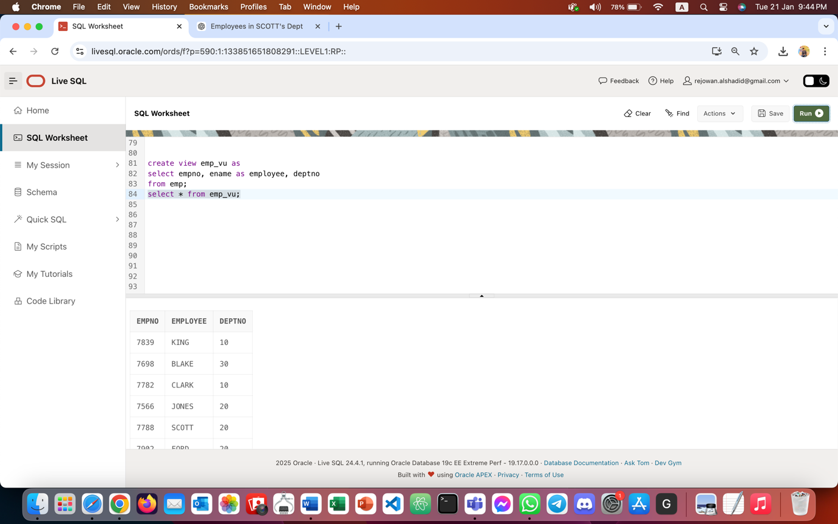

2. Create a view named DEPT20 that contains the employee number, employee name, and department number for all employees in department 20. Label the view column EMPLOYEE_ID, EMPLOYEE, and DEPARTMENT_ID.

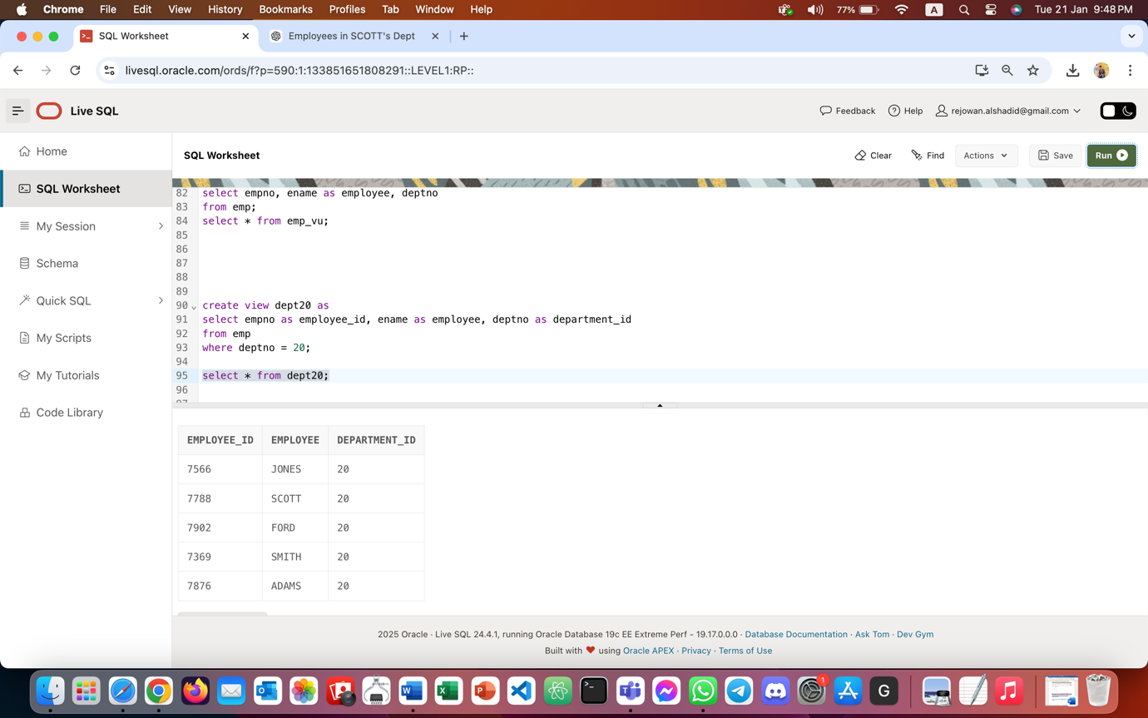

3. Create a view called SALARY_VU based on the employee name, department name, salary, and salary grade for all employees. Label the columns Employee, Department, Salary, and Grade, respectively.

