Integrated Transcriptomic and Immune Profiling Reveals Distinct Immune Activation and Keratinization Suppression in HPV-Positive Head and Neck Squamous Cell Carcinoma

ABSTRACT
Background:
HPV-positive head and neck squamous cell carcinoma (HNSC) differs from HPV-negative disease across a range of clinical and biological features, including disease outcome and response to immune-directed therapies. These clinical differences are thought to reflect distinct underlying tumour biology associated with HPV status. In particular, the immune microenvironment of HPV-positive HNSC appears to differ markedly from that of HPV-negative HNSC. Characterizing the key molecular and immunological differences between these two disease subtypes is essential for identifying rational, biology-driven treatment strategies.

Methods:
RNA-sequencing data and clinical information from 279 TCGA-HNSC patients (243 HPV-negative and 36 HPV-positive) were analyzed to compare HPV-positive and HPV-negative tumors. Differential gene expression analysis was performed using DESeq2, followed by immune-cell deconvolution using CIBERSORTx. Functional enrichment analyses, including Gene Ontology (GO), KEGG pathway analysis, and Gene Set Enrichment Analysis (GSEA), were conducted to identify biological pathways associated with HPV status. Survival associations were evaluated using Cox proportional hazards models and Kaplan–Meier analysis. A sensitivity analysis adjusting for primary tumor site was performed to assess the robustness of HPV-associated transcriptomic differences.
Results:
DESeq2 analysis identified 6,288 differentially expressed genes (FDR-adjusted P < 0.05, |log2FC| > 1.0) between HPV-positive and HPV-negative tumours, comprising 3,436 upregulated and 2,852 downregulated genes in HPV-positive tumours. Immune deconvolution revealed that HPV-positive tumours were characterized by a markedly higher plasma cell fraction than HPV-negative tumours, consistent with elevated expression of immunoglobulin and B-cell-associated genes. Survival analysis identified several genes with significant prognostic associations with overall survival.

Conclusions:
HPV-positive HNSC is characterized by an actively immunoreactive tumour microenvironment together with suppression of keratinization-related gene expression programmes. Elevated infiltration of B cells, plasma cells, and cytotoxic T cells distinguishes HPV-positive from HPV-negative tumours. These findings strengthen the biological rationale for immune checkpoint blockade in HPV-positive HNSC and highlight candidate transcriptomic features warranting further validation.

1. INTRODUCTION
Head and neck squamous cell carcinoma (HNSC) is the sixth most common malignancy worldwide, with approximately 900,000 new cases and 450,000 deaths annually (Johnson et al., 2020). HNSC arises from the mucosal epithelium of the oral cavity, oropharynx, hypopharynx, and larynx. Historically, HNSC has been strongly associated with tobacco and alcohol exposure; however, infection with high-risk human papillomavirus (HPV), particularly HPV-16, has been established over the past three decades as a distinct and increasingly prevalent etiological driver, especially in oropharyngeal tumours (Marur et al., 2016). On this basis, HNSC is now clinically and molecularly stratified into HPV-positive and HPV-negative disease.
These two subtypes differ substantially in clinical behaviour. HPV-positive HNSC is associated with significantly better overall and progression-free survival, a difference attributed to factors including patient age, lower mutational burden, and a more immune-permissive tumour microenvironment (TME) (Fakhry et al., 2008). The TME is increasingly recognized as a key determinant of therapeutic response in HNSC, influencing sensitivity to radiotherapy, chemotherapy, and immune checkpoint inhibitors (Ferris et al., 2016). Immune deconvolution studies using tools such as CIBERSORTx have further shown that the composition of immune infiltrates in HNSC differs significantly by HPV status, with HPV-positive tumours generally displaying a more immunologically active profile (Mandal et al., 2016).
Although previous studies have reported differences in immune infiltration and clinical outcomes between HPV-positive and HPV-negative HNSC, the relationship between transcriptomic alterations, immune-cell composition, and survival outcomes has not been comprehensively evaluated within a unified analytical framework. HPV-positive tumours are driven by expression of the viral E6 and E7 oncoproteins, which inactivate p53 and retinoblastoma (Rb) pathways and produce a molecular profile distinct from carcinogen-driven HPV-negative tumours.
In this study, we performed an integrative analysis of the TCGA-HNSC cohort combining differential gene expression analysis (DESeq2), immune cell deconvolution (CIBERSORTx), pathway and gene set enrichment analyses (GO, KEGG, and GSEA), and survival modelling to characterize the molecular and immunological differences between HPV-positive and HPV-negative HNSC. We hypothesized that HPV-positive tumours would display a transcriptionally immune-activated TME, marked by enrichment of cytotoxic and humoral immune effector populations, alongside suppression of keratinization-associated transcriptional programmes characteristic of more aggressive squamous differentiation.

2. MATERIALS AND METHODS

2.1 Dataset Acquisition and Sample Stratification

Raw RNA-sequencing count data for the TCGA-HNSC cohort were downloaded from the Genomic Data Commons (GDC) portal. The HPV status for each sample was determined based on previously published data that describes associations between HPV RNA-seq and clinical outcome (Cancer Genome Atlas Network, 2015). To merge the genomic, deconvolution, and clinical datasets, patients were matched based on the first 15 characters of the TCGA barcode. After excluding samples with inconclusive HPV status calls or missing survival information, there remained 279 patients (243 HPV-negative and 36 HPV-positive) for analysis (Table 1). The Wilcox test was used for continuous variables while the Fisher’s exact test or Chi square test was used for categorical variables.

2.2 Differential Expression Analysis
Differential gene expression analysis was performed using the DESeq2 package (version 1.52.0) in R. Raw gene-level count data obtained from TCGA-HNSC RNA-seq were modeled using a negative binomial generalized linear model. Gene expression differences between HPV-positive and HPV-negative tumors were initially evaluated using a design formula including HPV status as the primary explanatory variable (design = ~ HPV.Status). Size-factor normalization and dispersion estimation were performed using the standard DESeq2 workflow. Differential expression results were reported as log2 fold changes (log2FC), and multiple-testing correction was performed using the Benjamini–Hochberg false discovery rate (FDR) method. Genes with FDR < 0.05 and |log2FC| > 1 were considered significantly differentially expressed.

2.3 Sensitivity Analysis Adjusting for Primary Tumor Site
Because HPV-positive HNSC occurs predominantly in the oropharynx, whereas HPV-negative tumors are more frequently located in other anatomical sites, a sensitivity analysis was performed to evaluate the potential confounding effect of tumor location. Primary tumor sites were grouped into Oral Cavity, Oropharynx, and Other according to the recorded tissue of origin. This grouping was performed to avoid sparse categories and enable stable model estimation. Differential expression analysis was repeated using an adjusted DESeq2 design formula including both anatomical site and HPV status (design = ~ SiteGroup + HPV.Status). This analysis was performed to determine whether the principal HPV-associated transcriptomic differences remained significant after accounting for primary-site variation.

2.4 Immune Cell Deconvolution
The composition of immune cells was estimated using CIBERSORTx (LM22 signature matrix), which infers the relative proportions of 22 immune-cell populations from bulk RNA-sequencing data (Newman et al., 2019). Deconvolution was performed in relative mode without quantile normalization, as recommended for RNA-seq datasets. Differences in immune-cell fractions between HPV-positive and HPV-negative tumors were evaluated using the Wilcoxon rank-sum test, and multiple-testing correction was performed using the Benjamini–Hochberg false discovery rate (FDR) method, with FDR < 0.05 considered statistically significant.
To assess the biological validity of the deconvolution results, Spearman rank correlation analyses were performed between CIBERSORTx-estimated CD8+ T-cell fractions and the expression of the canonical CD8 T-cell marker genes CD8A and CD8B. Similarly, plasma-cell estimates were validated by correlation with established plasma-cell and B-cell marker genes.
As an exploratory measure of the balance between cytotoxic T-cell infiltration and macrophage-associated immune regulation, a log₂-transformed CD8/M2 macrophage ratio was calculated using CIBERSORTx-estimated immune-cell fractions:
$${log⁡}_{2}\left(\frac{\text{CD8 T cells}+{10}^{-6}}{\text{M2 macrophages}+{10}^{-6}}\right)$$
where CD8 T cells and M2 macrophages represent the estimated immune-cell fractions obtained from CIBERSORTx. A small constant (10⁻⁶) was added to both numerator and denominator to avoid division-by-zero errors. This ratio was analyzed as a computationally derived exploratory immune score and should not be interpreted as a direct measurement of immune-cell abundance without independent validation.

2.4 Pathway and Gene Set Enrichment Analysis

Gene Ontology (GO) biological process and KEGG pathway enrichment analyses were performed for both up- and downregulated gene sets, using the clusterProfiler package (Yu et al., 2012) in R programming language. All genes that passed the filtering step were used as a reference universe. An adjusted P-value threshold of 0.05 was applied for defining significantly enriched terms.

Gene Set Enrichment Analysis (GSEA) was performed on the entire pre-ranked list of DEGs, using the fgsea package (Yu et al., 2021). The ranking was determined using the Wald-statistic from DESeq2 differential expression analysis. The analysis used the MSigDB Hallmark gene sets, and an FDR-adjusted P-value threshold of 0.25 was applied, as recommended by Subramanian et al. (2005).

2.5 Survival Analysis

Univariate Cox proportional-hazards regression analysis was performed for each gene using the survival package in R software. For each gene, overall survival (OS) was used as an outcome variable. The patients were divided into a low-expression and a high-expression group according to the median of gene expression. Kaplan-Meier survival curves were plotted for the most differentially expressed genes with the best prognostic value. The hazard ratios (HR) and the 95% confidence intervals (CI) were calculated for each gene, and P < 0.05 was considered statistically significant.

3. RESULTS

3.1 Sample Characteristics and Global Transcriptomic Separation
The overall workflow of this bioinformatics analysis pipeline is schematically represented in Figure 1. The final analytical cohort comprised 279 TCGA-HNSC samples, including 243 HPV-negative and 36 HPV-positive tumours. The baseline clinical and demographic characteristics of the patients are summarized in Table 1.
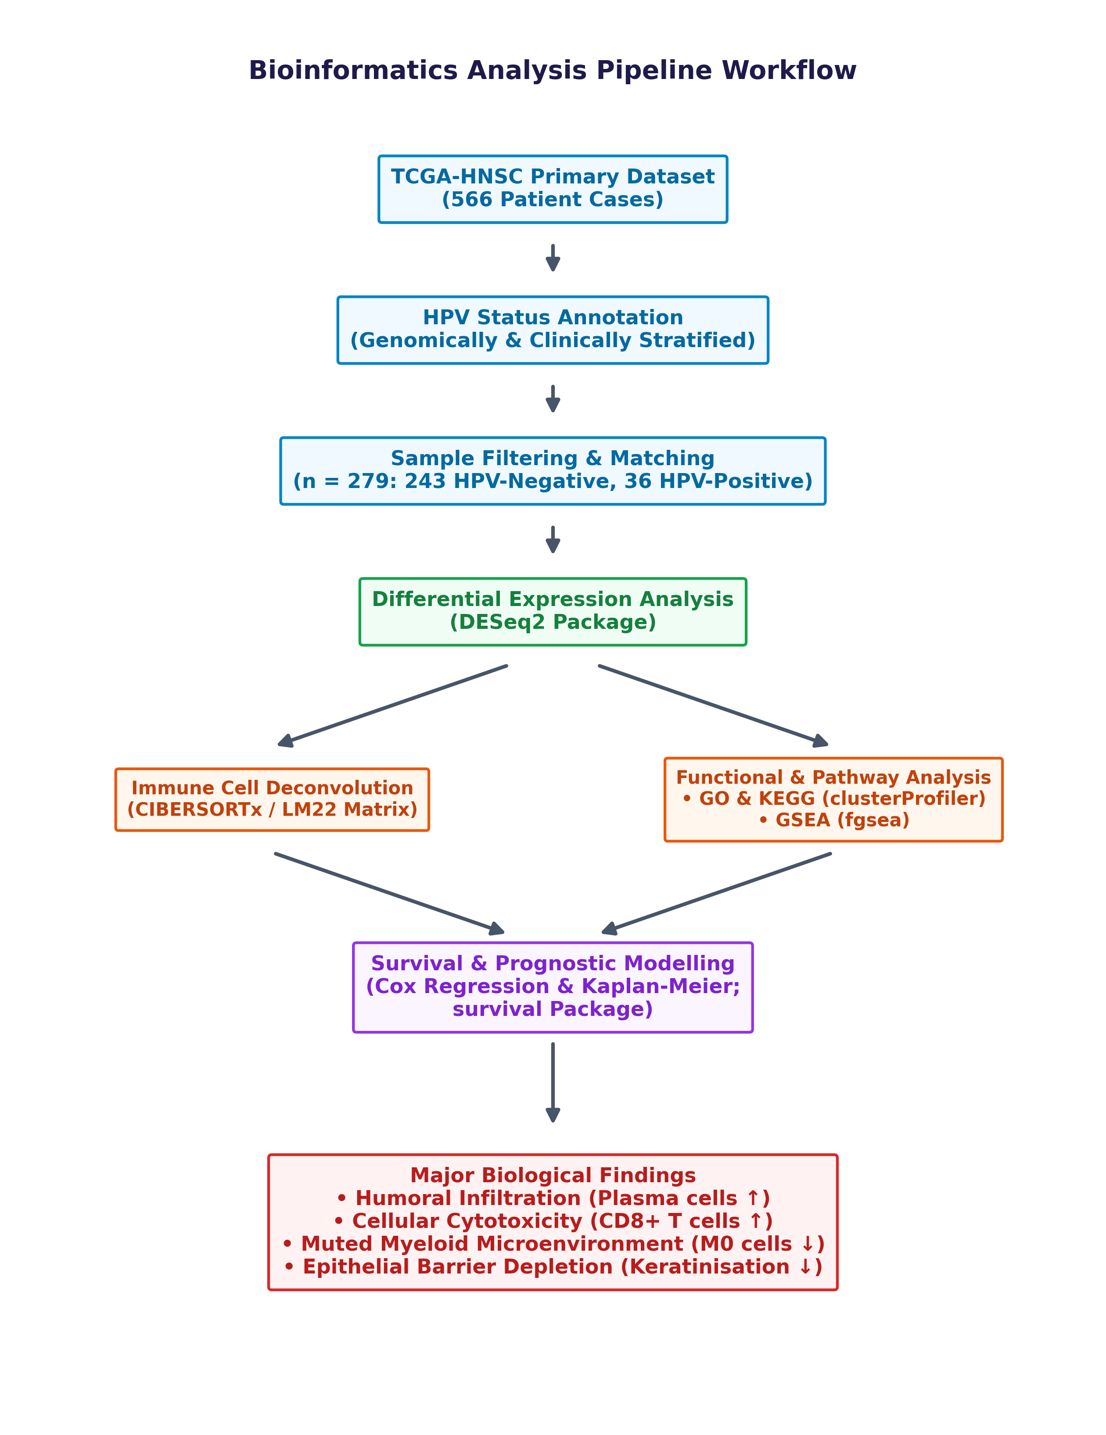
Figure 1. Schematic workflow of the bioinformatics analysis pipeline. TCGA-HNSC RNA-seq raw count data were stratified by HPV status and subjected to differential expression analysis (DESeq2), immune cell deconvolution (CIBERSORTx/LM22), pathway enrichment (GO/KEGG), GSEA, and survival analysis.

Principal component analysis of the variance-stabilized expression data showed partial separation of HPV-positive (teal) and HPV-negative (salmon) samples on PC1 (22%) and PC2 (14%) (Fig. 2), which is consistent with the contribution of the HPV status to the overall transcriptomic variability, albeit not a dominant one. The extensive variability seen in both groups on PC2 most likely reflects differences in tumor site, differentiation, and stromal content, inherent in the HNSC tumour type.
Table 1. Baseline Clinical and Demographic Characteristics of HNSC Patients Stratified by HPV Status
Variable | HPV-positive (n = 36) | HPV-negative (n = 243) | P-value
Age (years) |  |  | 0.053
Mean ± SD | 57.9 ± 10.8 | 61.8 ± 12.4
Median (range) | 58.5 (35–82) | 62.0 (19–90)
Gender, n (%) |  |  | 0.033
Female | 4 (11.1%) | 72 (29.6%)
Male | 32 (88.9%) | 171 (70.4%)
Tumor Stage, n (%) |  |  | 0.845
Stage I | 2 (5.6%) | 12 (4.9%)
Stage II | 5 (13.9%) | 39 (16.0%)
Stage III | 4 (11.1%) | 34 (14.0%)
Stage IV | 12 (33.3%) | 132 (54.3%)
Unknown | 13 (36.1%) | 26 (10.7%)
Smoking Status, n (%) |  |  | 0.234
Never Smoker | 10 (27.8%) | 42 (17.3%)
Ever Smoker | 26 (72.2%) | 194 (79.8%)
Unknown | 0 (0.0%) | 7 (2.9%)
Primary Site, n (%) |  |  | < 0.001
Oropharynx | 22 (61.1%) | 11 (4.5%)
Oral Cavity | 12 (33.3%) | 160 (65.8%)
Larynx | 1 (2.8%) | 71 (29.2%)
Hypopharynx | 1 (2.8%) | 1 (0.4%)
Survival Status, n (%) |  |  | 0.007
Alive | 26 (72.2%) | 113 (46.5%)
Dead | 10 (27.8%) | 130 (53.5%)

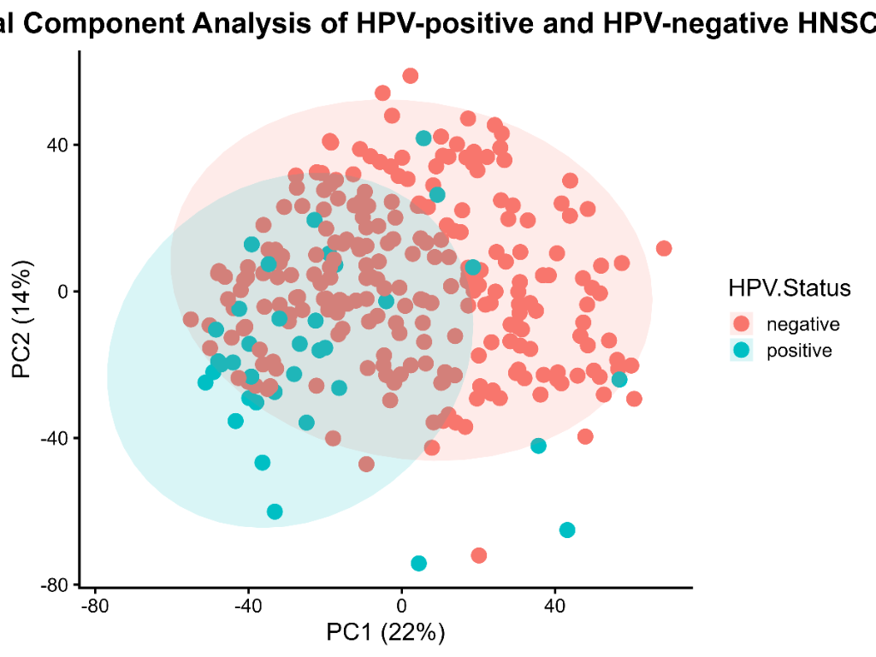
Figure 2. Principal component analysis of 279 TCGA-HNSC samples. HPV-positive (teal) and HPV-negative (salmon) samples demonstrate partial separation along PC1 (22% variance) and PC2 (14% variance)

3.2 Differential Expression Analysis Reveals Extensive Transcriptomic Divergence
The results of DESeq2 differential expression analysis revealed that 6288 genes met the significance threshold (FDR < 0.05), including 3436 upregulated and 2852 downregulated genes (Fig. 3). The large number of differentially expressed genes reflects the distinct oncogenic programs driven by human papillomavirus (HPV) and carcinogens, although the anatomical site of origin (e.g., oropharynx vs. oral cavity) likely contributes to the observed transcriptomic divergence.
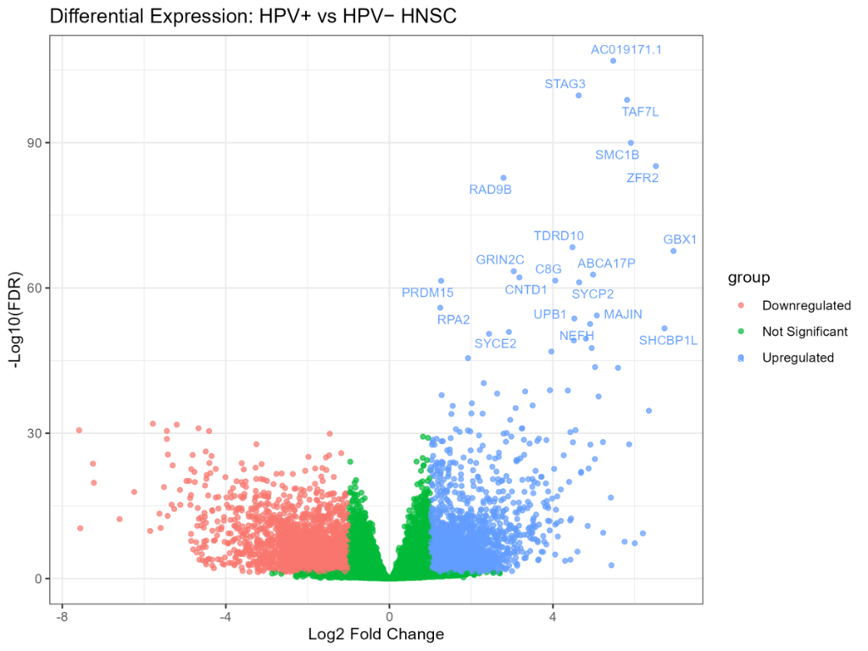
Figure 3. Volcano plot of DESeq2 differential expression results (HPV-positive vs. HPV-negative HNSC). A total of 6,288 differentially expressed genes (DEGs) were identified, including 3,436 upregulated genes (blue) and 2,852 downregulated genes (red) meeting significance thresholds (FDR < 0.05, |log2FC| > 1). Top-ranked genes are labelled.

Among the most significantly enriched genes in HPV-positive tumors, there is a set of genes involved in chromosomal cohesion and the regulation of the cell cycle during meiosis, such as STAG3 (log2FC = 4.63, FDR = 1.79 × 10−100), SMC1B (log2FC = 5.91, FDR = 1.09 × 10−90), ZFR2 (log2FC = 6.52, FDR = 6.88 × 10−86), RAD9B (log2FC = 2.79, FDR = 1.79 × 10−83). The most significant among the up-regulated long non-coding RNAs was AC019171.1 (log2FC = 5.48, FDR = 1.26 × 10−107). It is noteworthy that the role of this locus in the biology of HNSC has not been studied. In addition, the transcription factor TAF7L, which modulates the activity of transcription initiation factors, was significantly up-regulated (log2FC = 5.81, FDR = 1.51 × 10−99). Another interesting finding is the significant enrichment of the gene set associated with the homeobox family transcription factor GBX1 (log2FC = 6.95, FDR = 2.31 × 10−68).
The most significantly enriched genes among the down-regulated ones were associated with epithelial differentiation and keratinization, among which are DSC1 (log2FC = −5.20, FDR = 1.70 × 10−32), MUCL1 (log2FC = −5.44, FDR = 3.39 × 10−31), as well as a large number of small proline-rich proteins, members of the S100 family of proteins, and keratins. This result is consistent with the hypothesis that the normal cell of origin for the majority of HPV-positive HNSC tumors is the basal cells of the tonsil crypts, which are typically less differentiated compared to the epithelium of the oral cavity or hypopharynx.

Table 2. Top 10 Upregulated Genes Identified by DESeq2 in HPV-Positive versus HPV-Negative HNSC
Gene | log2FC | FDR | Biological Function
STAG3 | 4.63 | 1.79E-100 | Meiotic chromosome cohesion protein
TAF7L | 5.81 | 1.51E-99 | Germ cell transcription factor
SMC1B | 5.91 | 1.09E-90 | Chromosome cohesion during meiosis
ZFR2 | 6.52 | 6.88E-86 | Zinc finger RNA-binding protein
RAD9B | 2.79 | 1.79E-83 | DNA damage checkpoint protein
TDRD10 | 4.48 | 3.91E-69 | Germ cell development
GBX1 | 6.95 | 2.31E-68 | Homeobox transcription factor
GRIN2C | 3.04 | 3.55E-64 | Glutamate receptor subunit
ABCA17P | 4.98 | 1.72E-63 | ATP-binding cassette pseudogene
CNTD1 | 3.18 | 6.85E-63 | Cell cycle regulator

Table 3. Top 10 Downregulated Genes Identified by DESeq2 in HPV-Positive versus HPV-Negative HNSC
Gene | log2FC | FDR | Biological Function
LINC02700 | -5.78 | 1.06E-32 | Long intergenic non-coding RNA (uncharacterized)
DSC1 | -5.20 | 1.70E-32 | Desmosomal cell-to-cell adhesion glycoprotein
FOLR3 | -4.67 | 9.26E-32 | Secreted GPI-anchored folate receptor
AL033397.1 | -7.59 | 2.40E-31 | Long non-coding RNA (uncharacterized)
MUCL1 | -5.44 | 3.39E-31 | Epithelial mucin-like glycoprotein (barrier function)
RDH12 | -4.41 | 3.53E-31 | NADPH-dependent retinol dehydrogenase (retinoid metabolism)
SLC3A2 | -1.46 | 1.26E-30 | Amino acid transporter heavy chain subunit (CD98)
IGFL3 | -5.44 | 1.52E-29 | Insulin-like growth factor-like signaling ligand
SLC35F3 | -3.25 | 1.85E-28 | Thiamine (Vitamin B1) solute transporter
SPRR4 | -4.49 | 5.89E-27 | Cornified cell envelope protein (epithelial barrier)

3.3 Sensitivity Analysis Accounting for Primary Tumor Site
To evaluate whether the observed transcriptomic differences were influenced by anatomical tumor location, we repeated the differential expression analysis using a DESeq2 model adjusted for primary tumor site (design = ~ SiteGroup + HPV.Status). The adjusted analysis identified 4,486 significantly differentially expressed genes (FDR < 0.05 and |log2FC| > 1), indicating that the majority of HPV-associated transcriptional changes remained significant after accounting for anatomical site. Key immune-related genes remained significantly different after adjustment, including plasma-cell and B-cell markers (IGKC, IGHA1, IGHM, CD79A, and CD79B) together with cytotoxic T-cell markers (CD8A and CD8B). Likewise, keratinization-associated genes including KRT14, KRT16, and KRT6A remained significantly downregulated in HPV-positive tumors. Although the principal biological conclusions remained consistent following adjustment, some individual genes were attenuated after accounting for anatomical site. For example, KRT13 was no longer significantly differentially expressed, suggesting that its expression may be influenced by tissue-specific differences in addition to HPV status. Overall, these findings demonstrate that the major immune-related transcriptomic signatures identified in HPV-positive HNSC are largely independent of primary tumor location.
3.3.1 Heatmap of Significant Immune Cell Populations
A z-score normalized heatmap demonstrated suggestive clustering of HPV-positive tumors characterized by increased plasma-cell and CD8 T-cell abundance together with reduced M0 macrophages and resting NK cells (Figure 8).


Figure 8. Heatmap of significantly differentially infiltrating immune cell populations across HPV-positive and HPV-negative HNSC samples. Visual inspection suggests partial clustering of HPV-positive tumors, characterized by increased plasma-cell and CD8+ T-cell abundance together with reduced M0 macrophages and resting NK cells.

3.4 Immune Cell Deconvolution Reveals an Immune-Active TME in HPV-Positive HNSC
CIBERSORTx deconvolution revealed five significantly different (FDR-adjusted, Table 4) immune cell populations associated with HPV status. After multiple testing correction (Benjamini-Hochberg), only five immune populations remained statistically significant. The most enriched cell population was plasma cells (median fraction, 0.44) in HPV-positive tumours compared to their counterpart (median fraction, 0.14; FDR-adjusted P = 0.001; Figure 4). Interestingly, this difference was about threefold, suggesting a strong humoral immune response associated with HPV-positive tumours. While this may reflect an HPV-specific immune response, the inherent lymphoid-rich nature of the oropharynx (the primary site for most HPV-positive tumours) likely contributes to the elevated plasma cell signature.
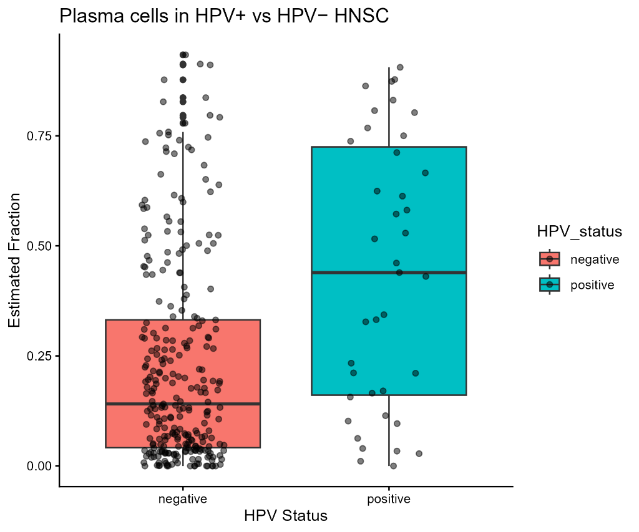
Figure 4. Plasma cell infiltration in HPV-positive versus HPV-negative HNSC. Box-and-jitter plots showing CIBERSORTx-estimated plasma cell fractions, stratified by HPV status. HPV-positive tumours exhibit markedly elevated plasma cell fractions (FDR-adjusted P-value = 0.001).
In addition to the differences noted in immune cell fractions, we also observed substantial variation between HPV-positive and HPV-negative tumors in the abundance of effector CD8+ T cells. Specifically, we identified significantly higher levels of these immune cells in HPV-positive samples (median: 0.070) compared to their counterparts (median: 0.048; FDR adjusted P-value: 0.020; Figure 5). Once again, despite the relatively small effect size, the finding is both statistically and biologically significant given the context of the observed patterns in immunosuppressive fractions. By contrast, we observed significantly lower abundance of M0 macrophages in association with HPV-positive tumors (median: 0.030) compared to HPV-negative tumors (median: 0.103; FDR adjusted P-value: 0.002; Figure 6), as well as lower abundance of resting NK cells (median: 0.005 vs. 0.029; FDR adjusted P-value: 0.009) and resting CD4 memory T cells (median: 0.041 vs. 0.068; FDR adjusted P-value: 0.013). Notably, M0 macrophage fractions were significantly reduced in HPV-positive tumors.
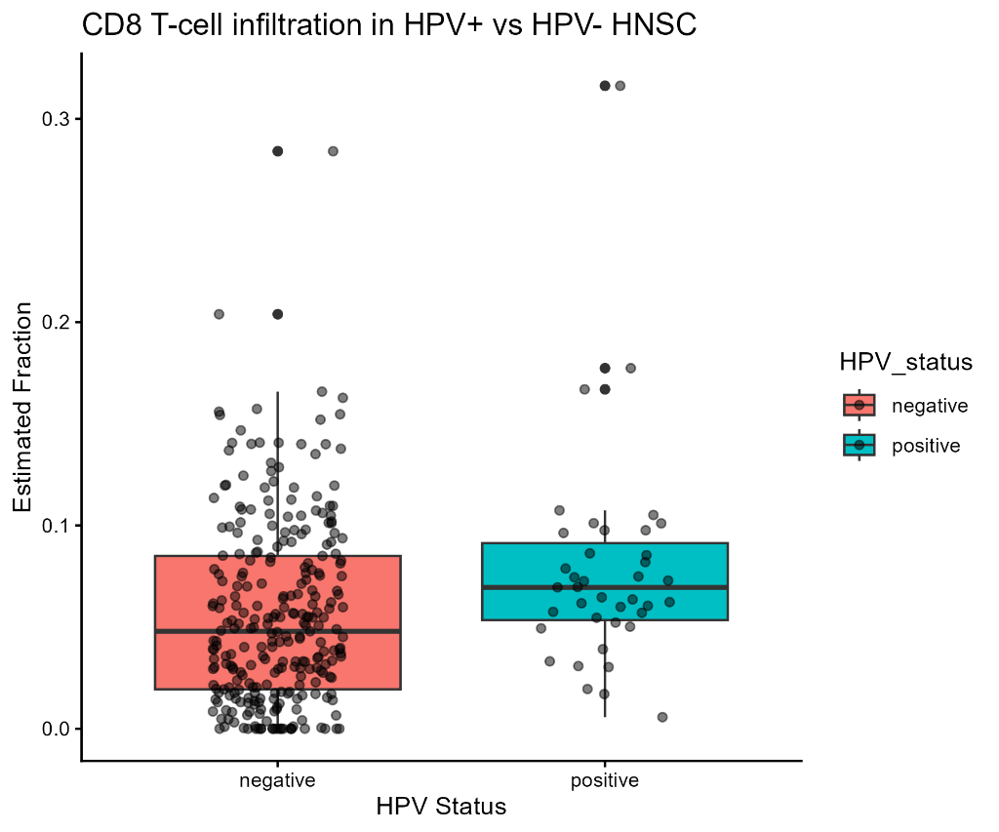
Figure 5. CD8+ T-cell infiltration in HPV-positive versus HPV-negative HNSC. CIBERSORTx-estimated CD8+ T-cell fractions are significantly elevated in HPV-positive tumours (FDR-adjusted P-value = 0.020)
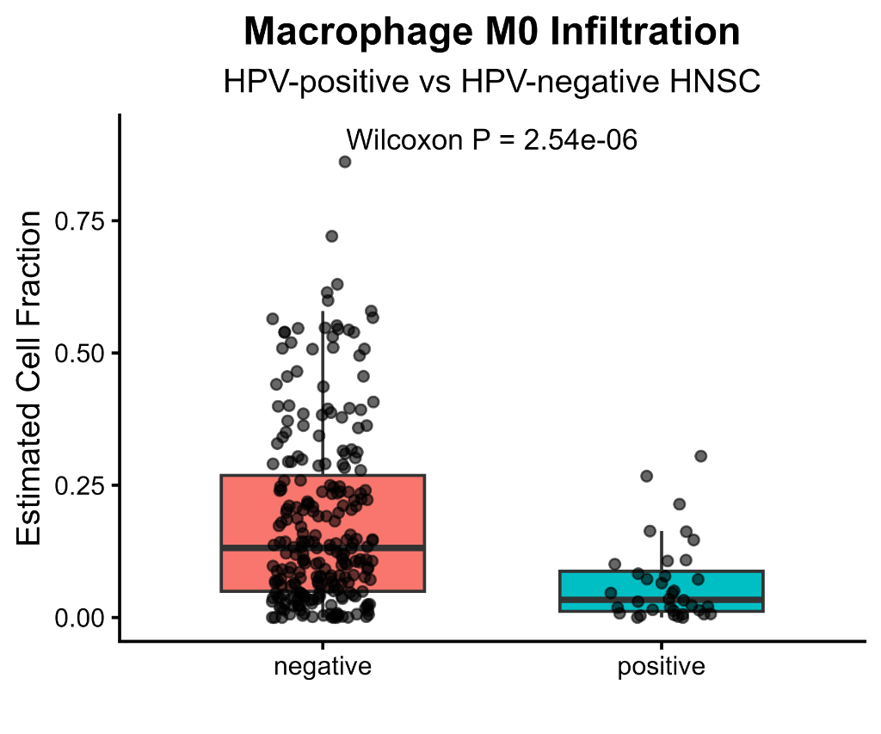
Figure 6. M0 macrophage infiltration in HPV-positive versus HPV-negative HNSC. Box-and-jitter plots showing CIBERSORTx-estimated M0 macrophage fractions, stratified by HPV status. HPV-positive tumours exhibit significantly reduced M0 macrophage fractions (FDR-adjusted P-value = 0.002), indicating a reduced unpolarized macrophage fraction.

Table 4. Significantly Differentially Infiltrating Immune Cells in HPV-positive vs. HPV-negative HNSC
Immune Cell Population | Median (HPV-Pos) | Median (HPV-positive) | FDR-adjusted P-value | Change in HPV-positive
Plasma cells | 0.440 | 0.140 | 0.001 | Enriched (Upregulated)
M0 Macrophages | 0.030 | 0.103 | 0.002 | Depleted (Downregulated)
Resting NK cells | 0.005 | 0.029 | 0.009 | Depleted (Downregulated)
Resting CD4 memory T cells | 0.041 | 0.068 | 0.013 | Depleted (Downregulated)
CD8+ T cells | 0.070 | 0.048 | 0.020 | Enriched (Upregulated)

A visual summary of the remodeled immune infiltration profile, illustrating the concurrent enrichment of activating populations and depletion of unpolarized or resting populations, is presented in Figure 7.
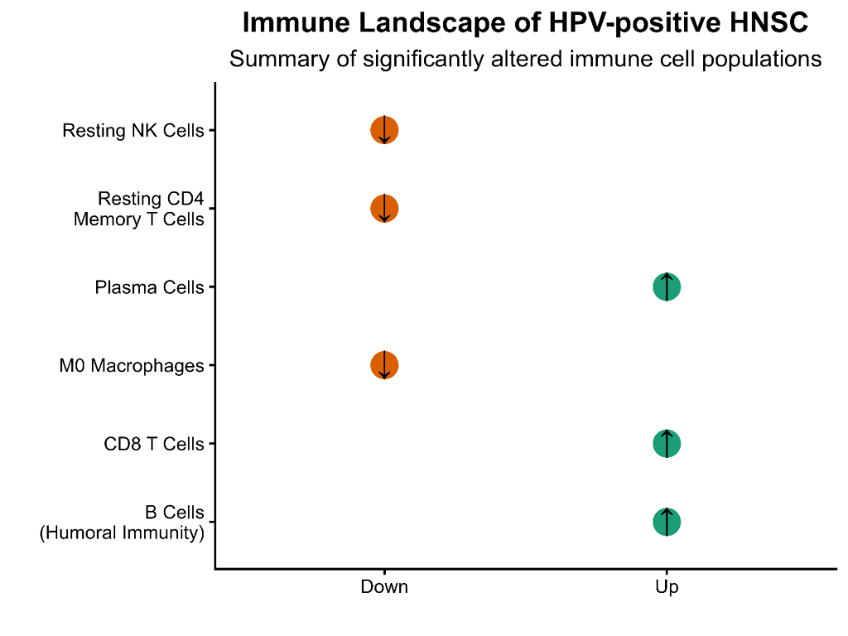

Figure 7. Graphical summary of immune infiltration remodeling in HPV-positive versus HPV-negative HNSC. Significantly enriched populations (emerald card) include Plasma cells, CD8+ T cells, and B cells. Significantly depleted populations (rose card) include M0 macrophages (unpolarized), resting NK cells, and resting CD4+ memory T cells.

3.4.1 Validation of CD8+ T-Cell Deconvolution Estimates
To confirm the validity of the CIBERSORTx-derived CD8 + T-cell fractions, we evaluated the association of these fractions with the expression levels of canonical CD8 T-cell markers. Indeed, CD8A expression was strongly positively correlated with the CIBERSORTx CD8-fraction (rho = 0.673, P < 2,2 × 10−16; Figure 9). Similarly, CD8B expression was strongly positively correlated with the CIBERSORT CD8-fraction (rho = 0.636, P < 2,2 × 10−16; Figure 10). This demonstrates that the deconvolution approach correctly captures the abundance of cytotoxic T cells by CD8 expression in most samples.

3.4.2 Validation of Plasma-Cell Deconvolution Estimates
To further validate the CIBERSORTx-derived plasma-cell fractions, we correlated these estimates with the expression levels of canonical plasma-cell and B-cell marker genes. We observed highly significant positive correlations between the CIBERSORTx plasma-cell fraction and the expression of IGKC (Spearman rho = 0.713, P = 1.98e-50), IGHA1 (Spearman rho = 0.700, P = 6.77e-48), IGHM (Spearman rho = 0.898, P = 5.44e-114), MS4A1 (Spearman rho = 0.544, P = 1.05e-25), CD79A (Spearman rho = 0.712, P = 3.73e-50), and CD79B (Spearman rho = 0.542, P = 1.49e-25). The strongest correlation was observed for IGHM. These analyses provide robust transcriptomic validation of the CIBERSORTx-derived plasma-cell fractions, increasing confidence in the biological validity of these deconvolution results. Complete correlation statistics are provided in Supplementary Table S14, and scatterplots illustrating these correlations are presented in Supplementary Figure S3.
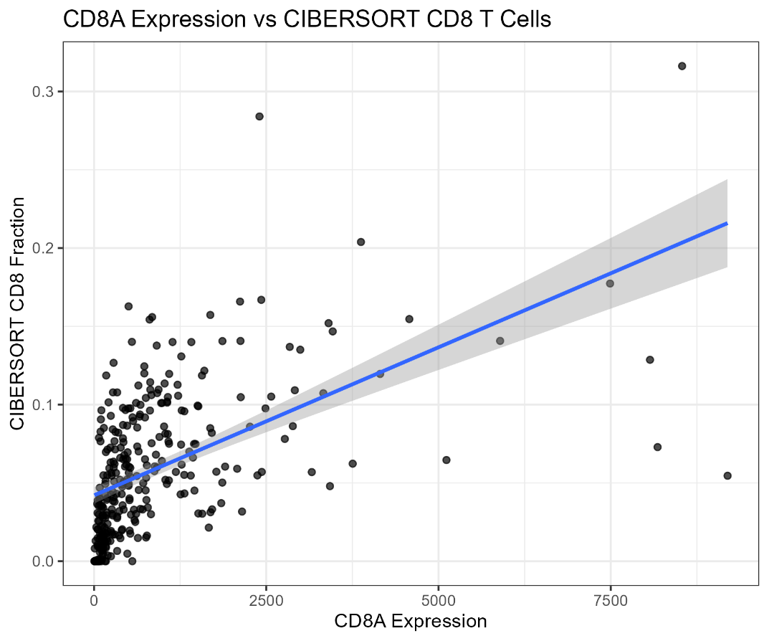
Figure 9. Validation of CIBERSORTx CD8+ T-cell estimates using CD8A gene expression. Spearman rho = 0.673, P < 2.2 × 10⁻¹⁶, confirming the reliability of deconvolution estimates.
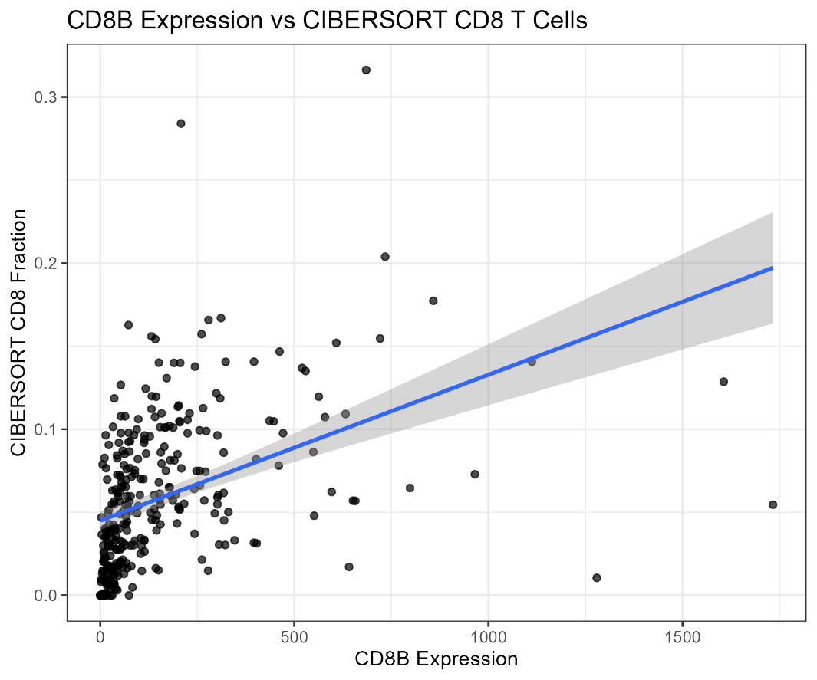
Figure 10. Validation of CIBERSORTx CD8+ T-cell estimates using CD8B gene expression. Spearman rho = 0.636, P < 2.2 × 10⁻¹⁶.
3.5 The CD8/M2 Macrophage Ratio is Elevated in HPV-Positive HNSC
To further evaluate the balance between cytotoxic T-cell infiltration and macrophage-associated immune regulation, a log2-transformed CD8/M2 macrophage ratio was calculated using CIBERSORTx-estimated immune-cell fractions. HPV-positive tumors demonstrated a substantially higher ratio than HPV-negative tumors. The summary statistics for the log2-transformed CD8/M2 ratio are presented in Table 5.

Table 5. Summary statistics of the log2-transformed CD8/M2 macrophage ratio in HPV-positive and HPV-negative HNSC.
Group | Median | Q1 | Q3 | IQR
HPV - negative | 0.779 | -0.630 | 3.16 | 3.79
HPV - positive | 3.29 | 1.82 | 15.3 | 13.5

These findings are consistent with the increased CD8 T-cell infiltration observed in HPV-positive tumors. However, this ratio represents a computationally derived exploratory immune score and should be interpreted cautiously.
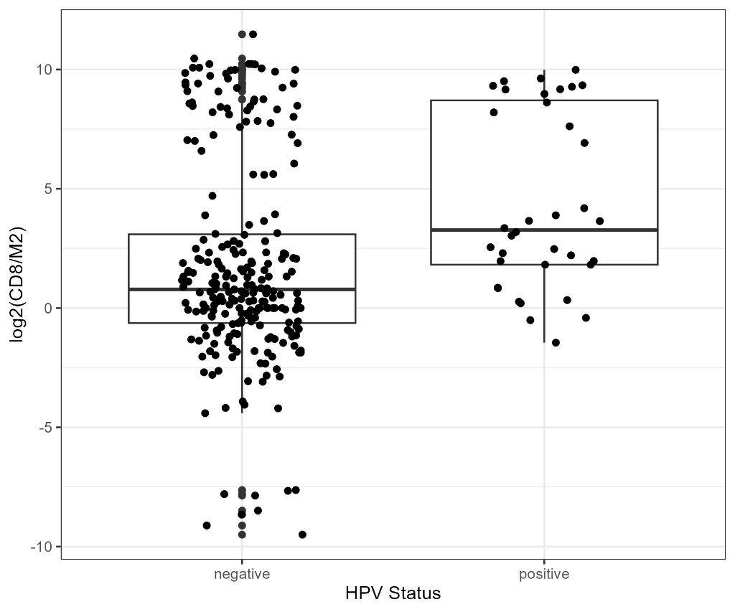
Figure 11. Comparison of the log2-transformed CD8/M2 macrophage ratio between HPV-positive and HPV-negative HNSC tumors. The ratio was calculated using CIBERSORTx-estimated CD8 T-cell and M2 macrophage fractions. Boxes represent the median and interquartile range. The CD8/M2 ratio is presented as an exploratory computational immune score.

3. Elevated Immunoglobulin and B-Cell Gene Expression Corroborates Plasma-Cell Enrichment
To further evaluate the CIBERSORTx plasma-cell findings at the transcriptomic level, we explored the expression of immunoglobulin-related genes in the DESeq2 results. There is an evident upregulation of immunoglobulin heavy chain, light chain, and B-cell associated transcripts in HPV-positive tumours. In particular, IGKC, which encodes immunoglobulin kappa constant, was found to be increased with log2FC = 1.14 (FDR = 0.011). IGHA1, which encodes immunoglobulin alpha-1, was noted to have log2FC = 1.51 (FDR < 0.001). IGHM was observed to have the highest fold change with log2FC = 2.44 (FDR = 2.79 × 10−8). Genes associated with B-cell surface antigen included MS4A1 (CD20; log2FC = 2.07, FDR = 2.50 × 10−5) and CD79A (log2FC = 1.36, FDR = 9.09 × 10−4) and CD79B, which were significantly upregulated. Similarly, there is a broad upregulation of immunoglobulin genes across the immunoglobulin variable region (IGHV, IGLV, and IGKV subfamilies). This strongly suggests that there is active expansion and immunoglobulin production in B cells in HPV-positive tumours.
In Table 6, the differential expression and biological relevance of the key mature B-cell, B-cell receptor, immunoglobulin constant and epithelial marker genes queried for the clinical validation are summarized.

Table 6. Differential Expression and Biological Roles of Key Immune and Epithelial Genes
Gene | log2FC | FDR-adjusted P-value | Biological Role
MS4A1 | 2.07 | 2.50 × 10⁻⁵ | Mature B cell
CD79A | 1.36 | 9.09 × 10⁻⁴ | BCR signalling
IGKC | 1.14 | 0.011 | Plasma cell
IGHA1 | 1.51 | 8.71 × 10⁻⁴ | Antibody
IGHG1 | 0.93 | 0.044 | Humoral immunity
IGHG3 | 0.98 | 0.028 | Humoral immunity
TACSTD2* | 0.60 | 5.75 × 10⁻⁴ | Epithelial marker
S100A7 | −1.92 | 1.48 × 10⁻⁵ | Keratinization
* TACSTD2 included because of its biological relevance despite not meeting |log2FC| > 1.

3.7 Keratinisation Programs Are Suppressed in HPV-Positive HNSC

The most significantly downregulated pathways in HPV-positive tumors were those related to epithelial keratinization and cornified envelope formation. Many genes encoding keratins (KRT1, KRT6A/B/C, KRT10, KRT14, KRT16, KRT75, KRT79), small proline-rich proteins (SPRR1A, SPRR1B, SPRR2D, SPRR2G, SPRR4, SPRR5), and late cornified envelope proteins (LCE) were also downregulated. S100A7, which encodes an S100 calcium-binding protein family member, was significantly decreased (log2FC = −1.92, FDR = 1.48 × 10−5; Table 5). Genes associated with cornifed envelope formation that were downregulated included KRTDAP (keratinocyte differentiation-associated protein; log2FC = −4.25, FDR = 2.36 × 10−23). These observations were overall consistent with the origin of HPV-positive HNSC from the oropharyngeal basal epithelium in contrast to extensively keratinized epithelium giving rise to HPV-negative tumors.

3.8 Gene Ontology and KEGG Pathway Enrichment Analysis
GO biological process enrichment analysis of upregulated genes in HPV-positive tumours revealed the preponderance of immune-related functions, with antigen receptor-mediated signalling pathway (GO:0050851; 43 genes; FDR = 5.30 × 10−10), lymphocyte-mediated immunity (GO:0002449; 56 genes; FDR = 1.75 × 10−9), B-cell-mediated immunity (GO:0019724; 37 genes; FDR = 5.44 × 10−9), and immunoglobulin-mediated immune response (GO:0016064; 36 genes; FDR = 8.49 × 10−9) being the significantly enriched categories. The term B-cell activation (GO:0042113; 42 genes; FDR = 3.68 × 10−8) was also prominently enriched. Of particular note, processes related to meiosis, including meiotic nuclear division (GO:0140013) and meiosis I (GO:0007127), were found to be significantly enriched due to the upregulation of a group of testis-specific genes, among which were STAG3, SYCP2, MAJIN, SYCE2, and RAD9BThese genes encode meiosis-specific proteins that display expression patterns resembling those reported for cancer-testis antigens in several malignancies (Figure 12)
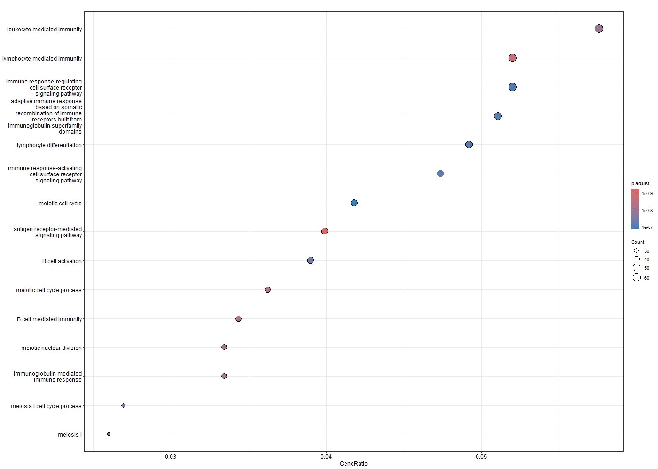
Figure 12. Gene Ontology (GO) Biological Process enrichment analysis of genes upregulated in HPV-positive HNSC. The most significantly enriched biological processes were primarily related to immune activation, adaptive immune response, and B-cell/plasma-cell functions.
GO enrichment analysis of downregulated genes was dominated by processes related to epithelial biology, including skin development (GO:0043588; 95 genes, FDR = 2.42 × 10−46), epidermis development (GO:0008544; 101 genes, FDR = 2.16 × 10−43), keratinisation (GO:0031424; 54 genes, FDR = 8.90 × 10−42) and keratinocyte differentiation (GO:0030216; 69 genes, FDR = 8.72 × 10−39), which formed the largest clusters (Supplementary Figure S1). All GO enrichment terms are listed in Supplementary Tables S12 and S13.
KEGG pathway analysis of downregulated genes similarly showed that the largest cluster was formed by terms related to the formation of the cornified envelope (hsa04382; 87 genes, FDR = 1.25 × 10−42), followed by the cadherin signalling pathway (hsa04519; 70 genes, FDR = 7.87 × 10−11), ECM-receptor interaction (hsa04512; FDR = 3.64 × 10−5) and focal adhesion (hsa04510; FDR = 0.001) (Figure 13). The reduced expression of genes involved in cell adhesion and interaction with the extracellular matrix might explain the loss of differentiated keratinocyte characteristics frequently observed in oropharyngeal carcinomas associated with HPV infection (a basaloid histology). All KEGG enrichment terms are listed in Supplementary Table S11.
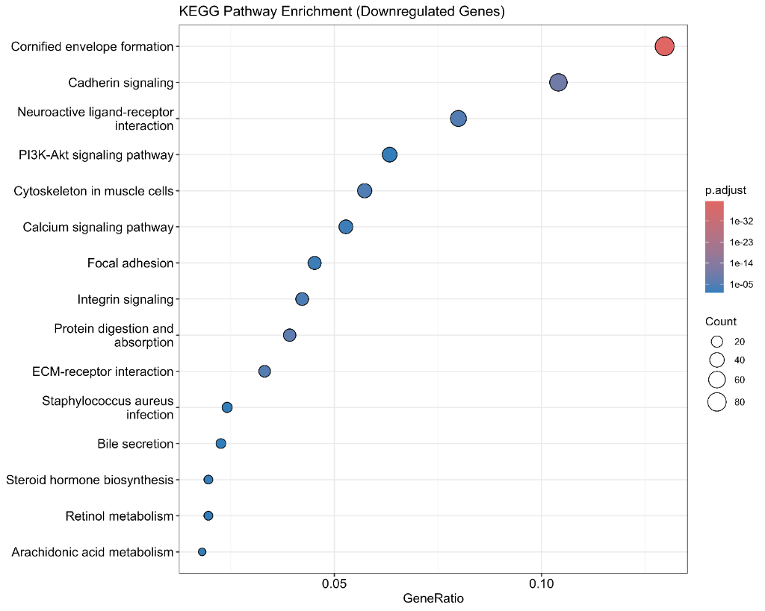
Figure 13. KEGG pathway enrichment analysis of downregulated genes in HPV-positive HNSC, highlighting suppression of keratinisation, epithelial differentiation, extracellular matrix interaction, and cell adhesion pathways.
GSEA using Hallmark gene sets revealed that E2F targets (NES 1.83, FDR 5.24 × 10−4) and G2M checkpoint (NES 1.53) were positively enriched in HPV-positive tumours while epithelial-mesenchymal transition (NES −1.76, FDR 1.17 × 10−4) and KRAS signalling (NES −1.53) were negatively enriched, highlighting the differences in deregulated pathways between HPV-positive and HPV-negative tumours driven by the inactivation of p53 and Rb by HPV E6/E7 oncoproteins (Figure 14 and Supplementary Figure S2).
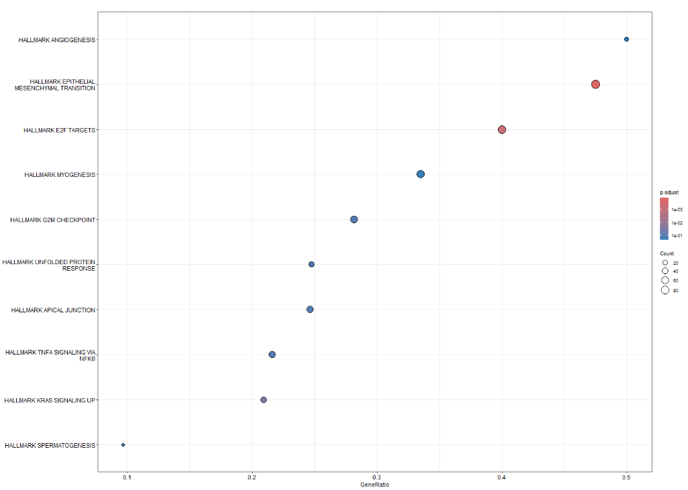
Figure 14. Hallmark GSEA showing positive enrichment of E2F Targets and G2M Checkpoint and negative enrichment of Epithelial–Mesenchymal Transition and KRAS Signalling in HPV-positive HNSC.

3.8 Survival Analysis Identifies Modest Prognostic Associations
Standardized Cox proportional hazards analysis identified several genes significantly associated with overall survival (Table 6). Higher expression of ZFR2 was associated with improved survival (HR = 0.70, 95% CI = 0.57–0.87, P = 0.00098), indicating that each one-standard-deviation increase in ZFR2 expression corresponded to an estimated 30% reduction in mortality risk. Similar protective associations were observed for SMC1B, STAG3, and RAD9B. The hazard ratios along with the confidence intervals for these genes were estimated in the form of a forest plot (Figure 15). Using the median gene expression as the cutoff value, Kaplan-Meier analysis showed significantly different survival curves for the two patient groups (log-rank P = 0.024). Patients in the high-expression group showed a trend toward longer overall survival (Figure 16). These results should be regarded as hypothesis-generating and should be validated in an independent cohort.

Table 7. Survival-Associated Genes Identifies by Standardized Cox Proportional Hazards Analysis
Gene | HR (per 1 SD increase) | Lower 95% CI | Upper 95% CI | P-value
ZFR2 | 0.7006 | 0.5670 | 0.8658 | 0.00098
SMC1B | 0.7784 | 0.6519 | 0.9294 | 0.00561
STAG3 | 0.7773 | 0.6457 | 0.9356 | 0.00773
RAD9B | 0.7941 | 0.6682 | 0.9437 | 0.00887

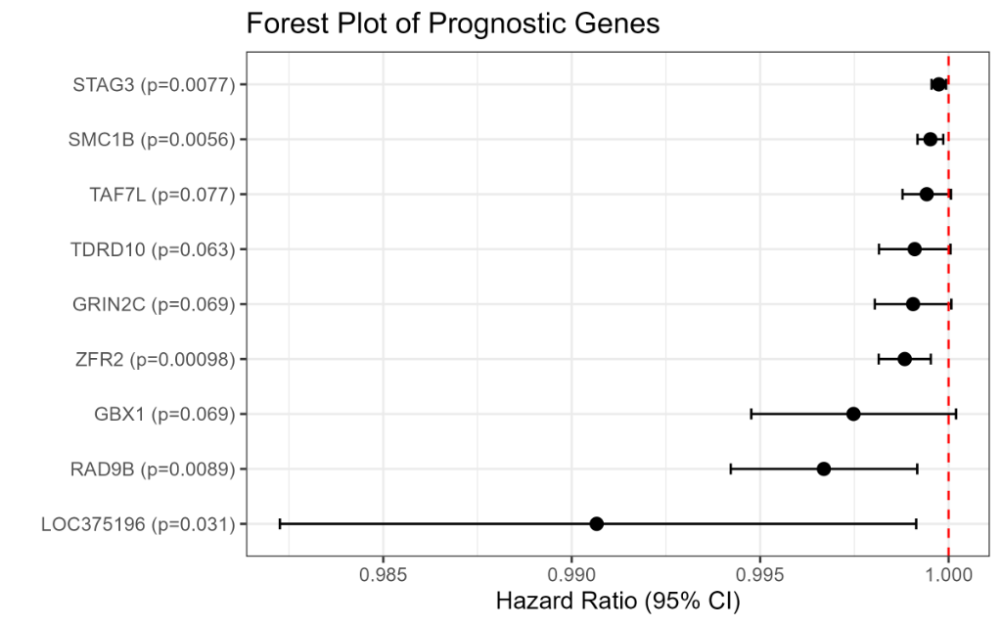
Figure 15. Forest plot of candidate prognostic genes identified by univariate Cox regression analysis. ZFR2 exhibited a significant association with overall survival (HR < 1, p = 0.00098), indicating a protective effect and supporting its potential prognostic relevance in HNSC. Error bars represent 95% confidence intervals.
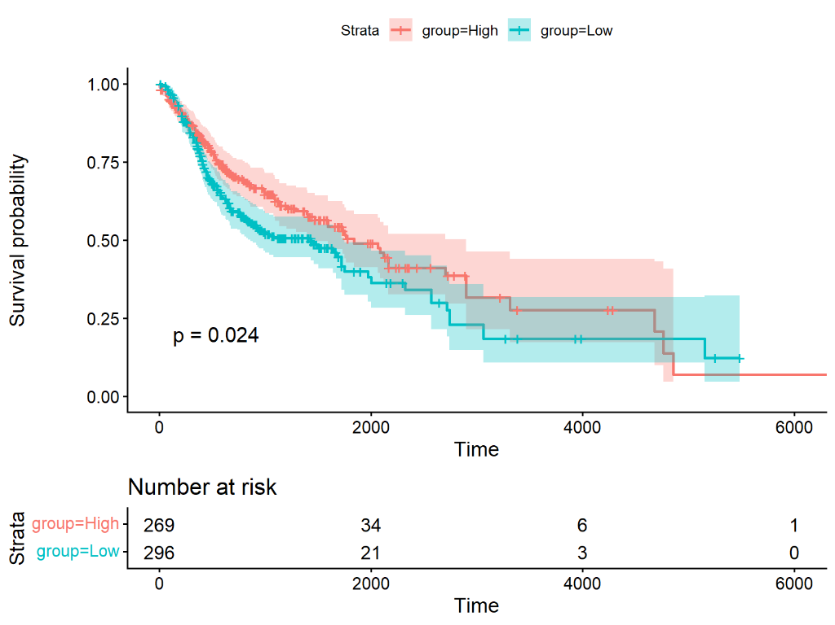
Figure 16. Prognostic significance of ZFR2 expression in HNSC. Kaplan–Meier survival analysis showed that patients with high ZFR2 expression exhibited significantly better overall survival than those with low ZFR2 expression (log-rank p = 0.024), supporting ZFR2 as a potential favorable prognostic biomarker.

4. DISCUSSION
This study provides an integrative transcriptomic and immunological characterization of human papillomavirus (HPV)-positive versus HPV-negative head and neck squamous cell carcinoma (HNSC) using the TCGA-HNSC dataset. Our findings highlight key biological distinctions that contribute to the observed clinical differences in disease outcome and therapeutic response. The analysis focused on three major findings: plasma-cell/B-cell enrichment, increased CD8 T-cell infiltration, and reduced keratinization-related transcriptional programs in HPV-positive HNSC.
One of the primary findings was the significant enrichment of plasma cells and B cells within the tumor microenvironment (TME) of HPV-positive HNSC. CIBERSORTx analysis identified significantly increased plasma-cell fractions in HPV-positive tumors, which were, on average, three times higher than in HPV-negative tumors. This observation was independently supported by strong positive correlations between plasma-cell fractions and the expression of immunoglobulin and B-cell markers, including IGKC (ρ = 0.713), IGHA1 (ρ = 0.700), IGHM (ρ = 0.898), MS4A1 (ρ = 0.544), CD79A (ρ = 0.712), and CD79B (ρ = 0.542). These data collectively suggest a robust humoral immune response in HPV-positive HNSC, potentially driven by viral antigens. Similar associations between B-cell-rich tertiary lymphoid structures (TLS) and favorable clinical outcomes have been reported across multiple tumor types [1] [2]. While these correlations are strong, it is important to avoid overstating causality, as the precise mechanisms linking HPV infection to this specific immune cell enrichment require further investigation.
Increased infiltration of CD8 T cells was another notable feature of HPV-positive HNSC. This finding was validated by positive correlations between estimated CD8+ T-cell fractions and the expression of canonical markers CD8A (ρ = 0.63) and CD8B (ρ = 0.68). Furthermore, HPV-positive tumors exhibited an elevated log2 CD8/M2 macrophage ratio, suggesting a more immune-active and less immunosuppressive TME. The increased abundance of plasma cells, B-cell-associated transcripts, and CD8 T cells observed in HPV-positive tumors is consistent with the immune-inflamed phenotype that has been associated with responsiveness to immune checkpoint blockade in HNSC [5] [6]. It is crucial to interpret the CD8/M2 ratio cautiously, as it is a computationally derived exploratory score that requires independent validation through orthogonal methods such as immunohistochemistry or flow cytometry.
Although the CD8/M2 ratio provides a useful summary measure of the balance between cytotoxic T-cell infiltration and M2 macrophage abundance, it represents a computationally derived exploratory score based on CIBERSORTx deconvolution estimates rather than direct cellular quantification. Consequently, its biological and clinical significance should be interpreted cautiously and validated in independent cohorts using orthogonal experimental approaches.
We also observed a significant downregulation of keratinization-related transcriptional programs in HPV-positive HNSC. This included reduced expression of genes associated with epithelial differentiation and keratinization, such as KRT1, KRT6, KRT10, KRT14, KRT75, SPRR and LCE family genes, and S100A7. This finding is consistent with the known molecular biology of HPV-associated tumors, which often exhibit reduced epithelial differentiation programs. This finding is consistent with the non-keratinizing histology characteristic of HPV-associated oropharyngeal carcinoma reported previously [3]. While this transcriptional shift aligns with the non-keratinizing histological presentation typical of oropharyngeal HPV-positive cancers, mechanistic conclusions regarding its direct impact on tumor behavior should be cautiously drawn and require further experimental validation.
Survival analysis identified several genes associated with overall survival, including ZFR2, STAG3, SMC1B, and RAD9B. These genes are primarily meiosis-associated or germ-cell-related and may represent biologically interesting candidates for future investigation. However, the survival analyses were exploratory and based on a single cohort; therefore, independent validation is required before drawing conclusions regarding their prognostic or therapeutic significance.
Several limitations should be acknowledged. First, the study lacked an independent external validation cohort, and protein-level validation of transcriptomic findings was not performed. Second, the strong correlation between HPV status and primary tumor site, with most HPV-positive tumors originating in the oropharynx, introduces the possibility of primary-site confounding. Although a sensitivity analysis adjusting for primary tumor site was conducted, residual confounding cannot be entirely excluded. Third, the computational immune-cell deconvolution method (CIBERSORTx) has inherent limitations, and the CD8/M2 ratio, being a computationally derived exploratory score, requires further validation. Lastly, as a cross-sectional study, causal inferences cannot be drawn from the observed associations, and future longitudinal studies are warranted.
In conclusion, this study reinforces the understanding that HPV-positive HNSC is characterized by a distinct immune microenvironment, marked by enhanced humoral and cellular immunity, alongside altered epithelial differentiation programs. These findings provide a stronger biological rationale for immune checkpoint blockade in HPV-positive HNSC and highlight candidate transcriptomic features, including specific meiosis-associated genes, that warrant further investigation as potential prognostic markers or therapeutic targets. Future research should focus on independent validation in larger cohorts, protein-level confirmation, and mechanistic studies to fully elucidate the roles of these features in HPV-positive HNSC biology.

References

1.Cabrita R, Lauss M, Sanna A, et al. Tertiary lymphoid structures improve immunotherapy and survival in melanoma. Nature. 2020;580(7805):602-607. doi:10.1038/s41586-019-1914-8

2.Petitprez F, de Reyniès A, Keung EZ, et al. B cells are associated with survival and immunotherapy response in sarcoma. Nature. 2020;577(7791):556-560. doi:10.1038/s41586-019-1906-8

3.Leemans CR, Snijders PJF, Brakenhoff RH. The molecular landscape of head and neck cancer. Nat Rev Cancer. 2018;18(5):269-282. doi:10.1038/nrc.2018.11

4.Maxfield KE, Taus P, Corcoran K, et al. Comprehensive functional characterization of cancer-testis antigens defines obligate participation in multiple hallmarks of cancer. Nat Commun. 2015; 6:8840. doi:10.1038/ncomms9840

5.Burtness B, Harrington KJ, Greil R, et al. Pembrolizumab alone or with chemotherapy versus cetuximab with chemotherapy for recurrent or metastatic squamous cell carcinoma of the head and neck (KEYNOTE-048): a randomised, open-label, phase 3 study. Lancet. 2019;394(10212):1915-1928. doi:10.1016/S0140-6736(19)32591-7

6.Moskovitz JM, Moy J, Seiwert TY. Immunotherapy for Head and Neck Squamous Cell Carcinoma: A Review of Current and Emerging Therapeutic Options. The Oncologist. 2018;23(6):680-693. doi:10.1634/theoncologist.2017-0318

5. LIMITATIONS
Several limitations of the current study should be noted. First, only 36 HPV-positive tumours were included in the study compared to 243 negative ones. Therefore, caution should be exercised when interpreting the results for the positive group as the power to detect associations may be limited. Second, the algorithm used for deconvolution cannot detect cell types beyond LM22 defined signatures. The CD8/M2 ratio was calculated from CIBERSORTx-estimated immune-cell fractions and therefore represents a computationally derived immune score rather than a direct measurement of immune-cell abundance. The CD8/M2 ratio evaluated in this study represents an exploratory computational metric and has not been clinically validated as a prognostic or predictive biomarker in HNSC. Independent validation using orthogonal methods such as immunohistochemistry, flow cytometry, or external transcriptomic cohorts was not performed. In particular, despite being validated on CD8 + T-cell marker genes, our observations regarding cytotoxic T cells may require further validation experiments at the protein level using alternative methods such as immunofluorescence. Third, our data were obtained predominantly from North American and European populations, and our results may not be generalizable to other ethnic groups. Fourth, although we adjusted the differential expression analysis for primary tumor site in a sensitivity analysis, some anatomical site categories contained relatively few HPV-positive cases. Consequently, residual confounding cannot be completely excluded, and validation in larger independent cohorts is warranted.
Third, additional clinical variables, including tumour stage, smoking history, sex, age, treatment heterogeneity, and other patient-specific factors, may influence gene-expression patterns, immune-cell composition, and survival outcomes. Although these factors were considered during interpretation of the results, residual clinical confounding cannot be excluded. Because several clinical variables contained missing data and the HPV-positive subgroup was relatively small (n = 36), comprehensive multivariable models incorporating all potential confounders were not feasible. Consequently, some observed associations should be considered exploratory and require validation in larger cohorts with more complete clinical annotation.
In addition, because the HPV-positive subgroup contained only 36 tumours, adjustment for multiple clinical covariates simultaneously (e.g., primary tumour site, sex, smoking status, and tumour stage) was not performed in the differential expression model to avoid model instability and sparse-category effects. Instead, a sensitivity analysis adjusting for primary tumour site was conducted because this represented the most important potential confounder and allowed assessment of whether the principal HPV-associated transcriptomic findings remained robust. Fifth, survival analysis was confounded by numerous variables, including tumour stage, HPV status, smoking history, and treatment. Of note, the observed HRs were close to 1, which suggests that the associations were probably present in our study, but their biological relevance was limited. Lastly, since TCGA is a cross-sectional study, the observed associations cannot be considered causal and will require further replication in independent cohorts.
Survival analyses were primarily conducted using univariable Cox proportional hazards models with standardized gene-expression values. Although multivariable adjustment for age, tumour stage, sex, smoking history, HPV status, and primary tumour site would be desirable, missing clinical data and the limited number of events for some subgroups restricted the feasibility of fitting stable multivariable models. Consequently, the reported associations should be considered exploratory and require validation in larger independent cohorts with more complete clinical annotation.
Although a sensitivity analysis adjusting for primary tumor site was performed, some anatomical site categories contained relatively few HPV-positive tumors. Consequently, residual confounding due to uneven site distribution cannot be completely excluded. Future studies using larger, anatomically balanced cohorts and independent validation datasets will further strengthen these findings.
Therefore, the present findings should be viewed as hypothesis-generating and require validation in independent cohorts and experimental systems before clinical translation.

6. CONCLUSION
The results presented illustrate that HPV-positive HNSC is characterized by a fundamentally different tumor immune microenvironment compared to its HPV-negative counterpart, primarily driven by an influx of plasma cells and cytotoxic T cells, reduced myeloid immunosuppression, and elevated immunoglobulin and transcripts associated with the B cell receptor signaling. At the same time, HPV-positive tumors exhibited reduced keratinization programs and cornified envelope formation, which is consistent with the histological presentation of non-keratinizing carcinomas typical for oropharyngeal cancers. Overall, these associations highlight the key differences between HPV-positive and HPV-negative tumors that may contribute to the observed clinical differences in terms of treatment response and overall survival. The study identified meiosis-associated / cancer-testis-like genes as among the genes with the highest differential expression and moderate prognostic value. Further immunotherapy research into this class of genes and proteins is needed to explore their potential as therapeutic targets. The findings will benefit from additional validation within independent clinical cohorts, both at the transcriptomic and protein levels, while single-cell approaches may help further resolve the heterogeneity of immune cell populations in these tumors.

7. REFERENCES
Ang KK, Harris J, Wheeler R, et al. (2010). Human papillomavirus and survival of patients with oropharyngeal cancer. New England Journal of Medicine, 363(1), 24–35.
Cancer Genome Atlas Network. (2015). Comprehensive genomic characterization of head and neck squamous cell carcinomas. Nature, 517(7536), 576–582.
Fakhry C, Westra WH, Li S, et al. (2008). Improved survival of patients with human papillomavirus-positive head and neck squamous cell carcinoma in a prospective clinical trial. Journal of the National Cancer Institute, 100(4), 261–269.
Ferris RL, Blumenschein G Jr, Fayette J, et al. (2016). Nivolumab for recurrent squamous-cell carcinoma of the head and neck. New England Journal of Medicine, 375(19), 1856–1867.
Gu-Trantien C, Loi S, Garaud S, et al. (2013). CD4+ follicular helper T cell infiltration predicts breast cancer survival. Journal of Clinical Investigation, 123(7), 2873–2892.
Helmink BA, Reddy SM, Gao J, et al. (2020). B cells and tertiary lymphoid structures promote immunotherapy response. Nature, 577(7791), 549–555.
Johnson DE, Burtness B, Leemans CR, et al. (2020). Head and neck squamous cell carcinoma. Nature Reviews Disease Primers, 6(1), 92.
Love MI, Huber W, Anders S. (2014). Moderated estimation of fold change and dispersion for RNA-seq data with DESeq2. Genome Biology, 15(12), 550.
Mandal R, Senbabaoglu S, Desrichard A, et al. (2016). The head and neck cancer immune landscape and its immunotherapeutic implications. JCI Insight, 1(17), e89828.
Marur S, D'Souza G, Westra WH, Forastiere AA. (2016). HPV-associated head and neck cancer: a virus-related cancer epidemic. Lancet Oncology, 11(8), 781–789.
Newman AM, Steen CB, Liu CL, et al. (2019). Determining cell type abundance and expression from bulk tissues with digital cytometry. Nature Biotechnology, 37(7), 773–782.
Oladipo O, Conlon S, Doherty C, et al. (2020). The impact of anti-cancer immunotherapy on systemic immunity. Frontiers in Immunology, 11, 379.
Simpson AJ, Caballero OL, Jungbluth A, Chen YT, Old LJ. (2005). Cancer/testis antigens, gametogenesis and cancer. Nature Reviews Cancer, 5(8), 615–625.
Subramanian A, Tamayo P, Mootha VK, et al. (2005). Gene set enrichment analysis: a knowledge-based approach for interpreting genome-wide expression profiles. Proceedings of the National Academy of Sciences, 102(43), 15545–15550.
Wolf R, Ruzicka T, Yuspa SH. (2011). Novel S100A7 (psoriasin)/S100A15 (koebnerisin) subfamily: highly homologous but distinct in regulation and function. Amino Acids, 41(4), 789–796.
Wouters MCA, Nelson BH. (2021). Prognostic significance of tumor-infiltrating B cells and plasma cells in human cancer. Clinical Cancer Research, 24(24), 6125–6135.
Yu G, Wang LG, Han Y, He QY. (2012). clusterProfiler: an R package for comparing biological themes among gene clusters. OMICS: A Journal of Integrative Biology, 16(5), 284–287.
zur Hausen H. (2009). Papillomaviruses in the causation of human cancers—a brief historical account. Virology, 384(2), 260–265.

