Transcriptionally active HPV-positive head and neck squamous cell carcinoma is associated with a coordinated meiotic gene programme and promoter hypomethylation

Abstract
Background. Human papillomavirus-positive (HPV+) head and neck squamous cell carcinoma (HNSCC) differs from HPV− disease in its methylome and its immune microenvironment. Germ-cell gene expression in tumours is usually attributed to stochastic de-repression of cancer–testis antigens (CTAs). We asked whether meiotic gene expression in HPV+ HNSCC instead forms a specific, coordinated programme, and where in the tumour it resides.
Methods. Differential expression and enrichment analyses of 279 TCGA-HNSC tumours (36 HPV+) identified meiosis as a dominant HPV-associated theme. A 95-gene panel of the meiotic machinery, with the classic MAGE/CTAG antigens as a comparator, was tested for promoter methylation in TCGA (n = 125), validated in GSE65858 (n = 256), which records HPV DNA status and viral transcriptional activity separately, and replicated for methylation in GSE38266 (n = 42). Immune composition was estimated with CIBERSORTx, and two single-cell RNA-seq cohorts (35 tumours) were used to localise the signal.
Results. Meiotic gene categories, but not the MAGE/CTAG family, were enriched among HPV+-upregulated genes (odds ratio 10.9). Eighteen of 49 panel promoters were hypomethylated in HPV+ tumours, and hypomethylation correlated with meiotic expression (ρ = −0.755). A six-gene core meiotic score separated transcriptionally active HPV+ tumours from HPV− tumours (AUC = 0.959, 95% CI 0.90–1.00), whereas HPV DNA-positive, transcriptionally silent tumours did not differ detectably from HPV− tumours (P = 0.56); MAGE/CTAG antigens performed at chance (AUC = 0.411, 95% CI 0.31–0.51). The core genes were co-expressed as a module only in HPV+ tumours (mean ρ = 0.556 vs 0.149), and methylation differences replicated across cohorts (ρ = 0.688). HPV+ tumours had more plasma cells and CD8+ T cells, yet at single-cell resolution the core score differed by HPV status only in malignant cells (Δ = 0.103 vs ≤ 0.011 in non-malignant cell types). The malignant-cell signal replicated in a second cohort (AUC = 0.945, 95% CI 0.84–1.00) and was attenuated by 22% after adjustment for proliferation.
Conclusions. Transcriptionally active HPV+ HNSCC is associated with a coordinated meiotic gene programme in malignant cells, accompanied by promoter hypomethylation, whereas the classic cancer–testis antigens show none of these features. The meiotic machinery, rather than the broader cancer–testis antigen repertoire, is the more specific germ-cell feature of HPV-driven HNSCC.
Keywords: Human papillomavirus · Head and neck squamous cell carcinoma · DNA methylation · Meiosis · Cancer–testis antigens · Synaptonemal complex · Meiotic cohesin · Tumour immune microenvironment

1. Introduction
Head and neck squamous cell carcinoma (HNSCC) is the sixth most common cancer worldwide, with roughly 900,000 new cases and 450,000 deaths annually [1]. Within it, tumours associated with human papillomavirus (HPV) infection have risen steeply in incidence over the past three decades, particularly in the oropharynx and in younger patients without the tobacco and alcohol exposure that characterises the classical disease [2]. HPV+ HNSCC is now recognised as a disease entity distinct from its HPV− counterpart, with a different mutational landscape, a characteristic transcriptional profile and a markedly better prognosis [3–5]. The prognostic difference is large enough to have changed staging and to have motivated de-escalation trials [6], yet its mechanistic basis is only partly understood, and HPV+ patients who nonetheless relapse cannot currently be identified from viral status alone.
The proximate cause of the difference is viral. The E6 and E7 oncoproteins inactivate p53 and RB, respectively, and in doing so restructure the host cell rather than simply disabling two checkpoints: E7 releases E2F-driven transcription and drives the p16 accumulation used clinically as a surrogate marker, and both proteins engage chromatin-modifying complexes [7]. A substantial part of the resulting distinction is therefore epigenetic. HPV+ tumours carry a reproducible methylation signature [8], E7 can drive locus-specific promoter methylation changes [9], and both hypermethylation and hypomethylation events have been catalogued in this setting [10–12]. Viral DNA can, however, be present without ongoing viral transcription, and integration status and transcriptional activity are not equivalent [13, 14], a distinction that any claim of a virus-driven host programme has to address.
HPV+ and HPV− tumours also differ in cellular composition. HPV+ tumours generally show a more immunologically active microenvironment with greater lymphocytic infiltration, which has been linked to their favourable prognosis [5]. This compartment matters here in two ways: it is part of the biology that distinguishes the two diseases, and it is the main alternative explanation for any expression difference measured in bulk tissue, because a shift in cell proportions can resemble a change of state within tumour cells.
Against this background, germ-cell transcripts in somatic tumours have a long-standing interpretation. Cancer–testis antigens (CTAs), prominently the MAGE, GAGE and CTAG families, are silenced in normal somatic tissue by promoter methylation and become detectable in tumours as that silencing is lost [15, 16]. Global hypomethylation is one of the oldest recognised epigenetic features of malignancy [17], and promoter demethylation is sufficient to activate cancer-germline genes such as MAGEA1 [18], so ectopic germ-cell expression is usually framed as a largely stochastic by-product: promoters that happen to lose methylation happen to be expressed. This reading underpins interest in CTAs as broadly shared immunotherapeutic targets [19, 20], an interest sharpened in HNSCC by the activity of checkpoint blockade in recurrent and metastatic disease [21].
That framing has been challenged from a different direction. A subset of germ-cell genes expressed in tumours encodes the machinery of meiosis itself: the synaptonemal complex that synapses homologous chromosomes, the meiosis-specific cohesin complex that holds them together, and the recombination and double-strand-break (DSB) factors that execute meiotic pairing. Unlike the MAGE/CTAG families, whose somatic function is largely unknown, these are structurally and enzymatically active components. Meiotic cohesin expressed in mitotic cells generates chromosome instability [22]; the meiotic protein HORMAD1, when expressed in tumours, has been linked to genomic instability and homologous-recombination deficiency [23, 24] and to the protection of stalled replication forks [25]; and the concept of “meiomitosis” proposes that partial, mis-scheduled activation of the meiotic programme in somatic cells may itself be oncogenic [26]. Isolated testis-antigen de-repression may therefore be a passenger event, whereas meiotic reactivation may represent a candidate oncogenic programme.
Individual meiotic genes are already known to be associated with HPV. Pyeon et al. reported that HPV+ head and neck and cervical cancers overexpress testis-specific genes normally expressed only in meiotic cells, that SYCP2 and TCAM1 are synergistically induced by E6 and E7, and that STAG3 is upregulated in HPV+ head and neck cancer [27]. SYCP2 deregulation was subsequently proposed as a marker of early-stage HPV+ oropharyngeal carcinoma [28]; a hypomethylated CpG-island-shore region at SYCP2 correlated with its expression in TCGA HNSCC, with SYCP2 and SMC1B among hypomethylated, overexpressed genes [8]; and SYCP2 and TAF7L emerged from a combined TCGA expression and methylation analysis [29]. What has not been established is whether these genes behave as a specific, coordinated programme rather than as independent de-repression events: whether expression is confined to the meiotic machinery as opposed to the MAGE/CTAG antigens, whether the genes are co-regulated, whether expression depends on viral transcription rather than viral DNA, whether it is coupled to promoter methylation across the programme, and whether it resides in malignant cells. These two views have rarely been tested against each other in the same tumours, and HPV+ HNSCC is an informative setting in which to do so. It combines extensive methylome remodelling [8, 10] with a defined initiating agent whose transcriptional activity can be measured independently of viral DNA [14], and well-characterised public cohorts with paired methylation and expression data are available [3]. The two models make different predictions. Stochastic de-repression predicts that germ-cell expression is distributed across germ-cell gene classes in proportion to their promoter methylation, that affected genes vary independently between tumours, and that the phenomenon tracks global hypomethylation rather than any particular viral activity. Programmatic reactivation predicts concentration in one functional class, correlated behaviour among its members, and dependence on the driving stimulus.
Here we characterise the transcriptome of HPV+ HNSCC and test these predictions. We asked which genes and pathways distinguish HPV+ from HPV− tumours and whether germ-cell expression is concentrated in the meiotic machinery; whether the affected genes behave as a coordinated module; whether their expression is accompanied by promoter demethylation and tracks viral DNA or viral transcriptional activity; how the immune microenvironment differs between HPV+ and HPV− tumours and whether the meiotic programme resides in malignant cells rather than in that microenvironment; and, in exploratory analyses, whether expression of the leading HPV-associated genes is associated with overall survival. Throughout, the classic MAGE/CTAG antigens serve as an internal comparator that the stochastic model predicts should behave like the meiotic genes.

2. Materials and Methods

2.1. Data sources and cohort selection
Raw gene-level RNA-sequencing counts for TCGA-HNSC (STAR – Counts workflow) were obtained from the Genomic Data Commons with TCGAbiolinks. Samples were restricted to primary tumours (sample type code 01), and cases without an HPV call were excluded; genomic and clinical records were matched on the first 15 characters of the TCGA barcode. Of 566 RNA-seq samples, 520 were primary tumours and 279 had an HPV call (36 HPV+, 243 HPV−). These 279 tumours form the transcriptomic cohort used for differential expression, enrichment, immune deconvolution and survival analyses. Baseline clinical characteristics were compared between HPV groups with the Wilcoxon rank-sum test for continuous variables and Fisher’s exact or χ² tests for categorical variables (Table 1).
The panel and methylation analyses used a separate processing of the same study: RSEM-normalised expression (Z-scored) and HM450 methylation (β-values) retrieved through the cBioPortal API [30, 31]. Panel-gene coverage and the completeness of p16/in situ hybridisation (ISH) annotations give these analyses smaller sample counts (Table 2). The two TCGA sample sets are therefore not interchangeable, and each analysis below states which it uses.
Four further cohorts were analysed (Table 2). GSE65858 [14] was used for transcriptional validation and downloaded as a GEO series matrix (Illumina HT-12 v4), with probes collapsed to gene symbols by maximum mean intensity using the GPL10558 annotation. GSE38266 [10] provided HM450 data for oropharyngeal tumours only, so that anatomical site was controlled by design; probes were mapped to panel genes through the GPL13534 manifest and restricted to promoter-proximal probes. Two single-cell RNA-seq cohorts were used: GSE181919 [32], which annotates HPV status, tissue type and cell-type identity per barcode and was restricted to primary tumour specimens, and GSE182227 [33], an oropharyngeal cohort deposited without cell-type or malignant-cell labels. In both single-cell cohorts, counts were normalised to 10,000 counts per cell and log-transformed.

2.2. HPV classification
In the transcriptomic cohort, HPV status was taken from the TCGA Network characterisation of HNSCC [3] (cBioPortal study hnsc_tcga_pub), in which viral status was called primarily from HPV transcripts in RNA-sequencing data. In the panel and methylation analyses, HPV status was taken from the p16 and ISH clinical annotations: a tumour was called HPV+ if either assay was positive and was excluded if neither returned a call. Both attributes are recorded at patient level and were mapped to the primary-tumour sample barcode; these calls were audited against the HPV calls supplied by the originating project for samples common to both. GSE65858 records HPV DNA status and HPV transcriptional activity as separate variables, allowing a three-way split into HPV+ tumours with active viral transcription, HPV DNA-positive but transcriptionally silent tumours, and HPV− tumours; samples without a usable call were excluded. Because p16 positivity outside the oropharynx is often unrelated to HPV, two stricter TCGA definitions were used as sensitivity analyses: ISH positivity alone, and the p16-or-ISH rule restricted to oropharyngeal tumours (tonsil, base of tongue and oropharynx).

2.3. Differential expression analysis
Differential expression between HPV+ and HPV− tumours was assessed with DESeq2 (v1.52.0) [34] using a negative-binomial generalised linear model with HPV status as the explanatory variable (design ∼ HPV status; reference level HPV−). Size-factor normalisation and dispersion estimation followed the standard DESeq2 workflow, and P values were adjusted with the Benjamini–Hochberg procedure. Genes with FDR < 0.05 and |log₂FC| > 1 were considered differentially expressed. Because HPV+ tumours were predominantly oropharyngeal, a sensitivity analysis added primary site as a covariate (design ∼ site + HPV status), with sites grouped as oral cavity, oropharynx and other to avoid sparse categories. Variance-stabilised expression was used for principal component analysis and survival modelling.

2.4. Functional enrichment and gene set enrichment analysis
Gene Ontology (GO) biological-process and KEGG pathway over-representation analyses were performed separately for up- and downregulated genes with clusterProfiler (v4.20.0) [35], using all genes passing expression filtering as the background; terms with adjusted P < 0.05 were considered significant. Gene set enrichment analysis (GSEA) [36] was performed with clusterProfiler (gseGO) against GO biological-process gene sets, using the full gene ranking by the DESeq2 Wald statistic (duplicate identifiers collapsed by maximum Wald statistic; gene-set size 10–500; Benjamini–Hochberg correction; random seed 123). Because gene symbols in the count matrix were incompletely annotated, identifiers were re-mapped to current HGNC symbols before panel genes were queried. Over-representation of panel genes among upregulated genes was assessed with the hypergeometric test at two significance thresholds; category-level enrichment was assessed with the hypergeometric test with Bonferroni correction across categories, and meiotic categories were compared with the MAGE/CTAG comparator by Fisher’s exact test.

2.5. Gene panel and core module definition
The panel comprises 95 genes in seven categories. Its scope was motivated by the genome-wide enrichment analysis, which identified meiosis as a dominant HPV-associated theme; gene membership, however, was defined from the meiosis literature and CTdatabase family conventions rather than from the differential-expression results, and category assignments were fixed before the analyses below. Six categories cover the germline machinery: synaptonemal complex (n = 10), meiosis-specific cohesin (4), meiotic recombination and DSB factors (23), piRNA/Tudor germline factors (12), cell-cycle regulators with meiosis-specific roles (5) and other germ-cell genes (8). The seventh category, the classic MAGE/CTAG cancer–testis antigen family (33), is the comparator predicted to behave equivalently under stochastic de-repression.
Because the discovery, validation, replication and single-cell datasets were generated on different platforms, a single core module was defined so that the same score could be computed in every cohort. A gene was retained only if it was measurable in every cohort: the TCGA-HNSC expression and HM450 methylation matrices, the GSE65858 array after probe collapsing, the GSE38266 HM450 matrix restricted to promoter-proximal probes, and both single-cell count matrices. Expression levels, effect sizes, P values and the HPV contrast were not considered. One core gene, MAJIN, is recorded under its previous HGNC symbol C11orf85 in the deposited single-cell matrices, so both symbols were queried (Supplementary Table S1).

2.6. Promoter methylation and methylation–expression coupling
In TCGA-HNSC, methylation was summarised per gene as the mean β-value of all probes annotated to the gene in the HM450 manifest. HPV+ versus HPV− differences were tested with the Mann–Whitney U test and Benjamini–Hochberg correction across all testable panel genes. Methylation–expression coupling was assessed per gene as the Spearman correlation between β and expression across samples with both measurements. At sample level, a composite hypomethylation score (mean of Z-scored, sign-inverted β over the core module) and a composite meiotic expression score (mean Z-scored expression over the same genes) were correlated. Replication in GSE38266 was assessed in three ways. The first two used the same gene-level summary as in TCGA (mean β over all annotated probes, 44 genes shared with the discovery cohort): Spearman correlation of per-gene HPV+ minus HPV− methylation differences between the two cohorts, and a sign-concordance binomial test over the same genes, which is insensitive to platform differences in dynamic range. The third was a set-level comparison of mean methylation across the 227 promoter-proximal probes (GPL13534 manifest) mapping to 16 panel genes.
To apply a single promoter definition in both methylation cohorts, the core-module analyses were repeated with probe-level β values: GDC-harmonised (SeSAMe) HM450 β values for the 125 TCGA-HNSC tumours [37] and the deposited β values for GSE38266. Promoter CpGs were defined identically in both cohorts as those lying between 1,500 bp upstream and 500 bp downstream of an annotated transcription start site of the gene (GENCODE v36 HM450 manifest [38]), and the all-annotated-probe summary was recomputed from the same data for comparison. Because MEI1 and STAG3 are also expressed in B and plasma cells, HPV effects on core-module methylation were re-estimated in linear models adjusted for B-cell and plasma-cell content, measured by CIBERSORTx B-cell plus plasma-cell fractions where available and, for all tumours with expression data, by a marker-expression score (mean Z-score of CD19, CD79A, JCHAIN, MS4A1 and MZB1), which correlated with the CIBERSORTx B-cell plus plasma-cell fraction across the 279 transcriptomic tumours (Spearman ρ = 0.697).

2.7. Module scoring, specificity and coordination
In the bulk cohorts, a module score was the mean Z-scored expression of its member genes. Discrimination between groups was quantified as the area under the receiver-operating-characteristic curve (AUC), with Mann–Whitney P values, for the module score, for each gene and for each panel category; 95% confidence intervals for AUCs were obtained with DeLong's method [39] and checked against a stratified bootstrap (2,000 resamples); for the category-level and single-cell comparator AUCs, for which per-sample scores were not re-derived, intervals were obtained with the Hanley–McNeil method from the AUC and group sizes [40]. In GSE65858, transcriptionally active HPV+ tumours and DNA-positive but transcriptionally silent tumours were each compared with HPV− tumours. Because stochastic de-repression predicts similar behaviour across germ-cell gene classes, specificity was assessed separately within each of the seven panel categories, and the meiotic categories were compared with the MAGE/CTAG comparator. Coordination was quantified as the mean off-diagonal Spearman correlation among module genes within each group. To account for the smaller HPV+ group, an empirical null distribution was generated from 1,000 random HPV− subsets matched to the HPV+ group size, giving an empirical 95% interval and permutation P value for the observed coherence of each HPV+ group (35 transcriptionally active and 25 transcriptionally silent tumours).

2.8. Immune-cell deconvolution
Immune-cell composition of the 279 TCGA tumours was estimated with CIBERSORTx [41] and the LM22 signature matrix of 22 immune-cell populations. Raw counts were converted to transcripts per million (TPM), Ensembl identifiers were mapped to HGNC symbols with org.Hs.eg.db (for duplicated symbols, the row with the highest mean expression was retained), and deconvolution was run in relative mode with 100 permutations, without quantile normalisation or batch correction. Fractions were compared between HPV groups with the Wilcoxon rank-sum test and Benjamini–Hochberg correction across all 22 populations (FDR < 0.05). Estimates were validated by Spearman correlation of CD8+ T-cell fractions with variance-stabilised CD8A and CD8B expression and of plasma-cell fractions with IGHM and MS4A1 expression in the TPM matrix supplied to CIBERSORTx. As an exploratory summary, a log₂ CD8/M2 ratio, log₂[(CD8 T cells + 10⁻⁶)/(M2 macrophages + 10⁻⁶)], was compared between groups with the Wilcoxon test.

2.9. Confounder controls
Three potential confounders of the meiotic signal were addressed. In GSE65858 (virus-active HPV+ vs HPV− tumours), anatomical site was controlled by repeating the analysis in oropharyngeal tumours only, and proliferation, summarised as the mean Z-score of six proliferation-associated genes (MKI67, PCNA, TOP2A, CCNB1, BUB1 and AURKA), was included as a covariate in logistic regression models of HPV status on the core meiotic score, given the functional overlap between meiotic and mitotic cell-cycle processes. In TCGA-HNSC, tumour purity was addressed by merging consensus purity estimates (CPE) [42], testing their association with HPV status and with the core meiotic score, and adding purity, and then purity and proliferation, as covariates to a linear model of the core meiotic score on HPV status. p16 expression was not used as a covariate, because p16 status is one of the two assays that define HPV status in the TCGA panel cohort and adjustment would condition on a component of the outcome definition.

2.10. Single-cell analysis
In GSE181919, each deposited cell-type label was re-tested for enrichment of canonical lineage markers relative to all other labelled cell types, and per-cell-type sequencing depth was tabulated to detect compartment-specific dropout. Module activity was scored per cell with the control-gene-binned method of Tirosh et al. [43], which corrects the mean expression of a gene set against 50 expression-matched control genes drawn from 25 bins. Two meiotic scores were used: the six-gene core score (MEI1, SMC1B, STAG3, SYCP2, SYCE2, MAJIN) and a four-gene meiosis-specific score (SMC1B, SYCP2, SYCE2, MAJIN) that excludes MEI1 and STAG3, the two core genes detected in lymphocytes (Section 3.11). Scores were also computed for the wider meiotic panel, the MAGE/CTAG comparator and a six-gene proliferation score. Group differences were assessed with the Mann–Whitney test, with rank-biserial AUC as the effect size. Because cells from the same tumour are not independent, a linear mixed model was fitted with patient as a random effect, log-transformed per-cell gene count as a covariate and an HPV × malignant interaction term; in addition, malignant cells were aggregated into one pseudobulk profile per tumour (counts per million; patients contributing fewer than 20 malignant cells excluded). Per-gene detection rates were compared with Fisher’s exact test and Benjamini–Hochberg correction, and the compartment specificity of each core gene was quantified as its detection rate in malignant cells divided by that in the non-malignant compartment with the highest detection rate.
Cell-type and malignant-cell assignments were not available for GSE182227 and were derived de novo. Clusters were annotated with the same canonical marker panels, each lineage being required to show enrichment for its own markers relative to all other cells. The epithelial compartment was divided into malignant and normal epithelium using two criteria that were independent of HPV status and of any meiotic gene: the fraction of cells in each epithelial cluster that originated from adjacent-normal tissue, and a per-cell copy-number score inferred from windowed expression along the genome. A cluster was classified as normal only when both criteria agreed. Malignant cells were aggregated into one profile per tumour, and the HPV contrast was tested at tumour level with the Mann–Whitney test and AUC. Proliferation was pre-specified as the principal confounder and included as a covariate in linear models of the per-tumour meiotic score, fitted within each cohort and in the pooled data; robustness was assessed with heteroskedasticity-consistent standard errors and Huber robust regression.

2.11. Exploratory survival analysis
Overall survival (months) and vital status for the 279-tumour transcriptomic cohort were taken from the cBioPortal TCGA-HNSC clinical annotation. The nine most significant HPV-upregulated genes (LOC375196, STAG3, TAF7L, SMC1B, ZFR2, RAD9B, TDRD10, GBX1 and GRIN2C) were analysed. For each gene, a univariable Cox proportional-hazards model (survival v3.8.6) was fitted to variance-stabilised expression scaled to unit variance, so that hazard ratios (HRs) are expressed per standard deviation. Kaplan–Meier curves were drawn for ZFR2, with tumours split at the median. Models were not adjusted for HPV status, stage, smoking or treatment, and P values were not corrected for multiple testing; these analyses were regarded as exploratory.

2.12. Statistical analysis and software
Unless stated otherwise, tests were two-sided and multiple testing was controlled with the Benjamini–Hochberg procedure. Bulk transcriptomic, enrichment and survival analyses were performed in R 4.6.0 with Bioconductor 3.23 (DESeq2, clusterProfiler, enrichplot, org.Hs.eg.db, TCGAbiolinks and survival). Code, processed data and output tables for the TCGA analyses are available at https://github.com/rejoy2004-rgb/TCGA-HNSC-HPV-Transcriptomics.

3. Results

3.1. Cohorts and clinical characteristics
The transcriptomic cohort comprised 279 TCGA-HNSC primary tumours, 36 HPV+ and 243 HPV−. HPV+ tumours arose predominantly in the oropharynx (61.1% vs 4.5%; P < 0.001), HPV+ patients were more often male (88.9% vs 70.4%; P = 0.033), and fewer HPV+ patients had died during follow-up (27.8% vs 53.5%; P = 0.007); age, stage and smoking status did not differ significantly (Table 1). Principal component analysis showed partial separation of HPV+ and HPV− tumours on the first two components (22% and 14% of variance; Supplementary Fig. S1), indicating that HPV status contributes to, but does not dominate, global transcriptomic variation.
Five cohorts were included in the panel-based analyses (Table 2). In TCGA-HNSC, the p16/ISH rule (Section 2.2) identified 44 HPV+ and 81 HPV− tumours with usable promoter methylation data and 41 HPV+ and 80 HPV− tumours with usable expression data; these calls agreed with those of the originating project for all 53 overlapping samples. GSE65858 comprised 35 HPV+ tumours with active viral transcription, 25 HPV DNA-positive tumours without detectable viral transcription and 196 HPV− tumours. GSE38266 contributed 21 HPV+ and 21 HPV− oropharyngeal tumours; 44 panel genes had gene-level methylation in both GSE38266 and the discovery cohort, of which 16 had promoter-proximal probes (227 probes). The single-cell cohorts contributed 23,088 cells from 20 patients (GSE181919) and 16 oropharyngeal tumours, 11 HPV+ and 5 HPV− (GSE182227).
Table 1. Baseline clinical and demographic characteristics of the TCGA-HNSC transcriptomic cohort by HPV status.
Variable | HPV+ (n = 36) | HPV− (n = 243) | P
Age, years: mean ± SD | 57.9 ± 10.8 | 61.8 ± 12.4 | 0.053
Age, years: median (range) | 58.5 (35–82) | 62.0 (19–90)
Sex: female / male | 4 (11.1%) / 32 (88.9%) | 72 (29.6%) / 171 (70.4%) | 0.033
Stage I / II / III / IV | 2 (5.6%) / 5 (13.9%) / 4 (11.1%) / 12 (33.3%) | 12 (4.9%) / 39 (16.0%) / 34 (14.0%) / 132 (54.3%) | 0.845
Stage unknown | 13 (36.1%) | 26 (10.7%)
Smoking: never / ever / unknown | 10 (27.8%) / 26 (72.2%) / 0 | 42 (17.3%) / 194 (79.8%) / 7 (2.9%) | 0.234
Site: oropharynx | 22 (61.1%) | 11 (4.5%) | < 0.001
Site: oral cavity | 12 (33.3%) | 160 (65.8%)
Site: larynx / hypopharynx | 1 (2.8%) / 1 (2.8%) | 71 (29.2%) / 1 (0.4%)
Vital status: alive / dead | 26 (72.2%) / 10 (27.8%) | 113 (46.5%) / 130 (53.5%) | 0.007
Table 2. Cohorts, platforms and analytical roles.
Cohort | Platform | HPV+ | HPV− | Role
TCGA-HNSC, transcriptomic cohort | RNA-seq (STAR counts, GDC) | 36 | 243 | Differential expression, enrichment, immune deconvolution, survival
TCGA-HNSC, panel expression | RNA-seq (RSEM, cBioPortal) | 41 | 80 | Expression discovery
TCGA-HNSC, panel methylation | Illumina HM450 | 44 | 81 | Methylation discovery
GSE65858 | Illumina HT-12 v4 microarray | 60 (35 active, 25 silent) | 196 | Independent expression validation
GSE38266 | Illumina HM450 | 21 | 21 | Independent methylation replication (oropharynx only)
GSE181919 | Single-cell RNA-seq | 7 patients | 13 patients | Malignant-cell localisation
GSE182227 | Single-cell RNA-seq | 11 tumours | 5 tumours | Independent single-cell replication (oropharynx)

3.2. Transcriptomic divergence between HPV+ and HPV− tumours is headed by meiotic genes
Of 27,662 tested genes, 4,744 were differentially expressed (FDR < 0.05, |log₂FC| > 1): 2,139 were upregulated and 2,605 downregulated in HPV+ tumours (Fig. 1a). Meiotic genes headed the upregulated list. Six of the twelve most significant upregulated genes belong to the meiotic panel: STAG3 (log₂FC = 4.63, FDR = 1.0 × 10⁻¹⁰⁰), SMC1B (5.91, 6.7 × 10⁻⁹¹), ZFR2 (6.52, 4.5 × 10⁻⁸⁶), RAD9B (2.79, 1.2 × 10⁻⁸³), TDRD10 (4.48, 2.6 × 10⁻⁶⁹) and CNTD1 (3.18, 4.8 × 10⁻⁶³). The synaptonemal-complex genes SYCP2 (4.64, 4.4 × 10⁻⁶²), MAJIN (5.07, 4.7 × 10⁻⁵⁵) and SYCE2 (2.92, 9.1 × 10⁻⁵²) and the recombination initiator MEI1 (3.32, 1.5 × 10⁻³⁹) were induced on a similar scale (Fig. 1b; Supplementary Table S2), consistent with earlier reports of SYCP2, STAG3 and TAF7L upregulation in HPV+ head and neck cancer [27–29]. Other leading upregulated genes included the germ-cell transcription factor gene TAF7L (5.81, 9.9 × 10⁻¹⁰⁰) and the homeobox gene GBX1 (6.95, 3.2 × 10⁻⁶⁸).
Downregulated genes were dominated by epithelial differentiation and keratinisation, including DSC1 (log₂FC = −5.20, FDR = 1.1 × 10⁻³²), MUCL1 (−5.44, 2.3 × 10⁻³¹), SPRR4 (−4.49, 4.0 × 10⁻²⁷), KRTDAP (−4.25, 1.6 × 10⁻²³), KRT1 (−4.90, 4.8 × 10⁻²¹) and S100A7 (−1.92, 1.1 × 10⁻⁵), together with multiple small proline-rich, late cornified envelope and keratin genes (Supplementary Tables S2 and S3). This pattern is consistent with the tonsillar-crypt origin and non-keratinising histology of most HPV+ tumours.
Because HPV+ tumours arise predominantly in the oropharynx, the analysis was repeated with primary site as a covariate. The site-adjusted model identified 4,800 differentially expressed genes at the same thresholds, slightly more than the unadjusted model, consistent with removal of between-site variance. Fold changes were highly concordant between the two models (Spearman ρ = 0.94 across all genes), 3,975 of the 4,744 unadjusted differentially expressed genes remained significant after adjustment, and the meiotic, immune (IGKC, IGHA1, IGHM, MS4A1, CD79A, CD79B, CD8A, CD8B) and keratinisation (KRT1, KRT14, KRT16, KRT6A, KRTDAP) genes described here all remained significant (Supplementary Table S3). The transcriptional separation is therefore not explained by anatomical site.
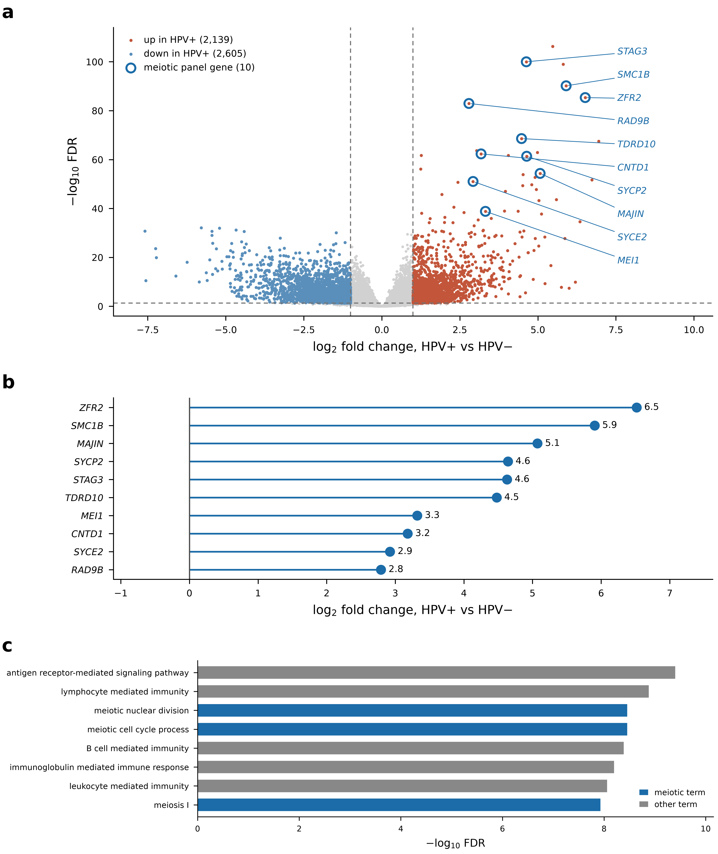
Figure 1. Differential expression in HPV+ versus HPV− TCGA-HNSC tumours places the meiotic machinery among the most strongly induced programmes. (a) Volcano plot of differential expression between HPV+ and HPV− tumours: 4,744 differentially expressed genes (2,139 upregulated, 2,605 downregulated); six of the twelve most significant genes are meiotic, and the ten meiotic panel genes are highlighted. (b) Log₂ fold changes of the ten meiotic panel genes (range 2.8–6.5). (c) The eight most significantly enriched GO biological-process terms among upregulated genes, with meiotic terms in blue: immune terms rank first and second, meiotic nuclear division and meiotic cell cycle process third and fourth, and meiosis I eighth. n = 279 tumours (36 HPV+, 243 HPV−).

3.3. Pathway analysis identifies meiotic, adaptive-immune and epithelial-differentiation programmes
GO over-representation analysis of upregulated genes identified 69 enriched biological-process terms (FDR < 0.05), 16 of them related to meiosis or germ-cell biology. Two themes led the ranking. The first was adaptive immunity, including antigen receptor-mediated signalling pathway (43 genes; FDR = 5.3 × 10⁻¹⁰), lymphocyte-mediated immunity (56 genes; FDR = 1.8 × 10⁻⁹), B cell-mediated immunity (37 genes; FDR = 5.4 × 10⁻⁹) and immunoglobulin-mediated immune response (36 genes; FDR = 8.5 × 10⁻⁹). The second was meiosis, led by meiotic nuclear division (3.8-fold enrichment) and meiotic cell cycle process, which ranked third and fourth overall (Fig. 1c). KEGG analysis of upregulated genes was likewise led by immune pathways, including primary immunodeficiency (16 genes; FDR = 1.9 × 10⁻⁹) and haematopoietic cell lineage (18 genes; FDR = 1.9 × 10⁻⁴). GSEA over the full ranking gave stronger enrichment for the meiotic theme: of 245 positively enriched terms (FDR < 0.05), meiosis-related terms dominated the top of the ranking by normalised enrichment score (NES): meiosis I cell cycle process (NES = 2.91), meiosis I (2.87) and meiotic nuclear division (2.82) were among the five highest-scoring terms, second only to DNA-templated DNA replication (2.92), and the remaining high-ranking terms were DNA replication and recombination processes that share genes with the meiotic programme (Supplementary Fig. S2a).
Downregulated genes mapped to the opposite pole of squamous biology. GO analysis was dominated by skin development (95 genes; FDR = 2.4 × 10⁻⁴⁶), epidermis development (101 genes; FDR = 2.2 × 10⁻⁴³), keratinisation (54 genes; FDR = 8.9 × 10⁻⁴²) and keratinocyte differentiation (69 genes; FDR = 8.7 × 10⁻³⁹), and KEGG analysis by cornified envelope formation (87 genes; FDR = 1.4 × 10⁻⁴²), cadherin signalling (70 genes; FDR = 8.2 × 10⁻¹¹), ECM–receptor interaction (21 genes; FDR = 3.7 × 10⁻⁵) and focal adhesion (31 genes; FDR = 1.2 × 10⁻³) (Supplementary Fig. S3). Keratinisation was also the most negatively enriched GSEA term (NES = −3.17).
The meiotic result, rather than a pre-specified germ-cell hypothesis, motivated construction of the gene panel, so the panel’s overlap with the differential-expression output measures signal magnitude rather than providing independent evidence. Of the 86 panel genes testable after symbol re-annotation, 37 were upregulated at FDR < 0.05, a 2.0-fold enrichment over chance (P = 9.6 × 10⁻⁶), rising to 19.6-fold among the 406 most strongly induced genes (22 panel genes observed vs 1.1 expected; P = 1.4 × 10⁻²²; Supplementary Fig. S2c). Two features of this overlap cannot be attributed to panel construction. First, 49 of the 86 panel genes were not upregulated, so the panel is not a subset of the result against which it is tested. Second, the class specificity examined in this study was already present genome-wide: the meiotic categories were enriched among upregulated genes (34 of 59 genes), whereas the MAGE/CTAG comparator was not (3 of 27; odds ratio 10.9, Fisher P = 4.6 × 10⁻⁵; Supplementary Fig. S2b; Supplementary Table S4). Because both classes were curated from external sources by the same procedure, this contrast cannot have been introduced by panel construction.

3.4. A six-gene core module is measurable in every cohort
Applying the cross-platform intersection criterion to the meiotic-machinery categories identified six genes measurable in all five cohorts: MEI1, SMC1B, STAG3, SYCP2, SYCE2 and MAJIN (Supplementary Table S1). These genes span three functional components of the meiotic apparatus, the synaptonemal complex and its attachment machinery (SYCP2, SYCE2, MAJIN), meiosis-specific cohesin (SMC1B, STAG3) and recombination initiation (MEI1), so the module is not a proxy for a single protein complex. Selection was based only on measurability. Re-mapping incomplete gene-symbol annotations increased the number of testable panel genes from 82 to 86, and the four recovered genes entered the candidate pool under the same criteria. MAJIN was recovered in both single-cell matrices only when its previous symbol, C11orf85, was also queried.

3.5. Meiotic promoters are hypomethylated in HPV+ tumours, and methylation is coupled to expression
Of 49 panel genes with testable promoter methylation in TCGA-HNSC, 18 (37%) were significantly hypomethylated in HPV+ tumours (FDR < 0.05; Fig. 2a). The largest effect, at MEI1, was a 0.45 decrease in mean promoter β. Seventeen of the 18 hypomethylated genes showed a negative methylation–expression correlation (median ρ = −0.55; Fig. 2b), the direction expected if methylation loss permits expression. At the module level, the composite hypomethylation score and the meiotic expression score were correlated across samples (ρ = −0.755, P = 1.5 × 10⁻²³), so the coupling holds per sample and not only between group means. This extends to the whole module the previously reported correlation between hypomethylation of a CpG-island-shore region at SYCP2 and SYCP2 expression in TCGA HNSCC [8].
The methylation findings were replicated in GSE38266, an entirely oropharyngeal cohort with 21 HPV+ and 21 HPV− tumours, which removes anatomical site as a confounder. Gene-level methylation differences (mean β over all annotated probes) agreed between the two cohorts (ρ = 0.688, P = 2.5 × 10⁻⁷ over 44 shared genes; Fig. 2c), with 29 of 44 genes sharing the same sign (binomial P = 0.05). At set level, mean methylation across the 227 promoter-proximal probes in 16 genes was lower in HPV+ than in HPV− tumours (P = 6.8 × 10⁻⁴). Only one locus survived per-gene Bonferroni correction in this 42-sample cohort, so replication rests on effect-size concordance and the set-level test rather than on individual loci.
Applying one promoter definition to both cohorts (Section 2.6; Supplementary Table S5) gave the same picture for the core module. In TCGA-HNSC (44 HPV+ vs 81 HPV− tumours), promoter methylation was lower in HPV+ tumours at five of the six core genes (FDR < 0.05; Δβ from −0.049 at STAG3 to −0.207 at SYCP2), and the same five genes were hypomethylated in GSE38266 (Δβ from −0.048 to −0.135; FDR < 0.05 for MEI1, STAG3, SYCP2 and MAJIN), whereas SYCE2 differed in neither cohort. At set level, mean β across the 80 core-module promoter probes in GSE38266 was 0.257 in HPV+ and 0.334 in HPV− tumours (P = 1.1 × 10⁻⁶). With promoter probes, per-sample core-module methylation and expression were coupled in TCGA (ρ = −0.641, n = 121, P = 2.2 × 10⁻¹⁵; four-gene module ρ = −0.632). Absolute differences in these GDC-harmonised data are smaller than in the gene-level summary used for the panel-wide analysis (for example, Δβ = −0.126 at MEI1), reflecting differences in β-value processing and probe aggregation. Adjustment for B-cell and plasma-cell content left the HPV effect on the core-module promoter composite essentially unchanged (Δβ = −0.100 unadjusted and −0.098 adjusted for the marker score, n = 121; −0.118 and −0.129 adjusted for CIBERSORTx fractions, n = 53), as it did for the four-gene composite (−0.102 and −0.103). At MEI1, the marker score was independently associated with promoter methylation (P = 0.008) and adjustment attenuated the HPV effect by 16% (Δβ = −0.137 to −0.115), but the effect remained significant (P = 2.9 × 10⁻⁷).

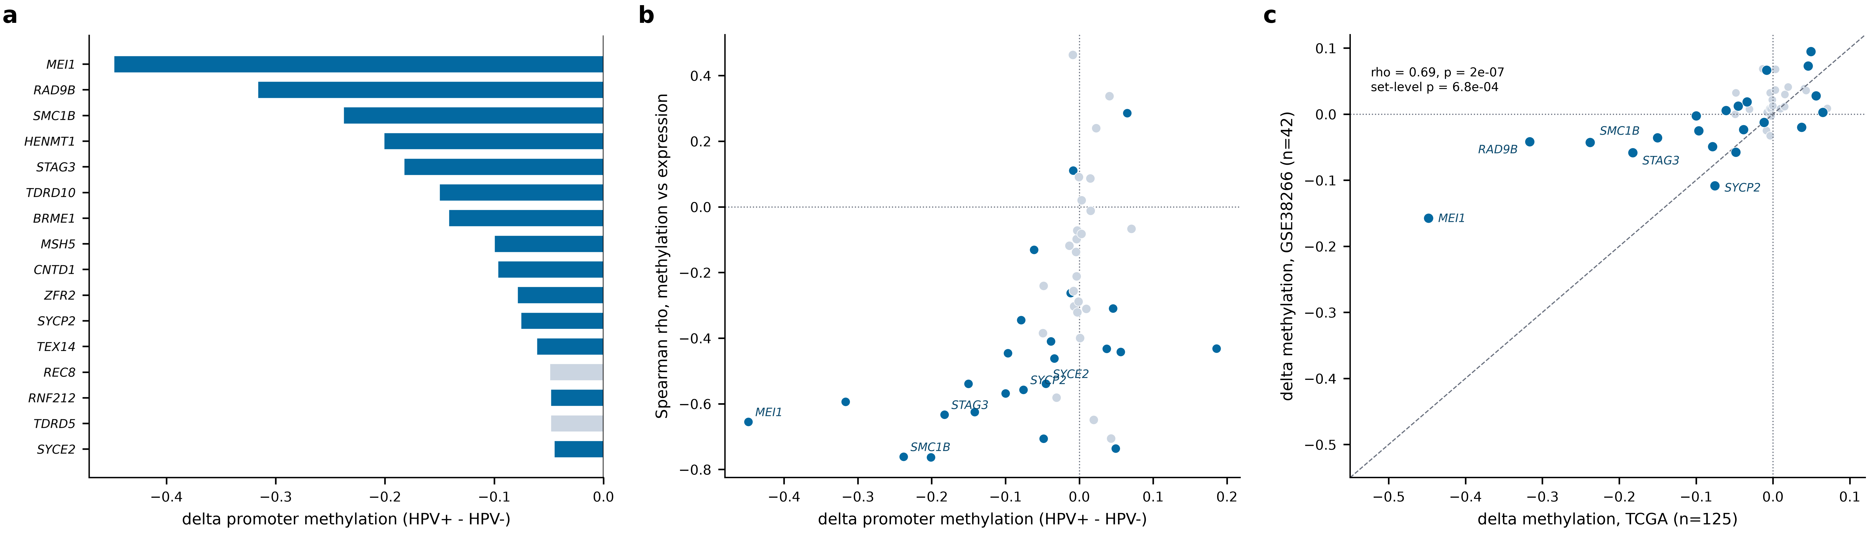
Figure 2. Promoter hypomethylation at meiotic loci in HPV+ HNSCC and its coupling to expression. (a) Panel genes with differential promoter methylation in TCGA-HNSC (44 HPV+ vs 81 HPV−), ranked by effect size; blue indicates FDR < 0.05. (b) Promoter methylation difference versus methylation–expression Spearman correlation; 17 of 18 FDR-significant genes lie in the lower-left quadrant (hypomethylated and inversely coupled to expression). (c) Replication of per-gene methylation differences in GSE38266 (21 HPV+ vs 21 HPV−, all oropharyngeal); the dashed line marks identity.

3.6. The programme tracks viral transcriptional activity rather than viral DNA
GSE65858 records HPV DNA status and HPV transcriptional activity separately. The six-gene core meiotic score separated tumours with active viral transcription from HPV− tumours (AUC = 0.959, 95% CI 0.90–1.00; P = 5.2 × 10⁻¹⁸), whereas tumours carrying HPV DNA without transcriptional activity did not differ detectably from HPV− tumours (AUC = 0.464, 95% CI 0.30–0.62; P = 0.56; Fig. 3a). With 25 silent tumours, this absence of a difference does not establish equivalence, and low-level viral transcription below the detection threshold in some of these tumours cannot be excluded. Grouping by viral DNA alone, the conventional definition, reduced discrimination to AUC = 0.753 (95% CI 0.66–0.85) because the silent tumours dilute the positive group. The programme therefore tracks viral gene expression rather than viral presence, consistent with a position downstream of E6/E7 activity rather than of viral DNA presence.

3.7. Specificity is confined to the meiotic machinery
Germ-cell gene classes behaved differently, which argues against global hypomethylation as the sole explanation. The synaptonemal complex (AUC = 0.930), meiotic cohesin (0.907) and recombination/DSB machinery (0.829) all discriminated strongly, whereas the classic MAGE/CTAG antigens, the largest category in the panel (33 genes, 29 measurable on this platform), performed at chance (AUC = 0.411, 95% CI 0.31–0.51; P = 0.09; Fig. 3c; Table 3). The point estimate lies slightly below 0.5, so there was no residual trend in the expected direction. The same ordering held for individual genes, the top discriminators being meiotic structural or recombination components: MAJIN (0.938), SMC1B (0.937), SYCP2 (0.929) and STAG3 (0.929) (Fig. 3b).
Table 3. Discrimination of virus-active HPV+ (n = 35) from HPV− (n = 196) tumours in GSE65858 by gene category. Category assignments were fixed before analysis. Genes, number of panel members measurable on the array; AUC, from the mean Z-scored expression of each category, with Hanley–McNeil 95% CI; P, Mann–Whitney U test.
Gene category | Genes | AUC (95% CI) | P
Synaptonemal complex | 5 | 0.930 (0.87–0.99) | 5.2 × 10⁻¹⁶
Meiotic cohesin | 4 | 0.907 (0.84–0.97) | 1.7 × 10⁻¹⁴
Meiotic recombination/DSB | 16 | 0.829 (0.74–0.92) | 5.7 × 10⁻¹⁰
Other germ-cell | 7 | 0.827 (0.74–0.91) | 7.3 × 10⁻¹⁰
piRNA/Tudor germline | 11 | 0.740 (0.64–0.84) | 6.1 × 10⁻⁶
Cell-cycle meiosis | 4 | 0.697 (0.59–0.80) | 2.1 × 10⁻⁴
Cancer–testis antigen (MAGE/CTAG) | 29 | 0.411 (0.31–0.51) | 0.09

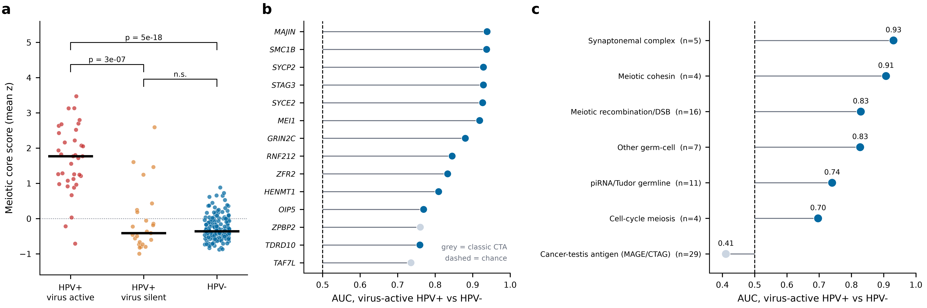
Figure 3. The meiotic programme is associated with transcriptionally active HPV and is specific to the meiotic machinery (GSE65858). (a) Six-gene core meiotic score across the three groups: virus-active HPV+ tumours (n = 35) are elevated, whereas virus-silent HPV DNA+ tumours (n = 25) are indistinguishable from HPV− tumours (n = 196). (b) Per-gene AUC for virus-active HPV+ versus HPV− tumours; grey marks classic cancer–testis antigens. (c) Per-category AUC; the MAGE/CTAG family is at chance, whereas every meiotic category is elevated. Panels b and c are anchored at AUC = 0.5 (dashed line).

3.8. The core meiotic genes are co-expressed as a module
Coordinated expression of the core genes provides further evidence against independent, stochastic promoter de-repression. The mean pairwise correlation among the six core genes was higher in virus-active HPV+ tumours than in HPV− tumours (0.556 vs 0.149; Table 4; Supplementary Fig. S4). In 1,000 random size-matched subsets of HPV− tumours the 95% interval was 0.026–0.272, which the observed value exceeded (P = 0.002), so the higher coherence is unlikely to reflect group size. Coherence was specific to the core module: in the same tumours, the wider meiotic panel reached only 0.083 and the classic CTAs 0.081. Coherence was almost as high in the transcriptionally silent HPV+ group (0.541), although its mean expression was not elevated. Against its own size-matched null (1,000 random subsets of 25 HPV− tumours; 95% interval −0.003 to 0.299), this coherence was also higher than expected by chance (P = 0.001), suggesting that the internal coordination of the module and its overall activation are separable. The four-gene meiosis-specific score, which excludes the lymphocyte-expressed MEI1 and STAG3 (Section 3.11), behaved in the same way: it separated virus-active HPV+ from HPV− tumours (AUC = 0.957, 95% CI 0.90–1.00), and its coherence was 0.546 in virus-active and 0.521 in silent HPV+ tumours but 0.179 in HPV− tumours, both HPV+ values exceeding their size-matched nulls (P = 0.001 and 0.002).
Table 4. Module coherence (mean off-diagonal Spearman ρ among member genes) by group and gene set in GSE65858.
Group | Gene set | Samples | Genes | Mean ρ
HPV+ active | Core meiotic | 35 | 6 | 0.556
HPV+ active | All meiotic | 35 | 25 | 0.083
HPV+ active | Classic CTA | 35 | 29 | 0.081
HPV+ silent | Core meiotic | 25 | 6 | 0.541
HPV+ silent | All meiotic | 25 | 25 | 0.092
HPV+ silent | Classic CTA | 25 | 29 | 0.067
HPV− | Core meiotic | 196 | 6 | 0.149
HPV− | All meiotic | 196 | 25 | 0.027
HPV− | Classic CTA | 196 | 29 | 0.104

3.9. Site, proliferation and tumour purity do not account for the meiotic signal
Three further alternative explanations were tested directly (Supplementary Table S5). In GSE65858, restricting the comparison of virus-active HPV+ and HPV− tumours to the oropharynx (28 vs 47 tumours) left discrimination by the core meiotic score essentially unchanged (AUC = 0.960, 95% CI 0.90–1.00; P = 3.3 × 10⁻¹¹), so the effect is not attributable to the anatomical distribution of HPV+ disease. In logistic regression with virus-active HPV status as the outcome and the core meiotic score as the predictor (GSE65858; 35 virus-active HPV+ and 196 HPV− tumours; n = 231), adding the proliferation score did not attenuate the meiotic-score coefficient (β = 4.45 alone vs 4.52 adjusted; model AUC 0.959 vs 0.961). Tumour purity was examined in TCGA-HNSC using consensus purity estimates (CPE) [42]. HPV+ tumours were purer than HPV− tumours (mean CPE 0.63 vs 0.48; Mann–Whitney P = 8.0 × 10⁻⁶), making purity a potential confounder; however, purity was not correlated with the core meiotic score (Spearman ρ = 0.027, P = 0.66). In a linear model with the core meiotic score as the outcome and HPV status as the predictor, adding purity left the HPV coefficient unchanged (β = 2.29 unadjusted and 2.29 adjusted; purity coefficient −0.022, P = 0.89), and adding purity and proliferation together gave an HPV coefficient of 2.25. Higher purity in HPV+ tumours may appear at odds with their lymphocyte-rich composition (Section 3.10); consensus purity integrates estimators that capture all non-malignant content, including stroma, so lower stromal content in oropharyngeal HPV+ tumours could outweigh their greater immune infiltration, and purity was therefore treated as a covariate rather than as a measure of immune infiltration. A p16-adjusted model was not fitted because p16 immunohistochemistry is one of the two assays defining the HPV grouping; instead, the TCGA analyses were repeated with stricter HPV definitions. Under the main p16-or-ISH rule, the core meiotic expression score separated HPV+ from HPV− tumours with AUC = 0.933 (95% CI 0.87–1.00; 41 vs 80). Requiring ISH positivity (21 vs 65) gave complete separation (AUC = 1.000) and a larger core-module promoter hypomethylation effect (Δβ = −0.116 vs −0.092 under the main rule; AUC = 0.964, 95% CI 0.93–1.00), and restricting the p16-or-ISH rule to oropharyngeal tumours (34 vs 8) gave AUC = 0.974 (95% CI 0.92–1.00). The GSE65858 analysis (Section 3.6), in which HPV DNA and transcriptional activity are recorded independently of p16, provides a further independent test.

3.10. HPV+ tumours have a plasma-cell- and CD8+ T-cell-rich immune microenvironment
Consistent with the adaptive-immune terms among upregulated genes, CIBERSORTx deconvolution of the 279 TCGA tumours identified five of the 22 LM22 populations whose estimated fractions differed by HPV status after correction for multiple testing (Fig. 4; Table 5; all 22 populations in Supplementary Table S6). Plasma cells showed the largest increase in HPV+ tumours (median fraction 0.488 vs 0.145; FDR = 8.1 × 10⁻⁴), and CD8+ T cells were also higher (0.071 vs 0.043; FDR = 1.7 × 10⁻³). HPV+ tumours had lower fractions of M0 macrophages (0.033 vs 0.131; FDR = 5.6 × 10⁻⁵), resting NK cells (0.005 vs 0.029; FDR = 1.7 × 10⁻³) and resting CD4+ memory T cells (0.041 vs 0.068; FDR = 0.042). The exploratory log₂ CD8/M2 ratio was correspondingly higher in HPV+ tumours (median 3.29, IQR 1.82 to 15.35, vs 0.78, IQR −0.63 to 3.16; P = 1.0 × 10⁻⁴; Fig. 4f; Supplementary Table S7).
Marker-gene expression supported the deconvolution estimates. CD8+ T-cell fractions correlated with CD8A (Spearman ρ = 0.735) and CD8B (ρ = 0.689) expression (Supplementary Fig. S5), and plasma-cell fractions correlated with IGHM (ρ = 0.913) and MS4A1 (ρ = 0.590) expression (Supplementary Table S8). At the transcript level, immunoglobulin and B-cell genes were upregulated in HPV+ tumours, including IGHM (log₂FC = 2.44, FDR = 2.0 × 10⁻⁸), MS4A1 (2.07, 1.8 × 10⁻⁵), IGHA1 (1.51, 6.4 × 10⁻⁴), CD79A (1.36, 6.7 × 10⁻⁴) and IGKC (1.14, 8.3 × 10⁻³), as were CD8A (1.26, 5.3 × 10⁻⁵) and CD8B (1.18, 2.5 × 10⁻⁴); all remained significant after adjustment for primary site (Supplementary Table S3).
HPV+ tumours therefore differ from HPV− tumours in composition as well as in tumour-cell transcription, with a larger lymphoid and plasma-cell component. Because two core meiotic genes, MEI1 and STAG3, also have documented lymphocyte functions, this compositional difference is the main alternative explanation for a bulk meiotic signal; it is addressed in the analyses that follow.
Table 5. Immune-cell populations whose CIBERSORTx-estimated fractions differed between HPV+ (n = 36) and HPV− (n = 243) TCGA-HNSC tumours. Wilcoxon rank-sum test; Benjamini–Hochberg FDR across all 22 LM22 populations.
Immune-cell population | Median HPV+ | Median HPV− | P | FDR | Direction in HPV+
Plasma cells | 0.488 | 0.145 | 7.4 × 10⁻⁵ | 8.1 × 10⁻⁴ | Higher
CD8+ T cells | 0.071 | 0.043 | 2.8 × 10⁻⁴ | 1.7 × 10⁻³ | Higher
M0 macrophages | 0.033 | 0.131 | 2.5 × 10⁻⁶ | 5.6 × 10⁻⁵ | Lower
Resting NK cells | 0.005 | 0.029 | 3.1 × 10⁻⁴ | 1.7 × 10⁻³ | Lower
Resting CD4+ memory T cells | 0.041 | 0.068 | 9.4 × 10⁻³ | 0.042 | Lower
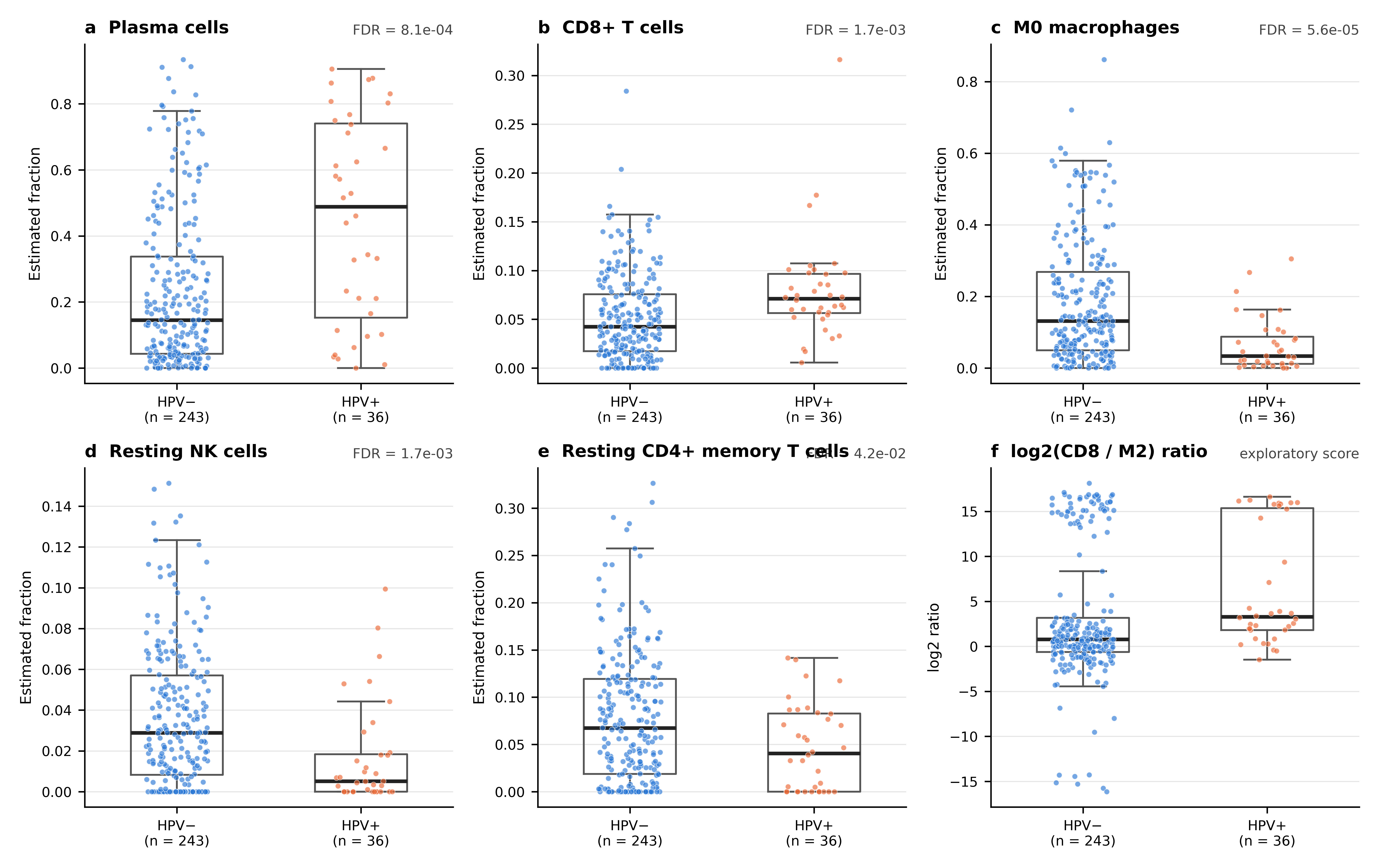
Figure 4. Tumour immune microenvironment of HPV+ versus HPV− TCGA-HNSC tumours. CIBERSORTx (LM22) estimated fractions of (a) plasma cells, (b) CD8+ T cells, (c) M0 macrophages, (d) resting NK cells and (e) resting CD4+ memory T cells, the five populations that differed after Benjamini–Hochberg correction across 22 cell types (FDR shown above each panel). (f) Exploratory log₂ CD8/M2 macrophage ratio. Boxes show the median and interquartile range; points are individual tumours (36 HPV+, 243 HPV−).

3.11. The meiotic programme is confined to malignant cells
All the cohorts above comprise bulk tissue, and HPV+ tumours are richer in lymphocytes and plasma cells (Section 3.10). The meiotic signal could therefore reflect a larger population of non-malignant cells that constitutively express meiotic genes rather than reactivation within tumour cells. This was tested in GSE181919, a single-cell HNSCC atlas annotated for HPV status and malignant versus stromal identity. After restriction to primary tumours, 2,463 malignant cells from 7 HPV+ patients, 2,366 malignant cells from 13 HPV− patients and 18,259 non-malignant cells from the same tumours were available. Published cell-type annotations were re-derived from canonical markers, confirming all nine reported cell types. Malignant cells had the greatest sequencing depth (median 21,880 UMIs and 3,885 detected genes per cell), making differential dropout an unlikely explanation for a compartment-specific signal.
The HPV contrast was confined to the malignant compartment. With the six-gene core score computed per cell, malignant cells differed by 0.103 between HPV groups (AUC = 0.868), whereas every non-malignant cell type, including the T, B and plasma-cell compartments, differed by at most 0.011 in either direction (Fig. 5a, b). In a mixed model of the six-gene core score over all cells, with patient as a random effect and per-cell detection depth as a covariate, the HPV × malignant interaction was 0.090 (P = 8.1 × 10⁻¹¹²); within malignant cells alone, the HPV+ effect was 0.124 (95% CI 0.084–0.164). Including MAJIN under its deposited symbol did not alter the result: the per-cell contrast was 0.103 for the six-gene core and 0.117 for the five core genes matched by current symbol alone, with similar discrimination (AUC 0.868 and 0.865). Fig. 5 was generated with the five-gene version; six-gene values are reported in the text and Table 6.
The effect was not driven by a single tumour. With malignant cells aggregated per patient, all 7 HPV+ tumours scored above all 13 HPV− tumours on the core score computed from the five genes matched by current symbol (Mann–Whitney P = 1.3 × 10⁻⁵; Fig. 5e), with the same result for the six-gene core (Table 6), and separation persisted after removal of any single HPV+ patient (largest leave-one-out P = 3.7 × 10⁻⁵). Pseudobulk expression, a method independent of per-cell scoring, gave the same result: among 6 HPV+ and 13 HPV− tumours with at least 20 malignant cells, core-module pseudobulk expression (five current-symbol genes) was 7.0-fold higher in HPV+ malignant cells (P = 3.7 × 10⁻⁵), whereas the cancer–testis comparator was unchanged (0.96-fold, P = 0.26) (Fig. 5c). For individual genes, SYCP2 was detected in 35.8% of HPV+ versus 1.5% of HPV− malignant cells and SMC1B in 29.5% versus 0.6% (Fig. 5d); across the panel, 14 of 29 meiotic genes but only 4 of 13 cancer–testis antigens were detected significantly more often in HPV+ malignant cells (FDR < 0.05), reproducing within tumour cells the class asymmetry seen in bulk.
The core genes were not uniformly malignant-specific, and the departures were systematic. SYCP2 and SMC1B were detected 7.7- and 11.0-fold more often in malignant cells than in the most-detecting non-malignant compartment, whereas STAG3 showed little enrichment (1.18-fold) and MEI1 was detected more often in B/plasma cells than in malignant cells (0.22-fold; Supplementary Table S9). Both exceptions have documented lymphocyte functions alongside their meiotic roles, which links them directly to the plasma-cell and B-cell enrichment of HPV+ tumours. Excluding these two genes gave the four-gene meiosis-specific score (SMC1B, SYCP2, SYCE2, MAJIN), which removes the lymphoid contribution; all conclusions held for both scores (Table 6).

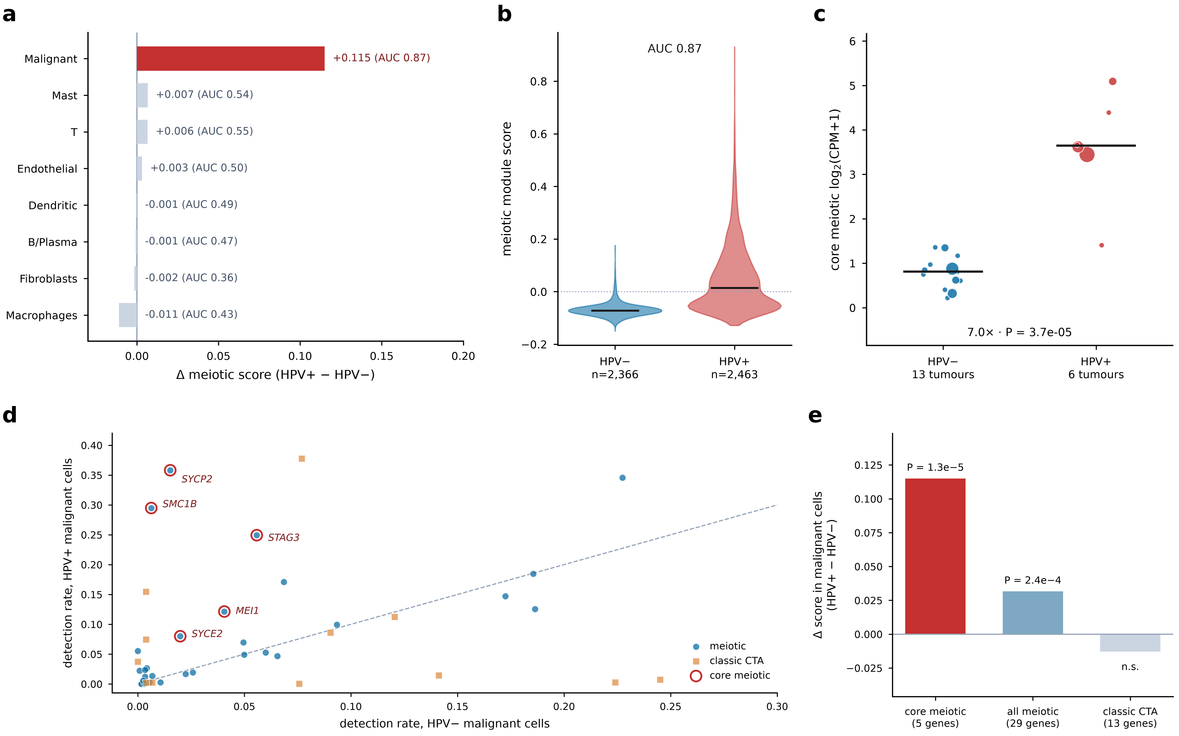
Figure 5. The meiotic programme is localised to malignant cells, not the tumour microenvironment (GSE181919; 23,088 primary-tumour cells). The core module in all panels comprises the five core genes matched by current gene symbol (MAJIN is deposited as C11orf85); six-gene values are given in the text and Table 6. (a) Difference in core module score between HPV+ and HPV− cells, by cell type. (b) Per-cell core module score in malignant cells. (c) Patient-level pseudobulk expression of the core module in malignant cells; point area is proportional to the number of contributing cells, and patients with fewer than 20 malignant cells are omitted. (d) Fraction of malignant cells in which each panel gene is detected, HPV+ against HPV−; the dashed line marks parity. (e) Patient-level effect sizes for the core module (five genes), the wider meiotic panel and the classic CTAs, showing that the contrast is specific to the meiotic machinery rather than a general germ-cell effect.

3.12. The malignant-cell localisation replicates in an independent single-cell cohort
Because a single-cell cohort with seven HPV+ tumours cannot support this conclusion alone, the analysis was repeated in GSE182227, an oropharyngeal cohort of 16 tumours (11 HPV+, 5 HPV−) deposited without cell-type or malignant-cell annotations. De novo annotation with the same canonical marker panels resolved nine lineages (Fig. 6a), and the epithelial compartment was divided into malignant and normal epithelium using adjacent-normal tissue fraction and inferred copy number, neither of which involves a meiotic gene. Malignant cells clustered by patient, whereas normal epithelium from different patients clustered together (Fig. 6b). One of 16 epithelial clusters contained 75% of all adjacent-normal epithelial cells in the cohort and had an inferred copy-number score of 0.094, compared with a median of 0.126 across malignant clusters; both criteria classified it as normal. With this assignment, 3.9% of normal epithelial cells (n = 2,127) detected any of the four meiosis-specific genes, compared with 37.2% of 23,709 malignant cells (Fig. 6c); retaining the normal cluster in the malignant set would have substantially inflated apparent meiotic expression in normal epithelium.
With the compartment defined, the HPV contrast was reproduced. Per tumour, the four-gene meiosis-specific score was 0.176 higher in HPV+ than in HPV− tumours (AUC = 0.945, 95% CI 0.84–1.00; P = 0.003; Fig. 6d), compared with 0.112 (AUC = 1.000, P = 7.4 × 10⁻⁵) for the same score in GSE181919, giving the same direction and comparable magnitude in two cohorts annotated by different procedures (Fig. 6e; Table 6). The six-gene core score gave equivalent results in both cohorts (Table 6). The cancer–testis comparator discriminated in neither cohort (AUC = 0.282, 95% CI 0.04–0.52, P = 0.15; AUC = 0.564, 95% CI 0.26–0.87, P = 0.74), nor did the proliferation score alone (AUC = 0.731 and 0.782). Tumour-level separation in GSE182227 was near-complete: two HPV+ tumours fell within the HPV− range (Fig. 6d), including OP13, which contributed only 155 malignant cells and scored marginally below the highest-scoring HPV− tumour (OP8). When the four-gene score was recomputed with an independently written implementation, OP13 versus OP8 was the only discordant pair (AUC = 0.982, P = 9.0 × 10⁻⁴), and the proportion of malignant cells detecting any of the four meiosis-specific genes separated the groups completely (AUC = 1.000, P = 5.0 × 10⁻⁴), suggesting that the prevalence of programme-positive cells is a more stable readout than the mean score when few cells are available.
Proliferation is an important potential confounder because meiotic and mitotic programmes share components and HPV+ tumours are more proliferative. In the pooled analysis of 35 tumours from both cohorts, adding the proliferation score reduced the HPV coefficient for the four-gene meiosis-specific score from 0.141 (P = 4.5 × 10⁻⁶) to 0.109 (P = 2.7 × 10⁻⁵), a 22% attenuation (Fig. 6f; Supplementary Table S10). Proliferation therefore accounted for about one-fifth of the association. The attenuation was larger in GSE182227 (34%) than in GSE181919 (6%), and in the pooled model proliferation had an independent coefficient of 0.359 (P = 2.8 × 10⁻⁴), supporting separability of the two associations. The pooled adjusted estimate was robust to the regression method: heteroskedasticity-consistent standard errors gave P = 1.3 × 10⁻⁴, and Huber robust regression gave a coefficient of 0.097 (P = 9.1 × 10⁻⁸).
Table 6. HPV contrast in per-tumour module scores in both single-cell cohorts, malignant cells only. Δ, difference in mean score between HPV+ and HPV− tumours; P, two-sided Mann–Whitney test on tumour-level means. These tumour-level contrasts are not directly comparable with the per-cell contrasts in Fig. 5a.
Cohort | Score | Δ | AUC | P | Complete separation
GSE181919 | Six-gene core | 0.113 | 1.000 | 7.4 × 10⁻⁵ | Yes
GSE181919 | Four-gene meiosis-specific | 0.112 | 1.000 | 7.4 × 10⁻⁵ | Yes
GSE181919 | CTA control (5 of 10 genes detected) | −0.089 | 0.282 | 0.15 | No
GSE181919 | Proliferation control (6 genes) | 0.038 | 0.731 | 0.13 | No
GSE182227 | Six-gene core | 0.162 | 0.945 | 0.003 | No
GSE182227 | Four-gene meiosis-specific | 0.176 | 0.945 | 0.003 | No
GSE182227 | CTA control (10 genes) | 0.087 | 0.564 | 0.74 | No
GSE182227 | Proliferation control (6 genes) | 0.145 | 0.782 | 0.09 | No

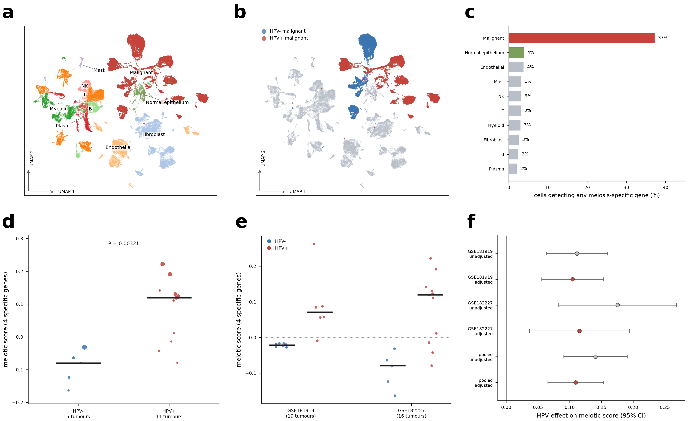
Figure 6. Independent replication in GSE182227 (16 oropharyngeal tumours, annotated de novo). (a) Lineage annotation from canonical markers. (b) Malignant cells, coloured by HPV status, cluster by patient, whereas normal epithelium is shared across patients, the property used to separate the two. (c) Percentage of cells detecting any of the four meiosis-specific genes, by compartment, after the epithelial split. (d) Per-tumour four-gene meiosis-specific score by HPV status; two HPV+ tumours fall within the HPV− range (see text). (e) The same four-gene contrast in both single-cell cohorts. (f) HPV effect on the four-gene meiosis-specific score with and without adjustment for proliferation, by cohort and pooled; bars are 95% confidence intervals.

3.13. Exploratory univariable survival analysis
All 279 tumours in the transcriptomic cohort had overall-survival annotation (140 deaths; Table 1). In exploratory univariable Cox models, higher expression of seven of the nine leading HPV-upregulated genes was nominally associated with longer overall survival, with HRs per standard deviation between 0.70 (ZFR2; 95% CI 0.56–0.87) and 0.82 (SMC1B and GRIN2C); associations for TDRD10 and RAD9B did not reach nominal significance (Supplementary Table S11; Supplementary Fig. S6). Kaplan–Meier curves for ZFR2, split at median expression, are shown in Supplementary Fig. S7. These models were not adjusted for HPV status, stage, smoking or treatment and were not corrected for multiple testing. Because the genes are strongly HPV-associated and HPV+ patients had markedly better outcomes in this cohort (Table 1), the associations are likely to reflect HPV status to a large extent and should not be interpreted as independent prognostic effects.

4. Discussion
HPV+ HNSCC differed from HPV− disease along three transcriptional axes: induction of the meiotic machinery, an adaptive-immune and plasma-cell-rich microenvironment, and reduced keratinisation and epithelial-differentiation programmes. The central finding concerns the first. Germ-cell genes expressed in HPV+ HNSCC were drawn preferentially from the meiotic machinery rather than representing a random subset of germline genes; they were co-expressed as a module, and their promoters showed demethylation that tracked their expression. These observations are inconsistent with the stochastic de-repression model proposed for cancer–testis antigen expression [15, 16]. The comparison was made within the same tumours using the pre-specified MAGE/CTAG comparator, which showed no discriminatory signal (AUC = 0.411), whereas the synaptonemal complex reached an AUC of 0.930.
The association with viral transcriptional activity is the most mechanistically informative result. HPV DNA-positive tumours without viral transcription resembled HPV− tumours on the core meiotic score (P = 0.56), whereas virus-active tumours were clearly separated. This ordering places the programme downstream of E6/E7 expression rather than of viral DNA presence and is consistent with the reported capacity of E7 to induce locus-specific promoter methylation changes [9]. It also has a practical implication: studies relying on HPV DNA status alone may underestimate associations of this type, as shown by the fall in AUC from 0.959 to 0.753 when DNA-based classification was applied to the same samples.
Two non-exclusive explanations could account for the preferential and coordinated activation of the meiotic machinery. One is shared regulatory architecture, whereby the core meiotic genes are governed by a common germline-restricted programme whose methylation-dependent repression is relieved together; this would account for both the specificity and the coherence of the programme. A concrete candidate exists. In somatic cells, meiosis-specific genes carry a conserved E2F6-binding element in their promoters [44], E2F6 silences SMC1B and STAG3 [45], and E2F6 recruits DNMT3B to establish methylation at germline gene promoters [46]; no comparable E2F6 dependence has been described for the MAGE/CTAG family, whose silencing is attributed mainly to promoter DNA methylation [18]. Because E7 disrupts RB–E2F control [7], interference with E2F6-dependent repression would provide a single mechanism for the class specificity, the coordination and the dependence on viral transcription observed here. This predicts reduced E2F6 or DNMT3B occupancy at core meiotic promoters in E7-expressing cells, and de-repression of the core genes, but not of MAGE/CTAG genes, after E2F6 depletion. The near-equal coherence in transcriptionally silent HPV+ tumours (0.541) and active ones (0.556) would also fit co-regulation that precedes activation; in both groups, coherence exceeded a size-matched null. The other is functional selection. Ectopic meiotic cohesin generates chromosomal instability [22], ectopically expressed HORMAD1 has been linked to genomic instability and homologous-recombination deficiency [23, 24] and to protection of stalled replication forks [25], and partial activation of the meiotic programme has been proposed to be oncogenic [26]. Under this model, the meiotic module could be retained because it confers an advantage to tumour cells rather than simply reflecting passive demethylation. Distinguishing these explanations will require perturbation experiments.
The immune findings place this programme in context. HPV+ tumours showed higher estimated plasma-cell and CD8+ T-cell fractions and lower M0 macrophage, resting NK-cell and resting CD4+ memory T-cell fractions, supported by correlations of the estimates with lineage marker genes and by upregulation of immunoglobulin and B-cell transcripts that persisted after adjustment for primary site. B-cell- and plasma-cell-rich infiltrates and tertiary lymphoid structures have been associated with favourable outcome and immunotherapy response in other tumour types [47, 48], and a lymphocyte-rich microenvironment is a recognised feature of HPV+ HNSCC [5]. The lymphoid-rich oropharynx, where most HPV+ tumours arise, probably contributes to the plasma-cell signal, and these are relative, computationally inferred fractions rather than direct cell counts. In this study the immune differences also define the compositional confound that a bulk meiotic signal must overcome, and the single-cell data address it. The HPV contrast was confined to malignant cells and was essentially absent from the lymphocyte populations that differ most in abundance between HPV+ and HPV− tumours. Within HPV+ tumours, core meiotic genes were also detected more often in malignant than in non-malignant cells of the same specimen, arguing against a tumour-wide field effect. The two exceptions to malignant-cell specificity, MEI1 and STAG3, were detected in B/plasma cells, exactly where the bulk immune analysis would predict contamination, and excluding them did not change the conclusion. That the same localisation was observed in a second cohort annotated de novo, with its malignant compartment defined by copy number and tissue of origin rather than deposited labels, makes an annotation artefact unlikely.
The reduced expression of keratinisation, cornified-envelope and epithelial-differentiation genes in HPV+ tumours is consistent with the non-keratinising histology and tonsillar-crypt origin of most HPV+ oropharyngeal carcinomas [5]. It persisted after adjustment for site and serves as an internal check that the transcriptomic contrast captures established HPV-associated biology. Whether loss of squamous differentiation is related to meiotic reactivation cannot be determined from these data.
These findings bear on how this gene class is used translationally. Cancer–testis antigens are pursued as immunotherapeutic targets largely because of their tumour-restricted expression [19, 20]. In HPV+ HNSCC, the MAGE/CTAG family did not distinguish tumours by HPV status, whereas the meiotic structural and recombination components did, were more tightly co-expressed, and were expressed in malignant cells within a lymphocyte-rich microenvironment. This is an argument about target selection based on expression specificity, not evidence of immunogenicity, which was not assessed. The exploratory survival analysis adds little to this argument: several leading HPV-associated genes were nominally associated with longer overall survival, but the models were univariable and not adjusted for HPV status, stage, smoking or treatment, so the associations probably reflect the better prognosis of HPV+ disease. Whether meiotic-programme activity carries prognostic information within HPV+ tumours requires larger, adequately adjusted cohorts.
The single-cell data do not indicate uniform activation across malignant cells. Even in HPV+ tumours, individual meiotic transcripts were detected in a minority of malignant cells; SYCP2 had the highest detection rate (35.8%). Limited detection partly reflects the sensitivity of 3′ droplet-based sequencing, but activation restricted to a malignant subpopulation cannot be excluded. Module scores and patient-level aggregates are therefore more robust measures of programme activation than single-cell detection, and higher-sensitivity approaches such as full-length or targeted single-cell sequencing will be needed to resolve this question.

4.1. Provenance and circularity
The panel was constructed after the genome-wide enrichment analysis had identified meiosis as a dominant theme, so the overlap statistics in Supplementary Fig. S2c quantify the magnitude of an effect in the same samples that motivated panel construction and are not independent evidence. Three considerations limit the consequences of this dependence. First, panel membership was defined from the meiosis literature and CTdatabase conventions rather than from the differential-expression results, and 49 of the 86 testable panel genes were not upregulated. Second, the substantive conclusions concern the specificity and structure of germ-cell expression rather than its presence: concentration in the meiotic machinery rather than the MAGE/CTAG family, coordinated behaviour, and dependence on viral transcriptional activity. None of these follows from the enrichment analysis, and the class contrast is present genome-wide (odds ratio 10.9), not only within the curated panel. Third, the discriminative, coordination and methylation findings were established in GSE65858 and GSE38266, and the malignant-cell localisation in GSE181919 and GSE182227, none of which contributed to panel construction.

5. Limitations
This study has several limitations. The TCGA transcriptomic cohort contains only 36 HPV+ tumours, and the single-cell evidence rests on 35 tumours in two cohorts (17 HPV+, 18 HPV−), both generated with 3′ droplet-based sequencing, which limits detection of lowly expressed transcripts. Malignant-cell annotations in GSE181919 were taken from the original study, whereas those in GSE182227 were assigned without external ground truth, although the two criteria used were concordant; tumour-level discrimination in GSE182227 was not complete, with two HPV+ tumours within the HPV− range (AUC = 0.945).
The methylation replication cohort was small (42 samples), with only one locus surviving per-gene Bonferroni correction, so replication rests on effect-size concordance (ρ = 0.688) and the set-level test (P = 6.8 × 10⁻⁴) rather than on individual loci. Evidence implicating demethylation remains correlative; directionality, per-sample association and replication are consistent with it, but causal inference requires demethylating-agent or targeted epigenetic-editing experiments. Gene-level methylation summarised as mean β across all annotated probes is a coarse measure that may obscure CpG-island substructure and allele-specific effects; a single promoter definition was applied to both cohorts for the six core genes, but the panel-wide statistics (18 of 49 hypomethylated genes; concordance over 44 genes) still rest on the all-annotated-probe summary, and the core-module re-analysis used GDC-harmonised β values, which give smaller absolute differences. MEI1 and STAG3 are also expressed in B and plasma cells, and HPV+ tumours are richer in these cells. The four-gene score that excludes them reproduced the bulk discrimination, coherence and methylation results, and adjustment for B-cell and plasma-cell content did not change the core-module methylation effect, but at MEI1 about one-sixth of the HPV-associated promoter methylation difference was attributable to this compartment. Expression was measured on different platforms in the discovery (RNA-seq) and validation (microarray) cohorts, so effect sizes are not directly comparable. Two HPV definitions were used within TCGA, RNA-seq-based for the transcriptomic cohort and p16/ISH-based for the panel analyses, which is why the sample counts of these analyses differ; because p16 positivity outside the oropharynx is often unrelated to HPV, the p16-or-ISH rule may misclassify some non-oropharyngeal tumours, although the results were stronger, not weaker, when ISH positivity was required; the oropharynx-restricted analysis included only eight HPV− tumours. DeLong confidence intervals were computed wherever per-sample scores were available; the category-level and single-cell comparator AUCs retain Hanley–McNeil intervals.
Immune-cell fractions were inferred computationally, are relative rather than absolute, are limited to the 22 LM22 populations and were not confirmed at the protein level; the CD8/M2 ratio is an exploratory derived score. Although differential expression was adjusted for primary site in a sensitivity analysis, residual site confounding of the immune estimates cannot be excluded given the oropharyngeal predominance of HPV+ tumours. The survival analyses were univariable, limited to nine candidate genes selected for their HPV association, not adjusted for HPV status, stage, smoking or treatment, and not corrected for multiple testing; they are hypothesis-generating only. The gene panel was defined after the discovery analysis had identified meiosis as the dominant theme, so its overlap with the discovery output (37 of 86 testable genes upregulated) indicates magnitude rather than independent evidence, although the class contrast and all external-cohort findings are unaffected. Finally, all cohorts are retrospective and observational and were drawn predominantly from North American and European populations, so the associations reported cannot be interpreted causally and may not generalise to other populations.

6. Conclusions
Transcriptionally active HPV+ head and neck squamous cell carcinoma is associated with a specific, internally coordinated meiotic gene programme, accompanied by promoter demethylation and dependent on viral transcriptional activity rather than viral presence. The classic cancer–testis antigens, tested as a pre-specified comparator in the same tumours, show none of these properties. HPV+ tumours also have a plasma-cell- and CD8+ T-cell-rich immune microenvironment and reduced keratinisation programmes, yet single-cell analysis in two independent cohorts localises the meiotic programme to malignant cells, and the association persists after adjustment for proliferation. These data establish associations rather than causal direction. They indicate that germ-cell gene expression in this disease is better described as a directed epigenetic programme than as stochastic de-repression, and that the meiotic machinery, rather than the MAGE/CTAG family, is the more informative compartment for mechanistic and translational study.

7. References
1. Sung H, Ferlay J, Siegel RL, et al. Global cancer statistics 2020: GLOBOCAN estimates of incidence and mortality worldwide for 36 cancers in 185 countries. CA Cancer J Clin. 2021;71:209–249. https://doi.org/10.3322/caac.21660
2. Chaturvedi AK, Engels EA, Pfeiffer RM, et al. Human papillomavirus and rising oropharyngeal cancer incidence in the United States. J Clin Oncol. 2011;29:4294–301. https://doi.org/10.1200/JCO.2011.36.4596
3. Cancer Genome Atlas Network. Comprehensive genomic characterization of head and neck squamous cell carcinomas. Nature. 2015;517:576–82. https://doi.org/10.1038/nature14129
4. Ang KK, Harris J, Wheeler R, et al. Human papillomavirus and survival of patients with oropharyngeal cancer. N Engl J Med. 2010;363:24–35. https://doi.org/10.1056/NEJMoa0912217
5. Leemans CR, Snijders PJF, Brakenhoff RH. The molecular landscape of head and neck cancer. Nat Rev Cancer. 2018;18:269–282. https://doi.org/10.1038/nrc.2018.11
6. Lechner M, Liu J, Masterson L, Fenton TR. HPV-associated oropharyngeal cancer: epidemiology, molecular biology and clinical management. Nat Rev Clin Oncol. 2022;19:306–327. https://doi.org/10.1038/s41571-022-00603-7
7. Moody CA, Laimins LA. Human papillomavirus oncoproteins: pathways to transformation. Nat Rev Cancer. 2010;10:550–60. https://doi.org/10.1038/nrc2886
8. Degli Esposti D, Sklias A, Lima SC, et al. Unique DNA methylation signature in HPV-positive head and neck squamous cell carcinomas. Genome Med. 2017;9:33. https://doi.org/10.1186/s13073-017-0419-z
9. Chalertpet K, Pakdeechaidan W, Patel V, Mutirangura A, Yanatatsaneejit P. Human papillomavirus type 16 E7 oncoprotein mediates CCNA1 promoter methylation. Cancer Sci. 2015;106:1333–40. https://doi.org/10.1111/cas.12761
10. Lechner M, Fenton T, West J, et al. Identification and functional validation of HPV-mediated hypermethylation in head and neck squamous cell carcinoma. Genome Med. 2013;5:15. https://doi.org/10.1186/gm419
11. Anayannis NV, Schlecht NF, Belbin TJ. Epigenetic mechanisms of human papillomavirus-associated head and neck cancer. Arch Pathol Lab Med. 2015;139:1373–8. https://doi.org/10.5858/arpa.2014-0554-RA
12. Xu Y, Wang Z, Wei P, et al. Hypermethylation of nc886 in HPV-positive oropharyngeal cancer and its clinical implications: an epigenome-wide association study. Mol Ther Nucleic Acids. 2022;30:596–605. https://doi.org/10.1016/j.omtn.2022.11.012
13. Parfenov M, Pedamallu CS, Gehlenborg N, et al. Characterization of HPV and host genome interactions in primary head and neck cancers. Proc Natl Acad Sci U S A. 2014;111:15544–9. https://doi.org/10.1073/pnas.1416074111
14. Wichmann G, Rosolowski M, Krohn K, et al. The role of HPV RNA transcription, immune response-related gene expression and disruptive TP53 mutations in diagnostic and prognostic profiling of head and neck cancer. Int J Cancer. 2015;137:2846–57. https://doi.org/10.1002/ijc.29649
15. Zhang C, Kawakami T, Okada Y, Okamoto K. Distinctive epigenetic phenotype of cancer testis antigen genes among seminomatous and nonseminomatous testicular germ-cell tumors. Genes Chromosomes Cancer. 2005;43:104–12. https://doi.org/10.1002/gcc.20160
16. Almeida LG, Sakabe NJ, deOliveira AR, et al. CTdatabase: a knowledge-base of high-throughput and curated data on cancer-testis antigens. Nucleic Acids Res. 2009;37:D816–9. https://doi.org/10.1093/nar/gkn673
17. Feinberg AP, Vogelstein B. Hypomethylation distinguishes genes of some human cancers from their normal counterparts. Nature. 1983;301:89–92. https://doi.org/10.1038/301089a0
18. Cannuyer J, Loriot A, Parvizi GK, De Smet C. Epigenetic hierarchy within the MAGEA1 cancer-germline gene: promoter DNA methylation dictates local histone modifications. PLoS One. 2013;8:e58743. https://doi.org/10.1371/journal.pone.0058743
19. Wei X, Chen F, Xin K, et al. Cancer-testis antigen peptide vaccine for cancer immunotherapy: progress and prospects. Transl Oncol. 2019;12:733–738. https://doi.org/10.1016/j.tranon.2019.02.008
20. Chiappinelli KB, Zahnow CA, Ahuja N, Baylin SB. Combining epigenetic and immunotherapy to combat cancer. Cancer Res. 2016;76:1683–9. https://doi.org/10.1158/0008-5472.CAN-15-2125
21. Ferris RL, Blumenschein G, Fayette J, et al. Nivolumab for recurrent squamous-cell carcinoma of the head and neck. N Engl J Med. 2016;375:1856–1867. https://doi.org/10.1056/NEJMoa1602252
22. Boukaba A, Liu J, Ward C, et al. Ectopic expression of meiotic cohesin generates chromosome instability in cancer cell line. Proc Natl Acad Sci U S A. 2022;119:e2204071119. https://doi.org/10.1073/pnas.2204071119
23. Watkins J, Weekes D, Shah V, et al. Genomic complexity profiling reveals that HORMAD1 overexpression contributes to homologous recombination deficiency in triple-negative breast cancers. Cancer Discov. 2015;5:488–505. https://doi.org/10.1158/2159-8290.CD-14-1092
24. Gantchev J, Messina-Pacheco J, Martínez Villarreal A, et al. Ectopically expressed meiosis-specific cancer testis antigen HORMAD1 promotes genomic instability in squamous cell carcinomas. Cells. 2023;12:1627. https://doi.org/10.3390/cells12121627
25. Herrera LR, Johnson RA, McGlynn K, et al. The cancer testes antigen, HORMAD1, limits genomic instability in cancer cells by protecting stalled replication forks. J Biol Chem. 2023;299:105348. https://doi.org/10.1016/j.jbc.2023.105348
26. Gantchev J, Martínez Villarreal A, Gunn S, et al. The ectopic expression of meiCT genes promotes meiomitosis and may facilitate carcinogenesis. Cell Cycle. 2020;19:837–854. https://doi.org/10.1080/15384101.2020.1743902
27. Pyeon D, Newton MA, Lambert PF, et al. Fundamental differences in cell cycle deregulation in human papillomavirus-positive and human papillomavirus-negative head/neck and cervical cancers. Cancer Res. 2007;67:4605–4619. https://doi.org/10.1158/0008-5472.CAN-06-3619
28. Masterson L, Sorgeloos F, Winder D, et al. Deregulation of SYCP2 predicts early stage human papillomavirus-positive oropharyngeal carcinoma: a prospective whole transcriptome analysis. Cancer Sci. 2015;106:1568–1575. https://doi.org/10.1111/cas.12809
29. Hinić S, Rich A, Anayannis NV, Cabarcas-Petroski S, Schramm L, Meneses PI. Gene expression and DNA methylation in human papillomavirus positive and negative head and neck squamous cell carcinomas. Int J Mol Sci. 2022;23:10967. https://doi.org/10.3390/ijms231810967
30. Cerami E, Gao J, Dogrusoz U, et al. The cBio cancer genomics portal: an open platform for exploring multidimensional cancer genomics data. Cancer Discov. 2012;2:401–4. https://doi.org/10.1158/2159-8290.CD-12-0095
31. Gao J, Aksoy BA, Dogrusoz U, et al. Integrative analysis of complex cancer genomics and clinical profiles using the cBioPortal. Sci Signal. 2013;6:pl1. https://doi.org/10.1126/scisignal.2004088
32. Choi JH, Lee BS, Jang JY, et al. Single-cell transcriptome profiling of the stepwise progression of head and neck cancer. Nat Commun. 2023;14:1055. https://doi.org/10.1038/s41467-023-36691-x
33. Puram SV, Mints M, Pal A, et al. Cellular states are coupled to genomic and viral heterogeneity in HPV-related oropharyngeal carcinoma. Nat Genet. 2023;55:640–650. https://doi.org/10.1038/s41588-023-01357-3
34. Love MI, Huber W, Anders S. Moderated estimation of fold change and dispersion for RNA-seq data with DESeq2. Genome Biol. 2014;15:550. https://doi.org/10.1186/s13059-014-0550-8
35. Yu G, Wang LG, Han Y, He QY. clusterProfiler: an R package for comparing biological themes among gene clusters. OMICS. 2012;16:284–287. https://doi.org/10.1089/omi.2011.0118
36. Subramanian A, Tamayo P, Mootha VK, et al. Gene set enrichment analysis: a knowledge-based approach for interpreting genome-wide expression profiles. Proc Natl Acad Sci U S A. 2005;102:15545–15550. https://doi.org/10.1073/pnas.0506580102
37. Zhou W, Triche TJ, Laird PW, Shen H. SeSAMe: reducing artifactual detection of DNA methylation by Infinium BeadChips in genomic deletions. Nucleic Acids Res. 2018;46:e123. https://doi.org/10.1093/nar/gky691
38. Zhou W, Laird PW, Shen H. Comprehensive characterization, annotation and innovative use of Infinium DNA methylation BeadChip probes. Nucleic Acids Res. 2017;45:e22. https://doi.org/10.1093/nar/gkw967
39. DeLong ER, DeLong DM, Clarke-Pearson DL. Comparing the areas under two or more correlated receiver operating characteristic curves: a nonparametric approach. Biometrics. 1988;44:837–845. https://doi.org/10.2307/2531595
40. Hanley JA, McNeil BJ. The meaning and use of the area under a receiver operating characteristic (ROC) curve. Radiology. 1982;143:29–36. https://doi.org/10.1148/radiology.143.1.7063747
41. Newman AM, Steen CB, Liu CL, et al. Determining cell type abundance and expression from bulk tissues with digital cytometry. Nat Biotechnol. 2019;37:773–782. https://doi.org/10.1038/s41587-019-0114-2
42. Aran D, Sirota M, Butte AJ. Systematic pan-cancer analysis of tumour purity. Nat Commun. 2015;6:8971. https://doi.org/10.1038/ncomms9971
43. Tirosh I, Izar B, Prakadan SM, et al. Dissecting the multicellular ecosystem of metastatic melanoma by single-cell RNA-seq. Science. 2016;352:189–96. https://doi.org/10.1126/science.aad0501
44. Kehoe SM, Oka M, Hankowski KE, et al. A conserved E2F6-binding element in murine meiosis-specific gene promoters. Biol Reprod. 2008;79:921–930. https://doi.org/10.1095/biolreprod.108.067645
45. Storre J, Schäfer A, Reichert N, et al. Silencing of the meiotic genes SMC1β and STAG3 in somatic cells by E2F6. J Biol Chem. 2005;280:41380–41386. https://doi.org/10.1074/jbc.M506797200
46. Velasco G, Hubé F, Rollin J, et al. Dnmt3b recruitment through E2F6 transcriptional repressor mediates germ-line gene silencing in murine somatic tissues. Proc Natl Acad Sci U S A. 2010;107:9281–9286. https://doi.org/10.1073/pnas.1000473107
47. Cabrita R, Lauss M, Sanna A, et al. Tertiary lymphoid structures improve immunotherapy and survival in melanoma. Nature. 2020;577:561–565. https://doi.org/10.1038/s41586-019-1914-8
48. Petitprez F, de Reyniès A, Keung EZ, et al. B cells are associated with survival and immunotherapy response in sarcoma. Nature. 2020;577:556–560. https://doi.org/10.1038/s41586-019-1906-8

Supplementary Material

Supplementary figures
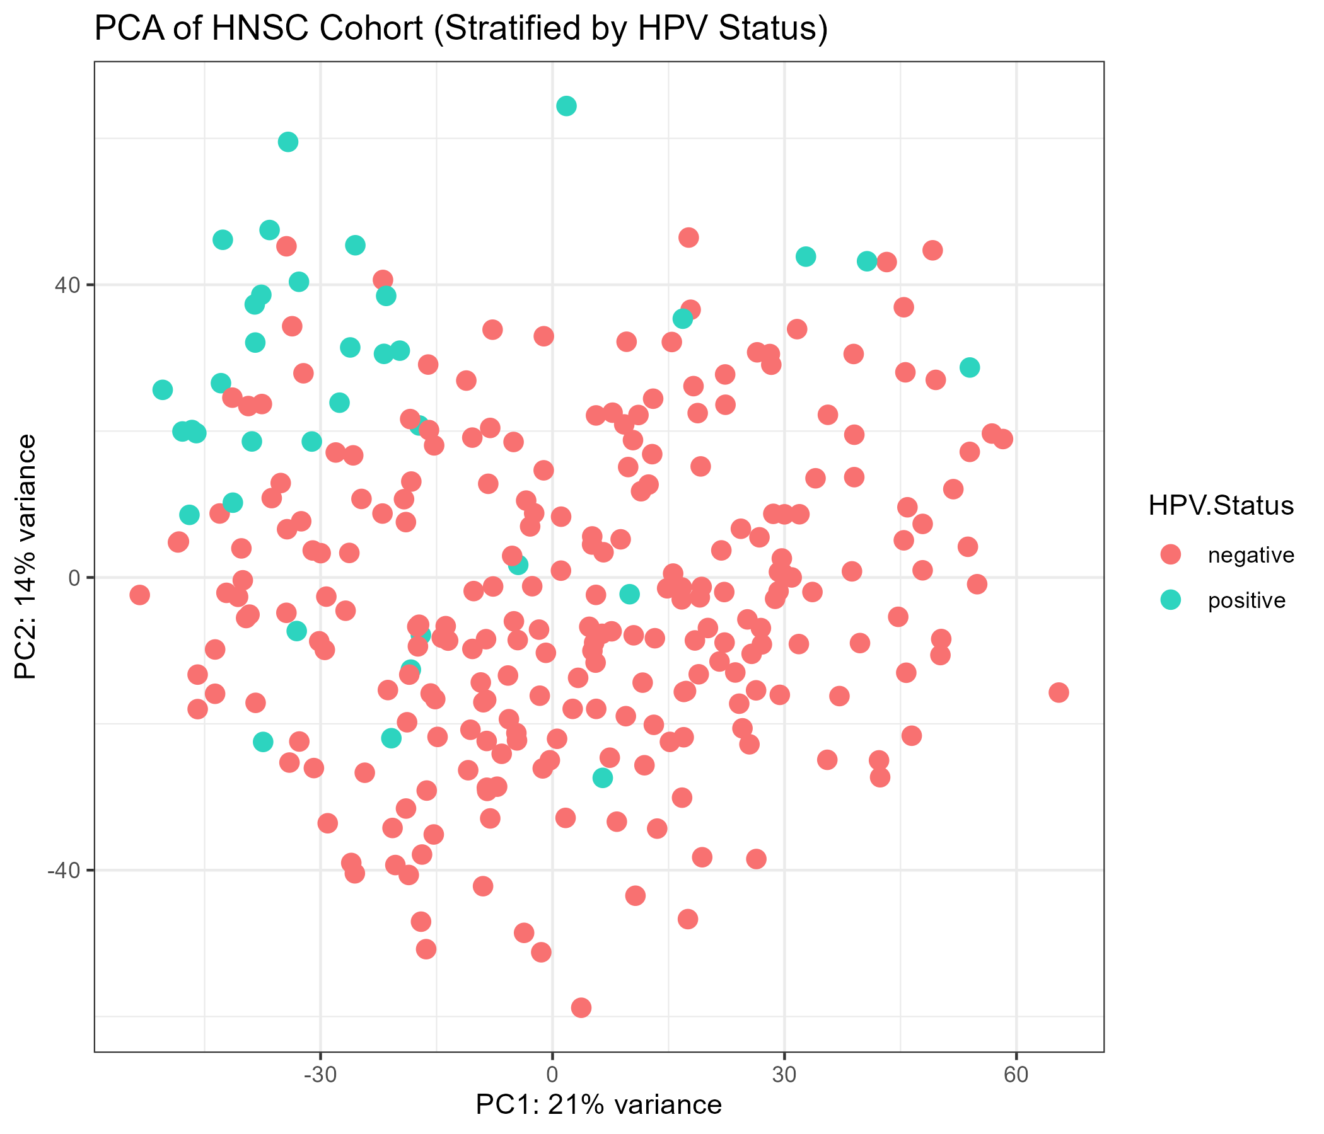
Supplementary Fig. S1. Principal component analysis of the 279 TCGA-HNSC tumours (variance-stabilised expression). HPV+ and HPV− tumours separate partially along PC1 (22% of variance) and PC2 (14%).
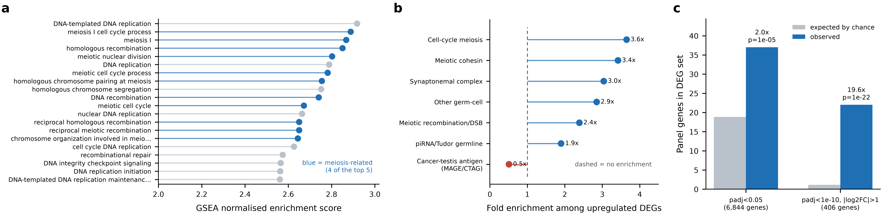
Supplementary Fig. S2. The meiotic hypothesis originates in an unbiased analysis. (a) The 20 most positively enriched GSEA biological-process terms in HPV+ versus HPV− TCGA-HNSC tumours; meiosis-related terms in blue. (b) Fold enrichment of each panel category among genes upregulated in HPV+ tumours (FDR < 0.05); the MAGE/CTAG comparator (red) is the only category not enriched. (c) Panel genes observed among upregulated differentially expressed genes versus the hypergeometric expectation, at two stringency thresholds.
Supplementary Fig. S3. Pathways downregulated in HPV+ tumours. Left, GO biological-process over-representation among downregulated genes; right, KEGG pathway over-representation among downregulated genes, led by cornified envelope formation and cadherin signalling.
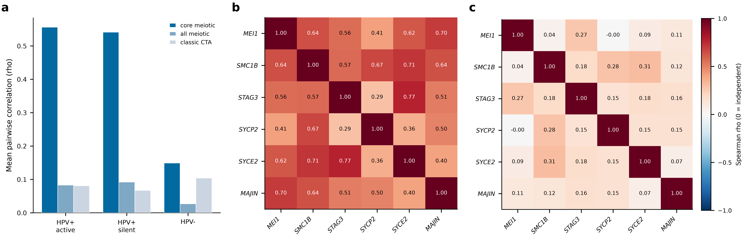
Supplementary Fig. S4. The core meiotic genes are co-expressed as a module (GSE65858). (a) Mean pairwise Spearman correlation within the six-gene core module, the wider meiotic panel and the classic cancer–testis antigens, by group. (b) Pairwise correlation matrix of the core genes in virus-active HPV+ tumours (n = 35). (c) The same matrix in HPV− tumours (n = 196), in which no module structure is present. The contrast is not attributable to group size (size-matched permutation P = 0.002).
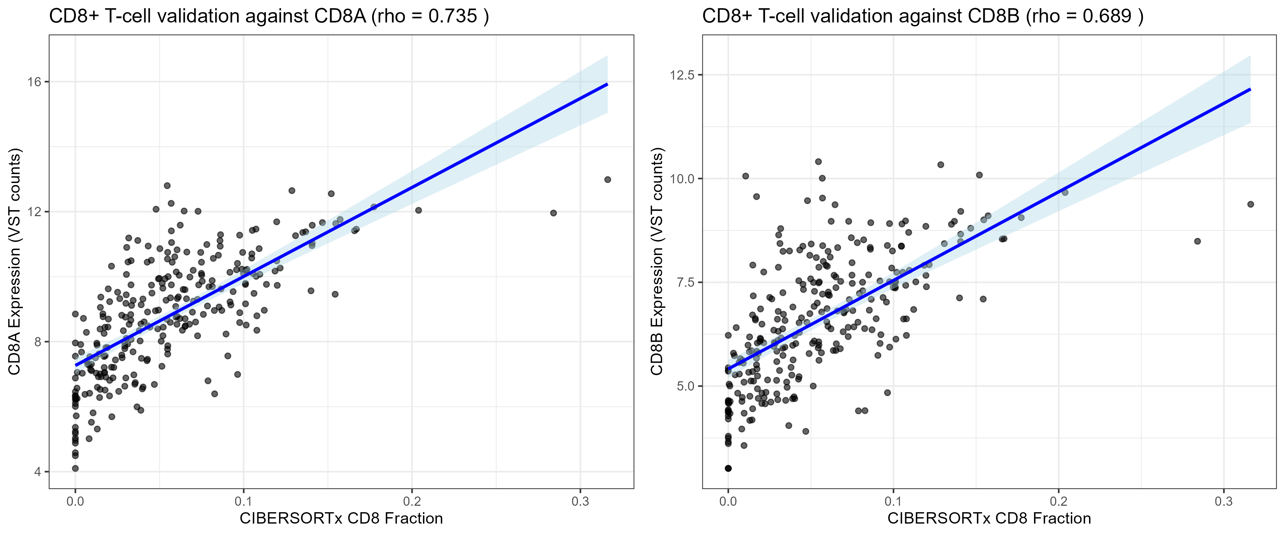
Supplementary Fig. S5. Validation of CIBERSORTx CD8+ T-cell estimates. CD8+ T-cell fraction versus variance-stabilised CD8A (left; Spearman ρ = 0.735) and CD8B (right; ρ = 0.689) expression in 279 tumours.
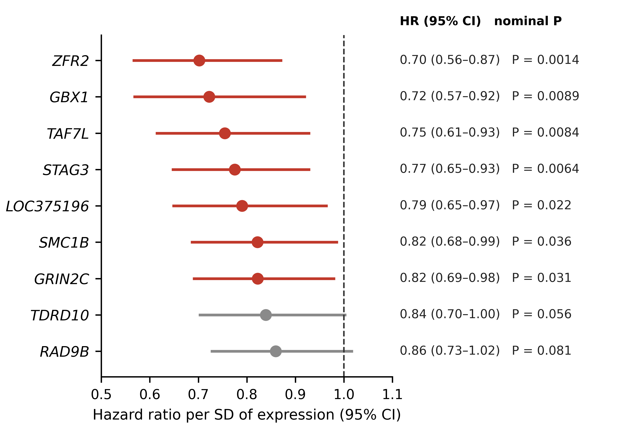
Supplementary Fig. S6. Exploratory univariable Cox models of overall survival for the nine leading HPV-upregulated genes (n = 279). HRs per standard deviation of variance-stabilised expression with 95% confidence intervals; red marks nominal P < 0.05; estimates are listed at right. Models are not adjusted for HPV status or other covariates.
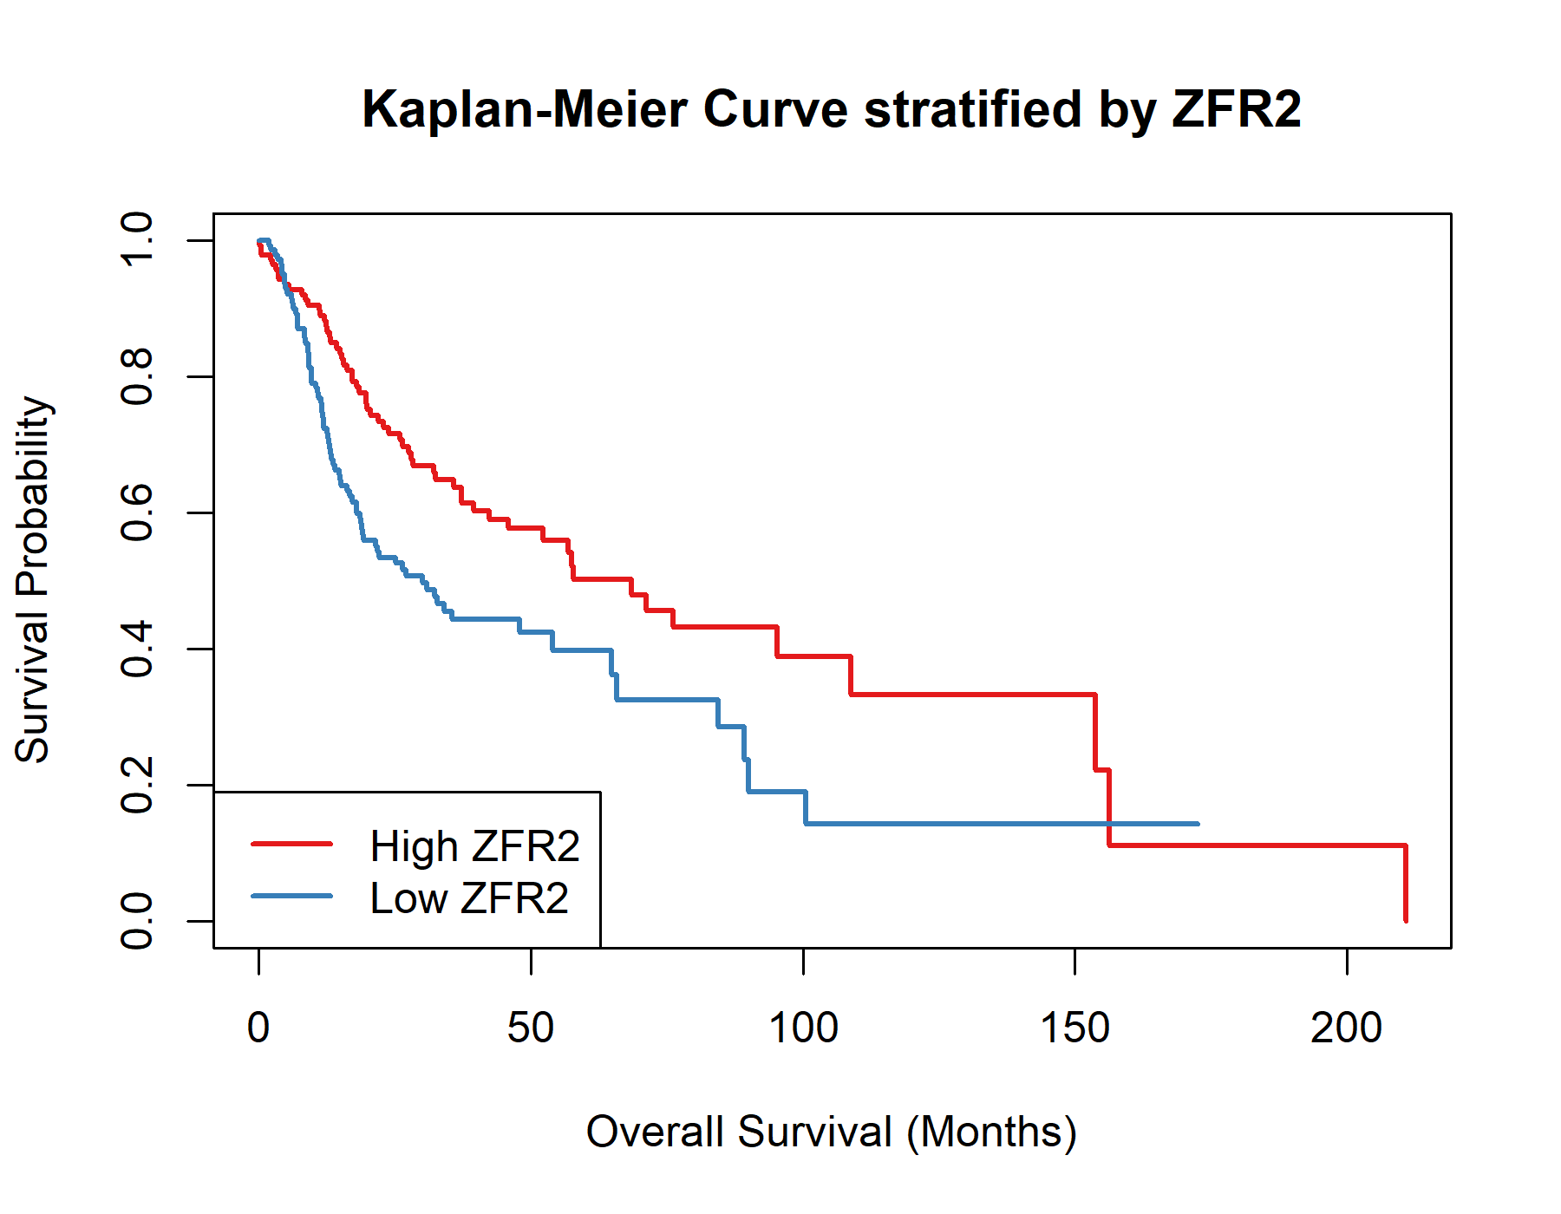
Supplementary Fig. S7. Kaplan–Meier overall survival of the 279 TCGA-HNSC tumours split at the median of ZFR2 expression (exploratory; unadjusted).

Supplementary tables
Supplementary Table S1. The six-gene core meiotic module, its functional components, gene symbols in the single-cell matrices and membership of the four-gene meiosis-specific score.
Gene | Functional component | Symbol in GSE181919 / GSE182227 | Four-gene score
SYCP2 | Synaptonemal complex | SYCP2 | Yes
SYCE2 | Synaptonemal complex | SYCE2 | Yes
MAJIN | Synaptonemal-complex attachment machinery | C11orf85 (previous symbol) | Yes
SMC1B | Meiosis-specific cohesin | SMC1B | Yes
STAG3 | Meiosis-specific cohesin | STAG3 | No (detected in B/plasma cells)
MEI1 | Recombination initiation | MEI1 | No (detected in B/plasma cells)

Supplementary Table S2. The twelve most significant up- and ten most significant downregulated genes in HPV+ versus HPV− TCGA-HNSC tumours (DESeq2; ranked by FDR). Panel, member of the meiotic gene panel.
Upregulated gene | log₂FC | FDR | Panel | Downregulated gene | log₂FC | FDR
LOC375196 | 5.48 | 5.1 × 10⁻¹⁰⁷ |  | LINC02700 | −5.78 | 7.4 × 10⁻³³
STAG3 | 4.63 | 1.0 × 10⁻¹⁰⁰ | Yes | DSC1 | −5.20 | 1.1 × 10⁻³²
TAF7L | 5.81 | 9.9 × 10⁻¹⁰⁰ |  | FOLR3 | −4.67 | 6.3 × 10⁻³²
SMC1B | 5.91 | 6.7 × 10⁻⁹¹ | Yes | AL033397.1 | −7.59 | 1.7 × 10⁻³¹
ZFR2 | 6.52 | 4.5 × 10⁻⁸⁶ | Yes | MUCL1 | −5.44 | 2.3 × 10⁻³¹
RAD9B | 2.79 | 1.2 × 10⁻⁸³ | Yes | RDH12 | −4.41 | 2.4 × 10⁻³¹
TDRD10 | 4.48 | 2.6 × 10⁻⁶⁹ | Yes | SLC3A2 | −1.46 | 8.2 × 10⁻³¹
GBX1 | 6.95 | 3.2 × 10⁻⁶⁸ |  | IGFL3 | −5.44 | 1.0 × 10⁻²⁹
GRIN2C | 3.04 | 2.3 × 10⁻⁶⁴ |  | SLC35F3 | −3.25 | 1.2 × 10⁻²⁸
ABCA17P | 4.98 | 1.2 × 10⁻⁶³ |  | SPRR4 | −4.49 | 4.0 × 10⁻²⁷
CNTD1 | 3.18 | 4.8 × 10⁻⁶³ | Yes
PRDM15 | 1.26 | 1.9 × 10⁻⁶²

Supplementary Table S3. Differential expression of immune and epithelial marker genes in the unadjusted and primary-site-adjusted DESeq2 models (TCGA-HNSC; 36 HPV+ vs 243 HPV−).
Gene | Role | log₂FC | FDR | log₂FC, site-adjusted | FDR, site-adjusted
IGHM | Immunoglobulin heavy chain | 2.44 | 2.0 × 10⁻⁸ | 2.63 | 1.8 × 10⁻⁸
MS4A1 | Mature B cell (CD20) | 2.07 | 1.8 × 10⁻⁵ | 2.03 | 4.2 × 10⁻⁵
IGHA1 | Immunoglobulin heavy chain | 1.51 | 6.4 × 10⁻⁴ | 1.57 | 8.6 × 10⁻⁴
CD79A | B-cell receptor | 1.36 | 6.7 × 10⁻⁴ | 1.40 | 8.3 × 10⁻⁴
CD79B | B-cell receptor | 1.16 | 7.6 × 10⁻⁵ | 1.10 | 3.1 × 10⁻⁴
IGKC | Immunoglobulin light chain | 1.14 | 8.3 × 10⁻³ | 1.22 | 7.5 × 10⁻³
IGHG1 | Immunoglobulin heavy chain | 0.93 | 0.035 | 0.99 | 0.038
IGHG3 | Immunoglobulin heavy chain | 0.98 | 0.022 | 1.29 | 3.6 × 10⁻³
CD8A | Cytotoxic T cell | 1.26 | 5.3 × 10⁻⁵ | 1.12 | 9.2 × 10⁻⁴
CD8B | Cytotoxic T cell | 1.18 | 2.5 × 10⁻⁴ | 1.07 | 2.2 × 10⁻³
KRT1 | Keratinisation | −4.90 | 4.8 × 10⁻²¹ | −4.09 | 1.1 × 10⁻¹³
KRTDAP | Keratinocyte differentiation | −4.25 | 1.6 × 10⁻²³ | −3.72 | 8.3 × 10⁻¹⁷
KRT14 | Basal keratin | −1.87 | 1.5 × 10⁻⁹ | −1.96 | 1.1 × 10⁻⁹
KRT16 | Keratinisation | −1.61 | 1.2 × 10⁻⁶ | −1.60 | 2.7 × 10⁻⁶
KRT6A | Keratinisation | −1.31 | 9.5 × 10⁻⁹ | −1.25 | 2.0 × 10⁻⁷
S100A7 | Keratinisation | −1.92 | 1.1 × 10⁻⁵ | −1.89 | 3.3 × 10⁻⁵

Supplementary Table S4. Panel-category enrichment among genes upregulated in HPV+ tumours. Counts are genes testable in the re-annotated table; P values are hypergeometric; P_{adj} is Bonferroni-corrected across the seven categories.
Category | Tested | Up | Expected | Fold | P | P_{adj}
Cell-cycle meiosis | 5 | 4 | 1.10 | 3.65 | 0.010 | 0.07
Meiotic cohesin | 4 | 3 | 0.88 | 3.42 | 0.04 | 0.25
Synaptonemal complex | 9 | 6 | 1.97 | 3.04 | 0.005 | 0.03
Other germ-cell | 8 | 5 | 1.75 | 2.85 | 0.02 | 0.11
Meiotic recombination/DSB | 21 | 11 | 4.60 | 2.39 | 0.002 | 0.01
piRNA/Tudor germline | 12 | 5 | 2.63 | 1.90 | 0.10 | 0.71
Cancer–testis antigen (MAGE/CTAG) | 27 | 3 | 5.92 | 0.51 | 0.95 | 1.00

Supplementary Table S5. Confounder and sensitivity analyses for the core meiotic signal. Site and proliferation analyses are in GSE65858 (virus-active HPV+ vs HPV−); logistic models predict HPV status from the core meiotic score with the stated covariates (β, meiotic-score coefficient). Purity analyses are in TCGA-HNSC with consensus purity estimates (CPE); linear models regress the core meiotic score on HPV status with the stated covariates (β, HPV coefficient). A p16-adjusted model is omitted because p16 contributes to the TCGA HPV-status definition; stricter HPV definitions are used instead. Promoter analyses use GDC-harmonised (TCGA) or deposited (GSE38266) β values and CpGs 1,500 bp upstream to 500 bp downstream of an annotated TSS; the B/plasma marker score is the mean Z-score of CD19, CD79A, JCHAIN, MS4A1 and MZB1. AUC 95% CIs by DeLong's method; Δβ, HPV+ minus HPV− mean β.
Analysis | Cohort (n) | Estimate | P
Within oropharynx only: core score AUC | GSE65858 (28 vs 47) | AUC = 0.960 (95% CI 0.90–1.00) | 3.3 × 10⁻¹¹
Logistic (outcome: HPV status): meiotic score alone | GSE65858 (231) | β = 4.45; model AUC = 0.959 | 7.6 × 10⁻⁹
Logistic (outcome: HPV status): meiotic score + proliferation | GSE65858 (231) | β = 4.52; model AUC = 0.961 | 9.1 × 10⁻⁹
Purity by HPV status (mean CPE) | TCGA-HNSC | 0.63 vs 0.48 | 8.0 × 10⁻⁶ (Mann–Whitney)
Purity vs core meiotic score | TCGA-HNSC | Spearman ρ = 0.027 | 0.66
Linear model (outcome: core meiotic score) + purity: HPV coefficient | TCGA-HNSC | β = 2.29 (unadjusted) vs 2.29 (adjusted); purity coefficient = −0.022 | 0.89 (purity)
Linear model (outcome: core meiotic score) + purity + proliferation: HPV coefficient | TCGA-HNSC | β = 2.25 | n/a
Four-gene score (excludes MEI1, STAG3): virus-active HPV+ vs HPV− AUC | GSE65858 (35 vs 196) | AUC = 0.957 (95% CI 0.90–1.00) | 8.1 × 10⁻¹⁸
Core-module coherence, transcriptionally silent HPV+ vs size-matched HPV− null | GSE65858 (25) | ρ = 0.541; null 95% interval −0.003 to 0.299 | 0.001 (permutation)
Four-gene coherence, virus-active / silent HPV+ vs size-matched nulls | GSE65858 (35; 25) | ρ = 0.546 / 0.521 (HPV−: 0.179) | 0.001 / 0.002 (permutation)
Core expression score AUC, HPV by p16 or ISH (main rule) | TCGA-HNSC (41 vs 80) | AUC = 0.933 (95% CI 0.87–1.00) | 8.0 × 10⁻¹⁵
Core expression score AUC, HPV by ISH only | TCGA-HNSC (21 vs 65) | AUC = 1.000 (complete separation) | 7.1 × 10⁻¹²
Core expression score AUC, p16 or ISH in oropharyngeal tumours only | TCGA-HNSC (34 vs 8) | AUC = 0.974 (95% CI 0.92–1.00) | 7.6 × 10⁻⁷
Core promoter composite, HPV by p16 or ISH (main rule) | TCGA-HNSC (44 vs 81) | Δβ = −0.092; AUC = 0.844 (95% CI 0.76–0.93) | 2.3 × 10⁻¹⁰
Core promoter composite, HPV by ISH only | TCGA-HNSC (22 vs 67) | Δβ = −0.116; AUC = 0.964 (95% CI 0.93–1.00) | 8.0 × 10⁻¹¹
Core promoter composite, p16 or ISH in oropharyngeal tumours only | TCGA-HNSC (35 vs 8) | Δβ = −0.084; AUC = 0.918 (95% CI 0.83–1.00) | 5.6 × 10⁻⁵
Promoter Δβ, MEI1 (TCGA; GSE38266) | 44 vs 81; 21 vs 21 | −0.126; −0.116 | 1.4 × 10⁻⁶; 2.9 × 10⁻⁴
Promoter Δβ, SMC1B (TCGA; GSE38266) | 44 vs 81; 21 vs 21 | −0.073; −0.048 | 8.7 × 10⁻⁸; 0.056
Promoter Δβ, STAG3 (TCGA; GSE38266) | 44 vs 81; 21 vs 21 | −0.049; −0.055 | 7.4 × 10⁻⁴; 0.006
Promoter Δβ, SYCP2 (TCGA; GSE38266) | 44 vs 81; 21 vs 21 | −0.207; −0.110 | 3.4 × 10⁻¹³; 0.001
Promoter Δβ, SYCE2 (TCGA; GSE38266) | 44 vs 81; 21 vs 21 | −0.007; 0.005 | 0.40; 0.34
Promoter Δβ, MAJIN (TCGA; GSE38266) | 44 vs 81; 21 vs 21 | −0.092; −0.135 | 9.1 × 10⁻⁶; 9.7 × 10⁻⁵
Set-level promoter β, 80 core-module probes (HPV+ vs HPV−) | GSE38266 (21 vs 21) | 0.257 vs 0.334 | 1.1 × 10⁻⁶
Promoter methylation vs expression, core-module composites (four-gene) | TCGA-HNSC (121) | Spearman ρ = −0.641 (−0.632) | 2.2 × 10⁻¹⁵ (8.1 × 10⁻¹⁵)
Core promoter composite: HPV Δβ unadjusted vs adjusted for B/plasma marker score | TCGA-HNSC (121) | −0.100 vs −0.098 | 9.4 × 10⁻¹⁵ vs 8.5 × 10⁻¹³
Core promoter composite: HPV Δβ unadjusted vs adjusted for CIBERSORTx B + plasma fraction | TCGA-HNSC (53) | −0.118 vs −0.129 | 1.5 × 10⁻⁷ vs 1.2 × 10⁻⁷
Four-gene promoter composite: HPV Δβ unadjusted vs adjusted for B/plasma marker score | TCGA-HNSC (121) | −0.102 vs −0.103 | 3.8 × 10⁻¹⁵ vs 1.2 × 10⁻¹³
MEI1 promoter: HPV Δβ unadjusted vs adjusted for B/plasma marker score | TCGA-HNSC (121) | −0.137 vs −0.115 | 4.1 × 10⁻¹⁰ vs 2.9 × 10⁻⁷

Supplementary Table S6. CIBERSORTx (LM22) estimated fractions of all 22 immune-cell populations in HPV+ (n = 36) and HPV− (n = 243) TCGA-HNSC tumours. Wilcoxon rank-sum test; Benjamini–Hochberg FDR across the 22 populations.
Population | Median HPV+ | Median HPV− | P | FDR
Macrophages M0 | 0.033 | 0.131 | 2.5 × 10⁻⁶ | 5.6 × 10⁻⁵
Plasma cells | 0.488 | 0.145 | 7.4 × 10⁻⁵ | 8.1 × 10⁻⁴
T cells CD8 | 0.071 | 0.043 | 2.8 × 10⁻⁴ | 0.0017
NK cells resting | 0.005 | 0.029 | 3.1 × 10⁻⁴ | 0.0017
T cells CD4 memory resting | 0.041 | 0.068 | 0.0094 | 0.042
Mast cells activated | 0.000 | 0.000 | 0.016 | 0.059
Macrophages M2 | 0.009 | 0.022 | 0.025 | 0.077
Monocytes | 0.000 | 0.009 | 0.036 | 0.100
NK cells activated | 0.002 | 0.000 | 0.105 | 0.256
T cells follicular helper | 0.057 | 0.050 | 0.118 | 0.260
T cells regulatory (Tregs) | 0.012 | 0.004 | 0.141 | 0.283
B cells naive | 0.000 | 0.000 | 0.179 | 0.322
B cells memory | 0.011 | 0.014 | 0.200 | 0.322
Dendritic cells resting | 0.022 | 0.026 | 0.205 | 0.322
Mast cells resting | 0.064 | 0.067 | 0.287 | 0.421
T cells CD4 naive | 0.000 | 0.000 | 0.374 | 0.514
Macrophages M1 | 0.041 | 0.049 | 0.585 | 0.756
T cells gamma delta | 0.000 | 0.000 | 0.678 | 0.820
Eosinophils | 0.000 | 0.000 | 0.708 | 0.820
Dendritic cells activated | 0.000 | 0.000 | 0.778 | 0.830
T cells CD4 memory activated | 0.002 | 0.003 | 0.792 | 0.830
Neutrophils | 0.009 | 0.009 | 0.898 | 0.898

Supplementary Table S7. Log₂ CD8/M2 macrophage ratio (exploratory) by HPV status; Wilcoxon rank-sum P = 1.0 × 10⁻⁴.
Group | n | Median | Q1 | Q3
HPV− | 243 | 0.78 | −0.63 | 3.16
HPV+ | 36 | 3.29 | 1.82 | 15.35

Supplementary Table S8. Spearman correlation between CIBERSORTx-estimated fractions and lineage marker-gene expression (n = 279). CD8A and CD8B, variance-stabilised expression; IGHM and MS4A1, TPM values supplied to CIBERSORTx.
Cell population | Marker | Expression | Spearman ρ | P
CD8+ T cells | CD8A | VST | 0.735 | 1.2 × 10⁻⁴⁸
CD8+ T cells | CD8B | VST | 0.689 | 1.3 × 10⁻⁴⁰
Plasma cells | IGHM | TPM | 0.913 | 6.5 × 10⁻¹¹⁰
Plasma cells | MS4A1 | TPM | 0.590 | 1.4 × 10⁻²⁷

Supplementary Table S9. Malignant-cell specificity of the six core genes in GSE181919. Detection rates are percentages of cells; the specificity ratio is detection in malignant cells divided by detection in the highest-detecting non-malignant cell type.
Gene | Malignant (%) | Highest other (%) | That cell type | Specificity ratio | Four-gene score
SMC1B | 15.3 | 1.4 | T | 10.96 | Yes
SYCP2 | 19.0 | 2.5 | T | 7.68 | Yes
MAJIN | 3.5 | 0.5 | Endothelial | 6.86 | Yes
SYCE2 | 5.1 | 2.0 | T | 2.51 | Yes
STAG3 | 15.4 | 13.1 | B/plasma | 1.18 | No
MEI1 | 8.2 | 37.4 | B/plasma | 0.22 | No

Supplementary Table S10. HPV effect on the per-tumour four-gene meiosis-specific score before and after adjustment for proliferation, by cohort and pooled (linear models on per-tumour means; n, tumours).
Cohort | n | Model | HPV β (SE) | P (HPV) | Proliferation β | P (proliferation)
GSE181919 | 19 | Unadjusted | 0.112 (0.025) | 2.9 × 10⁻⁴ | n/a | n/a
GSE181919 | 19 | + Proliferation | 0.105 (0.025) | 6.5 × 10⁻⁴ | 0.180 | 0.23
GSE182227 | 16 | Unadjusted | 0.176 (0.047) | 0.002 | n/a | n/a
GSE182227 | 16 | + Proliferation | 0.115 (0.040) | 0.01 | 0.414 | 0.005
Pooled | 35 | Unadjusted | 0.141 (0.026) | 4.5 × 10⁻⁶ | n/a | n/a
Pooled | 35 | + Proliferation | 0.109 (0.022) | 2.7 × 10⁻⁵ | 0.359 | 2.8 × 10⁻⁴

Supplementary Table S11. Exploratory univariable Cox proportional-hazards models of overall survival (TCGA-HNSC, n = 279; 140 deaths). HR per standard deviation of variance-stabilised expression. Models are not adjusted for HPV status, stage, smoking or treatment, and P values are not corrected for multiple testing.
Gene | HR | 95% CI | P (nominal)
ZFR2 | 0.70 | 0.56–0.87 | 0.0014
STAG3 | 0.77 | 0.65–0.93 | 0.0064
TAF7L | 0.75 | 0.61–0.93 | 0.0084
GBX1 | 0.72 | 0.57–0.92 | 0.0089
LOC375196 | 0.79 | 0.65–0.97 | 0.022
GRIN2C | 0.82 | 0.69–0.98 | 0.031
SMC1B | 0.82 | 0.68–0.99 | 0.036
TDRD10 | 0.84 | 0.70–1.00 | 0.056
RAD9B | 0.86 | 0.73–1.02 | 0.081

Supplementary data files
Complete DESeq2 results, unadjusted and site-adjusted (HNSC_DESeq2_All_Results.csv; HNSC_DESeq2_PrimarySite_Adjusted_All_Results.csv). GO, KEGG and GSEA results (HNSC_HPV_GO_Upregulated.csv; HNSC_HPV_GO_Downregulated.csv; HNSC_HPV_KEGG_Upregulated.csv; HNSC_HPV_KEGG_Downregulated.csv; HNSC_HPV_GSEA.csv). CIBERSORTx fractions for all samples (CIBERSORTx_Job14_Results.csv). Review sensitivity analyses (results/review_sensitivity/: GSE65858_core_module_CIs_and_nulls.json; TCGA_GSE38266_methylation_sensitivity.json; GSE182227_AUC_CI.json).

