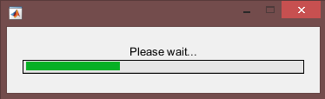



 Anfis KNN RVM

==============================

97.1429 94.2857 88.5714

TP TN

==============

100 90

proposed MSC NSAM DAL

=====================================

97.1429 96.1200 91.3200 93.0000

MSC - > Unsupervised Leukemia Cells Segmentation Based on Multi-space Color Channels 2016

SAM -> An Improved SAM Algorithm For Red Blood Cells and White Blood Cells Segmentation 2016

DAL -> White Blood Cells Segmentation and Classification to Detect Acute Leukemia 2013

















