***Assignment***

Find the same employee name from your table.

Spl> SELECT ename,COUNT(ename)

FROM emp

GROUP BY ename

HAVING COUNT(ename)>1;

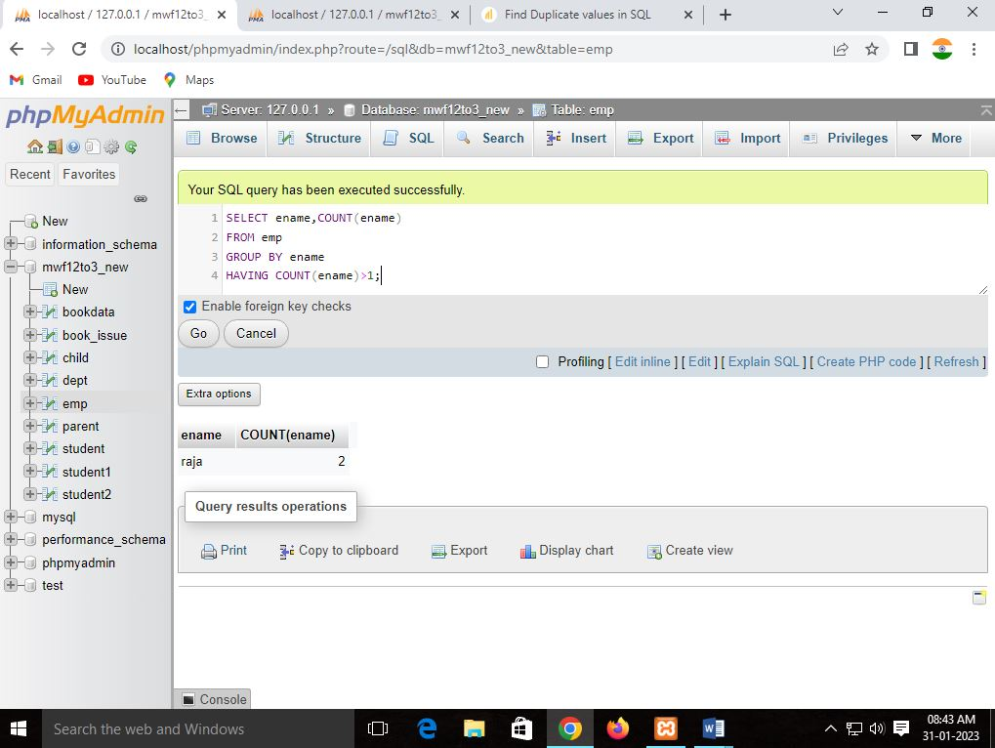

2.   Find the employee salary who is in “Mumbai” and Dept.name is  
“clerk” .

Ans: SELECT esal,eaddress,edesg

FROM `emp`

WHERE edesg="developer" AND eaddress="mumbai";

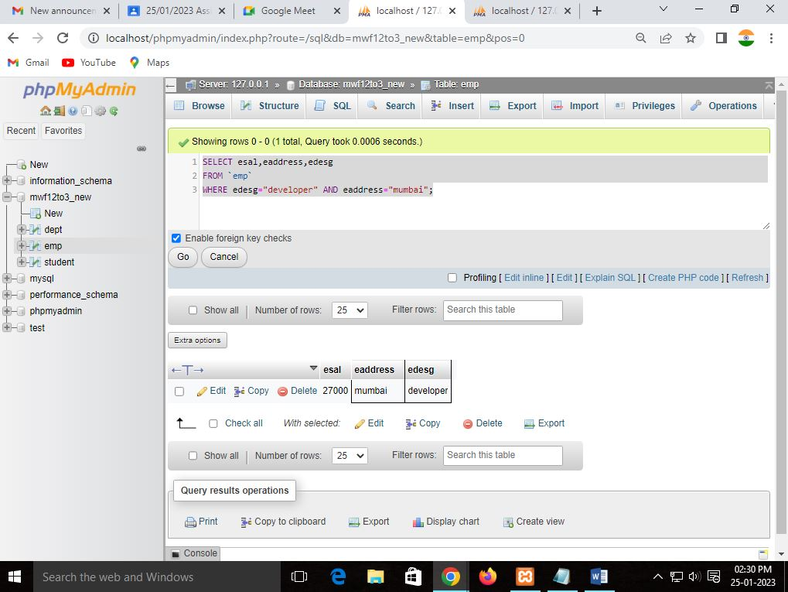

3. Find the dept.no from dept. Table who live in “Mumbai”.

Ans: SELECT dept_no,dept_address

FROM `dept`

WHERE dept_address="mumbai";

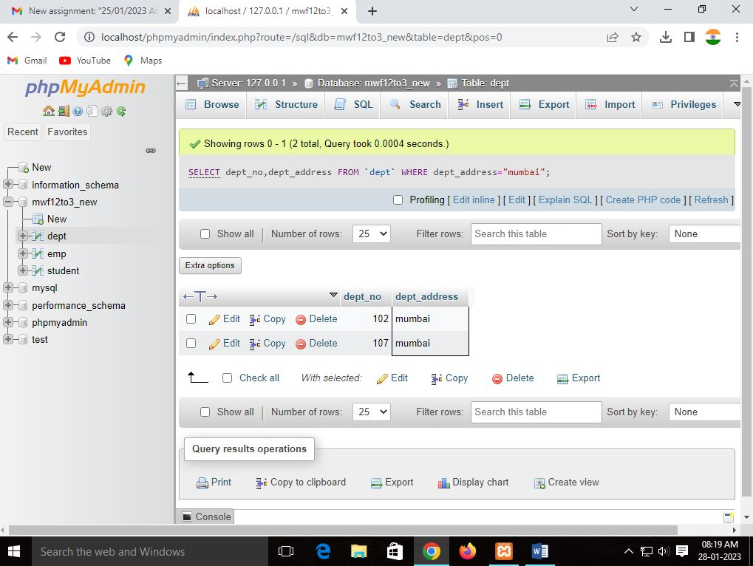

4. Find the employee whose middle name is “kumar”.

Ans: SELECT *

FROM `emp`

WHERE middlename LIKE '%kumar%';;

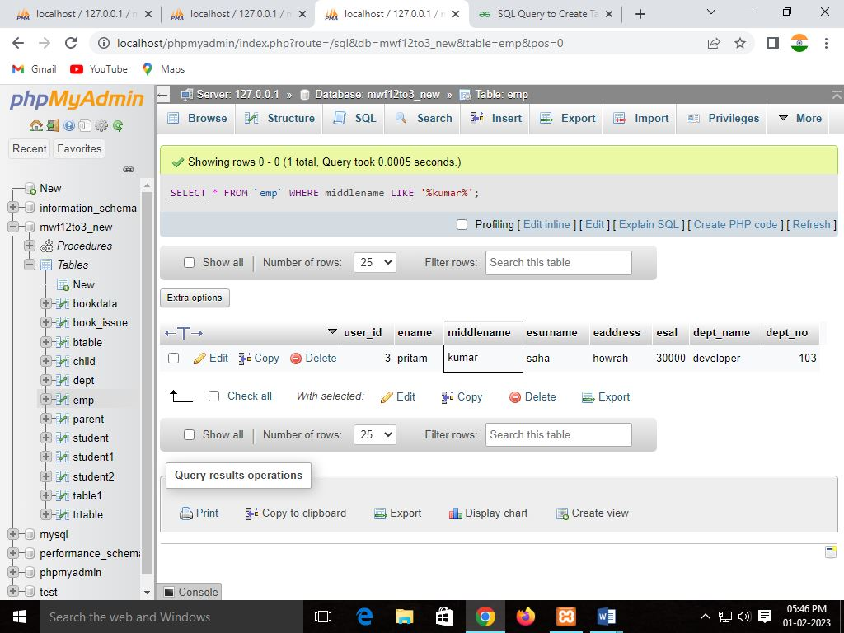

5. .   Find the second highest salary of the employee whose Dept.name is  
 “Clerk”.

Sql> SELECT ename,esal

FROM emp

WHERE dept_name="developer" AND esal=(

SELECT MAX(esal)

FROM emp

WHERE esal<(

SELECT MAX(esal)

FROM emp

WHERE dept_name="developer"

)

)

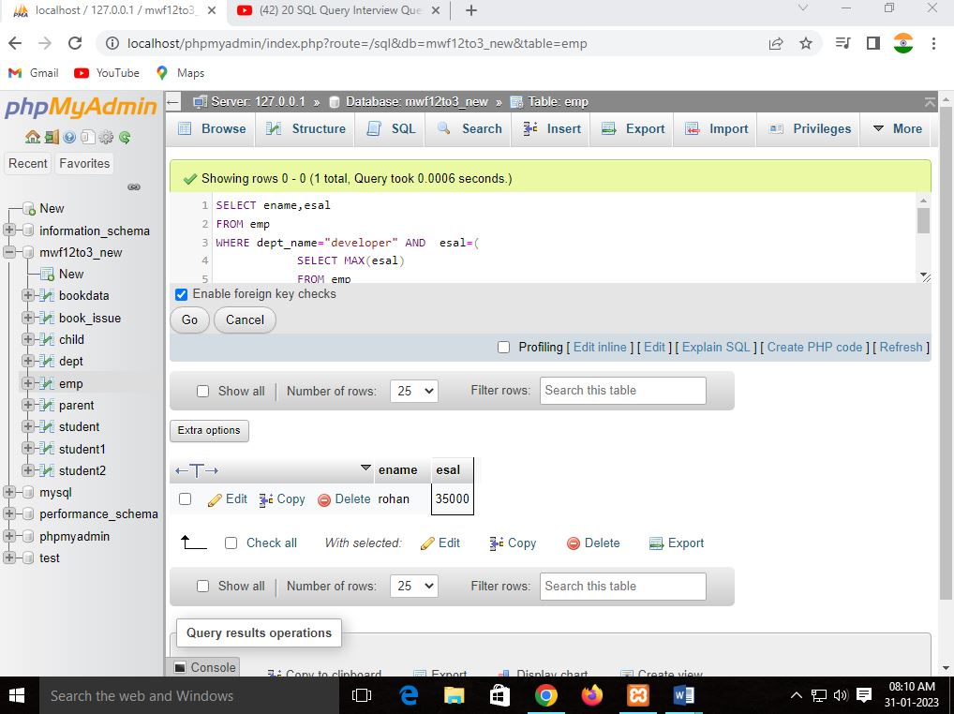;

6.   Find , how many employees work in “Mumbai”?

Sql> SELECT eaddress,COUNT(eaddress)

FROM `emp`

WHERE eaddress="mumbai";

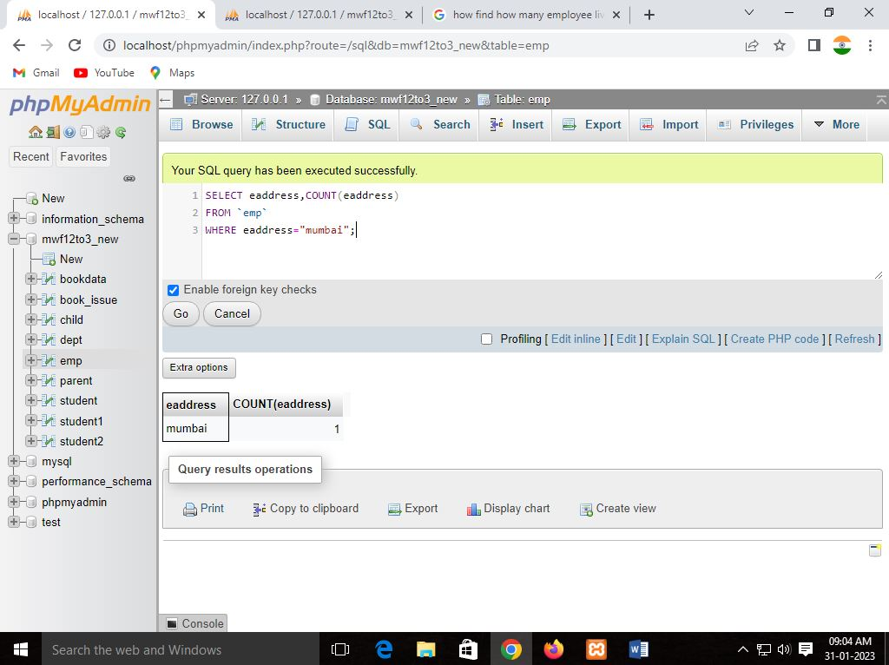

7.   Find all combinations of one employee who gets the  chances  
to match deptno from the dept table.  
  
sql> SELECT emp.ename,dept.dept_no

FROM emp LEFT JOIN dept

ON emp.dept_no=dept.dept_no;

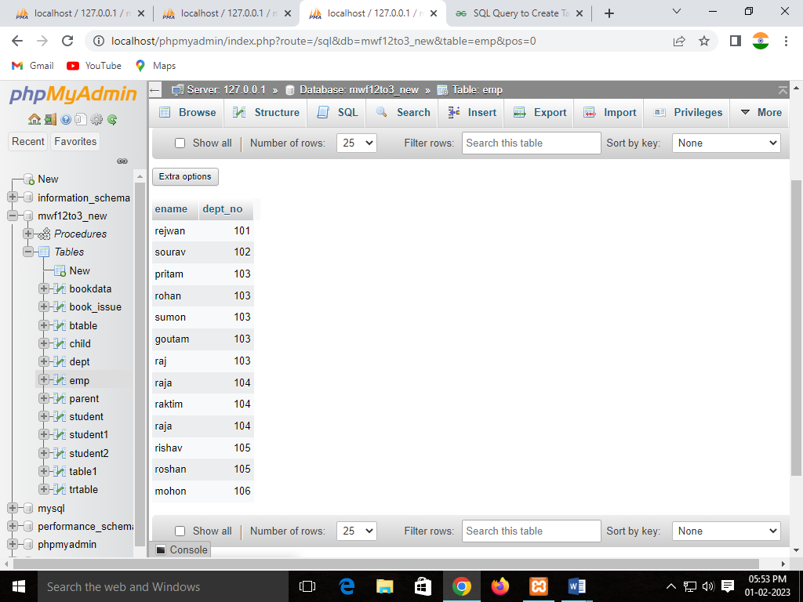

8.   Find the employee salary who earns the greater than the avg salary of a total salary.

Sql> SELECT *

FROM `emp`

WHERE esal>(

SELECT AVG(esal) AS avg_sal

FROM emp

);

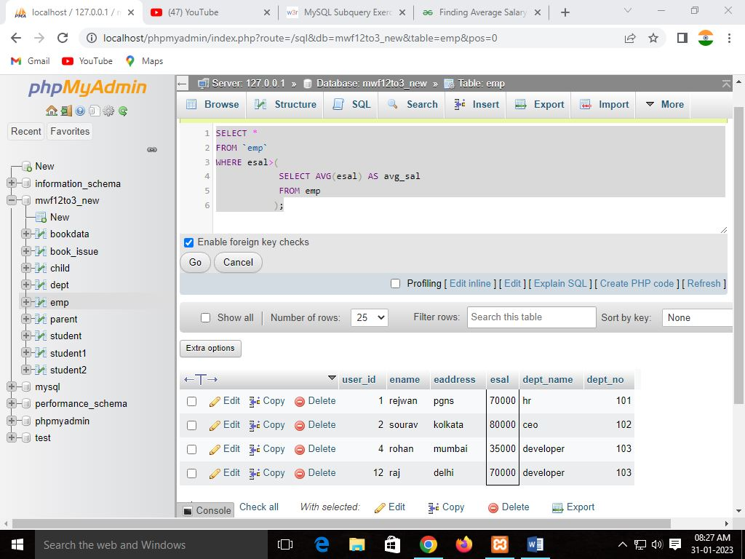

9. Create a primary key of a table, insert the data into this  
attribute. Find how to insert the data in another table from the first table?

10.  Find the employee name ,whose surnames are equal.

Sql> SELECT esurname,COUNT(esurname)

FROM `emp`

GROUP BY esurname

HAVING COUNT(esurname)=2;

