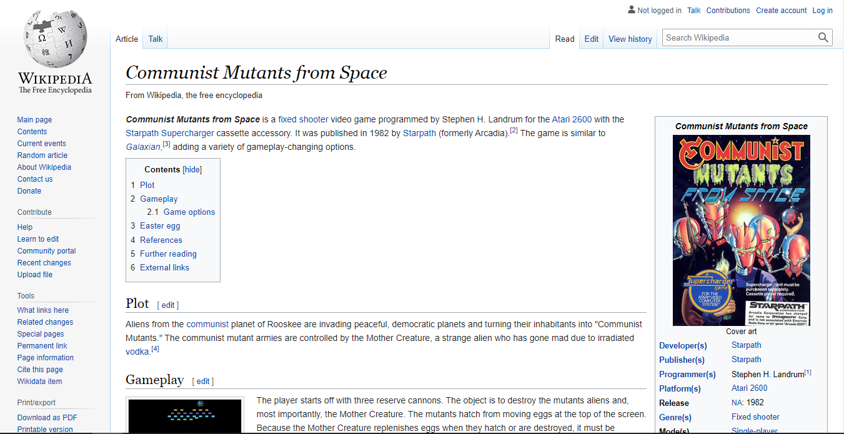

tagline

h1

p.sidebar-heading

sidebar-header width: 178px; height: 123px; bg-color: linear-gradient

header width: calc(100vw - 178px); height: 2.04cm (123px) bg-color: linear-gradient

.account-line a float: right

.edit-line .edit-tab .active-edit-tab .searchbar float: right

p.infobox-heading

width: 7.3cm (277px)

figure

table

h2, a.brackets

.box #contents ol p.contents-heading

.box #infobox float: right

p, strong, a, a.uppercase

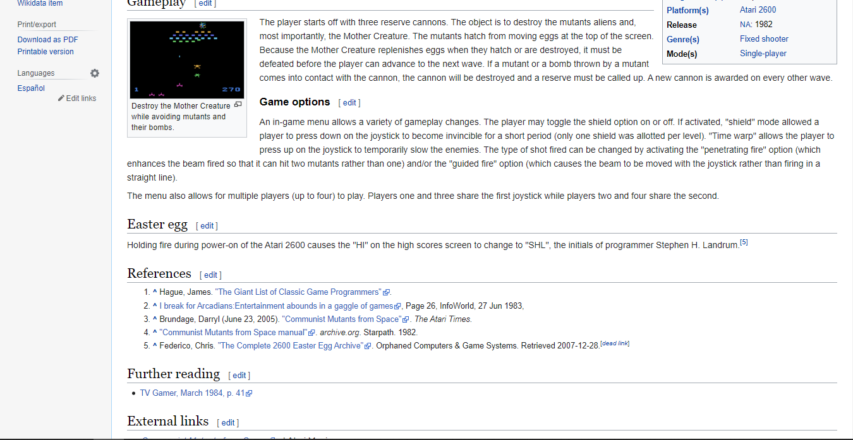

.box #mediabox

h3, a.brackets

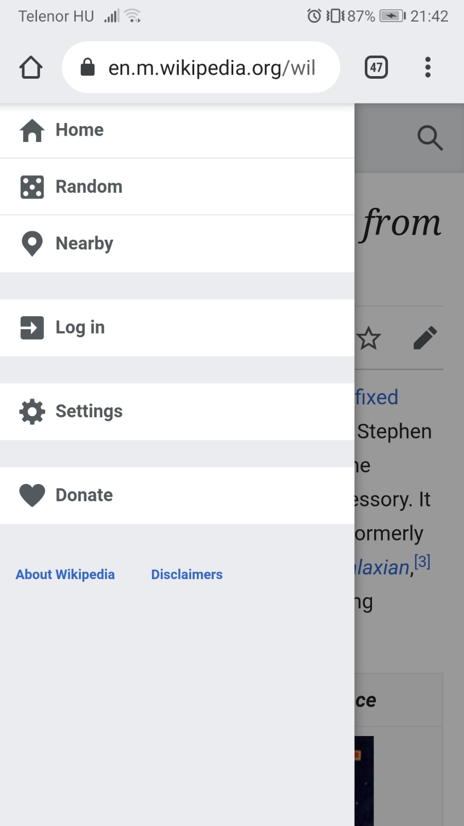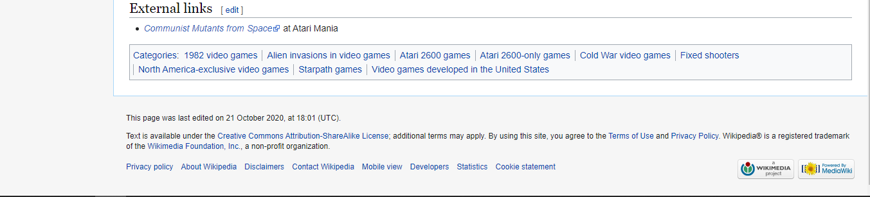

padding: 26px, 1.625rem

.box #categories-box

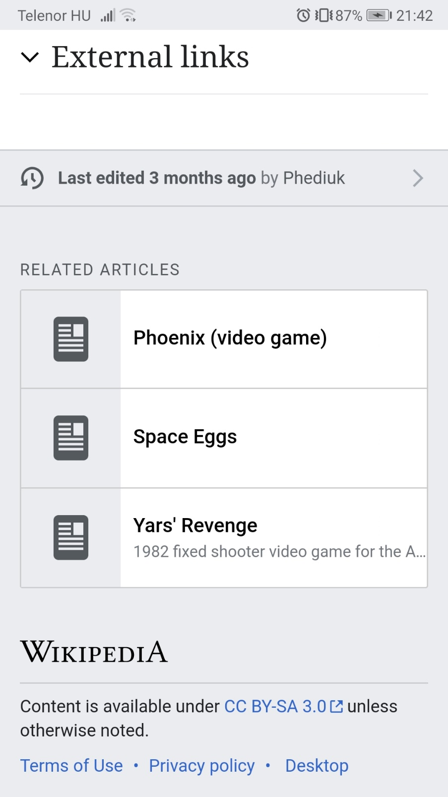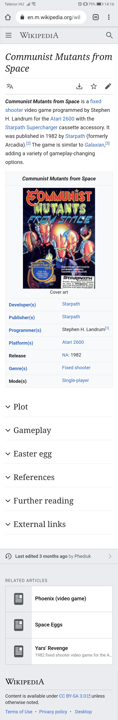

.mobile-sidebar

@768 display: hidden

@1025

header

# Colors

accent-background

#f6f6f6

default-background

#fff

border

#a2a9b1

main-content-border

#a7d7f9

links

#0645bf

h5, search, not logged in

#0645bf

# Fonts

'Linux Libertine','Georgia','Times',serif; h1, h2

sans-serif text

# Icons

        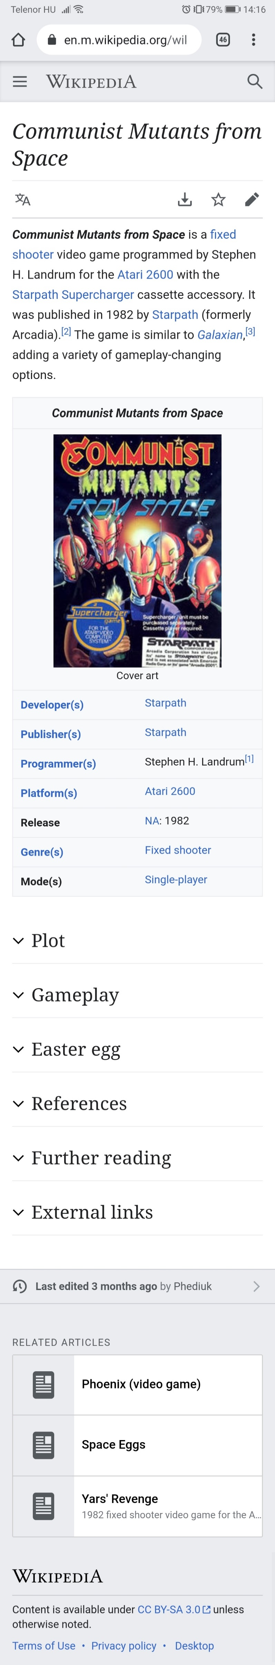 

|  |  |  |
| --- | --- | --- |
|  | Google Icons | Font Awesome |
|  | <link rel="stylesheet" href="https://fonts.googleapis.com/icon?family=Material+Icons"> | <link href="https://use.fontawesome.com/releases/v5.2.0/css/all.css" rel="stylesheet"> |
|  |  | <i class="fas fa-user"></i> |
|  |  | <i class="fas fa-search"></i> |
|  |  | <i class="fas fa-cog"></i> |
|  |  | <i class="fas fa-pen"></i> |
|  |  | <i class="fas fa-expand-alt"></i> |
|  |  | <i class='fas fa-external-link-alt></i> |
|  |  | <i class='fas fa-angle-down' style='font-size:24px'></i> |
|  | <i class="material-icons">history</i> | <i class='fas fa-history'></i> |
|  |  | <i class="fas fa-language"></i> |
|  |  | <i class='fas fa-download></i> |
|  |  | <i class="far fa-star"></i> |
|  |  | <i class="fas fa-file-alt"></i> |