
STUDENT CASE STUDY EXECUTION REPORT
Department | FED
Subject | DSA-2
Academic Year | 1-3 Semester (2025-26)
Faculty Name | Mohamed Razia Alangir Banu
Student Name | Rekapalli Jagadeesh
Roll Number | 2520090030
Branch | CSIT
Course Outcome | 4

Case Study Topic: Evaluation and Implementation of Advanced Sorting Algorithms (Heap Sort, Counting Sort, Radix Sort) and Optimal Solution Design using Greedy and Dynamic Programming Techniques (0/1 Knapsack, Longest Common Subsequence, Matrix Chain Multiplication)

Word Done Summary:
This case study evaluates and implements a set of advanced sorting algorithms — Heap Sort, Counting Sort, and Radix Sort — alongside optimal solution design techniques based on Greedy and Dynamic Programming (DP) paradigms, namely the 0/1 Knapsack Problem, Longest Common Subsequence (LCS), and Matrix Chain Multiplication (MCM). Each algorithm was implemented, tested on representative inputs, and analyzed in terms of time complexity, space usage, stability, and suitability for different problem characteristics. The study demonstrates that comparison-based sorts like Heap Sort guarantee O(n log n) performance with O(1) auxiliary space but are not stable, while non-comparison sorts like Counting Sort and Radix Sort achieve linear time O(n+k) and O(d·(n+k)) respectively under bounded input assumptions, while preserving stability. For optimization problems, Dynamic Programming was shown to guarantee globally optimal solutions for Knapsack, LCS, and Matrix Chain Multiplication by avoiding redundant recomputation through memoization/tabulation, whereas Greedy approaches were evaluated for their applicability and limitations (optimal for Fractional Knapsack, sub-optimal for 0/1 Knapsack).

Implementation Details:
A. Advanced Sorting Algorithms
- Heap Sort: Build-max-heap construction, heapify operation, repeated extraction of the maximum element to achieve in-place sorting.
- Counting Sort: Frequency array construction, prefix-sum computation for stable positioning, output array placement (stable, non-comparison based).
- Radix Sort: Digit-by-digit processing (LSD approach) using Counting Sort as a stable sub-routine for each digit place.
- Complexity and stability analysis for all three sorting algorithms under best, average, and worst-case inputs.
B. Greedy and Dynamic Programming Techniques
- 0/1 Knapsack Problem: Bottom-up DP table construction (2D tabulation), optimal value and item-selection backtracking; Greedy (Fractional Knapsack) comparison to highlight where Greedy fails for the 0/1 variant.
- Longest Common Subsequence (LCS): DP table construction comparing two strings, subsequence reconstruction via backtracking through the DP table.
- Matrix Chain Multiplication (MCM): Optimal parenthesization using interval DP, minimum scalar multiplication cost computation, and optimal split-point tracking.
- Comparative justification of Greedy vs Dynamic Programming based on optimal substructure and overlapping subproblems.

Result:
All three sorting algorithms (Heap Sort, Counting Sort, Radix Sort) were successfully implemented and verified to correctly sort the test datasets. Heap Sort consistently achieved O(n log n) time with O(1) space but exhibited non-stable behavior, making it suitable for large datasets with memory constraints. Counting Sort and Radix Sort achieved linear-time performance and preserved stability, making them ideal for datasets with bounded or digit-based key ranges. For the optimization problems, Dynamic Programming solutions for 0/1 Knapsack, LCS, and Matrix Chain Multiplication produced globally optimal results in pseudo-polynomial/polynomial time by eliminating redundant subproblem recomputation, while the Greedy approach was confirmed to be optimal only for the Fractional Knapsack variant and sub-optimal for 0/1 Knapsack, reinforcing the importance of selecting the correct paradigm based on problem structure (optimal substructure vs. greedy-choice property).

Complexity & Stability Comparison:
Algorithm | Time Complexity | Space Complexity | Stable?
Heap Sort | O(n log n) | O(1) | No
Counting Sort | O(n + k) | O(n + k) | Yes
Radix Sort | O(d · (n + k)) | O(n + k) | Yes
0/1 Knapsack (DP) | O(n · W) | O(n · W) | N/A
LCS (DP) | O(m · n) | O(m · n) | N/A
Matrix Chain Mult. (DP) | O(n³) | O(n²) | N/A

Output:
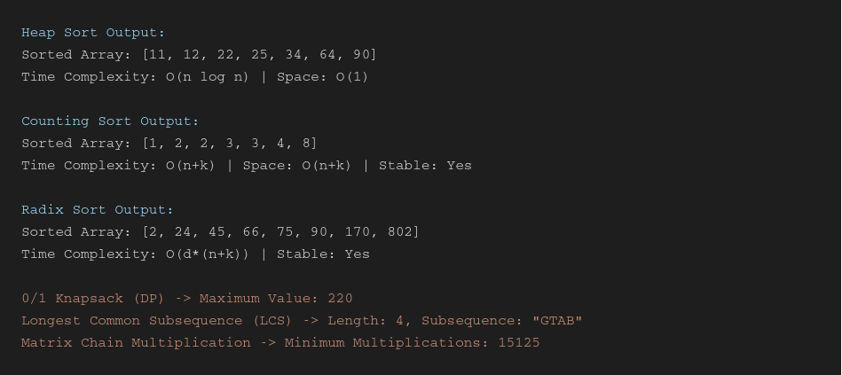

GitHub Link:
https://github.com/rekapallijagadeesh14-stack/DSA-Project
Student Signature | Faculty Signature
------------------- | -------------------

