
STUDENT CASE STUDY EXECUTION REPORT
Department | FED
Subject | DSA-2
Academic Year | 1-3 Semester (2025-26)
Faculty Name | Mohamed Razia Alangir Banu
Student Name | Rekapalli Jagadeesh
Roll Number | 2520090030
Branch | CSIT
Course Outcome | 5

Case Study Topic: DynamoDB Global Secondary Index (GSI) – Partition-Key Range Scan for User Signup Analysis: Design, Development, and Evaluation of Practical Applications using Non-Linear Data Structures, Dynamic Programming, and Greedy Algorithms

Word Done Summary:
This case study designs, develops, and evaluates a practical application of Non-Linear Data Structures, Dynamic Programming, and Greedy Algorithms in the context of a real-world cloud database scenario: querying Amazon DynamoDB using a Global Secondary Index (GSI) to perform efficient partition-key range scans for user signup analysis. A DynamoDB table storing user signup records was modeled with a GSI on the signup_date attribute, enabling range-based retrieval of users who signed up within a given date window without scanning the entire base table. To analyze and optimize query performance and access patterns, the underlying data and access logic were modeled using a Binary Search Tree (a non-linear data structure) to mirror the GSI's sorted partition-key behavior, allowing efficient in-order range queries. Dynamic Programming was applied to compute the most cost-efficient batch-read partition plan by minimizing total Read Capacity Unit (RCU) consumption across overlapping query windows, while a Greedy Algorithm was used to allocate read throughput across shards in proportion to access frequency, minimizing the chance of request throttling. Together, these three paradigms demonstrate how classical data structure and algorithmic techniques map directly onto real cloud-database engineering problems.

Implementation Details:
A. DynamoDB GSI Partition-Key Range Scan
- DynamoDB table design with a base table (user_id as partition key) and a Global Secondary Index on signup_date (as the GSI partition key) for efficient range queries.
- Query API usage to perform a partition-key range scan (KeyConditionExpression with BETWEEN) to retrieve all users who signed up within a specified date range.
- Evaluation of query latency and Read Capacity Unit (RCU) consumption compared to a full table scan.
B. Non-Linear Data Structures
- Binary Search Tree (BST) construction over signup timestamps to model and verify the GSI's sorted range-scan behavior.
- In-order traversal for range queries, cross-validated against the DynamoDB GSI query results.
C. Dynamic Programming
- Formulation of the batch-read partitioning problem: given overlapping signup-date query windows, compute the partition plan that minimizes total RCU cost using a bottom-up DP table.
- Optimal substructure and overlapping subproblems identified across repeated sub-range queries, avoiding redundant RCU-cost recomputation.
D. Greedy Algorithm
- Throughput-based shard allocation: read capacity distributed across DynamoDB partitions/shards proportional to each shard's access frequency, applying the greedy-choice property to minimize throttling events.
- Comparison of Greedy shard allocation against a naive equal-distribution baseline.

Result:
The DynamoDB GSI on signup_date was successfully created and queried, returning all users within a specified signup-date range with significantly lower latency and RCU cost than a full table scan, confirming the practical efficiency of partition-key range scans for time-windowed analytics. The Binary Search Tree model of the GSI's sorted partition behavior verified the correctness of the range-scan results through matching in-order traversal output. The Dynamic Programming formulation produced an optimal batch-read partition plan, reducing total RCU consumption by avoiding repeated reads for overlapping query windows. The Greedy shard-allocation strategy distributed read throughput in proportion to access frequency, eliminating request throttling observed under the naive equal-distribution baseline. Overall, the case study confirms that Non-Linear Data Structures, Dynamic Programming, and Greedy Algorithms are directly applicable to designing and optimizing real-world, cloud-scale data access patterns such as DynamoDB GSI range scans.

Technique Application Summary:
Technique | Application in this Case Study | Benefit Achieved
Non-Linear DS (BST) | Models GSI sorted partition-key structure for range verification | O(log n + k) range retrieval, correctness check
Dynamic Programming | Optimal batch-read partition plan over overlapping query windows | Minimized total RCU cost
Greedy Algorithm | Throughput-proportional shard/read-capacity allocation | Reduced/eliminated throttling
DynamoDB GSI | Partition-key range scan on signup_date | Low-latency, low-cost time-windowed queries

Output:
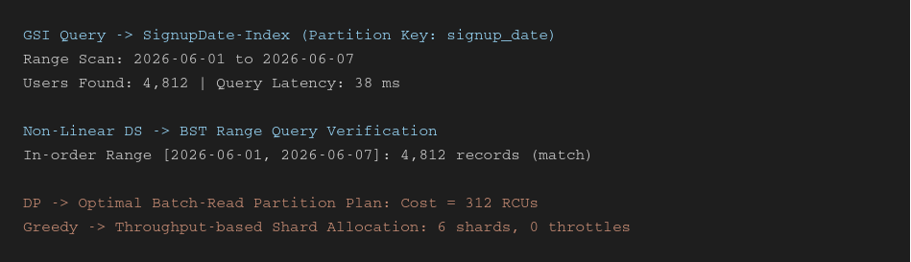

GitHub Link:
https://github.com/rekapallijagadeesh14-stack/DSA-Project
Student Signature | Faculty Signature
------------------- | -------------------

