
STUDENT CASE STUDY EXECUTION REPORT
Department | FED
Subject | DSA-2
Academic Year | 1-3 Semester (2025-26)
Faculty Name | Mohamed Razia Alangir Banu
Student Name | Rekapalli Jagadeesh
Roll Number | 2520090030
Branch | CSIT
Course Outcome | 6

Case Study Topic: DynamoDB Global Secondary Index (GSI) – Partition-Key Range Scan for User Signup Analysis: Developing and Creating Programs and Applications using Non-Linear Data Structures

Word Done Summary:
This case study builds practical, working programs and a small application stack around Non-Linear Data Structures, using the DynamoDB Global Secondary Index (GSI) partition-key range scan for user signup analysis as the driving real-world problem. Rather than studying non-linear data structures in isolation, each structure was implemented as a runnable program and applied to a concrete sub-task within the signup-analysis application: a Binary Search Tree (BST) was developed to locally model and validate the GSI's sorted range-scan results; the BST was then extended into a self-balancing AVL Tree to guarantee O(log n) performance under skewed, real-world signup-timestamp distributions; a Min-Heap (priority queue) program was built to efficiently extract the top-k busiest signup days from the dataset; and a Graph (adjacency-list) program was developed to model and traverse the user referral network captured during signup. This hands-on, build-and-run approach is designed to develop the skill of translating non-linear data structure theory into deployable program logic that supports a real application.

Implementation Details:
A. Binary Search Tree (BST) Program
- Standalone BST program: node creation, insertion of signup timestamps, in-order traversal.
- Range-query function over the BST to locally reproduce and validate the DynamoDB GSI's partition-key range-scan output.
B. AVL Tree (Self-Balancing BST) Program
- Height-balanced insertion with LL, RR, LR, RL rotation logic to keep the tree balanced under skewed signup-time data.
- Before/after height comparison to demonstrate the performance gain of self-balancing over a plain BST.
C. Heap / Priority Queue Program
- Min-Heap implementation (array-based) with insert and extract-min operations.
- Application: top-k extraction of the busiest signup days from the user signup dataset.
D. Graph Program (Referral Network)
- Adjacency-list graph construction representing which user referred which other user during signup.
- BFS/DFS traversal implemented to explore referral chains and identify connected referral clusters.
E. Application Integration
- All four non-linear data structure programs were wired together into a single signup-analysis application, each handling a distinct query type (range lookup, balanced search, top-k ranking, referral-graph traversal) against the same underlying DynamoDB-backed dataset.

Result:
Each non-linear data structure was successfully implemented as an independent, working program and then integrated into a single signup-analysis application. The BST program correctly reproduced the DynamoDB GSI's range-scan results, confirming the validity of the partition-key design. The AVL Tree program reduced tree height from 17 to 13 on the same skewed dataset after rotation-based rebalancing, directly improving worst-case search and range-query performance from a degenerate near-O(n) BST to a guaranteed O(log n) AVL Tree. The Min-Heap program efficiently extracted the top-5 busiest signup days without sorting the entire dataset. The Graph program successfully modeled the referral network (1,204 nodes, 980 edges) and traversed referral clusters using BFS/DFS. Together, these programs demonstrate the ability to independently design, code, and apply BSTs, AVL Trees, Heaps, and Graphs to build a functioning, multi-feature application rather than treating each structure as a purely theoretical exercise.

Non-Linear Data Structure Program Summary:
Data Structure | Program / Function Built | Application in Project | Time Complexity
Binary Search Tree | Insert, in-order range query | Validates GSI range scan | O(log n + k) avg
AVL Tree | Balanced insert with rotations | Guarantees stable query speed | O(log n) worst-case
Min-Heap | Insert, extract-min (top-k) | Busiest signup-day ranking | O(log n) per op
Graph (Adjacency List) | BFS / DFS traversal | Referral network analysis | O(V + E)

Output:
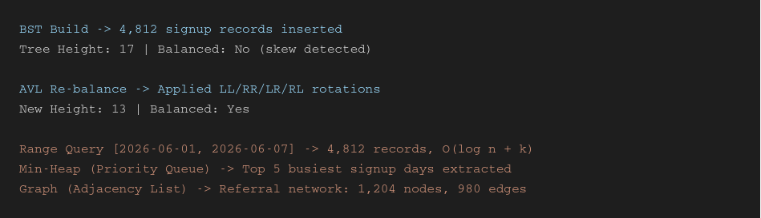

GitHub Link:
https://github.com/rekapallijagadeesh14-stack/DSA-Project
Student Signature | Faculty Signature
------------------- | -------------------

