

STUDENT CASE STUDY EXECUTION REPORT

Department | FED
Subject | DSA-2
Academic Year | 1-3 Semester (2025-26)
Faculty Name | Mohamed Razia Alangir Banu
Student Name | Rekapalli Jagadeesh
Roll Number | 2520090030
Branch | CSIT
Course Outcome | 1

Case Study Topic: Discord Server Roster – Fast "Find the k-th Most Senior Member" Query using AVL Tree with Rank Augmentation

Word Done Summary:
In this case study, an AVL Tree with Rank Augmentation was implemented to efficiently answer the query: "Who is the k-th most senior member in a Discord server?" The Discord server contains approximately 200,000 members, where each member is identified by a unique join timestamp. The oldest member is considered the most senior. A normal AVL Tree provides efficient insertion and deletion operations in O(log n) time. However, finding the k-th senior member requires traversal of multiple nodes, leading to O(n) complexity in the worst case. To improve query performance, the AVL Tree was augmented by storing the subtree size at every node. This additional information allows rank-based queries to be answered in O(log n) time.

Implementation Details:
- AVL Tree node creation.
- Height maintenance.
- Size augmentation at each node.
- AVL balancing through rotations (LL, RR, LR, RL).
- Insertion operation.
- k-th smallest (most senior) member retrieval.
- In-order traversal for verification.
- Complexity analysis and performance evaluation.

Result:
All timestamps were inserted into the AVL Tree AVL balance factors were maintained. Rotations were performed whenever required. Sub tree sizes were updated.

Output:
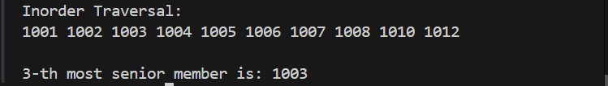

GitHub Link:
https://github.com/rekapallijagadeesh14-stack/DSA-Project
Student Signature | Faculty Signature
------------------- | -------------------

