

STUDENT CASE STUDY EXECUTION REPORT

Department | FED
Subject | DSA-2
Academic Year | 1-3 Semester (2025-26)
Faculty Name | Mahamed Razia Alangir Banu
Student Name | Rekapalli Jagadeesh
Roll Number | 2520090030
Branch | CSIT
Course Outcome | 2

Case Study Topic: DynamoDB Global Secondary Index (GSI) – Partition-Key Range Scan for User Signup Analysis

Word Done Summary:
In this case study, we analyzed how Amazon DynamoDB Global Secondary Indexes (GSIs) enable efficient querying of large-scale datasets.The objective is to efficiently retrieve:"All users in India (IN) who signed up during the last 30 days."The study explains why DynamoDB requires the partition key to be matched using equality conditions, how range queries are performed on sort keys, and how GSIs avoid expensive full table scans.The implementation simulates DynamoDB GSI behavior using Java collections and demonstrates efficient filtering based on country and signup date range.

Implementation Details:
- DynamoDB Table Structure
- Global Secondary Index (GSI)
- DynamoDB
- Range Query on Sort Key

Result:
| User ID | Country | Signup Date |
| | | |
| U101 | IN | 2026-05-01 |
| U102 | US | 2026-05-05 |
| U103 | IN | 2026-05-12 |
| U104 | IN | 2026-05-20 |

| U105 | UK | 2026-05-25 |
| U106 | IN | 2026-05-28 |

The Global Secondary Index efficiently supports alternate access patterns in DynamoDB. By using:
Partition Key = country_code Sort Key = signup_date
The database can quickly retrieve users from a specific country within a date range. Without the GSI, the query would require scanning the entire 100-million-user table. With the GSI, DynamoDB directly accesses the relevant partition and performs a range scan on sorted data, resulting in significantly better performance.

Output:
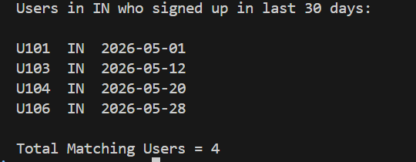

GitHub Link:
https://github.com/rekapallijagadeesh14-stack/DSA-Project

Student Signature | Faculty Signature
------------------- | -------------------

