

STUDENT CASE STUDY EXECUTION REPORT

Department | FED
Subject | DSA-2
Academic Year | 1-3 Semester (2025-26)
Faculty Name | Mohamed Razia Alangir banu
Student Name | Rekapalli Jagadeesh
Roll Number | 2520090030
Branch | CSIT
Course Outcome | 3

Case Study Topic: Wikipedia Hyperlink Graph – Six Degrees of Separation using Breadth First Search (BFS)

Word Done Summary:
In this case study, Breadth First Search (BFS) was used to analyze the concept of Six Degrees of Separation in a simplified Wikipedia hyperlink graph.
The graph consists of 8 Wikipedia articles:
Cricket India Mumbai Sachin Wankhede Tendulkar Bandra MumbaiCity

The hyperlinks between articles are treated as undirected edges. The objective is to determine the minimum hop-count (shortest path) from the article "Cricket" to every other article.BFS was selected because it explores the graph level-by-level, guaranteeing the shortest path in an unweighted graph.

Implementation Details:
- Graph creation using adjacency lists.
- BFS traversal from Cricket.
- Queue-based exploration.
- Distance (hop count) calculation.
- Display of shortest paths.
- Analysis of the Six Degrees of Separation concept.

Result:
BFS Traversal Output-Starting Article: Cricket
Cricket -> Distance 0 India -> Distance 1 Sachin -> Distance 1 Mumbai -> Distance 2 Tendulkar -> Distance 2 Wankhede -> Distance 2 Bandra -> Distance 3
MumbaiCity -> Distance 3
The BFS algorithm successfully determined the minimum hop-count from Cricket to all other Wikipedia articles. The level-by-level traversal ensured shortest path discovery and demonstrated the practical application of BFS in hyperlink networks. The case study also highlights the Six Degrees of Separation concept, showing how even large networks can maintain surprisingly short connection paths between nodes.

Output:
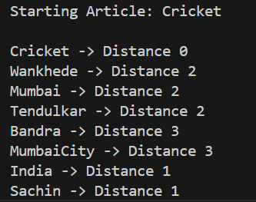

GitHub Link:
https://github.com/rekapallijagadeesh14-stack/DSA-Project

Student Signature | Faculty Signature
------------------- | -------------------

