PHP ERRORS

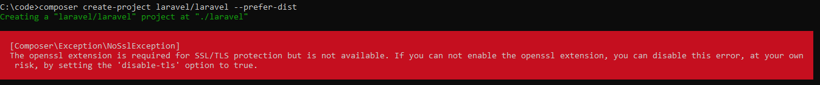

Solution : I rectified using the below link https://malfariza45.medium.com/resolved-error-unable-to-use-proxy-url-http-proxy-formatted-incorrectly-in-composer-231f43f060fd

Problem creating a new project with Laravel

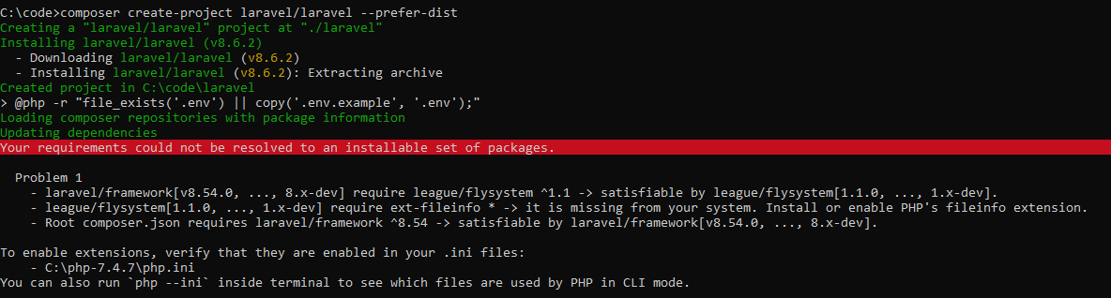

Solution : I rectified using the below link

https://stackoverflow.com/questions/65183425/problem-creating-a-new-project-with-laravel

