SESSION 11: SQOOP FLUME
Assignment 11.2

Problem Statement

Perform incremental load in Hive
Read from MySQL Table and load it in Hive table.
Create hive table if it does not exist.
If it exists, perform the incremental load.

Solution:-

Step 1 – Creating table company in MySQL

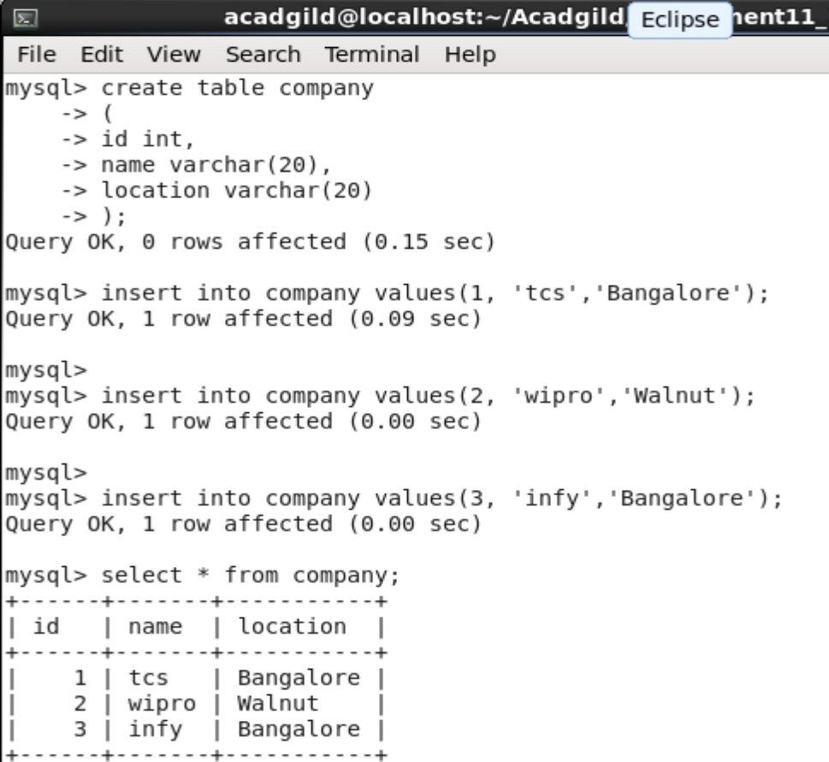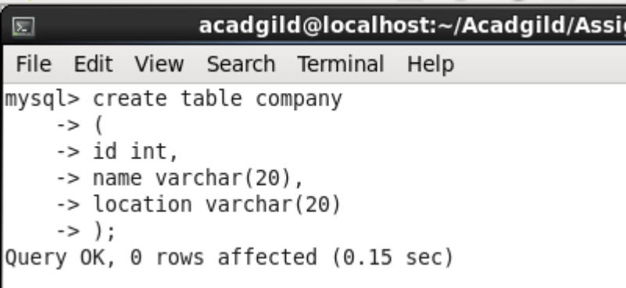

Step 2 – Importing the data from MySQL to HDFS

sqoop import --connect jdbc:mysql://localhost/testDb --username 'root' --table 'company' --target-dir '/sqoopout' -m 1;

Step 3 – Creating HIVE external table

CREATE EXTERNAL TABLE comp ( id int, name STRING,location STRING) ROW FORMAT DELIMITED FIELDS TERMINATED BY ‘,’ STORED AS TEXTFILE location ‘/sqoopout ‘;
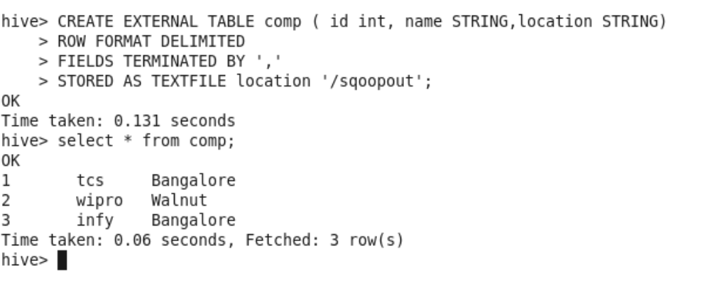
Step 4- Adding three new rows to emp table in MySQL

insert into company values(4, 'xyz','abc');
insert into company values(5, 'pqr','def');

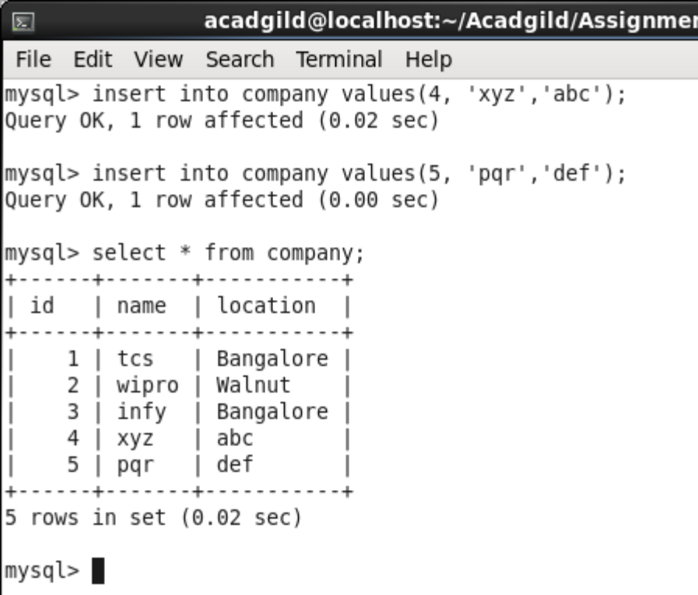

Step 5 – Performing incremental load via Sqoop

sqoop import --connect jdbc:mysql://localhost/testDb --username 'root' --table 'company' --target-dir '/sqoopout' --incremental append --check-column id --last-value 3 -m 1;

Checking external table in HIVE

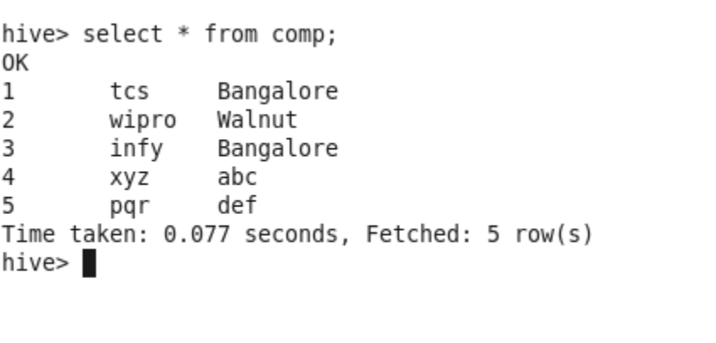
New records have been added to the table. Incremental load is successful.

