SESSION 11: SQOOP FLUME
Assignment 11.3

Problem Statement

Create a flume agent that streams data from Twitter and stores in the HDFS.

Solution:-

Step 1 – Creating an app in twitter

To create a Twitter application, click on the https://apps.twitter.com/. Sign in to your Twitter account.

Click on the Create New App button. You will be redirected to a window where you will get an application form in which you have to fill in your details in order to create the App. While filling the website address, give the complete URL pattern, for example, http://example.com

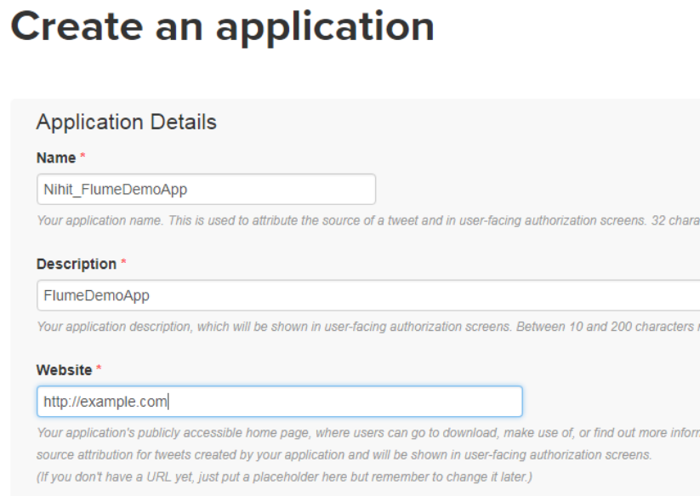
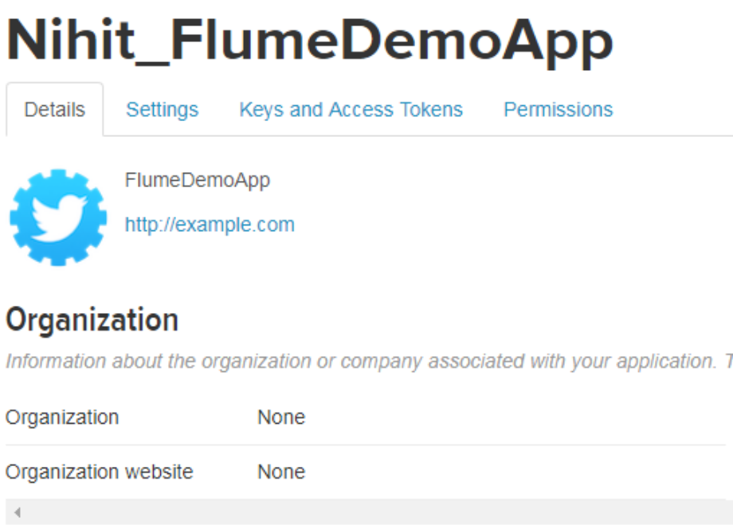

Under keys and Access Tokens tab at the bottom of the page, you can observe a button named Create my access token. Click on it to generate the access token.

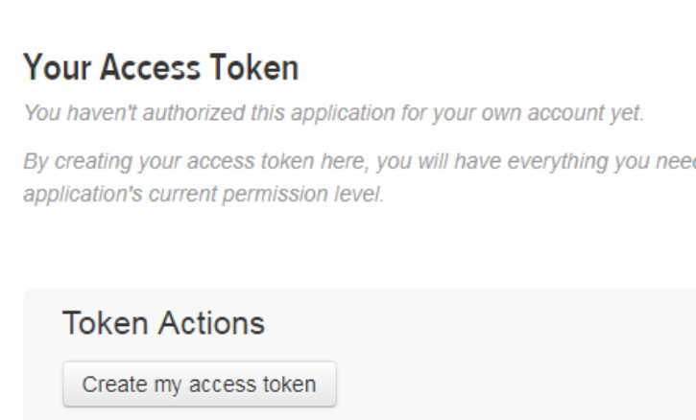

Finally, click on the Test OAuth button which is on the right side top of the page. This will lead to a page which displays your Consumer key, Consumer secret, Access token, and Access token secret. Copy these details. These are useful to configure the agent in Flume.

Step 2: Create a Directory in HDFS

In Hadoop DFS, you can create directories using the command mkdir. Browse through it and create a directory with the name twitter_data in the required path as shown below.
Hadoop fs –mkdir /twitter_data

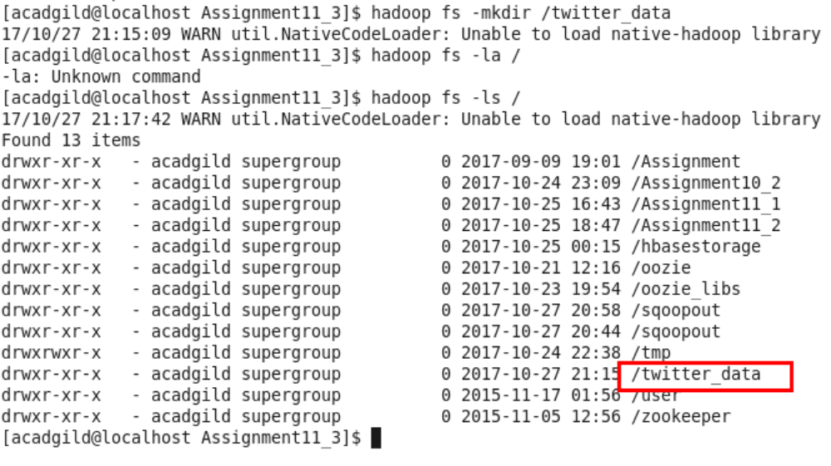

Step 3- Create configuration file

Create file twitter.conf and put in $FLUME_HOME/conf
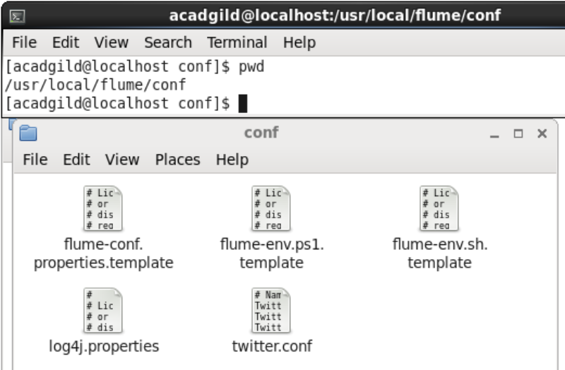

Contents of twitter.conf
# Naming the components on the current agent.
TwitterAgent.sources = Twitter
TwitterAgent.channels = MemChannel
TwitterAgent.sinks = HDFS

# Describing/Configuring the source
TwitterAgent.sources.Twitter.type = org.apache.flume.source.twitter.TwitterSource
TwitterAgent.sources.Twitter.consumerKey = -----------------------
TwitterAgent.sources.Twitter.consumerSecret = ------------------------
TwitterAgent.sources.Twitter.accessToken = --------------------------------------------------
TwitterAgent.sources.Twitter.accessTokenSecret = --------------------------------------------
TwitterAgent.sources.Twitter.keywords = tutorials point,java, bigdata, mapreduce, mahout, hbase, nosql, hi, hello, welcome, the, this
# Describing/Configuring the sink

TwitterAgent.sinks.HDFS.type = hdfs
TwitterAgent.sinks.HDFS.hdfs.path = hdfs://localhost:9000/twitter_data/
TwitterAgent.sinks.HDFS.hdfs.fileType = DataStream
TwitterAgent.sinks.HDFS.hdfs.writeFormat = Text
TwitterAgent.sinks.HDFS.hdfs.batchSize = 1000
TwitterAgent.sinks.HDFS.hdfs.rollSize = 0
TwitterAgent.sinks.HDFS.hdfs.rollCount = 10000

# Describing/Configuring the channel
TwitterAgent.channels.MemChannel.type = memory
TwitterAgent.channels.MemChannel.capacity = 10000
TwitterAgent.channels.MemChannel.transactionCapacity = 100

# Binding the source and sink to the channel
TwitterAgent.sources.Twitter.channels = MemChannel
TwitterAgent.sinks.HDFS.channel = MemChannel

Step 4 – Execution
Go to FLUME_HOME (/usr/local/flume in acadgild VM)
Run flume agent using command
flume-ng agent --conf ./conf/ -f conf/twitter.conf -Dflume.root.logger=DEBUG,console -n TwitterAgent

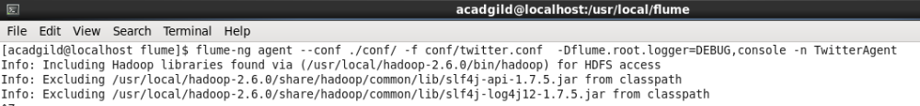

Checking output directory HDFS:/twitter_data
Command –
hadoop fs -ls /twitter_data
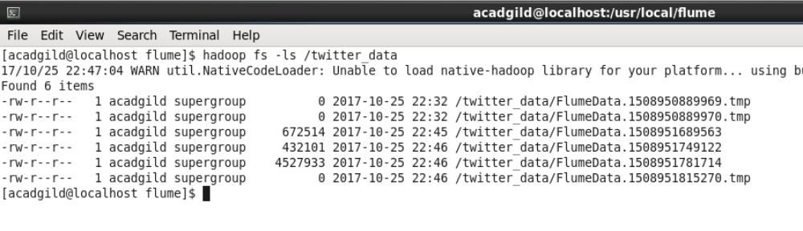
Upon examining the files we could see that Flume agent has dumped all twitter feed data in the files
Commands –
hadoop fs -tail -f /twitter_data/FlumeData.1508951689563
hadoop fs -tail -f /twitter_data/FlumeData.1508951749122
