PROJECT 1

INTRODUCTION TO SCALA

USA Crime Analysis
Introduction
This dataset contains attributes related to crimes taking place in various areas like type of crime, FBI code related to that criminal case, arrest frequency, location of crime etc.
Dataset Description
Columns
ID,Case Number,Date,Block,IUCR,Primary Type,Description,Location Description,Arrest,Domestic,Beat,District,Ward,Community Area,FBICode,X Coordinate,Y Coordinate,Year,Updated On,Latitude,Longitude,Location

Problem Statement
Write a mapreduce and pig program to calculate the number of cases investigated under each FBI code
Mapreduce
Driver Class
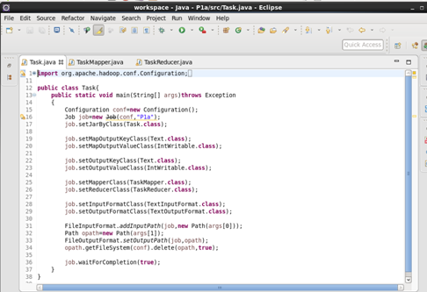

Mapper class
FBI code is given as key and count of 1 as value for each case.

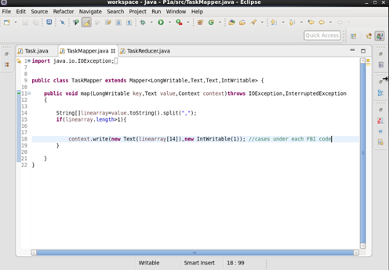
Reducer class
Counted the number of cases for each FBI code.
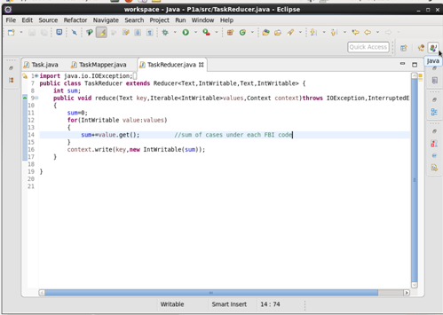

Running jar

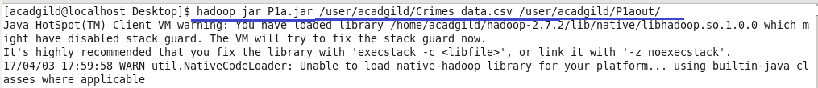

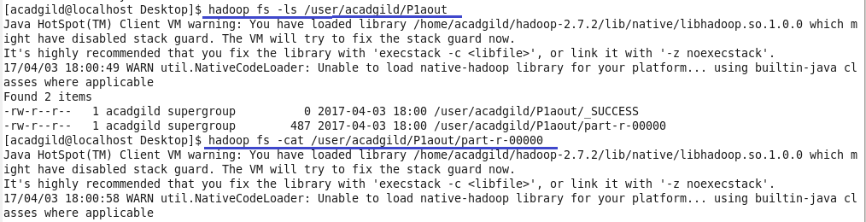

Output

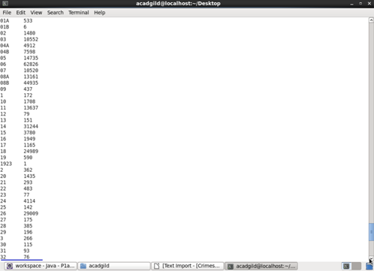

Output(contd.)

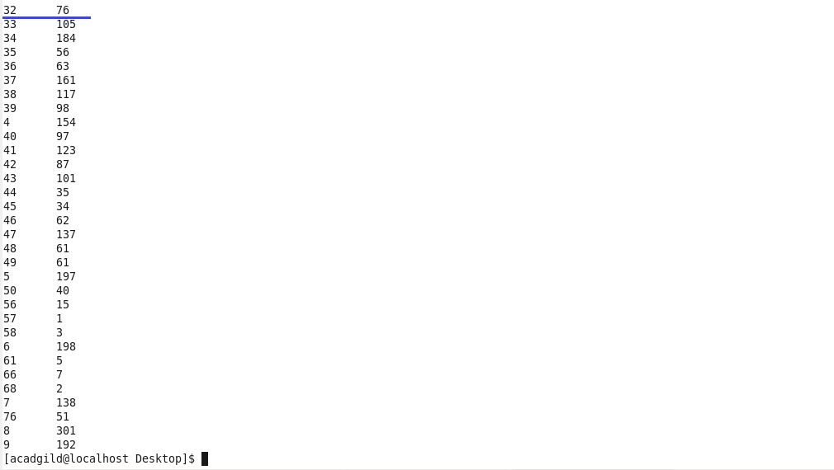
Pig Script
Logic: Loaded the dataset
grouped by fbi code and made a count of case id.

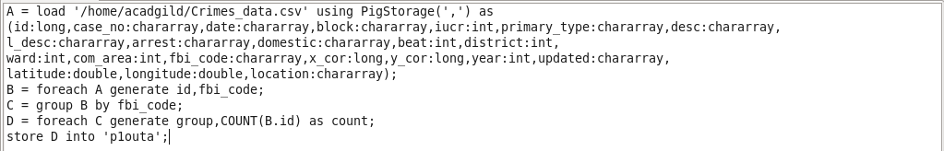
Running Pig Script
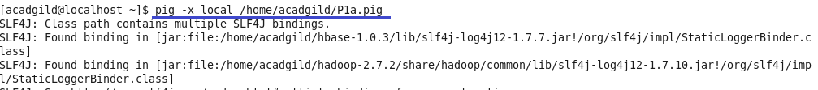

Output

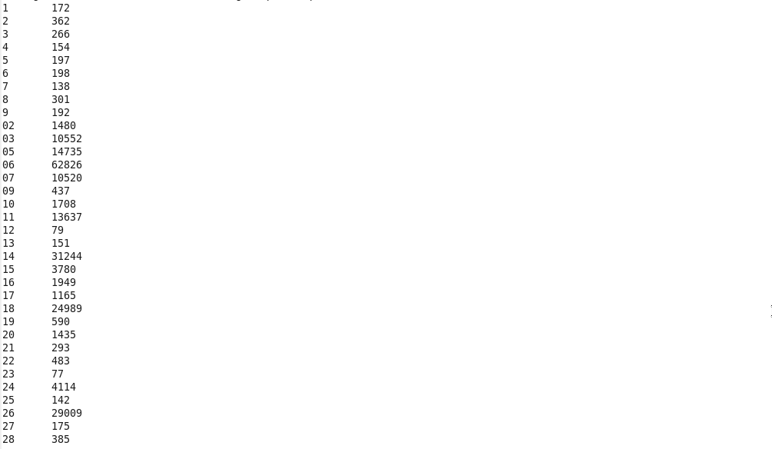
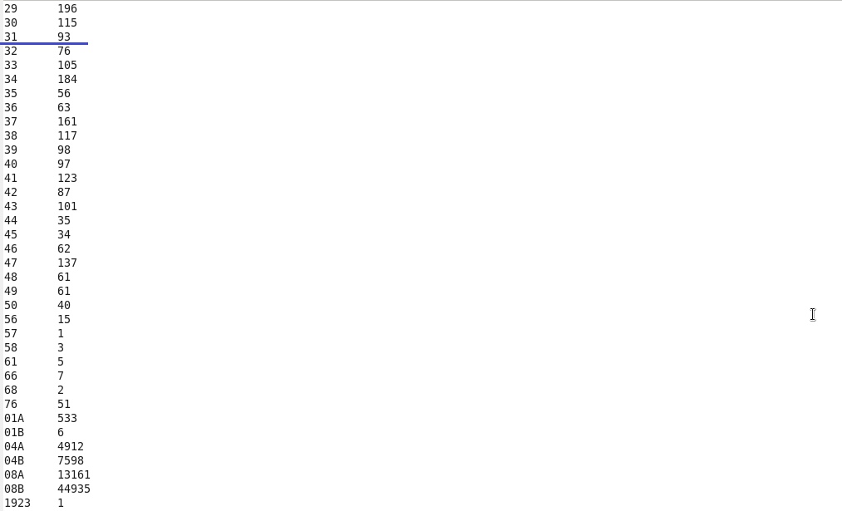
Write a mapreduce and pig program to calculate the number of cases investigated under FBI code 32.
Mapreduce
Driver class

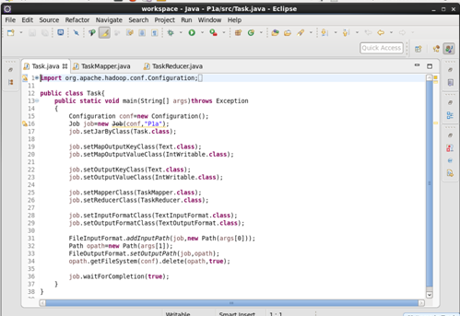

Mapper class
Filtered by FBI code=32 and given it as key and a count of 1 as value for each case

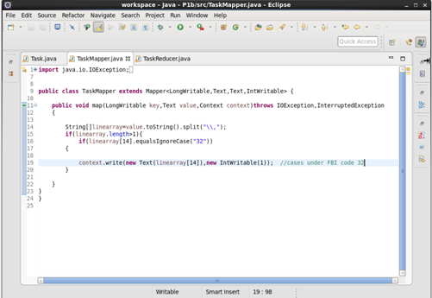
Reducer class
Counted the number of cases for fbi code 32.

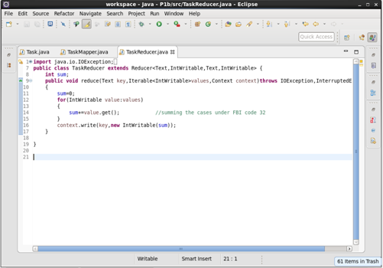
Running jar

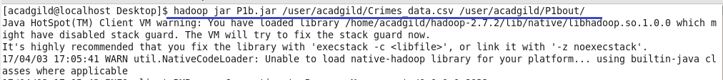

Output

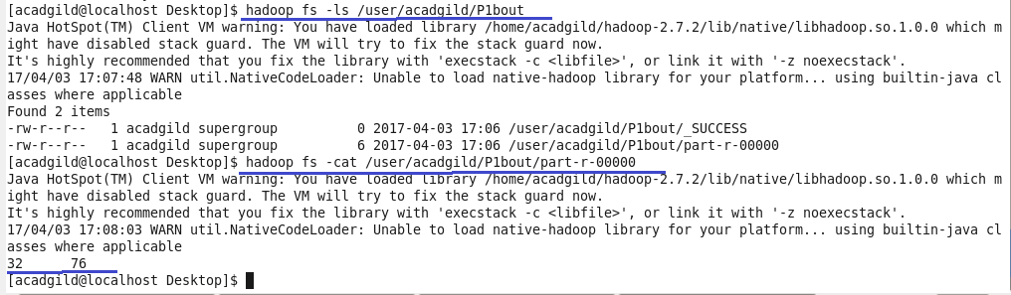

Pig Script
Logic
1.Loaded the dataset.
2.filtered by fbi code =32
3.grouped by fbi code and made a count of case id.

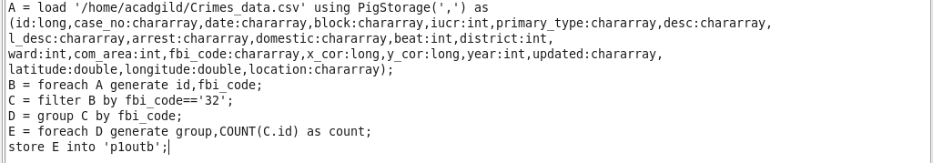

Running Pig Script

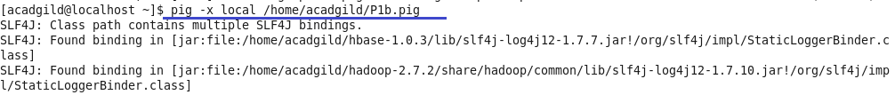

Output

Write a mapreduce and pig program to calculate the number of arrests in theft district wise.

Mapreduce
Driver class
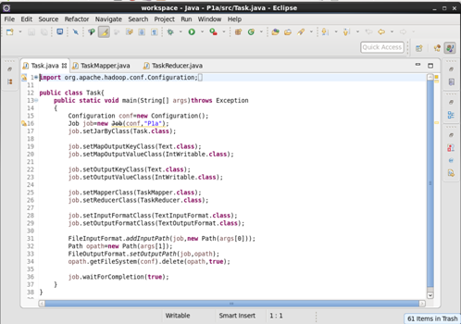

Mapper class
Logic:
Filtered by primary type theft and arrest = true.District is given as key and count of 1 as value for each arrest.

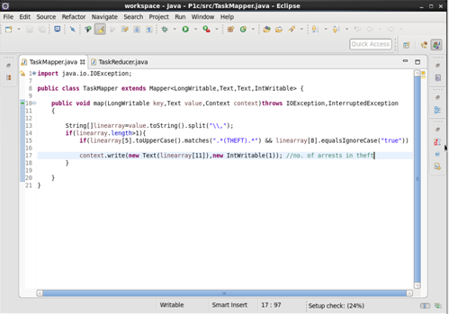

Reducer class
Counted the no. of arrests in theft for each district.
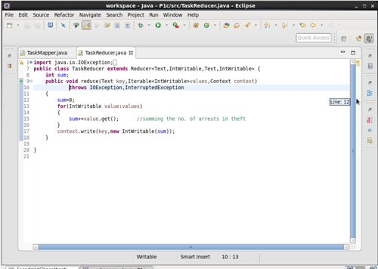
Running jar
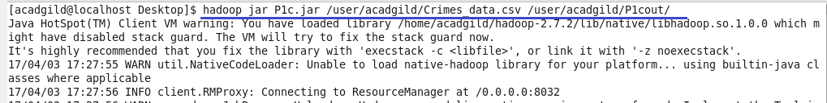
Output
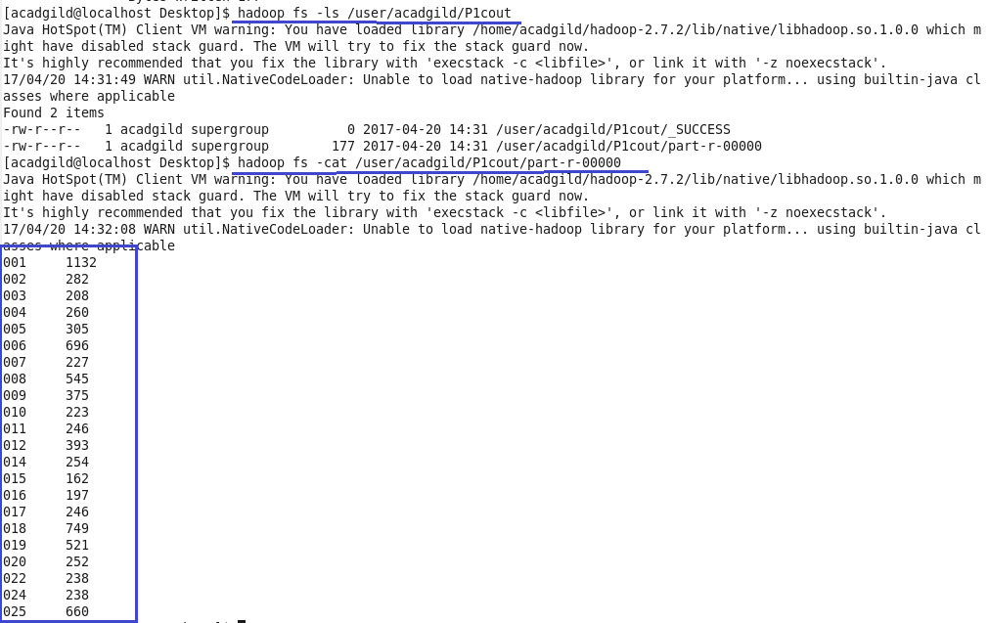
Pig Script
Logic:
1.loaded the dataset.
2.filtered by primary type theft using matches function and arrest=true
3.grouped by district and made count of primary type.

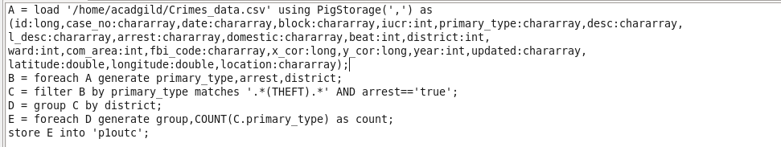
Running Pig Script
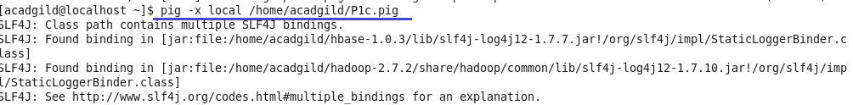
Output
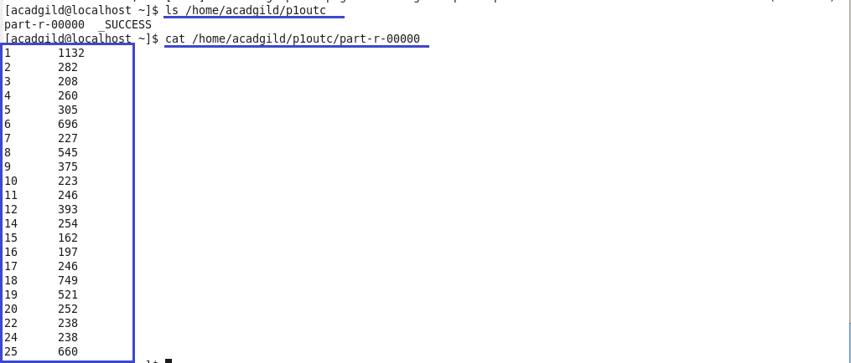
Write a mapreduce and pig program to calculate the number of arrests done between October 2014 and October 2015
Driver class
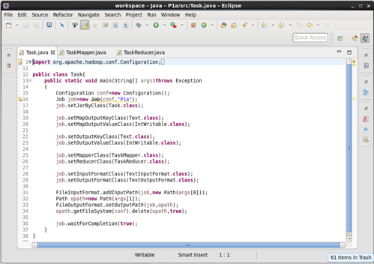

Mapper class
Logic
Date function is used to convert string into dates and filtered for arrest=true.
No. of arrests given as key and count of 1 as value for each arrest between the dates 30 sept 2014 and 1 nov 2015 for the period given oct 2014 to oct 2015.

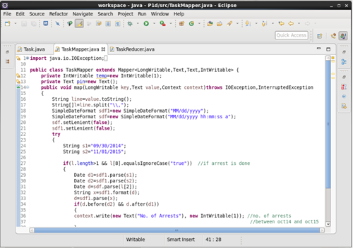

Mapper class(contd..)
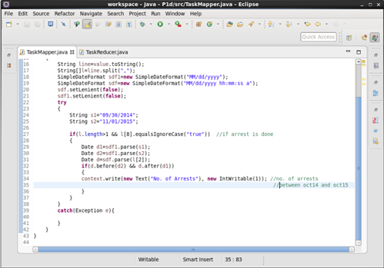

Reducer class
Counted the no of. Arrests for the given period.

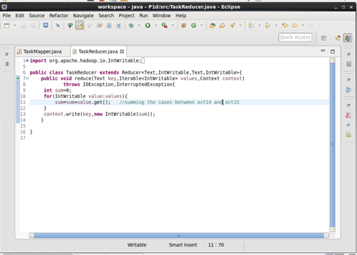

Running jar

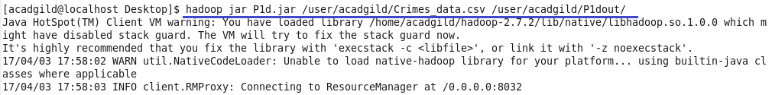

Output
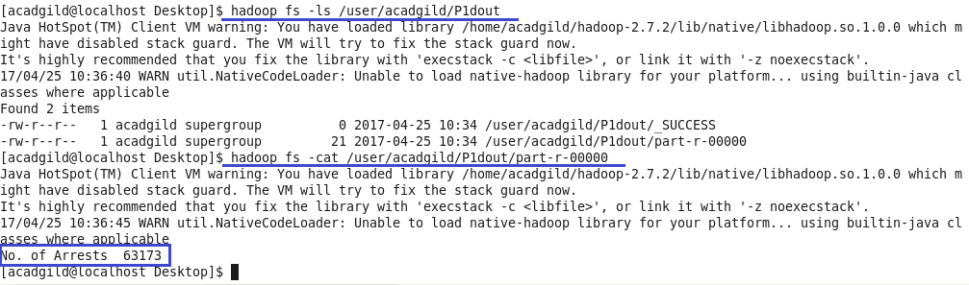

Pig Script
Logic
loaded the dataset
ToDate function is used to convert into dates and filtered for the given dates and arrest=true.
grouped by all and made count of arrests.

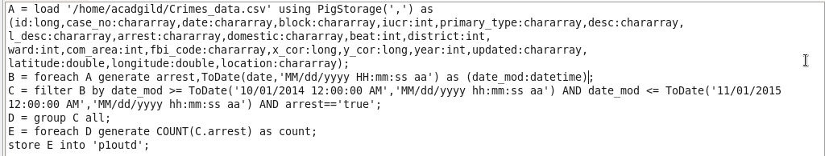

Running Pig Script

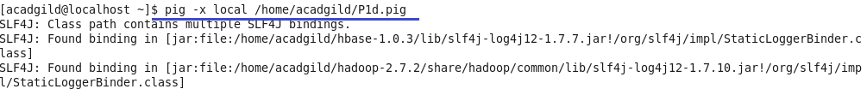

Output

