SCALA Session II
Assignment 13.1

Problem Statement
Create a Scala application to find the GCD of two numbers.

Solution:-

Scala Project - 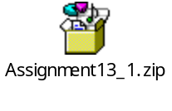

Code –

/**
* Author Nihit Rai
* This class provides method to find GCD of two numbers.
*
*/
class FindGCD {

/**
* Method to recusrively find GCD of two numbers passed as parameters
*/
def gcd(a: Int,b: Int): Int = {
if(b ==0) a else gcd(b, a%b)
}
}

object mainObj
{

def main(args: Array[String]) {
var obj = new FindGCD();

//Pass input as parameter
println(obj.gcd(25,50));
}
}

Output screenshot:-
For – 25 and 50
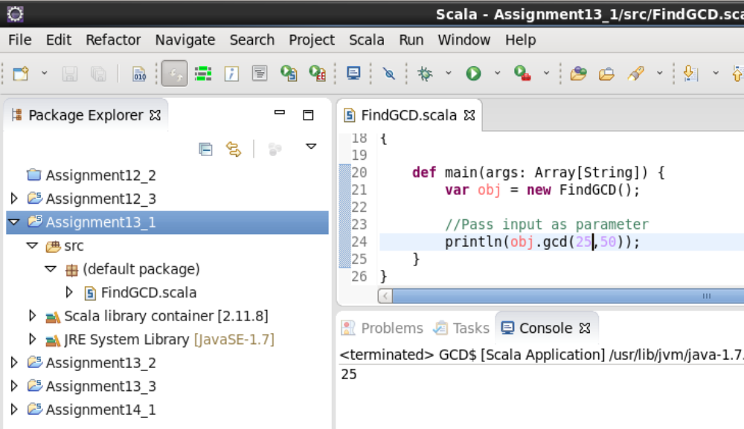

For – 5076 and 7614
