SCALA
Assignment 15.1

Problem Statement

1. Write a simple program to show inheritance in scala.
2. Write a simple program to show multiple inheritance in scala.

Solution:-

Project file- 

Code:-

- Simple program to show inheritance in Scala

Parent class:- Employee

/**
* author
* This is the parent class
*/
class Employee {
var salary:Float = 20000 ;
}

Child class:- Programmer
/**
* author
* This is the child class
*/
class Programmer extends Employee{
var bonus:Int = 2500;
println("Salary = "+salary);
println("Bonus = "+bonus);
}

object MainObject{
def main(args:Array[String]){
new Programmer();
}
}

Output:-
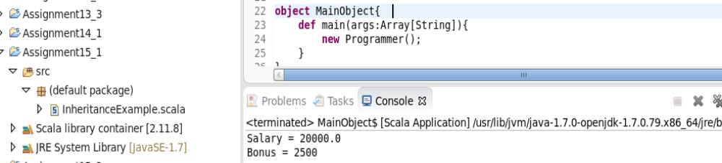

- Simple program to show multiple inheritance in Scala

//Create the base abstract class
abstract class Bird{
def sound:String;
}

//Create two traits each one overriding sound behaviour with some additional behaviour specific to the subclass
trait FlyingBird extends Bird{
override def sound = "Flying Sound";
def work () = { "Flying Flying"};
}

//Here we extends the abstract class and overridden sound behaviour and added one work method.
//Create one more subclass:-
trait RunningBird extends Bird{
override def sound = "Running Sound"
def run() = "Running Running"
}

//Now use mixin concept using with keyword:-
class FlyingRunningBird extends FlyingBird with RunningBird{
}
class RunningFlyingBird extends RunningBird with FlyingBird{
}

object MainObj{
def main(args:Array[String]){
var flyRunBird = new FlyingRunningBird();
println(flyRunBird.work()); // takes work method from FlyingBird class
println(flyRunBird.run()); // takes run method from RunningBird class
println(flyRunBird.sound); // As we have written “with RunningBird” so common behaviours(ie sound) is taken from RunningBird class hence we get sound behaviour is taken from RunningBird

println("-----------------------------------");

var runFlyBird = new RunningFlyingBird();
println(runFlyBird.work()); // takes work method from FlyingBird class
println(runFlyBird.run()); // takes run method from RunningBird class
println(runFlyBird.sound); // As “with FlyingBird” is written, so common behaviours(i.e. sound) is taken from FlyingBird class hence we get sound behaviour is taken from FlyingBird.

}
}

Output:--

