SCALA
Assignment 15.2

Problem Statement
- Write a partial function to add three numbers in which one number is constant and two
numbers can be passed as inputs and define another method which can take the partial
function as input and squares the result.

- Write a program to print the prices of 4 courses of Acadgild: Android-12999,Big Data
Development-17999,Big Data Development-17999,Spark-19999 using match and add a
default condition if the user enters any other course.

Solution:-

Scala Project - 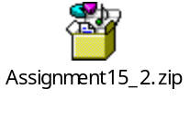

Code:-

- Partial function to add three numbers in which one number is constant and two numbers can be passed as inputs and define another method which can take the partial function as input and squares the result

Class – Problem1.scala

/**
* This class provides a partial function to all two integers and constant
* and another method to return square of integer
*
*/
class Problem1 {
//Defining constant integer
val constantInt: Int = 10;

/**
* Method to add two integers and return their sum
*/
def add(a: Int, b: Int): Int = a + b;

/**
* Partial function to add two parameters and constant
*/
object sumInt extends Function2[Int, Int, Int] {

override def apply(x: Int, y:Int): Int = add(add(x,y), constantInt)
}

/**
* Method to return square of input parameter
*/
def squareInt(i : Int):Int={
var retVal : Int = i*i;
return retVal;
}

}

object MainObj{
def main(args:Array[String]){
var Problem1= new Problem1();
//Testing partial function
println("Partial function returns : "+Problem1.sumInt(5,6));
println("Square function returns : "+Problem1.squareInt(Problem1.sumInt(5,6)));
}
}

Output:-

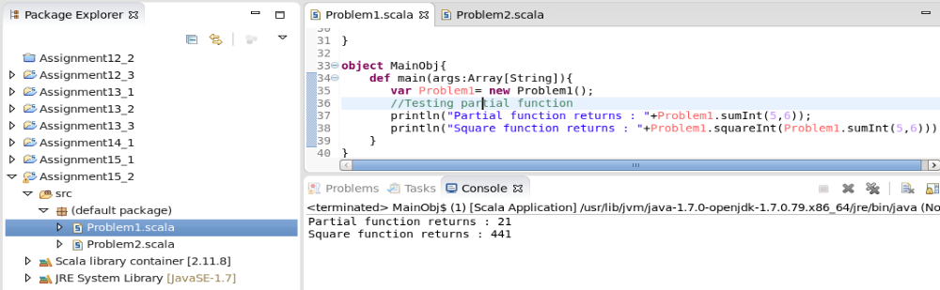

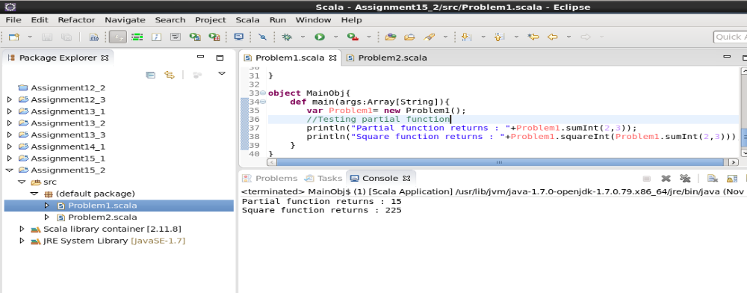

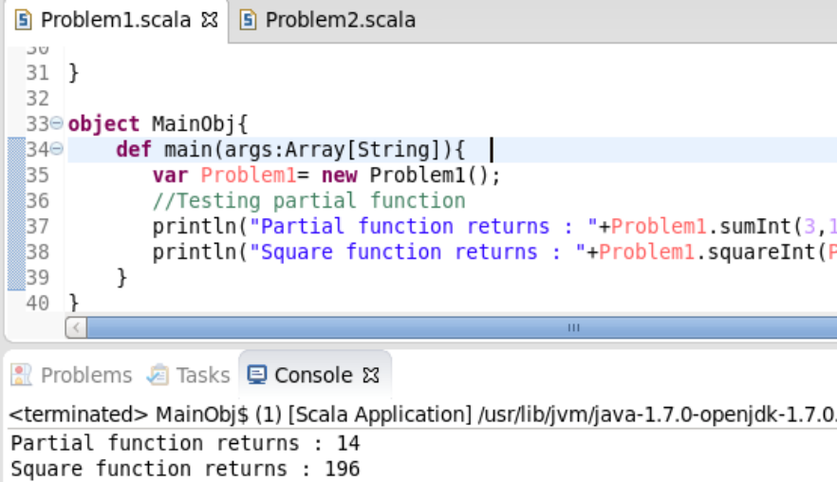

- Write a program to print the prices of 4 courses of Acadgild: Android-12999,Big Data
Development-17999,Big Data Development-17999,Spark-19999 using match and add a
default condition if the user enters any other course.

Class- Problem2.scala

/**
* this class provides method matchCourses to return price of course entered
*/
class Problem2 {

def matchCourses(x: String): Int = x.toUpperCase() match {
case "ANDROID" => 12999
case "BIG DATA DEVELOPMENT" => 17999
case "SPARK" => 19999
case _ => 0
}
}

//Main object
object MainDemo {
def main(args: Array[String]) {
while( true )
{
val input: String = readLine("enter course> ");
var obj = new Problem2();
var price: Int = obj.matchCourses(input);
if(price==0)
{
println("Course not found. Closing this app.");
return;
}
else
{
println("Price of "+input+" is " + price);
}
}
}
}

Output:-
