INTRODUCTION TO APACHE SPARK
Assignment 16.1

Problem Statement
Given a list of numbers - List[Int] (1, 2, 3, 4, 5, 6, 7, 8, 9, 10)
- find the sum of all numbers
- find the total elements in the list
- calculate the average of the numbers in the list
- find the sum of all the even numbers in the list
- find the total number of elements in the list divisible by both 5 and 3

Solution:-

Starting Spark shell
Command - spark-shell
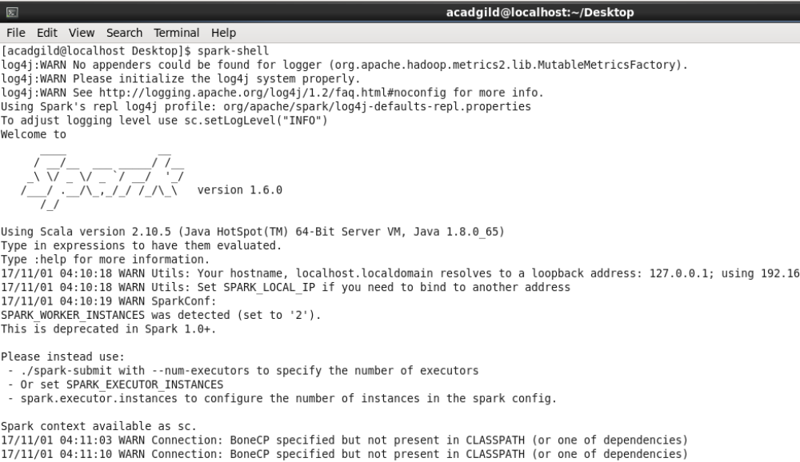

Creating a list and Loading it in Spark.

Commands:-

scala> var intList:List[Int]= List[Int](1, 2, 3, 4, 5, 6, 7, 8, 9, 10);
scala> val numbersRDD = sc.parallelize(intList);
scala> numbersRDD.collect().foreach(println);

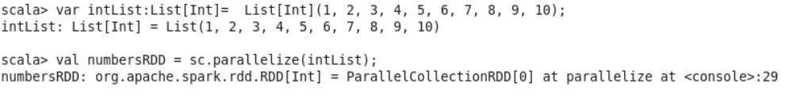
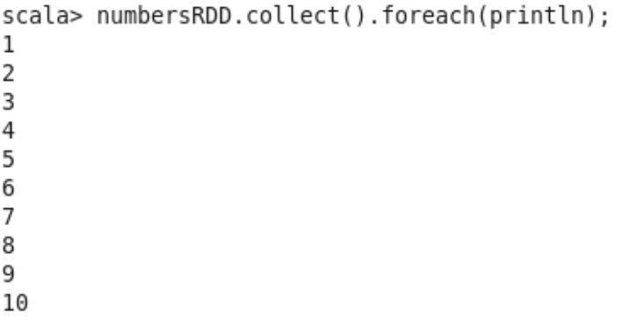

RDD numbersRDD is now loaded in Spark.
Solution to the problem statements could be found from data in numbersRDD

Solution to problem statements:-

- find the sum of all numbers

Command - scala> numbersRDD.reduce((x,y) => x+y);

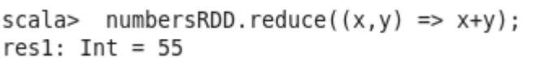

- find the total elements in the list

Command- scala> numbersRDD.count();

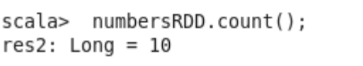

- calculate the average of the numbers in the list

Command - scala> numbersRDD.reduce((x,y) => x+y).toDouble / numbersRDD.count().toDouble;

- find the sum of all the even numbers in the list

Step 1- Filter out even numbers from numbersRDD and store in evenNumbersRDD

Command- scala> val evenNumbersRDD=numbersRDD.filter(i => (i%2==0));

Step 2- Find sum of numbers in evenNumbersRDD

Command- scala> evenNumbersRDD.reduce((x,y) => x+y);

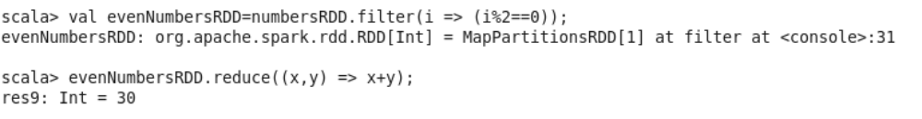
- find the total number of elements in the list divisible by both 5 and 3

- Number of elements divisible by both 5 and 3 is zero

Commands:-

scala> val divBy5And3RDD=numbersRDD.filter(i => ((i%5==0)&&(i%3==0)));

scala> divBy5And3RDD.count();

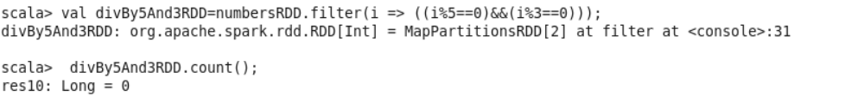

- Number of elements divisible by both 5 or 3 is 5

Commands:-

scala> val divBy5Or3RDD=numbersRDD.filter(i => ((i%5==0)||(i%3==0)));

scala> divBy5Or3RDD.count();

scala> divBy5Or3RDD.collect();

