RDD'S CONTD. & INTRODUCTION TO DATAFRAMES
Assignment 18. 2
Problem Statement

- Which route is generating the most revenue per year
- What is the total amount spent by every user on air-travel per year
- Considering age groups of < 20 , 20-35, 35 > ,Which age group is travelling the most every year.

Use the dataset given below:
https://drive.google.com/drive/folders/0B_P3pWagdIrrVThBaUdVSUtzbms

Solution:-
Starting Spark shell
Command - spark-shell
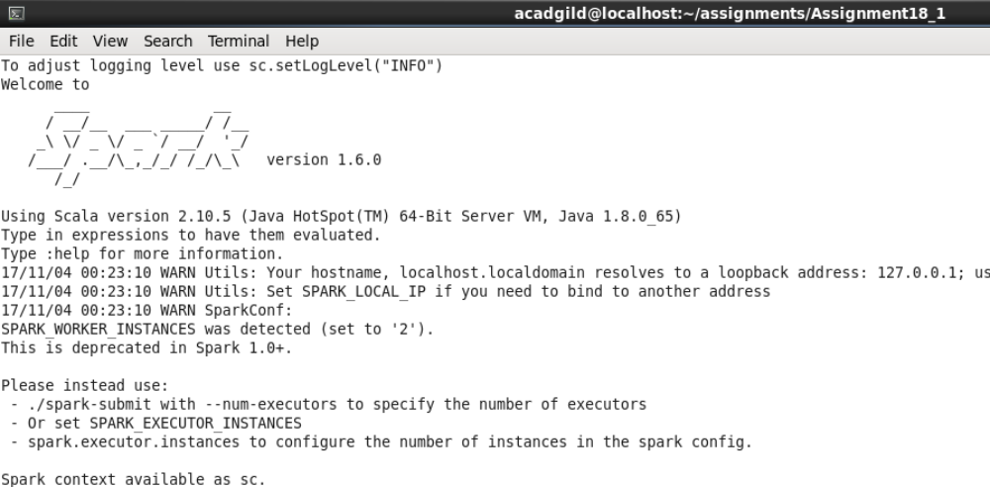

Loading data to dataframe:-

Scala> val holidaysRDD = sc.textFile("S18_Dataset_Holidays.txt");

Scala> val holidaysDF= holidaysRDD.map(lines=>lines.split(",")).map(arrays => (arrays(0),arrays(1),arrays(2),arrays(3),arrays(4),arrays(5))).toDF("Person_ID","Source","Destination","Mode","Distance","Year");

Scala> val transportRDD = sc.textFile("S18_Dataset_Transport.txt");

Scala> val transportDF= transportRDD.map(lines=>lines.split(",")).map(arrays=>(arrays(0),arrays(1))).toDF("Transport_Name","Fare");

Scala> val userRDD = sc.textFile("S18_Dataset_User_details.txt");

Scala> val userDF= userRDD.map(lines=>lines.split(",")).map(arrays=>(arrays(0),arrays(1),arrays(2))).toDF("Person_ID","Name","Age");

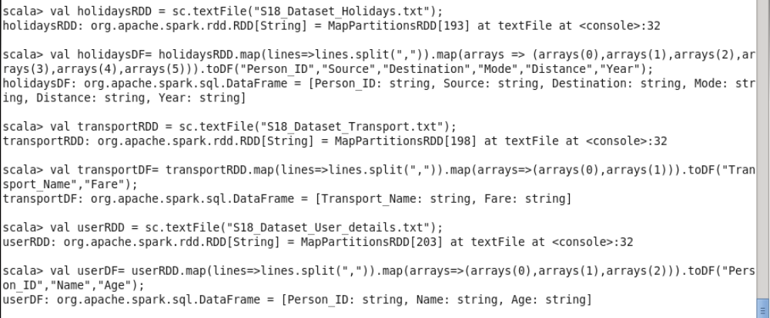

All the datasets have been loaded in to temporary tables.
These dataframes would be used to find solution to problem statements

Listing out dataframes and column names:-

holidaysDF -> "Person_ID","Source","Destination","Mode","Distance","Year"
transportDF -> "Transport_Name","Fare"
user DF -> "Person_ID","Name","Age"

Starting with problem statements now:-

- Which route is generating the most revenue per year

scala> val joinDF1 = holidaysDF.as("d1").join(transportDF.as("d2"), $"d1.Mode" === $"d2.Transport_Name").select($"d1.Source", $"d1.Destination", $"d1.Year",$"d2.Fare");

scala> val problem1DF = joinDF1.groupBy("Source","Destination","Year").agg(sum("Fare")).orderBy($"sum(Fare)".desc);
problem1DF

scala> val yearMax = problem1DF.groupBy("Year").agg(max("sum(Fare)"));
yearMax: org.apache.spark.sql.DataFrame

scala> val mostRevenueRoute = problem1DF.as("d1").join(yearMax.as("d2"), $"d1.Year" === $"d2.Year" && $"d1.sum(Fare)" === $"d2.max(sum(Fare))").select($"d1.Source", $"d1.Destination", $"d1.Year",$"d1.sum(Fare)").orderBy($"d1.Year");

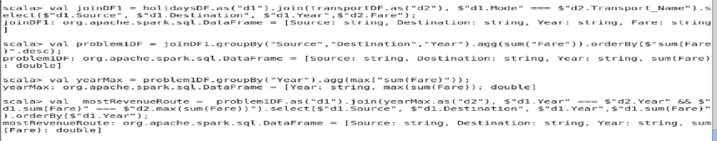
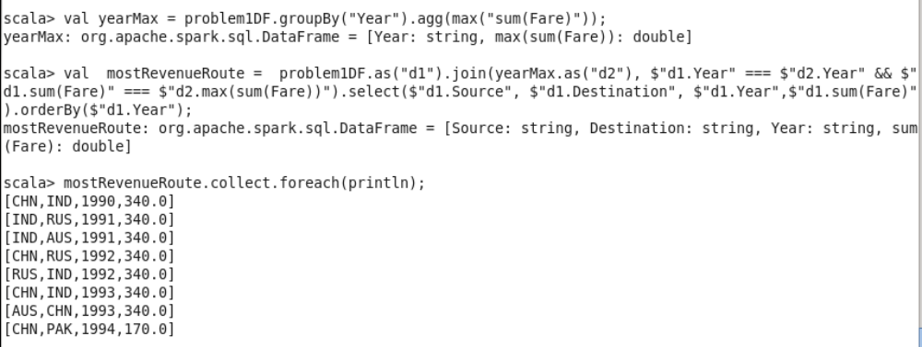

Above is the list of most profitable routes per year.

- What is the total amount spent by every user on air-travel per year

scala> val joinDF = holidaysDF.as("d1").join(userDF.as("d2"), $"d1.Person_ID" === $"d2.Person_ID").select($"d2.Name", $"d1.Year", $"d1.Mode");

scala> val joinWithPrice = joinDF.as("d1").join(transportDF.as("d2"), $"d1.Mode" === $"d2.Transport_Name").select($"d1.Name", $"d1.Year", $"d1.Mode",$"d2.Fare");

scala> val problem2DF= joinWithPrice.groupBy("Name","Year").agg(sum("Fare"));

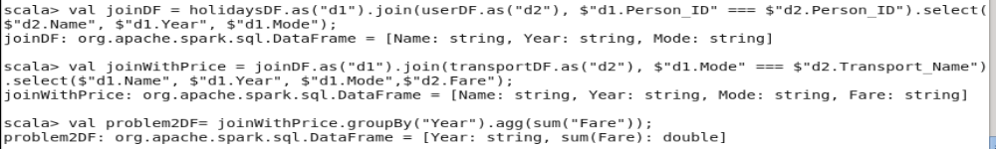

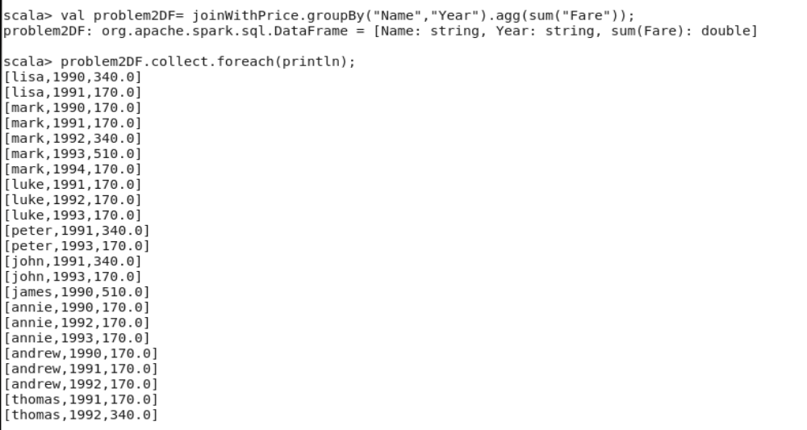
Above is the list of total amount spent by every user on air-travel per year
- Considering age groups of < 20 , 20-35, 35 > ,Which age group is travelling the most every year

scala> val ageGrp = udf((age: String) => { if(age.toInt < 20) { "<20"; } else { if(age.toInt > 35) { ">35"; } else { "20-35"; }}})

scala> val userDFGrp = userDF.withColumn("AgeGrp", ageGrp($"Age"))

scala> val joinDF3 = holidaysDF.as("d1").join(userDFGrp.as("d2"), $"d1.Person_ID" === $"d2.Person_ID").select($"d2.AgeGrp", $"d1.Year", $"d1.Mode");

scala> val groupedJoin = joinDF3.groupBy("AgeGrp","Year").count();

scala> val yearMax = groupedJoin.groupBy("Year").agg(max("count"));

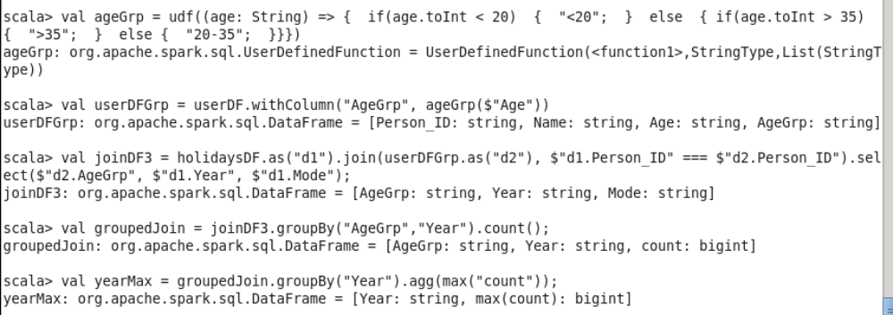

scala> val maxAgeGrp = groupedJoin.as("d1").join(yearMax.as("d2"), $"d1.Year" === $"d2.Year" && $"d1.count" === $"d2.max(count)").select($"d1.AgeGrp", $"d1.Year", $"d2.max(count)");

scala> maxAgeGrp.collect.foreach(println);

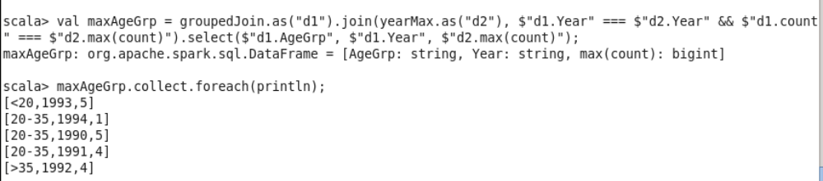

In 1990 age group 20-35 travelled most with 5 trips
In 1991 age group 20-35 travelled most with 4 trips
In 1992 age group >35 travelled most with 4 trips
In 1993 age group <20 travelled most with 5 trips
In 1994 age group 20-35 travelled most with 1 trip

