RDD'S CONTD. & INTRODUCTION TO DATAFRAMES
Assignment 18.3
Problem Statement

1) Considering age groups of < 20 , 20-35, 35 > ,Which age group spends the most
amount of money travelling.

2) What is the amount spent by each age-group, every year in travelling?

Use the dataset given below:
https://drive.google.com/drive/folders/0B_P3pWagdIrrVThBaUdVSUtzbms

Solution:-
Starting Spark shell
Command - spark-shell
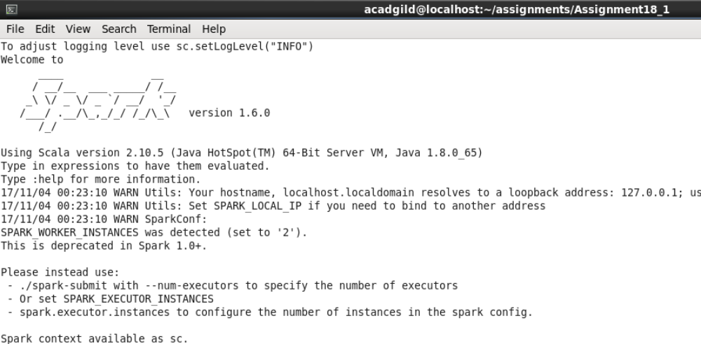

Loading data to dataframe:-

Scala> val holidaysRDD = sc.textFile("S18_Dataset_Holidays.txt");

Scala> val holidaysDF= holidaysRDD.map(lines=>lines.split(",")).map(arrays => (arrays(0),arrays(1),arrays(2),arrays(3),arrays(4),arrays(5))).toDF("Person_ID","Source","Destination","Mode","Distance","Year");

Scala> val transportRDD = sc.textFile("S18_Dataset_Transport.txt");

Scala> val transportDF= transportRDD.map(lines=>lines.split(",")).map(arrays=>(arrays(0),arrays(1))).toDF("Transport_Name","Fare");

Scala> val userRDD = sc.textFile("S18_Dataset_User_details.txt");

Scala> val userDF= userRDD.map(lines=>lines.split(",")).map(arrays=>(arrays(0),arrays(1),arrays(2))).toDF("Person_ID","Name","Age");
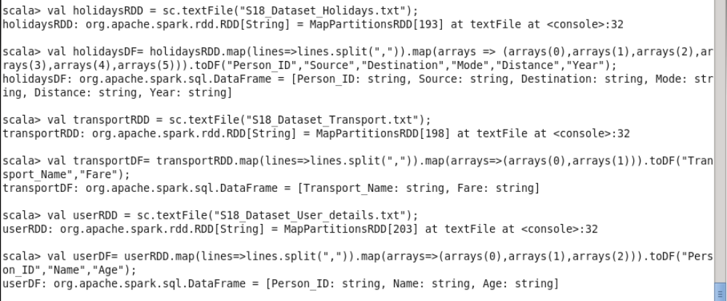

All the datasets have been loaded in to temporary tables.
These dataframes would be used to find solution to problem statements
Listing out dataframes and column names:-

holidaysDF -> "Person_ID","Source","Destination","Mode","Distance","Year"
transportDF -> "Transport_Name","Fare"
user DF -> "Person_ID","Name","Age"

Starting with problem statements now:-

1) Considering age groups of < 20 , 20-35, 35 > ,Which age group spends the most
amount of money travelling.

scala> val ageGrp = udf((age: String) => { if(age.toInt < 20) { "<20"; } else { if(age.toInt > 35) { ">35"; } else { "20-35"; }}});

scala> val userDFGrp = userDF.withColumn("AgeGrp", ageGrp($"Age"));

scala> val holidayWithPriceDF = holidaysDF.as("d1").join(transportDF.as("d2"), $"d1.Mode" === $"d2.Transport_Name").select($"d1.*", $"d2.Fare");

scala> val userHoliday = holidayWithPriceDF.as("d1").join(userDFGrp.as("d2"), $"d1.Person_ID" === $"d2.Person_ID").select($"d1.*", $"d2.*");

scala> val userGrpExpenditure = userHoliday.groupBy("AgeGrp").agg(sum("Fare")).orderBy($"sum(Fare)".desc);

scala> userGrpExpenditure.show(1);

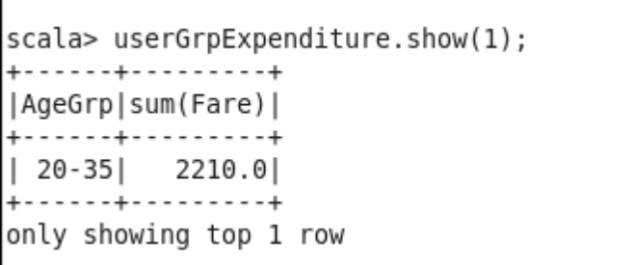

Age group 20-35 has spent most amounts i.e. 2210.0 on air travelling

2) What is the amount spent by each age-group, every year in travelling?

scala> val userGrpYearlyExpenditure = userHoliday.groupBy("AgeGrp","Year").agg(sum("Fare")).orderBy($"AgeGrp", $"Year", $"sum(Fare)".desc);
userGrpYearlyExpenditure: org.apache.spark.sql.DataFrame = [AgeGrp: string, Year: string, sum(Fare): double]

scala> userGrpYearlyExpenditure.show;

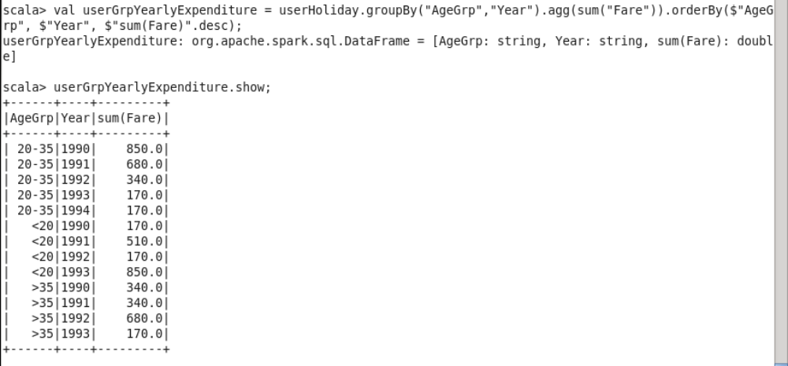

Above is a list of amount spent by each age-group, every year in travelling

