SPARK SQL
Assignment 19.1
Problem Statement

Using spark-sql, Find:
1. What are the total number of gold medal winners every year
2. How many silver medals have been won by USA in each sport

Use the dataset given below:



Solution:-
Starting Spark shell
Commands –
export SPARK_HOME=/usr/local/spark/spark-2.2.0-bin-hadoop2.7
spark-shell
(using latest version of spark for running spark SQL)

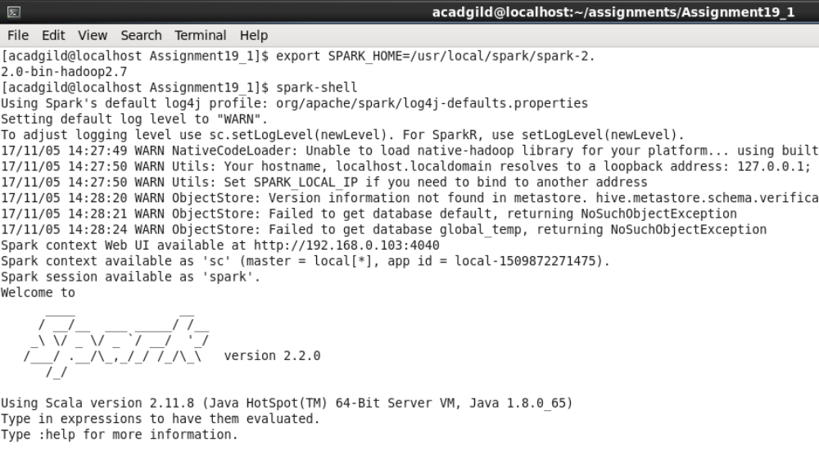

Loading the data:-

scala> val sportsRDD = sc.textFile("Sports_data.txt");

scala> val header = sportsRDD.first() ;

scala> val sportsRDDFiltered = sportsRDD.filter(row => row != header);

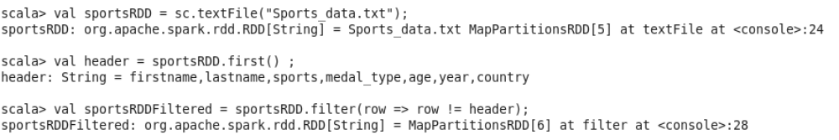

Loading the data into DataFrame

Scala> val sportsDF= sportsRDDFiltered.map(lines=>lines.split(",")).map(arrays => (arrays(0),arrays(1),arrays(2),arrays(3),arrays(4),arrays(5),arrays(6))).toDF("firstname","lastname","sports","medal_type","age","year","country");

Registering DataFrame as table:

Scala> sportsDF.registerTempTable("sports");

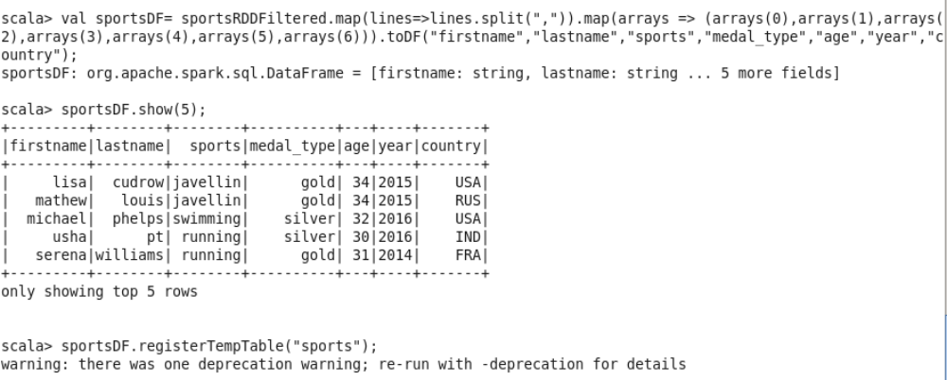

Based on table “sports” we can find solution to the problem statements

Using spark-sql, Find:

- What are the total number of gold medal winners every year

scala> val problem1DF = spark.sql("SELECT year, count(*) FROM sports where medal_type='gold' group by year order by year");

scala> problem1DF.show;

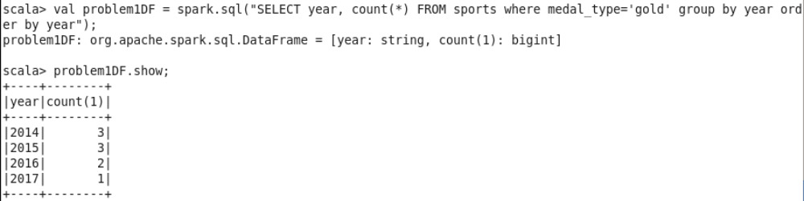

- How many silver medals have been won by USA in each sport

scala> val problem2DF = spark.sql("SELECT country, sports, count(*) FROM sports where country='USA' and medal_type='silver' group by country,sports");

scala> problem2DF.show;

