SPARK SQL
Assignment 19. 2
Problem Statement

Using udfs on dataframe
1. Change firstname, lastname columns into
Mr.first_two_letters_of_firstname<space>lastname
for example - michael, phelps becomes Mr.mi phelps

2. Add a new column called ranking using udfs on dataframe, where :
gold medalist, with age >= 32 are ranked as pro
gold medalists, with age <= 31 are ranked amateur
silver medalist, with age >= 32 are ranked as expert
silver medalists, with age <= 31 are ranked rookie

Use the dataset given below:

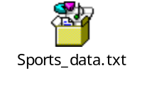

Solution:-
Starting Spark shell
Commands –
export SPARK_HOME=/usr/local/spark/spark-2.2.0-bin-hadoop2.7
spark-shell
(using latest version of spark for running spark SQL)

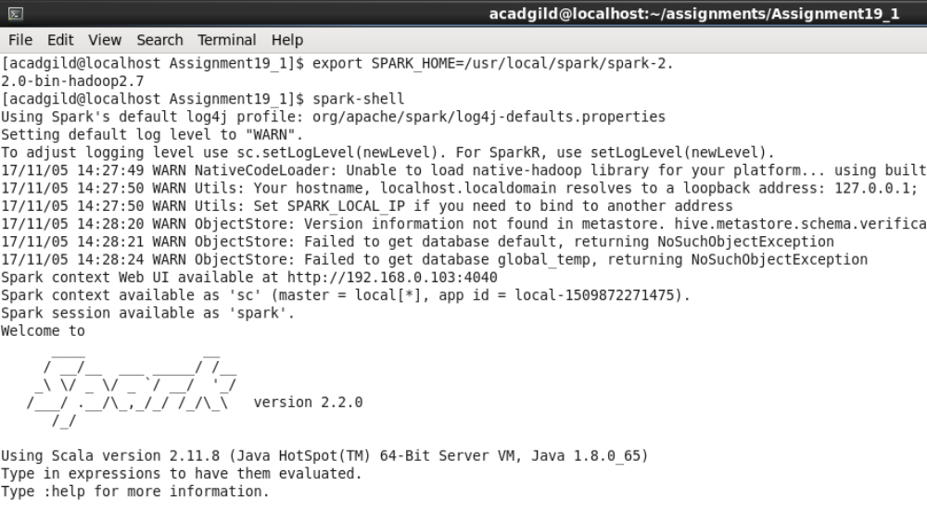

Loading the data:-

scala> val sportsRDD = sc.textFile("Sports_data.txt");

scala> val header = sportsRDD.first() ;

scala> val sportsRDDFiltered = sportsRDD.filter(row => row != header);

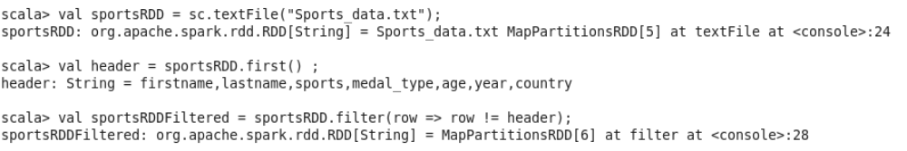

Loading the data into DataFrame

Scala> val sportsDF= sportsRDDFiltered.map(lines=>lines.split(",")).map(arrays => (arrays(0),arrays(1),arrays(2),arrays(3),arrays(4),arrays(5),arrays(6))).toDF("firstname","lastname","sports","medal_type","age","year","country");

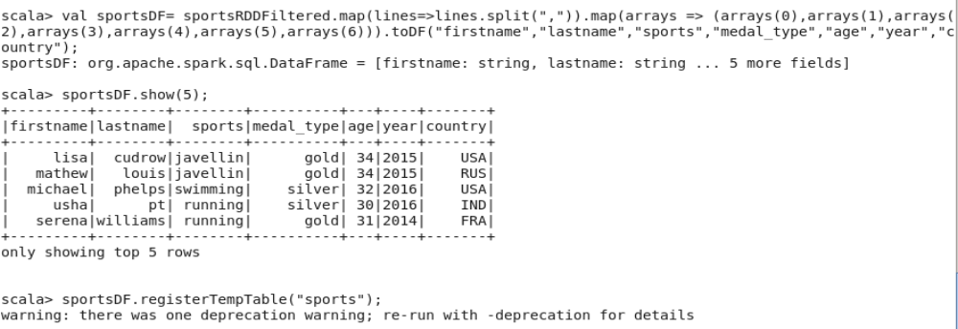

Based on DataFrame “sportsDF” we can find solution to the problem statements

1. Change firstname, lastname columns into
Mr.first_two_letters_of_firstname<space>lastname
for example - michael, phelps becomes Mr.mi phelps

Creating UDF :-
scala> val convertName = udf((fname: String, lname: String) => { "Mr."+fname.slice(0,2)+" "+lname+""});

Adding column “Fullname” to Data Frame using UDF:-
scala> val problem1DF = sportsDF.withColumn("Fullname", convertName($"firstname", $"lastname"));

Removing columns “firstname” and “lastname” from DataFrame problem1DF
scala> val problem1ResultDF = problem1DF.drop("firstname").drop("lastname");

scala>problem1ResultDF.show(50);

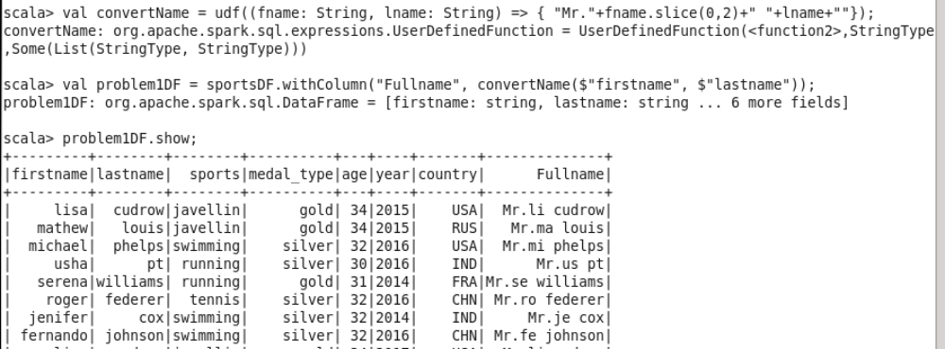

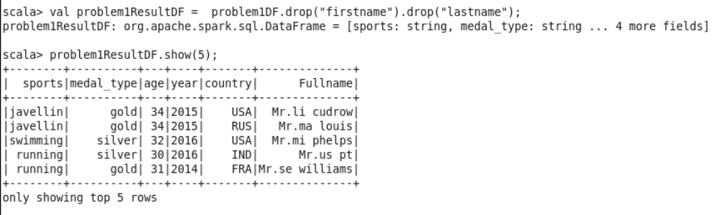

Required output is:-
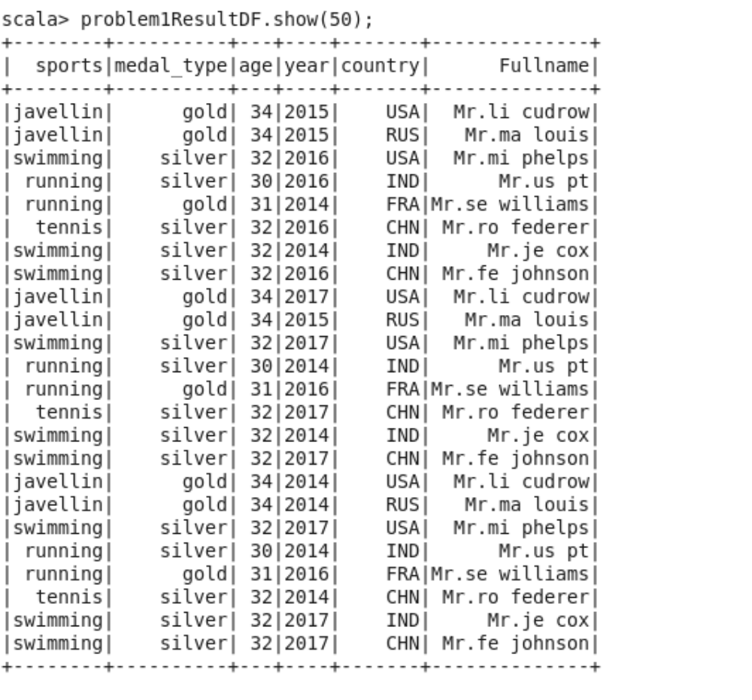

2. Add a new column called ranking using udfs on dataframe, where :
gold medalist, with age >= 32 are ranked as pro
gold medalists, with age <= 31 are ranked amateur
silver medalist, with age >= 32 are ranked as expert
silver medalists, with age <= 31 are ranked rookie

Creating UDF:-

scala> val playerClass = udf((medal:String, age: String) => { if(age.toInt <= 31 && medal=="silver") { "rookie"; } else { if(age.toInt >= 32 && medal=="silver") { "expert"; } else { if(age.toInt <= 31 && medal=="gold"){"amateur";} else{ if(age.toInt >= 32 && medal=="gold") {"pro";} else {"Could not determine class";}} }}});

Adding new column “Class” to DataFrame problem2DF

scala> val problem2DF = sportsDF.withColumn("Class", playerClass($"medal_type", $"age"));

scala> problem2DF.show(50);
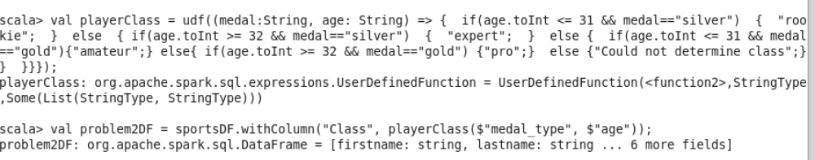

Required output is:-

