SPARK SQL
Assignment 19.3
Problem Statement

Create a dataframe with 1 to 100 and save as parquet file.

Solution:-
Starting Spark shell
Commands –
Spark-shell

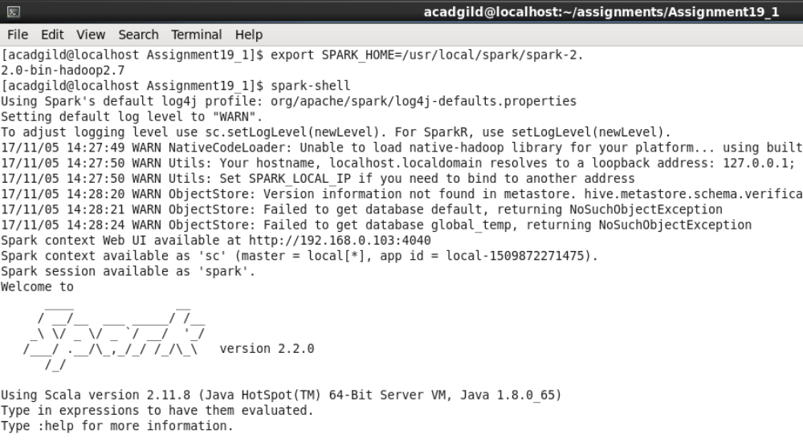

Loading numbers 1 to 100 in RDD:-

scala> val data = Array(1, 2, 3, 4, 5, 6, 7, 8, 9, 10, 11, 12, 13, 14, 15, 16, 17, 18, 19, 20, 21, 22, 23, 24, 25, 26, 27, 28, 29, 30, 31, 32, 33, 34, 35, 36, 37, 38, 39, 40, 41, 42, 43, 44, 45, 46, 47, 48, 49, 50, 51, 52, 53, 54, 55, 56, 57, 58, 59, 60, 61, 62, 63, 64, 65, 66, 67, 68, 69, 70, 71, 72, 73, 74, 75, 76, 77, 78, 79, 80, 81, 82, 83, 84, 85, 86, 87, 88, 89, 90, 91, 92, 93, 94, 95, 96, 97, 98, 99, 100);

scala> val dataRDD = sc.parallelize(data);

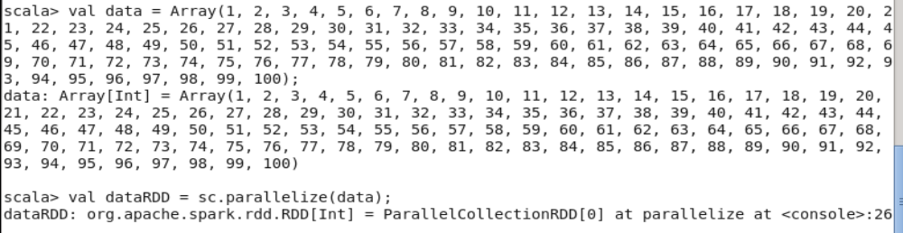

Creating data frame

scala> val dataDF = dataRDD.toDF();

scala> dataDF.show(5);

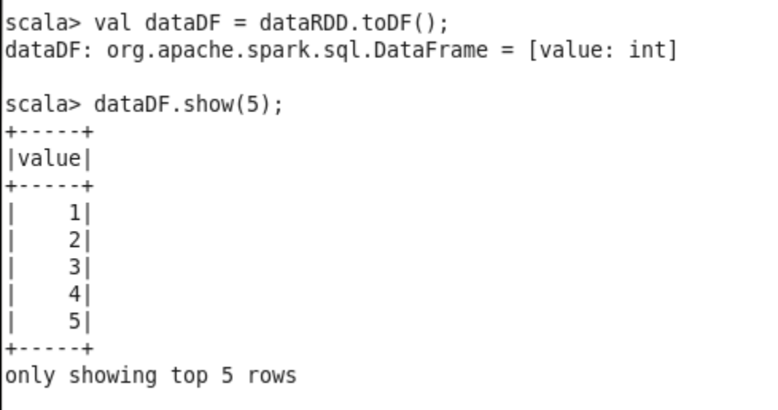

Storing dataframe as parquet file:-

scala> dataDF.write.format("parquet").save("numbers.parquet");

Directory “numbers.parquet” was created at “/home/acadgild/assignments/Assignment19_3”. Parquest files were created under directory “numbers.parquet”.

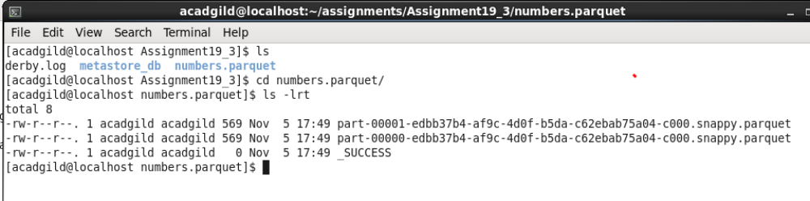

Attached files:-

Parquet directory - 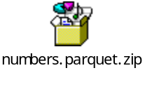 Parquet file 1- 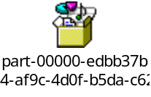 Parquet file 2-