SPARK STREAMING
Assignment 20.2
Problem Statement

Read two streams
1. List of strings input by user
2. Real-time set of offensive words
Find the word count of the offensive words inputted by the user as per the
real-time set of offensive words.

Solution:-

Scala Project - 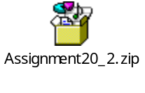

Offensive Words files - 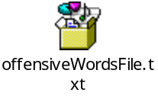 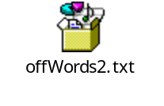

Jar file - 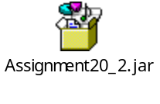

Command to run NetCat -> nc -lk 9999

Command to run Jar file -> spark-submit --master local[2] --class org.scala.OffensiveWordCount Assignment20_2.jar localhost 9999

Command to put files in HDFS –

hadoop fs -put offensiveWordsFile.txt /offensiveWords
hadoop fs -put offWords2.txt /offensiveWords

Code:---

1 . StreamingExample.scala

package org.scala
import org.apache.log4j.{Level, Logger}
import org.apache.spark.internal.Logging
object StreamingExamples extends Logging {
def setStreamingLogLevels() {
val log4jInitialized = Logger.getRootLogger.getAllAppenders.hasMoreElements
if (!log4jInitialized) {
// We first log something to initialize Spark's default logging, then we override the
// logging level.
logInfo("Setting log level to [WARN] for streaming example." +
" To override add a custom log4j.properties to the classpath.")
Logger.getRootLogger.setLevel(Level.WARN)
}
}
}

2. OffensiveWordCount.scala

package org.scala

import org.apache.spark.SparkConf
import org.apache.spark.storage.StorageLevel
import org.apache.spark.streaming.{Seconds, StreamingContext}
import scala.collection.mutable.ArrayBuffer
import org.apache.spark.streaming.dstream.DStream
import org.apache.spark.SparkContext

/**
* Counts words in UTF8 encoded, '\n' delimited text received from the network every second.
*
* Usage: OffensiveWordCount <hostname> <port>
* <hostname> and <port> describe the TCP server that Spark Streaming would connect to receive data.
*
* To run this on your local machine, you need to first run a Netcat server
* `$ nc -lk 9999`
*/
object OffensiveWordCount {
//ArrayBuffer to store list of offensive words in memory
val wordList: ArrayBuffer[String] = ArrayBuffer.empty[String];

def main(args: Array[String]) {
if (args.length < 2) {
System.err.println("Usage: OffensiveWordCount <hostname> <port>")
System.exit(1)
}

StreamingExamples.setStreamingLogLevels()

// Create the context with a 60 second batch size
val sparkConf = new SparkConf().setAppName("OffensiveWordCount")
val ssc = new StreamingContext(sparkConf, Seconds(60))

//Creating text file stream to store offensive words.
//It will monitor HDFS directory /offensiveWords
val offensiveLines = ssc.textFileStream("hdfs://localhost:9000/offensiveWords/");
val lines = ssc.socketTextStream(args(0), args(1).toInt, StorageLevel.MEMORY_AND_DISK_SER);

// Create a socket stream on target ip:port and count the
// words in input stream of \n delimited text (eg. generated by 'nc')
// Note that no duplication in storage level only for running locally.
// Replication necessary in distributed scenario for fault tolerance.

//getting offensive words from file
val offensiveWordCount = offensiveLines.flatMap(line => line.split(" ")).map(word => (word, 1)).reduceByKey(_ + _);
//storing offensive words in ArrayBuffer
offensiveWordCount.foreachRDD(a => { a.foreach(f => {wordList += f._1})});

//Getting all word count of all words entered by user
val wordCount = lines.flatMap(line => line.split(" ")).map(word => (word, 1)).reduceByKey(_ + _);

//Getting word count of offensive words only
val offensiveWordsRDD = wordCount.filter {x => matchWord(x._1)%2==1 };
offensiveWordsRDD.print();

ssc.start()
ssc.awaitTermination()
}

/**
* Filter Method for offensive words
*/
def matchWord(ln : String): Double={
val lineWords = ln.trim.toLowerCase();
var num: Double = 0;

for(y<-wordList)
{
if(y.toLowerCase() == lineWords)
{
num = 1;
return num;
}

}

return num;
}

}

-----------------------------------Now Running the Spark Streaming program---------------------------------------------

Step 1- Starting netcat

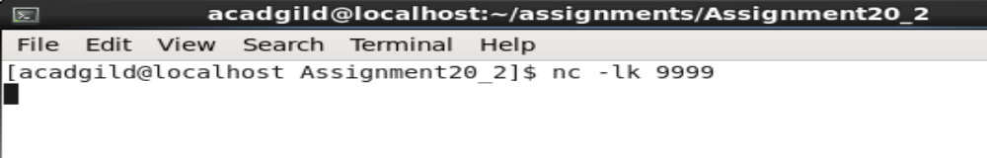

Step 2 – Starting Spark streaming application

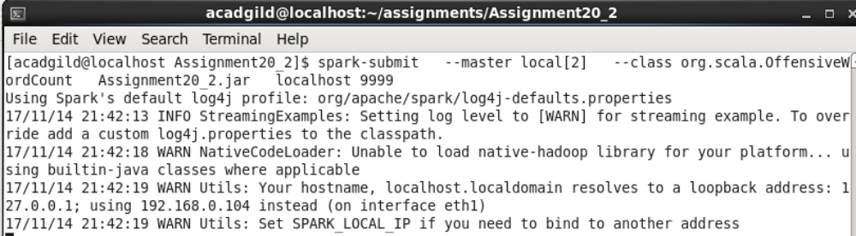
Now the application has started we can provide text input in netcat as well as put offensive word file in HDFS directory.

Sample input text –

he is a dumb idiot hello
he is a dumb idiot and got troll
test john hello dash
he is a dumb idiot

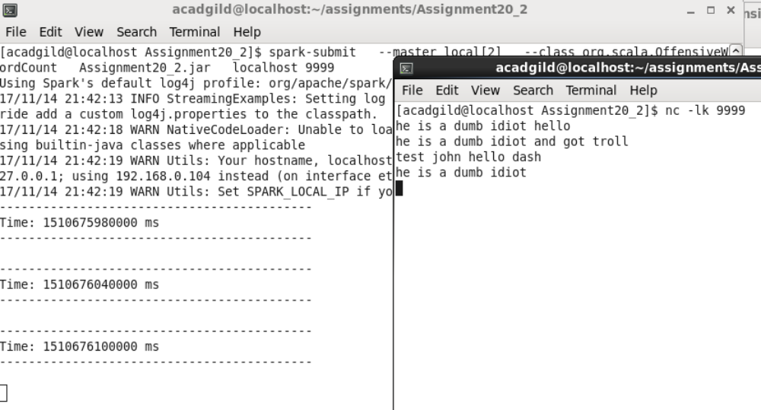

Nothing is printed on spark app as the list of offensive words in empty

Now loading first offensive word file

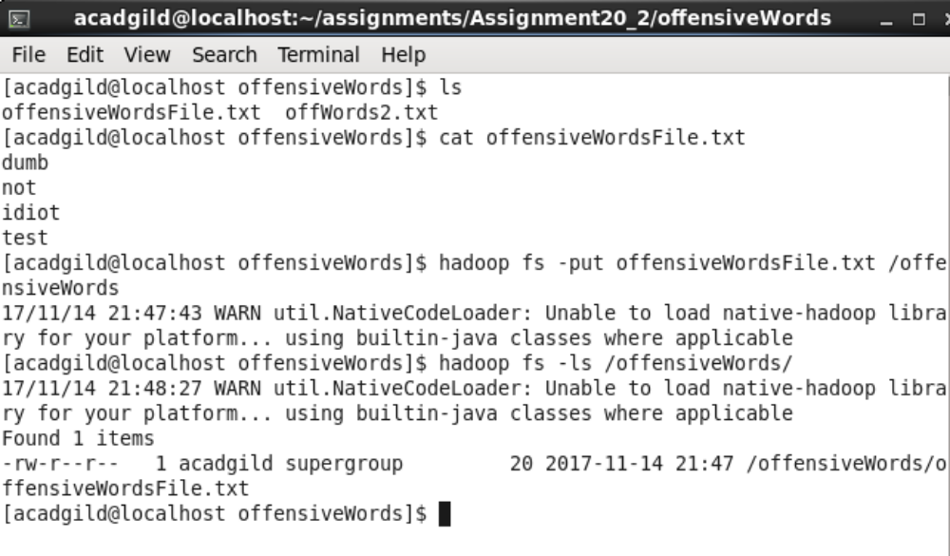

Now upon entering same input text, the app is returning word count of offensive words in file offensiveWordsFile.txt

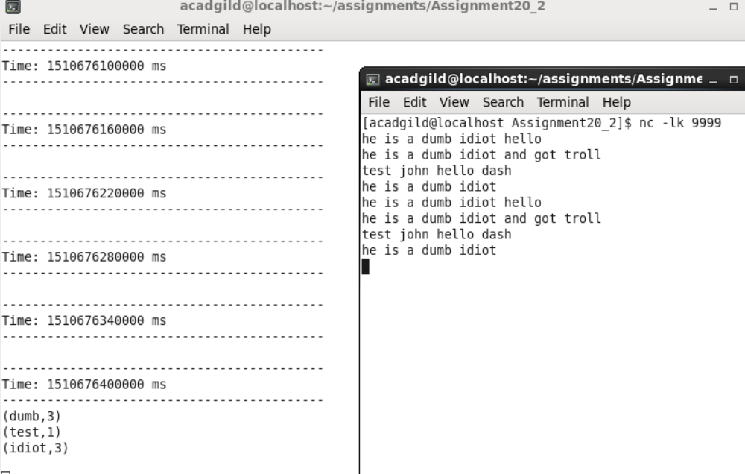

Adding another file with offensive words

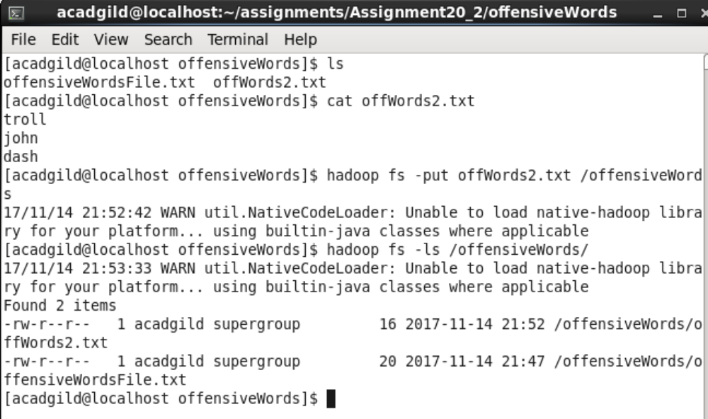

From below screenshot we could see that the app is now returning the word count of offensive words that were loaded previously as well as loaded later from file offWords2.txt.

