SPARK
Assignment 21.1
Problem Statement

Implement the below blog at your end and send the complete documentation.
https://drive.google.com/file/d/0B_Qjau8wv1KobUlaOEtfNEtQNkU/view?usp=sharing

Topic: Counting popular hashtags using Spark sql

Solution:-

Tweet File - 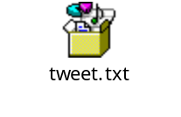

Starting Spark-shell
Command – spark-shell

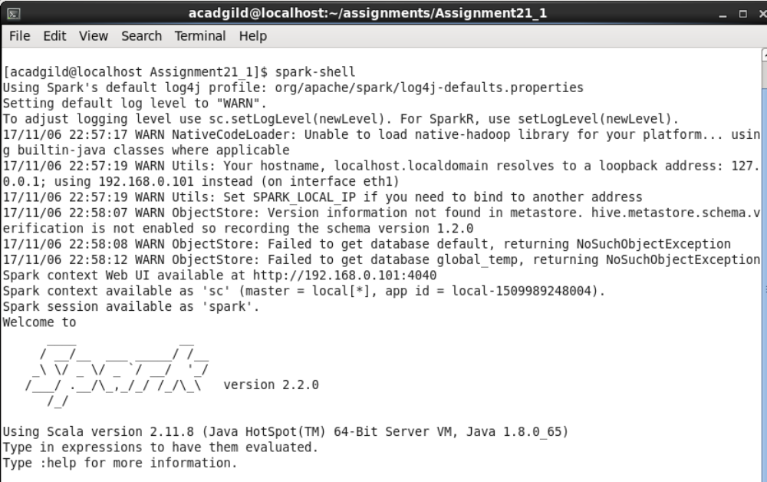

Loading tweet in spark

scala> val tweets = spark.read.json("tweet.txt").registerTempTable("tweets");

scala> val hashtags = spark.sql("select id as id,entities.hashtags.text as words from tweets").registerTempTable("hashtags");

scala> val hashtag_word = spark.sql("select id as id,hashtag from hashtags LATERAL VIEW explode(words) w as hashtag").registerTempTable("hashtag_word");

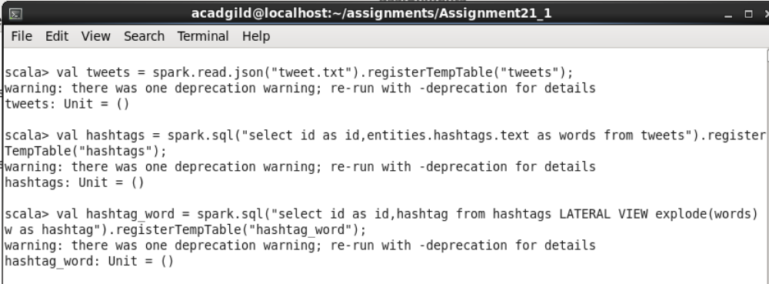

Getting hashtag count-

scala> val popular_hashtags = spark.sql("select hashtag, count(hashtag) as cnt from hashtag_word group by hashtag order by cnt desc").show;

