SPARK
Assignment 21.2
Problem Statement

Implement the below blog at your end and send the complete documentation.
https://drive.google.com/file/d/0B_Qjau8wv1KoUThzZ24tT1NsZGs/view?usp=sharing

The U.S. Department of Transportation’s (DOT) Bureau of Transportation Statistics (BTS) tracks the ontime performance of domestic flights operated by large air carriers. Summary information on the number of on-time, delayed, canceled, and diverted flights appears in DOT’s monthly Air Travel Consumer Report, published about 30 days after the month’s end, as well as in summary tables posted on this website. Summary statistics and raw data are made available to the public at the time the Air Travel Consumer Report is released.

You can download the datasets from the following links:
Delayed_Flights.csv

Delayed_Flights.csv Datasets
There are 29 columns in this dataset. Some of them have been mentioned below:
• Year: 1987 – 2008
• Month: 1 – 12
• FlightNum: Flight number
• Canceled: Was the flight canceled?
• CancelleationCode: The reason for cancellation.
For complete details, refer to this link.

Problem Statement 1
Find out the top 5 most visited destinations.

Problem Statement 2
Which month has seen the most number of cancellations due to bad weather?

Problem Statement 3
Top ten origins with the highest AVG departure delay

Problem Statement 4
Which route (origin & destination) has seen the maximum diversion?

(Solution from next page...............)

Solution:-

Starting Spark-shell
Command – spark-shell


Problem Statement 1
Find out the top 5 most visited destinations.

scala> val delayed_flights = sc.textFile("DelayedFlights.csv");

scala> val mapping = delayed_flights.map(x => x.split(",")).map(x => (x(18),1)).filter(x =>x._1!=null).reduceByKey(_+_).map(x => (x._2,x._1)).sortByKey(false).map(x => (x._2,x._1)).take(5);

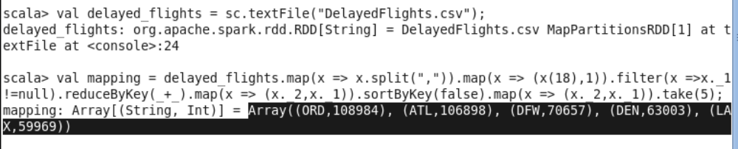

Problem Statement 2
Which month has seen the most number of cancellations due to bad weather?

scala> val delayed_flights = sc.textFile("DelayedFlights.csv");

scala> val canceled = delayed_flights.map(x => x.split(",")).filter(x => ((x(22).equals("1")) && (x(23).equals("B")))).map(x => (x(2),1)).reduceByKey(_+_).map(x =>(x._2,x._1)).sortByKey(false).map(x =>(x._2,x._1)).take(1);

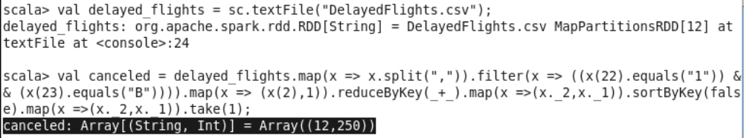

Problem Statement 3
Top ten origins with the highest AVG departure delay

scala> val delayed_flights = sc.textFile("DelayedFlightsNoHeader.csv");

scala> val avg = delayed_flights.map(x => x.split(",")).map(x => (x(17),x(16).toDouble)).mapValues((_,1)).reduceByKey((x, y) => (x._1 + y._1, x._2 + y._2)).mapValues{ case (sum, count) => (1.0 *sum)/count}.map(x => (x._2,x._1)).sortByKey(false).map(x => (x._2,x._1)).take(10);

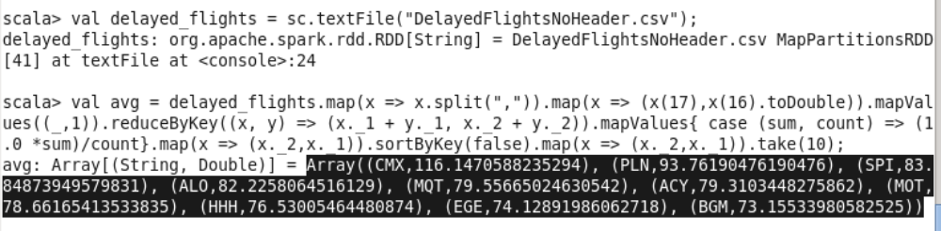

Problem Statement 4
Which route (origin & destination) has seen the maximum diversion?

scala> val delayed_flights = sc.textFile("DelayedFlights.csv");
delayed_flights: org.apache.spark.rdd.RDD[String] = DelayedFlights.csv MapPartitionsRDD[53] at textFile at <console>:24

scala> val diversion = delayed_flights.map(x => x.split(",")).filter(x => ((x(24).equals("1")))).map(x =>((x(17)+","+x(18)),1)).reduceByKey(_+_).map(x => (x._2,x._1)).sortByKey(false).map(x =>(x._2,x._1)).take(10).foreach(println);

