SPARK
Assignment 22.2
Problem Statement

Go through below blog and reiterate the same at your end.
https://docs.google.com/document/d/14YUd_wi-KJTBEqqtyoNtPMFeORjFU-
_yId4hJ11q90o/edit

Sentiment analysis on demonetization

Let us find out the views of different people on the demonetization by analysing the tweets from twitter. Here is the dataset where twitter tweets are gathered in CSV format. You can download the dataset from the below link
https://drive.google.com/open?id=0ByJLBTmJojjzNkRsZWJiY1VGc28
Dataset - 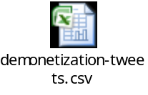 AFINN.txt - 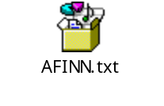

Solution:-
Starting Spark-shell
Command – spark-shell
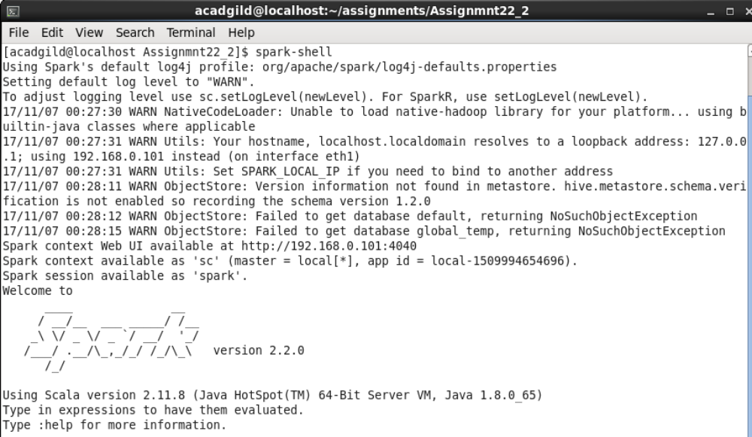
Loading data:-

scala> val tweets = sc.textFile("demonetization-tweets.csv").map(x => x.split(",")).filter(x=>x.length>=2).map(x => (x(0).replaceAll("\"",""),x(1).replaceAll("\"","").toLowerCase)).map(x => (x._1,x._2.split(" "))).toDF("id","words");

scala> tweets.registerTempTable("tweets");

scala> val explode = spark.sql("select id as id,explode(words) as word from tweets").registerTempTable("tweet_word");

scala> val afinn = sc.textFile("AFINN.txt").map(x => x.split("\t")).map(x => (x(0),x(1))).toDF("word","rating").registerTempTable("afinn");

scala> val join = spark.sql("select t.id,AVG(a.rating) as rating from tweet_word t join afinn a on t.word=a.word group by t.id order by rating desc");

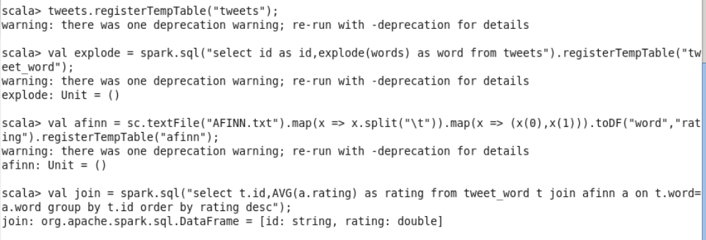

scala> join.show

