Session 3: EXPLORING MAPREDUCE
Assignment 3.3

Write a Map Reduce java program to find out the total units sold for each company and for each state for Onida Company.

Introduction:
In this assignment, I’m going to write a Map Reduce java program to calculate the total units sold for each company and the total units sold in each state for Onida Company.
The operation occurs in 3 stages,
- Mapper Phase
- Shuffle Phase
- Reducer Phase

Associated Data Files
https://drive.google.com/file/d/0Bxr27gVaXO5sVjQ5QW0wQ3RCTUU/view?usp=sharing

Problem Statement
We have a dataset of sales of different TV sets across different locations.
Records look like:
Samsung|Optima|14|Madhya Pradesh|132401|14200
The fields are arranged like:
Company Name|Product Name|Size in inches|State|Pin Code|Price
There are some invalid records which contain 'NA' in either Company Name or Product Name.
2. Write a Map Reduce program to calculate the total units sold for each Company.
3. Write a Map Reduce program to calculate the total units sold in each state for Onida
Company.

Actual Data Set:
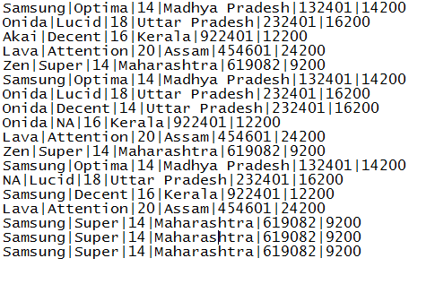

Map Reduce Java Program: Write a Map Reduce program to calculate the total units sold for each Company

Driver Code
package TotalUnitSale;

import org.apache.hadoop.conf.Configuration;
import org.apache.hadoop.fs.Path;
import org.apache.hadoop.io.IntWritable;
import org.apache.hadoop.io.Text;
import org.apache.hadoop.mapreduce.Job;
import org.apache.hadoop.mapreduce.lib.input.FileInputFormat;
import org.apache.hadoop.mapreduce.lib.input.TextInputFormat;
import org.apache.hadoop.mapreduce.lib.output.FileOutputFormat;
import org.apache.hadoop.mapreduce.lib.output.TextOutputFormat;

public class TotalUnitSale
{

public static void main(String[] args) throws Exception
{
Configuration conf = new Configuration();
Job job = new Job(conf, "TV TotalUnitSale");// the job runs under this

job.setJarByClass(TotalUnitSale.class);

job.setMapOutputKeyClass(Text.class); //mapper key output
job.setMapOutputValueClass(IntWritable.class); //mapper output value

job.setOutputKeyClass(Text.class);// output key of the mapreduce
job.setOutputValueClass(IntWritable.class);//output value of the mapreduce

job.setMapperClass(TotalUnitSaleMapper.class);// Mapper class
job.setReducerClass(TotalUnitSaleReducer.class);//reducer class

job.setNumReduceTasks(2);

job.setInputFormatClass(TextInputFormat.class);
job.setOutputFormatClass(TextOutputFormat.class);

FileInputFormat.addInputPath(job, new Path(args[0]));
FileOutputFormat.setOutputPath(job, new Path(args[1]));

job.waitForCompletion(true);

}

}

Mapper Code
package TotalUnitSale;

import java.io.IOException;
import java.util.StringTokenizer;

import org.apache.hadoop.io.IntWritable;
import org.apache.hadoop.io.LongWritable;
import org.apache.hadoop.io.Text;
import org.apache.hadoop.mapreduce.Mapper;

public class TotalUnitSaleMapper extends Mapper<LongWritable, Text, Text, IntWritable>
{
private final static IntWritable unit = new IntWritable(1); // declaring the Mapper value
private Text CompanyName = new Text(); //declaring the Mapper key

public void map(LongWritable key, Text value, Context context ) throws IOException, InterruptedException
{

String[] Linearray = value.toString().split("\\|");
StringTokenizer tokenizer=new StringTokenizer(Linearray[0]); //we have used the String Tokenizer class which takes array into single word/token.
while(tokenizer.hasMoreTokens()) // the while loop checks for the more tokens/words, if we have next token it will continue the loop
{
CompanyName.set(tokenizer.nextToken());

}
context.write(CompanyName, unit); // output of the Mapper Key and Value

}
}

Reducer Code
package TotalUnitSale;

import java.io.IOException;

import org.apache.hadoop.io.IntWritable;
import org.apache.hadoop.io.Text;
import org.apache.hadoop.mapreduce.Reducer;

public class TotalUnitSaleReducer extends Reducer<Text, IntWritable, Text, IntWritable>
{
public void reduce(Text CompanyName, Iterable<IntWritable> values, Context context) throws IOException, InterruptedException
{
int sum=0; // declaring a variable sum
for(IntWritable value:values) // the for loop get the iterable values and counting the values
{
sum+=value.get();
}
context.write(CompanyName, new IntWritable(sum)); // output of the the Key and value
}

}

Command to run the jar
hadoop jar mapreduce-0.0.1-SNAPSHOT.jar TotalUnitSale.TotalUnitSale/user/acadgild/hadoop/television.txt /user/acadgild/hadoop/TV
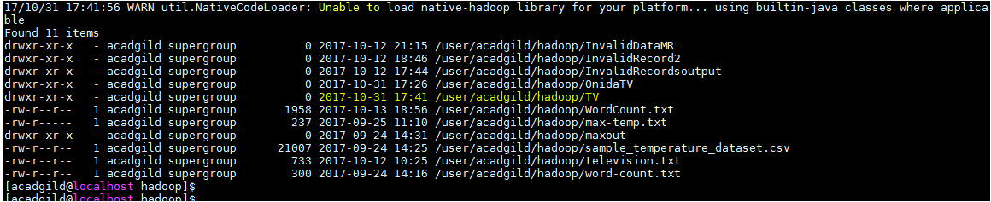

Expected Output
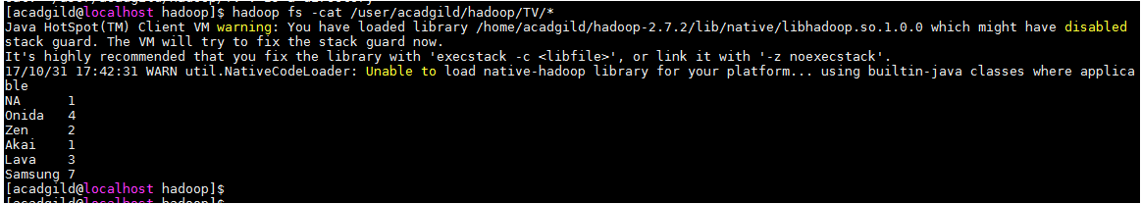

Write a Map Reduce program to calculate the total units sold in each state for Onida Company.

Driver Code
package OnidaTotalUnit;

import org.apache.hadoop.conf.Configuration;
import org.apache.hadoop.fs.Path;
import org.apache.hadoop.io.IntWritable;
import org.apache.hadoop.io.Text;

import org.apache.hadoop.mapreduce.Job;
import org.apache.hadoop.mapreduce.lib.input.FileInputFormat;
import org.apache.hadoop.mapreduce.lib.input.TextInputFormat;
import org.apache.hadoop.mapreduce.lib.output.FileOutputFormat;
import org.apache.hadoop.mapreduce.lib.output.TextOutputFormat;

public class OnidaTotalUnit

{
public static void main(String[] args) throws Exception

{

Configuration conf = new Configuration();
Job job = new Job(conf, "Onida Total Unit");// the job runs under this

job.setJarByClass(OnidaTotalUnit.class);

job.setMapOutputKeyClass(Text.class); //mapper key output
job.setMapOutputValueClass(IntWritable.class); //mapper output value

job.setOutputKeyClass(Text.class);//output key of the mapreduce
job.setOutputValueClass(IntWritable.class); //output value of the mapreduce

job.setMapperClass(OnidaMapper.class); // mapper class
job.setReducerClass(OnidaReducer.class);// reducer class

job.setNumReduceTasks(2);

job.setInputFormatClass(TextInputFormat.class);
job.setOutputFormatClass(TextOutputFormat.class);

FileInputFormat.addInputPath(job, new Path(args[0]));
FileOutputFormat.setOutputPath(job, new Path(args[1]));

job.waitForCompletion(true);
}

}

Mapper Code
package OnidaTotalUnit;

import java.io.IOException;

import org.apache.hadoop.io.IntWritable;
import org.apache.hadoop.io.LongWritable;
import org.apache.hadoop.io.Text;
import org.apache.hadoop.mapreduce.Mapper;

public class OnidaMapper extends Mapper<LongWritable, Text, Text, IntWritable>
{
public void map(LongWritable key, Text value, Context context) throws IOException, InterruptedException
{

String[] Linearray = value.toString().split("\\|"); //the array is split into string value and stored in Linearray
if(Linearray[0].equals("Onida")) // checking the word Onida in the linearray[0], if it is Onida print the state name in linearray[3]and unit value
{
Text State = new Text(Linearray[3]);
IntWritable unit= new IntWritable(1);
context.write(State, unit);
}
}

}

Reducer Code
package OnidaTotalUnit;

import java.io.IOException;

import org.apache.hadoop.io.IntWritable;
import org.apache.hadoop.io.Text;
import org.apache.hadoop.mapreduce.Reducer;

public class OnidaReducer extends Reducer<Text, IntWritable, Text, IntWritable>
{
public void reduce(Text State, Iterable<IntWritable> values, Context context) throws IOException, InterruptedException
{
int sum = 0; // declaring the variable sum
for(IntWritable value:values) // the for loop get the iterable values and counting the values
{
sum+= value.get();
}

context.write(State, new IntWritable(sum)); // print the state name which is the key and the number of units stored in the sum
}

}

Command to run the jar
hadoop jar mapreduce-0.0.1-SNAPSHOT.jar OnidaTotalUnit.OnidaTotalUnit/user/acadgild/hadoop/television.txt/user/acadgild/hadoop/OnidaTV
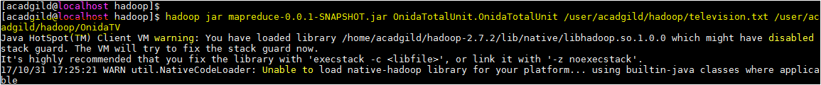
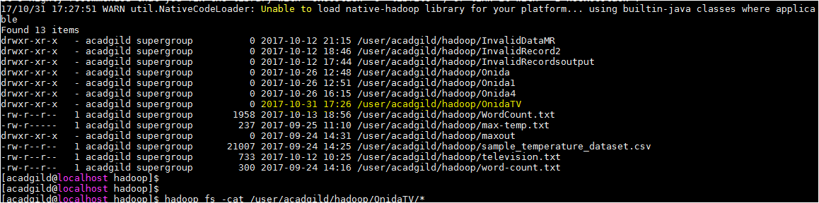

Expected Output
