Session 4: SCHEDULERS IN YARN & INTRODUCTION TO PIG

Assignment 4.3
Write a program to implement wordcount using Pig.
Share the screenshots of the commands used with its associated output.

Problem Statement
Write a program to implement word count using Pig. Share the screenshots of the commands used with its associated output.

Introduction
In this assignment we are going to write word count program using Pig Latin.

Input Texts
We have the below words in the text file wordcountpig.txt which is placed at /home/acadgild/hadoop.
“Write a program to implement wordcount using Pig. Share the screenshots of the commands used with its associated output.
Here we will write a simple pig script for the word count program.”

PIG Commands – Word Count Example

Load the data from HDFS
“Word_Count = LOAD '/home/acadgild/hadoop/wordcountpig.txt' USING PigStorage(',') AS (line:chararray);”

Convert the Sentence into words and Convert Column into Rows
“Convert_Words = FOREACH Word_Count GENERATE FLATTEN(TOKENIZE(line,' ')) AS word;”
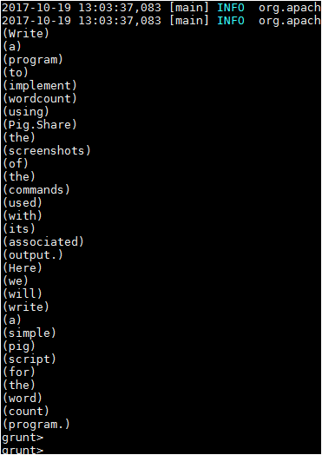

Apply GROUP BY
“Grouped = GROUP Convert_Words BY word;”
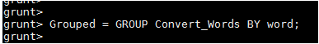
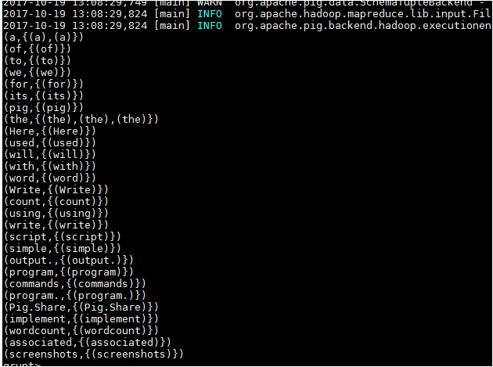

Generate Word Count
“wordcountpig = FOREACH Grouped GENERATE group, COUNT(Convert_Words);
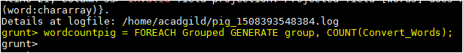

Expected Output
DUMP wordcountpig;
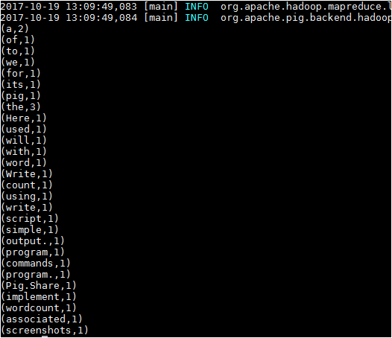

Complete PIG Code
Word_Count = LOAD '/home/acadgild/hadoop/wordcountpig.txt' USING PigStorage(',') AS (line:chararray);
Convert_Words = FOREACH Word_Count GENERATE FLATTEN(TOKENIZE(line,' ')) AS word;
Grouped = GROUP Convert_Words BY word;
wordcountpig = FOREACH Grouped GENERATE group, COUNT(Convert_Words);
DUMP wordcountpig;
xxxxxx--------------------COMPLETED------------------xxxxxx

