Session 4: SCHEDULERS IN YARN & INTRODUCTION TO PIG
Assignment 4.1
Write java codes for different examples.

Problem Statement:

Program 1: Addition of Two numbers
Write a java code with the class named ‘acad’ and a method ‘main’. Hard Code the program with two integers and print the sum of those two.
package NICE;

public class acad {

public static void main(String[] args)
{
// TODO Auto-generated method stub

int a=12;
int b=13;
int c=a+b;

System.out.print("The Value of C: ");
System.out.println(c);

}

}
Output:

Program 2: Addition, Runtime Input
Rewrite the above code, where, inputs are provided by the user at runtime and the output is printed.
public class acad
{

public static void main(String[] args)
{
// TODO Auto-generated method stub

int a,b;
int add;

Scanner buf=new Scanner(System.in);
System.out.println("Enter the value of a: ");
a=buf.nextInt();
System.out.println("Enter the Value of b: ");
b=buf.nextInt();
add=a+b;

System.out.println("The Sum is: " +add);

}

}

Output:
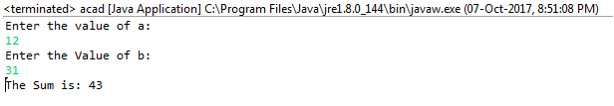

3)Program 3: Addition using the method sum()
Write a program with method name sum() that accepts two parameters from user and print the sum of two numbers. Output format should be as:
First number is:
Second number is:
Sum is:
public class acad {

public static void main(String[] args)
{
// TODO Auto-generated method stub
sum();

}
public static void sum()
{

Scanner buf=new Scanner(System.in);
System.out.print("First number is:");
int a=buf.nextInt();
System.out.print("Second number is:");
int b=buf.nextInt();

int c=a+b;
System.out.print("Sum is:" +c);

}

}
Output:
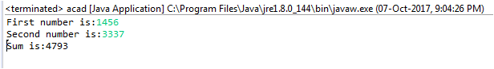

Program 4: Odd and Even
Write a program to accept two numbers from stdin and find all the odd as well as even numbers present in between them.
public class OddEven
{
public static void main(String[] args)
{

int n;
Scanner buf=new Scanner(System.in);
System.out.print("Enter the no. Of Elements: ");

n=buf.nextInt();
int a[]=new int[n];
System.out.println("Enter all elements: ");
for (int i=0; i<n; i++)
{
a[i]=buf.nextInt();
}
System.out.print("Odd numbers:");
for(int i = 0 ; i < n ; i++)
{
if(a[i] % 2 != 0)
{
System.out.print(a[i]+" ");
}
}
System.out.println("");
System.out.print("Even numbers: ");
for(int i = 0 ; i < n ; i++)
{
if(a[i] % 2 == 0)
{
System.out.print(a[i]+" ");
}
}
}
}
Output:
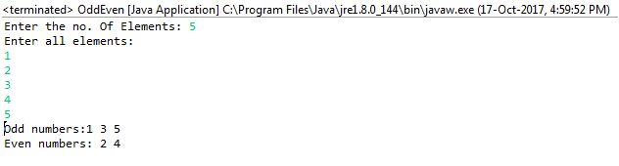

Program 5: Multiplication
Joe is scared to go to school. When her dad asked the reason, joe said she is unable to complete the task given by her teacher. The task was to find the “first 10 multiples” of the number entered from stdin . Eg:
Input: 3
O/p:
3 x 1 = 3
3 x 2 = 6
………
3 x 10 = 30
Help Joe in completing the task!
public class Multplication {

public static void main(String[] args)

{
// TODO Auto-generated method stub

Scanner buf=new Scanner(System.in);
System.out.print("Enter The Input Value: ");

int n=buf.nextInt();

for (int i=1;i<=10;i++)
{
System.out.println(n+" * "+i+" = "+n*i);
}
}
}
Output:
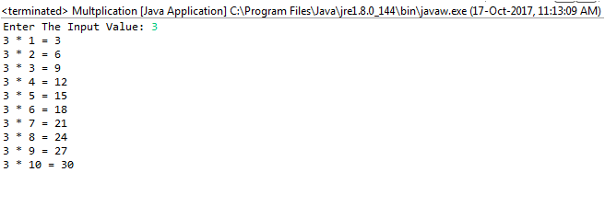

Program 6: Method Over Loading

Method overloading
If two or more method in a class have same name but different parameters, it is known as method overloading. Overloading always occur in the same class (unlike method overriding).
Method overloading is one of the ways through which java supports polymorphism. Method overloading can be done by changing number of arguments or by changing the data type of arguments. If two or more method have same name and same parameter list but differs in return type are not said to be overloaded method
Note: Overloaded method can have different access modifiers.
Write a program consisting method sum() and demonstrate the concept of method overloading using this method.
public class MethodOverLoading

{

void sum(int a, int b)

{
System.out.println("Sum is" + (a + b));
}

void sum(float a, float b)
{
System.out.println("Sum is" + (a + b));
}
public static void main(String[] args)
{
MethodOverLoading cal=new MethodOverLoading();
cal.sum (22,22);
cal.sum (2.3f,3.7f);

}

}
Output:

Program 7: Can methods be overloaded based on the return types
Can you overload a method with same return type? Explain your answer with proper logic.
In Java, method overloading is not possible by changing the return type of the method because there may occur ambiguity.
Consider the following example,
public class MethodOLRT

{
int sum(int a, int b)//Compile Time Error - Duplicate method sum(int, int)
{
return a+b;
}
void sum(int a, int b)//Compile Time Error - Duplicate method sum(int, int)
{
System.out.println(a+b);
}

public static void main(String[] args) {
// TODO Auto-generated method stub
MethodOLRT obj=new MethodOLRT();
int result=obj.sum(10, 10);
}

}

The method can be overloaded only on the following basis:
1. The method name are same (including the case. viz. sum and sum are not the same)
2. The signatures (argument) of the method. Return type cannot be used for the method overloading.
A method cannot be overloaded on the bases of return types because the compiler will check only the name of the method and the arguments. So a method cannot be overloaded on the bases of return types.

Program 8: Descending Order
Write a program in java using Arrays that sorts the element in descending order.
public class DescendingOrder

{
public static void main(String[] args)

{
int n, temp;
Scanner buf=new Scanner(System.in);
System.out.print("Enter no of Elements: ");
n=buf.nextInt();
int a[]=new int[n];

System.out.println("Enter all the elements: ");
for (int i=0; i<n; i++)
{
a[i]=buf.nextInt();
}

for (int i=0; i<n; i++)
{
for (int j=i+1; j<n; j++)
{
if(a[i]<a[j])
{
temp=a[i];
a[i]=a[j];
a[j]=temp;
}
}
}

System.out.print("Descending Order: ");
for (int i=0; i<n-1; i++)
{
System.out.print(a[i] + ",");
}
System.out.print(a[n-1]);
}
}

Output:
