Session 4: SCHEDULERS IN YARN & INTRODUCTION TO PIG
Assignment 4.2
Create a sample dataset and implement the below Pig commands on the same dataset.
In this assignment we are going to use the below as Input Data set for the first 8 PIG commands.

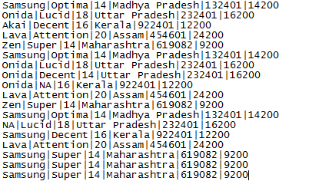
Problem Statement: Create a sample dataset and implement the below Pig commands on the same dataset.
1) Concat
2) Tokenize
3) Sum
4) Min
5) Max
6) Limit
7) Store
8) Distinct
9) Flatten
10) IsEmpty

1) Concat():
The CONCAT() function of Pig Latin is used to concatenate two or more expressions of the same type.
Command:
“baseRelation = LOAD '/home/acadgild/hadoop/television.txt' USING PigStorage('|') AS (company_name:chararray, unit_name:chararray, size:int, state:chararray, zip:int, price:int);
DUMP baseRelation;
DESCRIBE baseRelation;
company_unit_concat = FOREACH baseRelation GENERATE CONCAT(company_name, '-', unit_name);
DUMP company_unit_concat;”

Output:
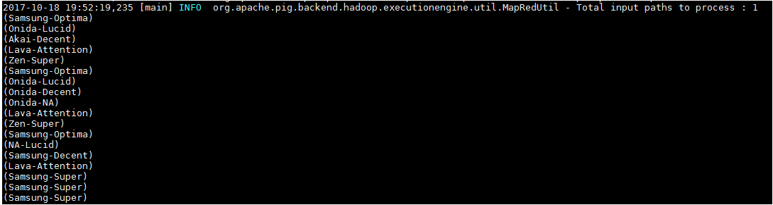

2) Tokenize()
The TOKENIZE() function of Pig Latin is used to split a string (which contains a group of words) in a single tuple and returns a bag which contains the output of the split operation.
Command:
“company_unit_tokenize = FOREACH baseRelation GENERATE TOKENIZE(company_name);
DUMP company_unit_tokenize;”

Output:
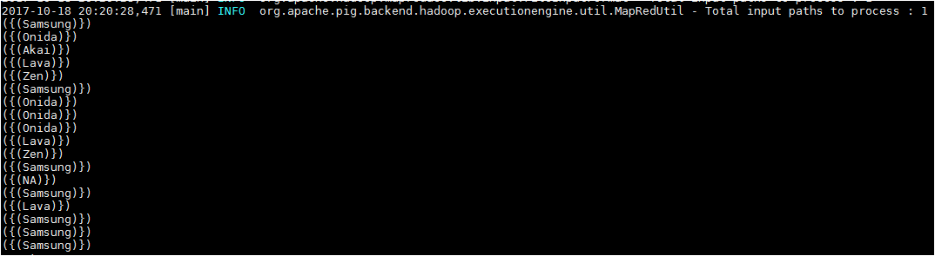

3) Sum():
You can use the SUM() function of Pig Latin to get the total of the numeric values of a column in a single-column bag. While computing the total, the SUM() function ignores the NULL values.
Note –
- To get the global sum value, we need to perform a Group All operation, and calculate the sum value using the SUM() function.
- To get the sum value of a group, we need to group it using the Group By operator and proceed with the sum function.
Command:
“company_price = GROUP baseRelation ALL;”

Output:
(all,{(Samsung,Super,14,Maharashtra,619082,9200),(Samsung,Super,14,Maharashtra,619082,9200),(Samsung,Super,14,Maharashtra,619082,9200),(Lava,Attention,20,Assam,454601,24200),(Samsung,Decent,16,Kerala,922401,12200),(NA,Lucid,18,Uttar Pradesh,232401,16200),(Samsung,Optima,14,Madhya Pradesh,132401,14200),(Zen,Super,14,Maharashtra,619082,9200),(Lava,Attention,20,Assam,454601,24200),(Onida,NA,16,Kerala,922401,12200),(Onida,Decent,14,Uttar Pradesh,232401,16200),(Onida,Lucid,18,Uttar Pradesh,232401,16200),(Samsung,Optima,14,Madhya Pradesh,132401,14200),(Zen,Super,14,Maharashtra,619082,9200),(Lava,Attention,20,Assam,454601,24200),(Akai,Decent,16,Kerala,922401,12200),(Onida,Lucid,18,Uttar Pradesh,232401,16200),(Samsung,Optima,14,Madhya Pradesh,132401,14200)})
“company_price_sum = FOREACH company_price GENERATE (baseRelation.company_name,baseRelation.price),SUM(baseRelation.price);”
(({(Samsung),(Samsung),(Samsung),(Lava),(Samsung),(NA),(Samsung),(Zen),(Lava),(Onida),(Onida),(Onida),(Samsung),(Zen),(Lava),(Akai),(Onida),(Samsung)},{(9200),(9200),(9200),(24200),(12200),(16200),(14200),(9200),(24200),(12200),(16200),(16200),(14200),(9200),(24200),(12200),(16200),(14200)}),262600)

4) MIN():
The MIN() function of Pig Latin is used to get the minimum (lowest) value (numeric or chararray) for a certain column in a single-column bag. While calculating the minimum value, the MIN() function ignores the NULL values.
Note
- To get the global minimum value, we need to perform a Group All operation, and calculate the minimum value using the MIN() function.
- To get the minimum value of a group, we need to group it using the Group By operator and proceed with the minimum function.

Command:
“company_price = GROUP baseRelation ALL;
company_price_min = FOREACH company_price GENERATE (baseRelation.company_name,baseRelation.price),MIN(baseRelation.price);”

Output
(({(Samsung),(Samsung),(Samsung),(Lava),(Samsung),(NA),(Samsung),(Zen),(Lava),(Onida),(Onida),(Onida),(Samsung),(Zen),(Lava),(Akai),(Onida),(Samsung)},{(9200),(9200),(9200),(24200),(12200),(16200),(14200),(9200),(24200),(12200),(16200),(16200),(14200),(9200),(24200),(12200),(16200),(14200)}),9200)

5)MAX()
The Pig Latin MAX() function is used to calculate the highest value for a column (numeric values or chararrays) in a single-column bag. While calculating the maximum value, the Max() function ignores the NULL values.
Note −
- To get the global maximum value, we need to perform a Group All operation, and calculate the maximum value using the MAX() function.
- To get the maximum value of a group, we need to group it using the Group By operator and proceed with the maximum function.
“company_price = GROUP baseRelation ALL;
company_price_max = FOREACH company_price GENERATE (baseRelation.company_name,baseRelation.price),MAX(baseRelation.price);”

Output
(({(Samsung),(Samsung),(Samsung),(Lava),(Samsung),(NA),(Samsung),(Zen),(Lava),(Onida),(Onida),(Onida),(Samsung),(Zen),(Lava),(Akai),(Onida),(Samsung)},{(9200),(9200),(9200),(24200),(12200),(16200),(14200),(9200),(24200),(12200),(16200),(16200),(14200),(9200),(24200),(12200),(16200),(14200)}),24200)

6)LIMIT()
The LIMIT operator is used to get a limited number of tuples from a relation.
Command:
“limit_data = LIMIT baseRelation 5;”

Output
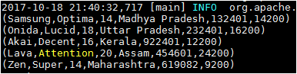

7)STORE()
You can store the loaded data in the file system using the store operator.
Command:
“STORE baseRelation INTO '/home/acadgild/hadoop/pigoutassignment' USING PigStorage('|');”
Output:
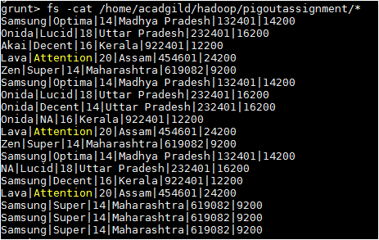

8)Distinct()
The DISTINCT operator is used to remove redundant (duplicate) tuples from a relation.
Command:
“distinct_data = DISTINCT baseRelation;”

Output:
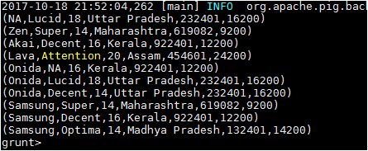

9)Flatten()
The FLATTEN operator looks like a UDF syntactically, but it is actually an operator that changes the structure of tuples and bags in a way that a UDF cannot. Flatten un-nests tuples as well as bags. The idea is the same, but the operation and result is different for each type of structure.
Input Dataset:
A.txt B.txt
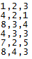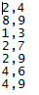
Command:
“A_Relation = LOAD '/home/acadgild/hadoop/A.txt' USING PigStorage(',') AS (a1:int,a2:int,a3:int);
B_Relation = LOAD '/home/acadgild/hadoop/B.txt' USING PigStorage(',') AS (b1:int,b2:int);
C_Relation = COGROUP A_Relation BY a1 inner, B_Relation BY b1 inner;
Dump C_Relation;
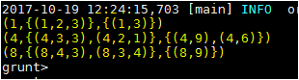
FLATTEN():
- X_Relation = FOREACH C_Relation GENERATE group, FLATTEN(A_Relation);
- X_Relation = FOREACH C_Relation GENERATE group, FLATTEN(A_Relation.a3);

Output
In this example the FLATTEN operator is used to eliminate nesting.
- 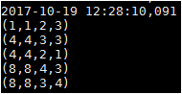
- 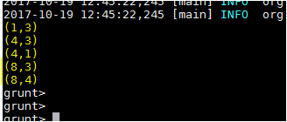

10)ISEMPTY()
The IsEmpty() function of Pig Latin is used to check if a bag or map is empty.
Input Data:
Employee_Sales.txt Employee_bonus.txt
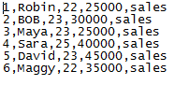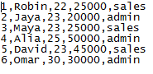
Command:
- sales_relation = LOAD '/home/acadgild/hadoop/Employee_sales.txt' USING PigStorage(',') AS (id:int, name:chararray, age:int, salary:int, dept:chararray);
DUMP sales_relation;
- bonus_relation = LOAD '/home/acadgild/hadoop/Employee_bonus.txt' USING PigStorage(',') AS (id:int, name:chararray, age:int, salary:int, dept:chararray);
DUMP bonus_relation;
- cogroup_data = COGROUP sales_relation by age, bonus_relation by age;
DUMP cogroup_data;

- isempty_data = FILTER cogroup_data by IsEmpty(sales_relation);
DUMP isempty_data;”

Output
Below is the output of the command number 3.
- (22,{(6,Maggy,22,35000,sales),(1,Robin,22,25000,sales )},{(1,Robin,22,25000,sales )})
(23,{(5,David,23,45000,sales ),(3,Maya,23,25000,sales ),(2,BOB,23,30000,sales )},{(5,David,23,45000,sales ),(3,Maya,23,25000,sales ),(2,Jaya,23,20000,admin )})
(25,{(4,Sara,25,40000,sales )},{(4,Alia,25,50000,admin )})
(30,{},{(6,Omar,30,30000,admin)})
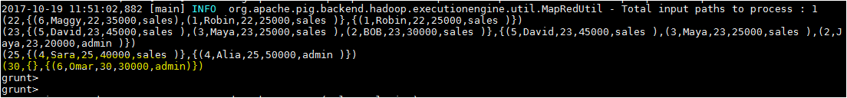
Output of the command number 4 IsEmpty(),The sales_relation holds the tuples that are not there in the relation bonus_relation.
